IEEE P802.11
Wireless LANs

Real-time mobile game Wi-Fi problem highlight
Date: 2018-08-22
Contributors:
Name | Affiliation | Address | Phone | email
Kate Meng | Tencent Holdings Limited | C1, Hi-Tech Park, NanShan, Shenzhen, China | +86 166-7516-1765 | Katemeng@tencent.com

Abstract

This document contains introduction of background information and network requirements of real-time mobile game under Wi-Fi.

Table of Contents
1. Terminology 3
2. Characteristics of real-time mobile game packet 3
3. Traffic Model 4
4. Problem Highlight 5
5. How latency and stability matter 5
6. Quadrant of jitter and latency of STA vs AP 6
7. Lagging distribution between 2.4G and 5G Wi-Fi bands 6
8. Root cause for lagging 7
9. Network requirements analysis from client to AP 7

Terminology

Real-time mobile game: The mobile game can connect multiple players together in a single game session and transfer data messages between game server and connected players. Real-time means the feedback should present on screen as users operate in game. For good game experience, the latency plus game servers processing time should not be noticed by users as they play.
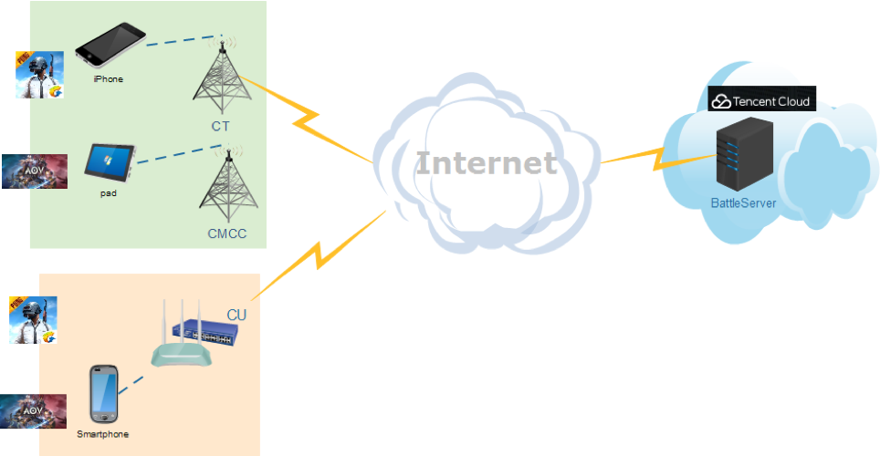

Gateway: Connect WLAN to WAN (Internet). Usually this entity refers to Wi-Fi router.
Lagging in game: lag is a noticeable delay between the action of players and the reaction of the server in a game. Usually, high latency cause lagging and lagging can be reflected as picture freeze or “fast-forward” or frame skipping in game.
In-game ping value/Latency: round trip time between client and game server in datacenter. Real-time mobile game has a low threshold. Usually users would not encounter lagging (due to network) when the value is less than 100ms.
Jitter: Jitter reflects the fluctuation of latency over time. It can be evaluated by the time difference between two adjacent in-game ping values. In real-time mobile game, the jitter is calculated as standard deviation during a period time.
Disconnect: when latency is too high even causes packet loss, client will disconnect from game servers after several times of retry connection.

Characteristics of real-time mobile game packet

Packet size: small packet with size of 100-500 Bytes (uplink and downlink), usually downlink packets are bigger than uplink.
Packet flow rate: every 30-60ms one packet (uplink and downlink), usually downlink packet interval is larger than uplink.
Bandwidth between client and AP: 0.5-1Mbps
Game data: Usually, the uplink packets carry users’ instructions, while downlink packets carry calculation results or calculation instructions. So, both uplink and downlink packets are important and should be delivered as soon as possible.

Protocol: mostly UDP

Traffic Model

There are two popular mechanisms of synchronization between client and game server in real-time mobile games, one is frame lockstep sync, the other one is status sync.
The games we used to build the model for frame lockstep sync are King glory and AoV, while PUBG for status sync.

- Traffic model for status sync real-time mobile game
Component | Distribution |  | Parameters |  | PDF(probability density function)
 | DL | UL | DL | UL
Initial packet size(Byte) | Uniform | Uniform | a=0,  b=20 | a=0,  b=20 | 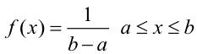
Packet arrival time (ms) | Largest Extreme Value | Largest Extreme Value | a=13,  b=3.7 | a=15,  b=5.7 | 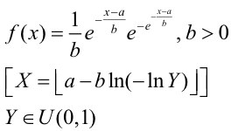
Packet size (Byte) | Largest Extreme Value | Largest Extreme Value | a=50,  b=11 | a=38,  b=3.7 | 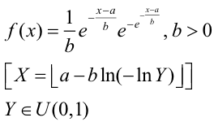
End packet  (Byte) | Uniform | Uniform | a=500,  b=600 | a=400,  b=550 | 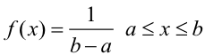

- Traffic model for frame lockstep sync real-time mobile game
Component | Distribution |  | Parameters |  | PDF
 | DL | UL | DL | UL
Initial packet size(Byte) | Uniform | Uniform | a=0,  b=80 | a=0,  b=80
Packet arrival time (ms) | Largest Extreme Value | Largest Extreme Value | a=28,  b=4.2 | a=22,  b=3.4
Packet size (Byte) | Largest Extreme Value | Largest Extreme Value | a=210,  b=35 | a=92,  b=38
End packet  (Byte) | Uniform | Uniform | a=1400,  b=1500 | a=500,  b=600

Problem Highlight

Users connect to game under various environment, such as home, restaurants, subway, malls etc.
Around 60% users connect to game via Wi-Fi, with 20-30% possibilities that users encounter lagging in-game.
60-70% lagging because of problems between client and gateway. (around 10-15% are remain unknown which pending a validate process/ test plan to locate problem).

Comparison of lagging rate between 4G and Wi-Fi based on big data is as following table

Mode | Chance of lagging
Wi-Fi | 23%
4G | 15%

Algorithm to identify reasons of lagging (simplified)

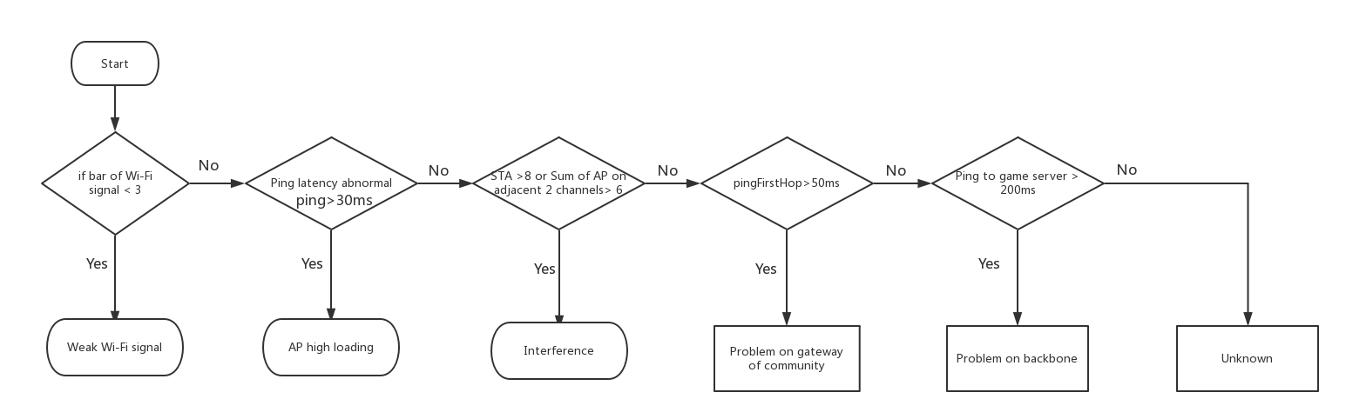

How latency and stability matter

Real-time mobile game request instant feedback of in-game operation from multiple players who are in the same battle room, the lagging will cause picture not fluent and impact user experience negatively.

Moreover, the time difference that user get the response will cause unfairness because the response is not synchronous.

A common observation is, during a period time, although average latency is low, worst case latency (spike) can be several times higher than the average. Jitter will cause spike in latency, when latency is too high which exceeds threshold and then cause packet loss, lagging is expected.

Quadrant of jitter and latency of STA vs AP
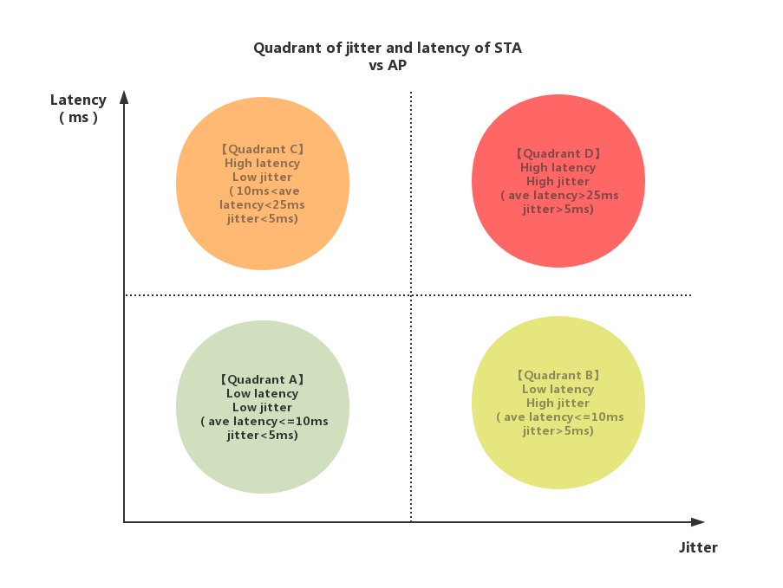
Latency is from STA to AP RTT.
Description of the quadrant:
Quadrant A: Network status between STA and AP is good
Quadrant B: Network status between STA and AP barely impact the game experience.
Quadrant C: Network status between STA and AP impact game experience.
Quadrant D: Network status between STA and AP impact game experience negatively.

Lagging distribution between 2.4G and 5G Wi-Fi bands

Below is lagging analysis under Wi-Fi based on data from over 100 million pvp (player vs player) games.

Band | No lagging | Lagging
2.4G | 74.59% | 25.41%
5G | 86.87% | 13.13%

Root cause for lagging

High latency till packet loss and disconnection.
• High latency itself will cause picture not fluent and users would feel they can hardly control the in-game character.

Low average latency but severe ping spikes.
• Random high ping spikes can cause packet delay/loss which will instantly affect user experience.

So, to summarize, the average latency is important since it is fundamental to realize the real-time manner and provide immersive game experience, but the worst-case latency is the key problem and should be improved and controlled. When average latency can be controlled in one certain range, the tradeoff between stability and latency is one direction that worth exploring.

Network requirements analysis from client to AP

Based on big data, the average latency from client to AP is 7ms, however user experience need to be considered over the complete path from client to game server.

The latency breakdown for good and acceptable game experience is as below.

The relationship between game experience and latency is as below table.

Specifications from client to AP in below table are open to discussion.

Specification | Value
Latency | <10ms
Packet loss | <0.1%
Jitter | <5ms (from client to AP)
High latency packet(>30ms) | <1%

Reference

PDF: http://reference.wolfram.com/language/ref/ExtremeValueDistribution.html

The packet size range estimation is based on popular real-time mobile game data capture. Please refer to Traffic Model part.
The packet characteristics of UL and DL are different since these are two independent process.
The bandwidth is based on popular real-time game data capture. The main idea is that real-time mobile games are low throughput.
Sum of AP on adjacent two channels >6 consider home-like environment. Home AP is different from enterprise AP which use as widely spaced channels as possible. The numbers in above picture is based on user game experience analysis experience.

