IEEE P802.11
Wireless LANs

Real-time mobile game Wi-Fi problem highlight
Date: 2018-08-17
Contributors:
Name | Affiliation | Address | Phone | email
Kate Meng | Tencent Holdings Limited | C1, Hi-Tech Park, NanShan, Shenzhen, China | +86 166-7516-1765 | Katemeng@tencent.com

Abstract

This document contains introduction of background information and network requirements of real-time mobile game under Wi-Fi.

Table of Contents
1. Terminology 3
2. Characteristics of real-time mobile game packet 3
3. Traffic Model 4
4. Problem Highlight 5
5. Why latency matters 5
6. Quadrant of jitter and latency of STA vs AP 6
7. Lagging distribution between 2.4G and 5G Wi-Fi band 6
8. Root cause for lagging 7
9. Network requirements from client to AP 7

Terminology

Real-time mobile game: The mobile game can connect multiple players together in a single game session and transfer data messages between game server and connected players. Real-time means the feedback should present on screen as users operate in game. For good game experience, the latency plus game servers processing time should not be noticed by users as they play.
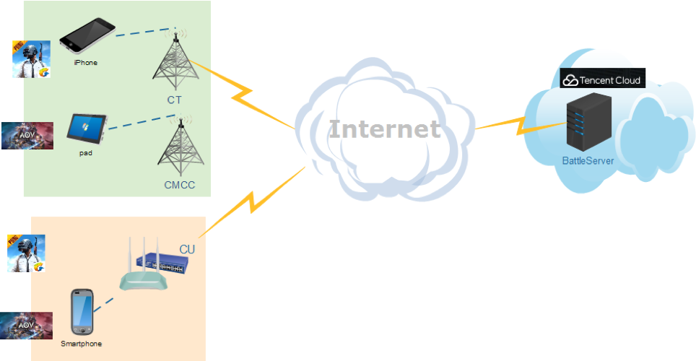

Gateway: Connect WLAN to WAN (Internet). Usually this entity refers to Wi-Fi router.
Lagging in game: lag is a noticeable delay between the action of players and the reaction of the server in a game. Usually, high latency cause lagging and lagging can be reflected as picture freeze or “fast-forward” or frame skipping in game.
In-game ping value/Latency: round trip time between client and game server in datacenter. Real-time mobile game has a low threshold. Usually users would not encounter lagging (due to network) when the value is less than 100ms.
Jitter: Jitter reflects the fluctuation of latency over time. It can be evaluated by the time difference between two adjacent in-game ping values. In real-time mobile game, the jitter is calculated as standard deviation during a period of time.
Disconnect: when latency is too high even causes packet loss, client will disconnect from game servers after several times of retry connection.

Characteristics of real-time mobile game packet

Packet size: small packet 100-500 Bytes (uplink and downlink), usually downlink packets are bigger than uplink.
Packet flow rate: every 30-60ms one packet (uplink and downlink), usually downlink packet interval is larger than uplink.
Bandwidth between client and AP: 0.5-1Mbps
Game data: Usually, the uplink packets carry users’ instructions, while downlink packets carry calculation results or calculation instructions. So, both uplink and downlink packets are important and should not be

Protocol: mostly UDP

Traffic Model

There are two popular mechanisms of synchronization between client and game server in real-time mobile games, one is frame lockstep sync, the other one is status sync.
The games we used to build the model for frame lockstep sync are King glory and AoV, while PUBG for status sync.

- Traffic model for status sync real-time mobile game
Component | Distribution |  | Parameters |  | PDF(probability density function)
 | DL | UL | DL | UL
Initial packet size(Byte) | Uniform | Uniform | a=0,  b=20 | a=0,  b=20 | 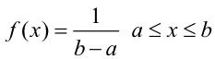
Packet arrival time (ms) | Largest Extreme Value | Largest Extreme Value | a=13,  b=3.7 | a=15,  b=5.7 | 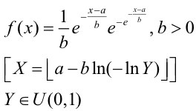
Packet size (Byte) | Largest Extreme Value | Largest Extreme Value | a=50,  b=11 | a=38,  b=3.7 | 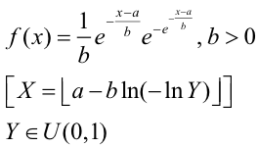
End packet  (Byte) | Uniform | Uniform | a=500,  b=600 | a=400,  b=550 | 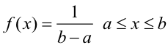

- Traffic model for frame lockstep sync real-time mobile game
Component | Distribution |  | Parameters |  | PDF
 | DL | UL | DL | UL
Initial packet size(Byte) | Uniform | Uniform | a=0,  b=80 | a=0,  b=80
Packet arrival time (ms) | Largest Extreme Value | Largest Extreme Value | a=28,  b=4.2 | a=22,  b=3.4
Packet size (Byte) | Largest Extreme Value | Largest Extreme Value | a=210,  b=35 | a=92,  b=38
End packet  (Byte) | Uniform | Uniform | a=1400,  b=1500 | a=500,  b=600

Problem Highlight

Users connect to game under various environment, such as home, restaurants, subway, malls etc.
Around 60% users connect to game via Wi-Fi, with 20-30% possibilities that users encounter lagging in-game.
60-70% lagging because of problems between client and gateway. (around 10-15% are remain unknown which pending a validate process/ test plan to locate problem).

Algorithm to identify reasons of lagging (simplified)

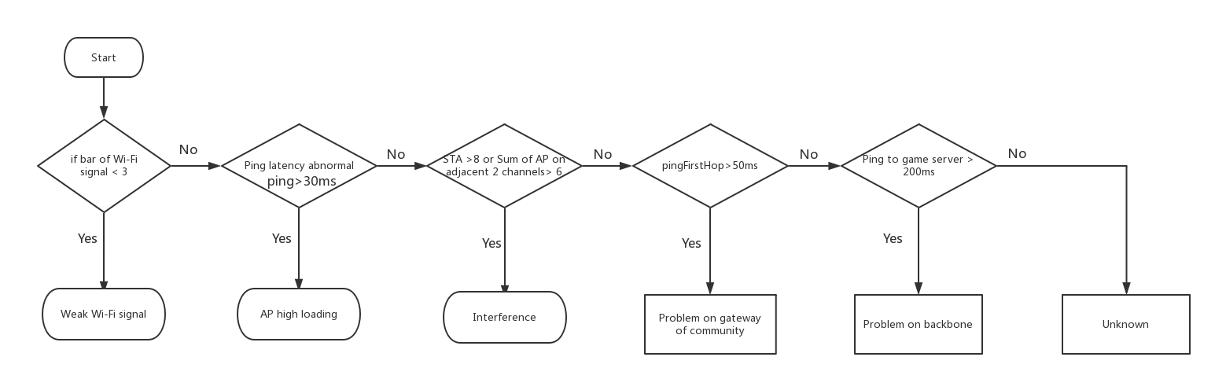
Note:
- The environment is home based. Home AP is different from enterprise AP which use as widely spaced channels as possible.
- The numbers in above picture is based on game experience analysis experience.

How latency and stability matter

Real-time mobile game request instant feedback of in-game operation from multiple players who are in the same battle room, the lagging will cause picture not fluent and impact user experience negatively.

Moreover, the time difference that user get the response will cause unfairness because the response is not synchronous.

A common observation is, during a period of time, although average latency is low, worst case latency (spike) can be several times higher than the average. Jitter will cause spike in latency, when latency is too high which exceeds threshold and then cause packet loss, lagging is expected.

Quadrant of jitter and latency of STA vs AP
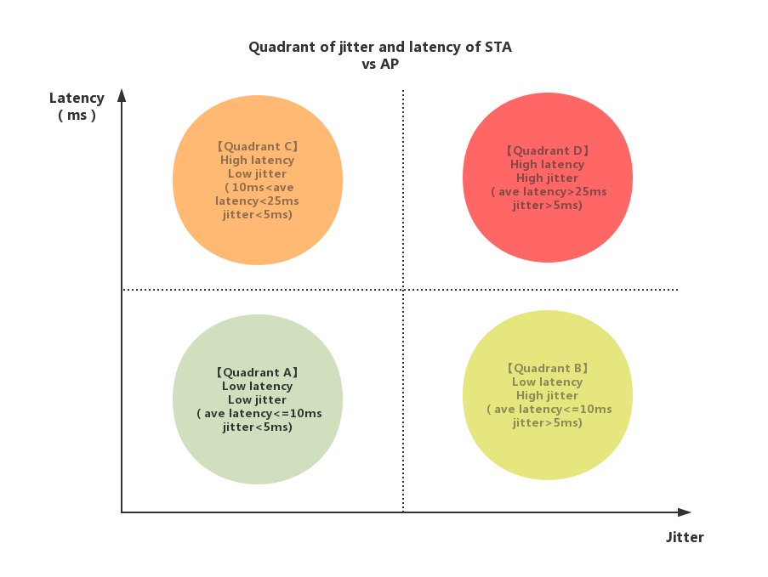
Latency is from STA to AP RTT.
Description of the quadrant:
Quadrant A: Network status between STA and AP is good
Quadrant B: Network status between STA and AP barely impact the game experience.
Quadrant C: Network status between STA and AP impact game experience.
Quadrant D: Network status between STA and AP impact game experience negatively.

Lagging distribution between 2.4G and 5G Wi-Fi bands

Below is lagging analysis under Wi-Fi based on data from over 100 million pvp (player vs player) games.

Band | No lagging | Lagging
2.4G | 74.59% | 25.41%
5G | 86.87% | 13.13%

Root cause for lagging

High latency till packet loss and disconnection.
• High latency itself will cause picture not fluent and users would feel they can hardly control the in-game character.
- Severe jitter(>100ms) might cause packet loss or disconnection.

So the worst case latency is the key problem and should be improved and controlled. When average latency can be controlled in one certain range, the tradeoff between stability and latency is one direction that worth exploring.

Network requirements from client to AP

Specification | Value
Latency | <10ms
Packet loss | <0.1%
Jitter | <5ms (from client to AP)

Reference
PDF: http://reference.wolfram.com/language/ref/ExtremeValueDistribution.html

