IEEE P802.11  
Wireless LANs

|  |  |  |  |  |
| --- | --- | --- | --- | --- |
| IEEE 802.11bb Channel Model for Conference Room Environment | | | | |
| Date: 2018-7-31 | | | | |
| Author(s): | | | | |
| Name | Affiliation | Address | Phone | email |
| Murat Uysal | Ozyegin University | Ozyegin University, Nisantepe Mh. Orman Sk. No:34-36 Çekmekoy 34794 Istanbul | +90 (216) 5649329 | murat.uysal@ozyegin.edu.tr |
| Farshad Miramirkhani | Ozyegin University | Ozyegin University, Nisantepe Mh. Orman Sk. No:34-36 Çekmekoy 34794 Istanbul |  |  |
| Tuncer Baykas | Istanbul Medipol University | Kavacık Istanbul |  |  |

**Notice: This document has been prepared to assist the IEEE 802.11. It is offered as a basis for discussion and is not binding on the contributing individual(s) or organization(s). The material in this document is subject to change in form and content after further study. The contributor(s) reserve(s) the right to add, amend or withdraw material contained herein.**

Release: The contributor acknowledges and accepts that this contribution becomes the property of IEEE and may be made publicly available by 802.11

.

Abstract

**This contribution proposes 802.11bb reference channel models for conference room envirionment.**

Conference Room Channel model

We consider a conference room where ten users sit around a table (see Fig. 1). The user (photodetector) locations are denoted as . The FOV and the area of the detector are 85° and 1 cm2, respectively. For standing persons (D1 and D10), the cell phone is held in their hand next to their ear and the detector is located on the top edge of the phone with 45º rotation upward the ceiling and at a height of 1.8 m (see Fig. 1.c). For sitting persons (D2, D3, D4, D5, D6, D7, D8, D9), the cell phone is held in their hand over their stomach. The detector is located on the top edge of the phone with 45º rotation upward the ceiling and at a height of 1.1 m (see Fig. 1c). Details on the floor, ceiling, walls, objects and users within the environment are provided in Table 1.

There are 10 LED luminaires each with 46 watt. These are denoted as  (see Fig. 1b). The LED luminaires used in simulations are commercially available from Cree (LR24-38SKA35). Relative spectral power distribution and relative intensity distribution of these LEDs are provided in Fig. 2. The spatial distribution of illumination levels and illumination level contours are calculated and illustrated in Fig. 3. Based on these, uniformity, average, maximum and minimum illumination levels are listed in Table 3. It can be also noted that the average illumination level required in conference room for general lighting is 750 lx.

**Table 1** Specifications of user models and man-made objects in the conference room

|  |  |
| --- | --- |
| **Conference Room** | |
| Walls | Plaster |
| Ceiling | Plaster |
| Floor | Pinewood |
| Windows | Glass |
| Monitor | Glass |
| Chairs | Black Gloss Paint |
| Table | Pinewood |
| Storage Cupboard | Aluminum Metal |
| **Humans (Users)** | |
| Shoes | Black Gloss Paint |
| Head & Hands | Absorbing |
| Clothes | Cotton |
| Cell Phones | Black Gloss Paint |

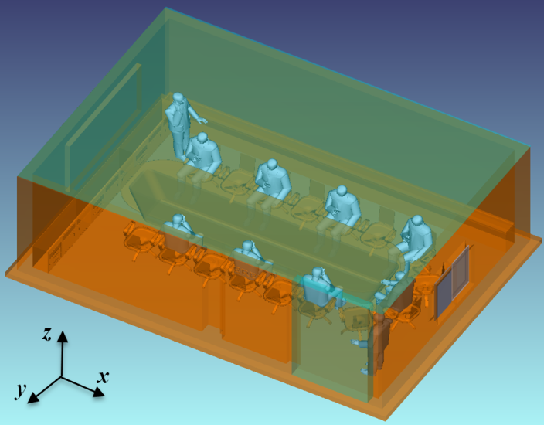

(a)

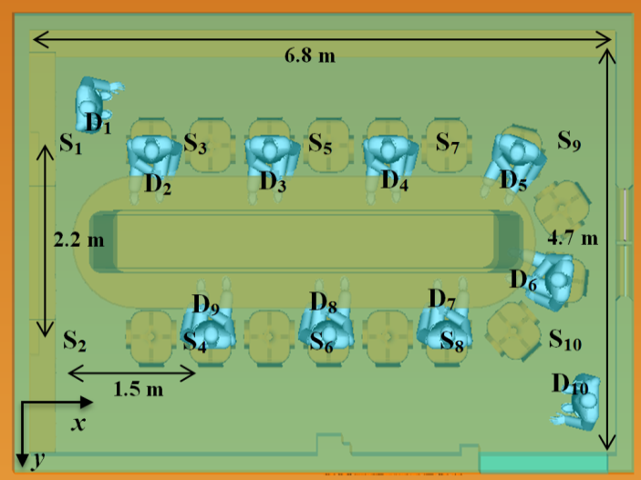

(b)

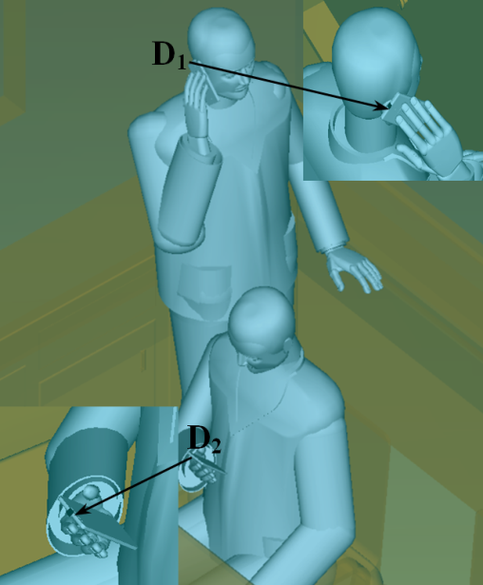

(c)

**Fig. 1.** Conference room under consideration

|  |  |
| --- | --- |
| (a) | (b) |

**Fig. 2.** (a) Relative spectral power distribution (b) relative intensity distribution of Cree® LR24-38SKA35

|  |
| --- |
| (a) |
| (b) |

**Fig. 3.** (a) Spatial distribution of illumination levels and (b) illumination level contours in conference room

**Table 2** Illumination level requirements for conference room

|  |  |
| --- | --- |
| Average of illumination level | 816.88 lx |
| Maximum of illumination level | 944.50 lx |
| Minimum of illumination level | 558.10 lx |
| Uniformity of illumination | 0.68 |

Based on the described simulation scenario above, we obtain 100 CIRs in total denoted as  where  and . The corresponding channel DC gain and RMS delay spreads are obtained and provided in Table 3. Ten sample CIRs are further presented in Fig. 4. It is observed from Fig. 4 that most of the CIRs in conference room are dominated by LOS components and multipath components generally take small value. This is a result of the fact that the luminaires in the conference room are arranged above each user.

|  |  |
| --- | --- |
| (a) | (b) |
| (c) | (d) |
| (e) | (f) |
| (g) | (h) |
| (i) | (j) |

**Fig. 4.** Sample CIRs for conference room

**Table 3** Channel parameters for conference room

|  |  |  |  |  |  |  |  |  |  |  |  |  |  |  |  |  |  |  |  |  |  |  |  |  |  |  |  |  |  |  |  |  |  |  |  |  |  |  |  |  |  |  |  |  |  |  |  |  |  |  |  |  |  |  |  |  |  |  |  |  |  |  |  |  |  |  |  |  |  |  |  |  |  |  |  |  |  |  |  |  |  |  |  |  |  |  |  |  |  |  |  |  |  |  |  |  |  |  |  |  |  |  |  |  |  |  |  |  |  |  |  |  |  |  |  |  |  |  |  |  |  |  |  |  |  |  |  |  |  |  |  |  |  |  |  |  |  |  |  |  |  |  |  |  |  |  |  |  |  |  |  |  |  |  |  |  |  |  |  |  |  |  |  |  |  |  |  |  |  |  |  |  |  |  |  |  |  |  |  |  |  |  |  |  |  |  |  |  |  |  |  |  |  |  |  |  |  |  |  |  |  |  |  |  |  |  |  |  |  |  |  |  |  |  |  |  |  |  |  |  |  |  |  |  |  |  |  |  |  |  |  |  |  |  |  |  |  |  |  |  |  |  |  |  |  |  |  |  |  |  |  |  |  |  |  |  |  |  |  |  |  |  |  |  |  |  |  |  |  |  |  |  |  |  |  |  |  |  |  |  |  |  |  |  |  |  |  |  |  |  |  |  |  |  |  |  |  |  |  |  |  |  |  |  |  |  |  |  |  |  |  |  |  |  |  |  |  |  |  |
| --- | --- | --- | --- | --- | --- | --- | --- | --- | --- | --- | --- | --- | --- | --- | --- | --- | --- | --- | --- | --- | --- | --- | --- | --- | --- | --- | --- | --- | --- | --- | --- | --- | --- | --- | --- | --- | --- | --- | --- | --- | --- | --- | --- | --- | --- | --- | --- | --- | --- | --- | --- | --- | --- | --- | --- | --- | --- | --- | --- | --- | --- | --- | --- | --- | --- | --- | --- | --- | --- | --- | --- | --- | --- | --- | --- | --- | --- | --- | --- | --- | --- | --- | --- | --- | --- | --- | --- | --- | --- | --- | --- | --- | --- | --- | --- | --- | --- | --- | --- | --- | --- | --- | --- | --- | --- | --- | --- | --- | --- | --- | --- | --- | --- | --- | --- | --- | --- | --- | --- | --- | --- | --- | --- | --- | --- | --- | --- | --- | --- | --- | --- | --- | --- | --- | --- | --- | --- | --- | --- | --- | --- | --- | --- | --- | --- | --- | --- | --- | --- | --- | --- | --- | --- | --- | --- | --- | --- | --- | --- | --- | --- | --- | --- | --- | --- | --- | --- | --- | --- | --- | --- | --- | --- | --- | --- | --- | --- | --- | --- | --- | --- | --- | --- | --- | --- | --- | --- | --- | --- | --- | --- | --- | --- | --- | --- | --- | --- | --- | --- | --- | --- | --- | --- | --- | --- | --- | --- | --- | --- | --- | --- | --- | --- | --- | --- | --- | --- | --- | --- | --- | --- | --- | --- | --- | --- | --- | --- | --- | --- | --- | --- | --- | --- | --- | --- | --- | --- | --- | --- | --- | --- | --- | --- | --- | --- | --- | --- | --- | --- | --- | --- | --- | --- | --- | --- | --- | --- | --- | --- | --- | --- | --- | --- | --- | --- | --- | --- | --- | --- | --- | --- | --- | --- | --- | --- | --- | --- | --- | --- | --- | --- | --- | --- | --- | --- | --- | --- | --- | --- | --- | --- | --- | --- | --- | --- | --- | --- | --- | --- | --- | --- | --- | --- | --- | --- | --- | --- | --- | --- | --- | --- | --- | --- | --- | --- | --- | --- | --- | --- |
| |  |  |  |  | | --- | --- | --- | --- | |  | | (ns) |  | | **S1** | **D1** | 2.15 | 2.06×10-5 | | **D2** | 6.63 | 3.74×10-6 | | **D3** | 9.39 | 1.15×10-6 | | **D4** | 10.18 | 4.44×10-7 | | **D5** | 9.49 | 2.52×10-7 | | **D6** | 7.23 | 4.93×10-7 | | **D7** | 8.70 | 4.67×10-7 | | **D8** | 8.55 | 9.16×10-7 | | **D9** | 6.70 | 2.59×10-6 | | **D10** | 4.49 | 6.95×10-8 | | **S2** | **D1** | 5.88 | 9.79×10-7 | | **D2** | 6.53 | 3.60×10-6 | | **D3** | 8.09 | 1.46×10-6 | | **D4** | 8.71 | 5.81×10-7 | | **D5** | 8.21 | 3.38×10-7 | | **D6** | 8.11 | 4.37×10-7 | | **D7** | 9.94 | 3.91×10-7 | | **D8** | 9.84 | 7.65×10-7 | | **D9** | 7.91 | 2.21×10-6 | | **D10** | 5.02 | 8.92×10-8 | | **S3** | **D1** | 7.58 | 6.23×10-7 | | **D2** | 5.89 | 6.92×10-6 | | **D3** | 7.10 | 4.19×10-6 | | **D4** | 10.11 | 1.10×10-6 | | **D5** | 9.77 | 3.58×10-7 | | **D6** | 8.74 | 8.91×10-7 | | **D7** | 9.17 | 9.89×10-7 | | **D8** | 7.99 | 2.42×10-6 | | **D9** | 6.70 | 4.49×10-6 | | **D10** | 7.17 | 1.34×10-7 | | **S4** | **D1** | 6.71 | 2.15×10-7 | | **D2** | 7.19 | 4.03×10-6 | | **D3** | 7.18 | 3.46×10-6 | | **D4** | 8.93 | 1.49×10-6 | | **D5** | 9.18 | 6.61×10-7 | | **D6** | 9.65 | 8.28×10-7 | | **D7** | 11.27 | 6.12×10-7 | | **D8** | 8.79 | 2.33×10-6 | | **D9** | 5.78 | 7.36×10-6 | | **D10** | 7.24 | 9.84×10-8 | | **S5** | **D1** | 7.22 | 1.82×10-7 | | **D2** | 9.93 | 1.49×10-6 | | **D3** | 6.46 | 6.57×10-6 | | **D4** | 7.14 | 4.80×10-6 | | **D5** | 9.46 | 1.46×10-6 | | **D6** | 8.36 | 1.83×10-6 | | **D7** | 7.87 | 2.65×10-6 | | **D8** | 6.64 | 4.85×10-6 | | **D9** | 7.43 | 3.08×10-6 | | **D10** | 6.86 | 1.68×10-7 | | |  |  |  |  | | --- | --- | --- | --- | |  | | (ns) |  | | **S6** | **D1** | 6.00 | 1.34×10-7 | | **D2** | 7.97 | 2.02×10-6 | | **D3** | 7.15 | 3.94×10-6 | | **D4** | 7.05 | 3.93×10-6 | | **D5** | 8.22 | 1.64×10-6 | | **D6** | 8.80 | 2.00×10-6 | | **D7** | 8.84 | 2.55×10-6 | | **D8** | 6.13 | 7.24×10-6 | | **D9** | 8.50 | 2.77×10-6 | | **D10** | 8.22 | 2.99×10-7 | | **S7** | **D1** | 5.83 | 7.77×10-8 | | **D2** | 10.29 | 3.55×10-7 | | **D3** | 9.44 | 1.56×10-6 | | **D4** | 6.67 | 5.80×10-6 | | **D5** | 6.28 | 5.42×10-6 | | **D6** | 7.52 | 3.29×10-6 | | **D7** | 6.97 | 4.65×10-6 | | **D8** | 7.88 | 2.77×10-6 | | **D9** | 8.59 | 1.25×10-6 | | **D10** | 7.55 | 2.94×10-7 | | **S8** | **D1** | 6.33 | 5.94×10-8 | | **D2** | 9.23 | 7.20×10-7 | | **D3** | 8.47 | 1.65×10-6 | | **D4** | 7.10 | 4.20×10-6 | | **D5** | 7.20 | 3.81×10-6 | | **D6** | 5.78 | 6.82×10-6 | | **D7** | 5.89 | 7.54×10-6 | | **D8** | 8.84 | 2.40×10-6 | | **D9** | 10.11 | 8.09×10-7 | | **D10** | 6.50 | 1.15×10-6 | | **S9** | **D1** | 5.44 | 8.50×10-8 | | **D2** | 6.95 | 2.13×10-7 | | **D3** | 9.93 | 6.87×10-7 | | **D4** | 8.85 | 1.70×10-6 | | **D5** | 6.28 | 5.48×10-6 | | **D6** | 8.24 | 2.23×10-6 | | **D7** | 6.93 | 2.86×10-6 | | **D8** | 7.61 | 1.42×10-6 | | **D9** | 7.66 | 6.89×10-7 | | **D10** | 6.79 | 7.37×10-7 | | **S10** | **D1** | 5.31 | 5.50×10-8 | | **D2** | 8.06 | 5.31×10-7 | | **D3** | 8.49 | 8.77×10-7 | | **D4** | 7.49 | 2.03×10-6 | | **D5** | 6.04 | 4.38×10-6 | | **D6** | 6.32 | 5.10×10-6 | | **D7** | 8.19 | 2.43×10-6 | | **D8** | 9.91 | 7.43×10-7 | | **D9** | 7.72 | 2.79×10-7 | | **D10** | 2.65 | 1.50×10-5 | |