IEEE P802.11
Wireless LANs
Proposed FD-TIG report text on usage model
Date: 2018-07-10
Author(s):
Name | Affiliation | Address | Phone | email
Ming Gan | Huawei Technologies |  |  | ming.gan@huawei.com
Dandan Liang |  |  |  | dandan.liang@huawei.com
Yan Xin |  |  |  | yan.xin@huawei.com
Abstract
This document provides the proposed text on self-interference cancellation to contribute to Sections 2 in the FD TIF report framework [1]. The proposed text is mainly based on the FD TIG presentation [2].

FD use cases

High Throughput Network

Dense network includes high density of APs and/or high density of STAs associated to each AP which work in 2.4 GHz, 5GHz and 6GHz, i.e., High density of APs and high density of STAs associated to each AP network, such as stadium, shopping mall, Indoor network with high density of STAs, such as lecture hall, dense-space office, and Indoor network with high density of APs, such as community Wi-Fi, dense apartment building.

Dense network-stadiums

Pre-Conditions
High density users access the internet through Wi-Fi in a physical space where a large quantity of APs are deployed. The traffics are bursty in time and uneven, some of which are high definition video.

Applications
Users are receiving uncompressed football match video with 24-bit color depth, 4K@60fps (required data rate: 11.94 Gbps); Users are uploading the recorded lightly compressed match video to the server or sharing it with their friends, 24-bit color depth, 1080P@60fps (required data rate: 2.98 Gbps); Thousands of users demanding 20 Mbps with best effort to access the internet for recreational content.

Environment
Open area with few obstacles and may suffer severe inter-user interference. Each AP services more than 100 devices in a 100 m² area. Inter-AP distance is between 12 and 20 meters.

Traffic Conditions
Interference between APs belonging to the same managed ESS due to very high density deployment; Interference between APs belonging to different managed ESS due to the presence of multiple operators;

Use Case
1. Users are receiving video show of some preferred football stars in an outdoor stadium;
2. Users access the internet for recreational content, supplemental event content (e.g., game stats) while uploading the recorded lightly compressed match video to the server or sharing it with their friends;
Users may be serviced by one AP for both uplink and downlink traffic at the same time;

Similar use cases can also be seen in other dense networks, such as Airports, Train Stations, and Exhibition Hall, etc. Interference from Bluetooth;

VR game

Pre-Conditions:
User has WLAN connectivity among game console, handset equipped with goggle and camera, and game handle

Application:
User plays immersive VR game with operations on the game handle, meanwhile the game console offers 360 degree vision and sounds. The user’s movement affects the output of video and sounds. The downlink data including compressed video and audio from game console transfers at ~7 Gbps (24-bit color depth, 2K@60fps with 2 lens), latency < 5 msec, jitter <5 msec, and PER<10E-2. If it is uncompressed video, the data rate can be up to more than 20 Gbps. Meanwhile the uplink data including the gesture transfers from handset is transmitted with data rate ~20 Mbps, latency < 5msec, and PER<10E-2.

Environment:
Devices are operating in an indoor environment such as a living/media room. Transmissions are most likely LOS. Distance between far corners of the room is <10 m.

Traffic Conditions:
Possible interference may be from neighboring devices. Microwave oven in the kitchen may be running for up to 5 minutes. The devices might be stationary or might be used with low-mobility during usage.

Use Case:
- The gamer is wearing his handset to start the game on VR platform;
- Move the game handle left and right and crouch from time to time or click the button to simulate the battle scenes;
- Cameras or sensors track the gesture of game handle and the player;
- The motion message is sent to gamming console from cameras;
- Meanwhile video and interaction behavior are non-disruptively streamed down to the goggle from the gaming console which is about 8 feet in front of him.

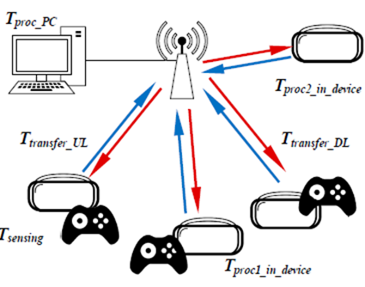

AR Shopping

Pre-Conditions:
User has WLAN connectivity among AR devices and the AP.

Application:
User wears AR devices or any device with AR app, which sends video to the AP, the AP sends the images or videos to the glasses at the same time. The images change with the AR devices movement. The downlink data from the AP to the AR devices, including video and images transmits at 20Mbp ~ 9 Gbps, latency <10 msec, jitter <10 msec, PER<10E-2. Meanwhile the uplink data from the AR devices to the root AP, including videos, is transmitted with data rate ~7 Gbps, latency <5msec, and PER<10E-2.

Environment:
Devices are operating in an indoor environment such as a store, a shopping mall, etc.

Traffic Conditions:
Possible interference may be from the other AP or devices. Deep fading due to the customers' movement.

Use Case:
- The Customer wears her WiFi-connected AR glasses and enters the store;
- The glasses send the video or picture captured by the camera to the AP;
- The AP sends the related information to the customer’s glasses, such as the good’s price, the coupon, the related live video, etc.

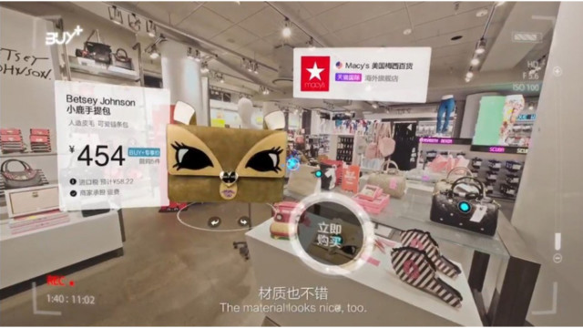

Telemedicine

Pre-Conditions:
Telecommunication and information technologies are used to provide clinical health care services from a distance.

Application:
A doctor diagnosed the patients in a remote office. The bidirectional traffics between doctor office and surgery room, including video and audio, are used to support remote diagnosis. Video sent from the surgery room is uncompressed at 24-bit color, 4K@60fps, and video sent from the doctor office is lightly compressed at 24-bit color, 1080P@60fps. Reliability and latency is a dominant requirement for such an application. Audio requirements are: 100Kbps, stream Jitter < 20 msec; delay < 10 msec; 1.0E-1 PER.
The compressed and uncompressed videos are transmitted/received through both APs, thus the total throughput for each AP is (11.94 Gbps+2.98 Gbps) = 14.92Gbps.

Environment:
Indoor hospital surgery room of 20 by 20 meter at one end, an office room of 10x10 meter to 40x40 meter coverage at the remote end. There are some unmanageable interferences around both ends.

Traffic Conditions:
Occasional interference from other rooms or mobile phones. Two-way video stream with possibility of background noise. QoS must be ensured.

Use Case:
- User turns on the displays, Cameras, WLAN, and prepares all the surgical instruments
- Uncompressed video and voice about the patients are sent to the AP in the surgery room , and then passed over the internet to the AP in the remote doctor’s office and further displayed in real time
- The instructions including voice and image are sent to the AP in the doctor office, and then passed over the internet to the AP in the surgery room and further displayed.

The kind of use case can be classified as multi-media chat, such as video conference call, skype or wechat video call.

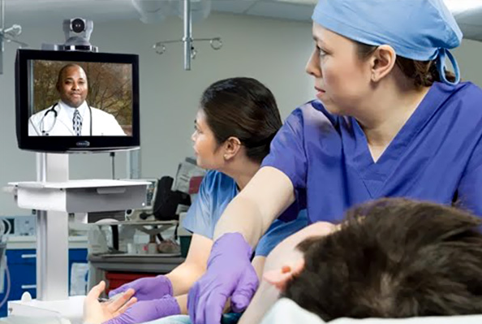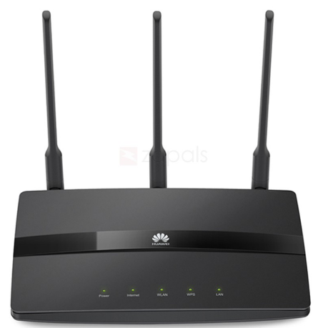

Relay-Based Network

A general rule of thumb in home networking says that Wi-Fi routers operating on the traditional 2.4 GHz band reach up to 150 feet (46 m) indoors and 300 feet (92 m) outdoors.

A general rule of thumb in home networking says that Wi-Fi routers operating on the traditional 2.4 GHz band reach up to 150 feet (46 m) indoors and 300 feet (92 m) outdoors.

A general rule of thumb in home networking says that Wi-Fi routers operating on the traditional 2.4 GHz band reach up to 150 feet (46 m) indoors and 300 feet (92 m) outdoors.

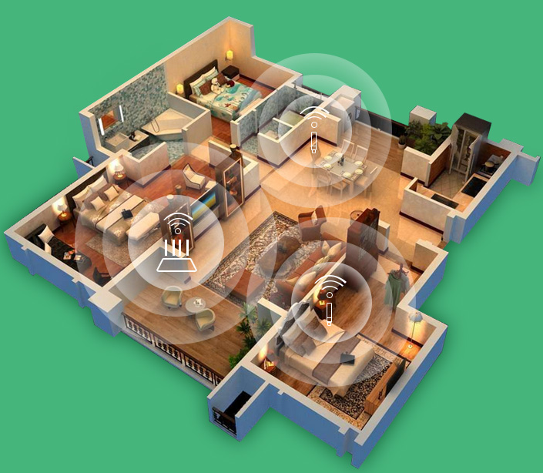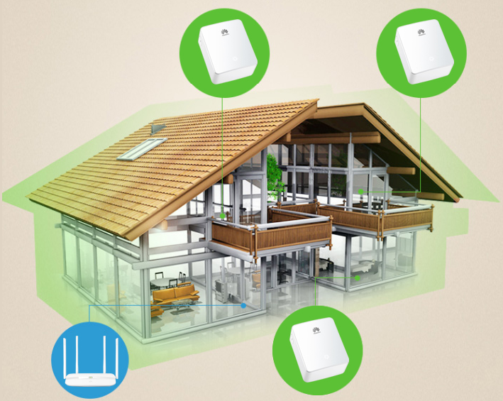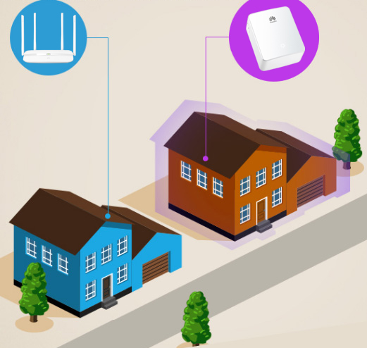
Apartment
House
Neighbor

Pre-Conditions:
A root AP and several Wi-Fi relays are deployed in an apartment or house. The topology of the network could allow the connectivity through multiple hops.

Application:
User deploys a root AP and several Wi-Fi relays in lieu of expensive fiber network or difficulty in placement to get the internet service at each corner of the house or apartment. Some data is transmitted through Wi-Fi relay to reach the destination. In this case, Wi-Fi relay is recommended to receive the data from the root AP and forward the data to the user simultaneously, so does the reverse link.

The data transfers at 2 Gbps with per link, the maximum number of hops should not exceed 3, and1.0E-1 PER.

Environment:
Devices are operating in indoor environment, such as an apartment or house with an area >100 m².

Traffic Conditions:
Potential interference from neighbour Wi-Fi devices.
Microwave in the kitchen may be running for up to 5 minutes.
Physical obstructions in homes such as brick walls and metal frames or siding.

Use Case:
1. A root AP is deployed in the living room and a wireless relay is deployed in the bedroom.
2. Alice opens video app using a mobile phone to watch a movie in the bedroom. The request is sent to wireless relay and forwarded to the root AP.
3. The video stream is downloaded to the root AP, and is sent to the Wi-Fi relay and forwarded to Alice.
4. At the Wi-Fi relay side, data is received and forwarded to the destination simultaneously.

In other use cases, Wi-Fi Relay with full duplex capability can also be implemented in mobile fronthauling, wireless backhaul with multi-hop [3] and mesh network

Security Systems

Security System provides the secure communication service which is achieved by full duplex technology.

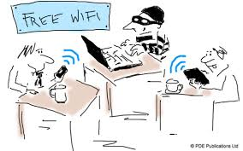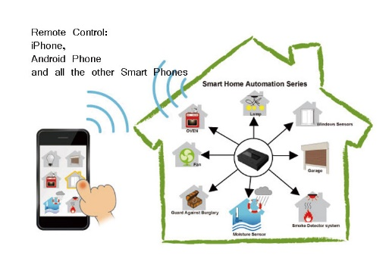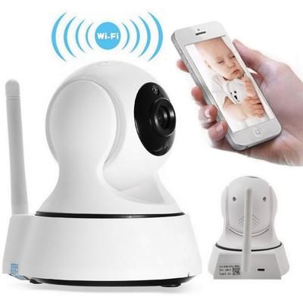
Public Wi-Fi
Smart Home
Wi-Fi Monitor
Important Meeting

Pre-Conditions
User has WLAN connectivity among monitors, mobile phones and tablets. The jamming signal is sent by the user for preventing eavesdropping.

Applications
Parents get the live video, audio and alerts on the some item from Wi-Fi monitor without any eavesdropping. Jamming range is 10-40 meters.

Environment
Transmissions are most likely Non-LOS. The distance between the Wi-Fi monitor and the mobile phone can be up to 40 meters. Neighbor houses are also operating WLANs.

Traffic Conditions
Potential interference from neighbor Wi-Fi devices.

Use Case
a. Parents open the Wi-Fi monitor and watch the baby’s status through the mobile phone;
b. The monitor sends the live video, audio and alerts of the baby to the parents’ mobile phone;
c. While receiving the data from monitor, the parents’ mobile phone sends the jamming signal to avoid eavesdropping.

References
[1] 11-18-0498-00-00fd-framework-fd-tig-report.
[2] 11-18-0758-00-00fd-full-duplex-usage-model.

