IEEE P802.11
Wireless LANs
Proposed FD-TIG report text on system efficiency improvement using FD based collision detection
Date: 2018-07-24
Author(s):
Name | Affiliation | Address | Phone | email
Genadiy Tsodik |  |  |  | genadiy.tsodik@huawei.com
Yan Xin | Huawei Technologies | 303 Terry Fox Dr., Suite 400, Ottawa, ON, Canada |  | yan.xin@huawei.com
Ming Gan |  |  |  | ming.gan@huawei.com
Shimi Shilo |  |  |  | shimi.shilo@huawei.com
Leonid Epstein |  |  |  | Leonid.epstein@huawei.com
Doron Ezri |  |  |  | Doron.Ezri@huawei.com
Abstract
This document provides the proposed text on collision detection to contribute to Sections 6.3 in the FD TIF report framework [1]. The proposed text is mainly based on the FD TIG presentation [2].

- FD Benefits and Challenges
  - Lower latency
  - Collision reduction

Full Duplex technology can be used for recognition and efficient resolution of the collisions in a WLAN network.

Collision Detection
STAs equipped with FD can listen to the media when transmitting, thus they can potentially recognize parallel transmissions caused by single or multiple STAs from the same network. Assuming that WLAN signals can be recognized based on the L-STF and L-LTF fields which are more robust than the data portion, collisions can be detected in every scenario of WLAN data transmission.
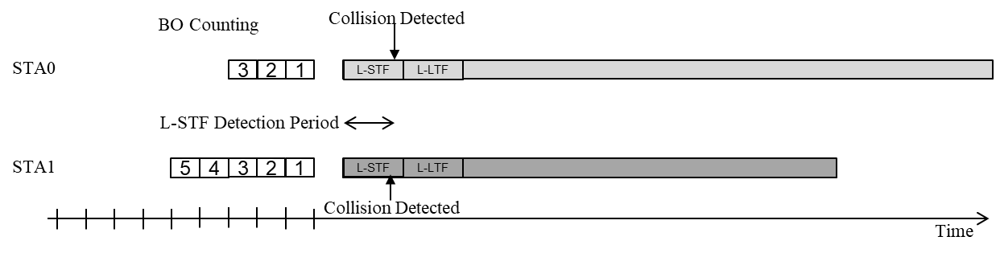

Actions based on Collision Detection

Initial Action
The probability to receive a signals involved in the collision is very low due to mutual interference. If nothing is done in case of collision, most likely the time period occupied by the collided STAs will be wasted. Thus upon collision detection, an action can be taken to reduce the time period where no signal can be transmitted or received. The optional procedure can be the following:
- A STA detects a collision
- The STA drops its own signal
- The STA waits to ensure medium is free
- If medium is free – the STA starts channel access procedure
- If medium is not free – the STA waits for medium to become free again

EDCA Based Procedure

A simple method to resolve channel access is to drop the collided signals and let every STA recognize energy drop, then resolve EDCA based back-off counting according to existing EDCA rules. In this case, the smallest time period required to start a new transmission is AIFS plus one slot. However, since STAs randomly choose the backoff period, this time period may be much longer. All the stations that listen to the medium and recognize energy drop can potentially be the next transmitter, including collided STAs. We can decrease the average time period before new transmission is taken my allowing collided STAs to use a very small CW value and finish a new back-off counting very fast. However, it still remains a statistical value limited by AIFS + 1 slot time period.
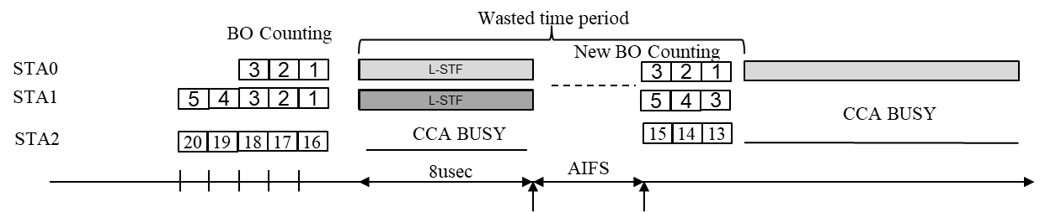

Fast Collision Resolution
Assuming all the collided STAs recognize the collision and drop their currently-transmitting signals, they can take advantage of knowledge that no STA will transmit within an AIFS period. Based on FD capabilities they can perform a very efficient negotiation procedure which resolves which STA, among those who collided, will transmit.
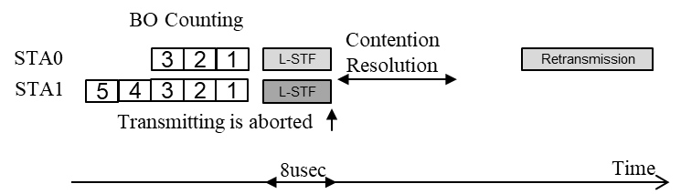
We assume that this action can be completed with very high probability within an AIFS period. Therefore, collided STAs can lead to a faster successful channel access and reduce the time period wasted in case of collisions.

Simulation Results

Simulated Procedures
We compared between:
- Current existing procedure with no collision detection capabilities
- Collision detection followed by EDCA based channel access (with small CW value for collided STAs)
- Collision detection with fast contention resolution
As was mentioned in previous section, we may assume some probability to finish the contention resolution procedure within certain time period. In current simulation we examined what can be achieved it the following probability is assumed:
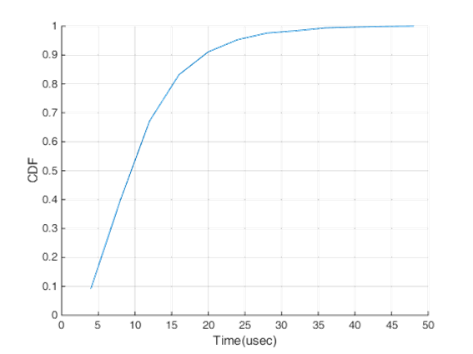

We ran simulation in time for several seconds, where different STAs had data to transmit at random times. Every STA that has a data to transmit generated back-off value based on CW rules defined in standard and counted to zero. The main criteria for the comparison was channel utilization rate computed by a ratio between a time of successful transmissions and overall time of the simulation. For the sake of simplicity we assume no additional overhead and no packet errors, and focus on impact of the proposed procedures only.

Simulation Results
Below we can see simulation results. It is clear that FD assisted collision detection followed by signal drop and EDCA based channel access leads to a significant improvement of channel utilization rate. We also can see that FD based contention resolution provides additional valuable gain on top of EDCA based procedure.
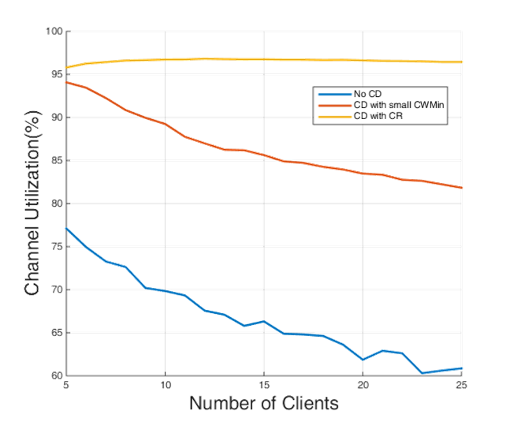

References
[1] 11-18-0498-00-00fd-framework-fd-tig-report
[2] 11-18-1019-01-00fd-improving-system-efficiency-using-full-duplex-based-collision-detection

