IEEE P802.11
Wireless LANs
Fixes to multi-band operations
Date: 2018-09-10
Author(s):
Name | Affiliation | Address | Phone | email
Carlos Cordeiro | Intel |  |  | carlos.cordeiro@intel.com
Mark Hamilton | Arris/Ruckus |  |  | Mark.hamilton@arris.com
Abstract
Among other things, this contribution fixes the OCT figure and primitives, which were correct in 802.11ad-2012, but were incorrectly modified in 11mc. There are no CIDs related to this contribution.

All the changes are related to 11md D1.2.

Discussion:
- Somewhere along the 11mc development, there were several erroneous changes to the OCT figure, name of primitives, and parameters compared to 802.11ad-2012. In this contribution, the proposal is to revert back to the original 802.11ad-2012 text.
- In addition, also propose:
  - Instead of keeping it implicit, to explicitly specify how to identify an MLME
  - That some fields in the Multi-band element are reserved if FST is not supported
  - To delete an outdated restriction on which types of primitives can be used with OCT. As a result of this deletion, additional behavior is introduced to cope with all cases.
  - To allow passing the RXVECTOR in the OCTunnel.indication primitive. This will enable the NT-MLME to make an informed decision if/how to respond to received frames as, for example, is allowed by 11ai (e.g., based on RSSI)

Proposed changes:

Replace all instances of “Specifies the parameters within the Multi-band element that identify the remote (peer) MAC entity” by “Specifies the parameters within the Multi-band element that are used to deliver messages to the peer MAC entity”

6.3.3.2.2 Semantics of the service primitive
Change the following row in the table below the primitive

ChannelList | Set of integers | Each channel is elected from the valid channel range for the appropriate PHY and carrier set. | Specifies a list of channels that are examined when scanning for a BSS. If the Multi-band local and Multi-band peer parameters are present in the primitive, the ChannelList parameter specifies the channels used by the TR-MLME and the Multi-band peer parameter contains the channels to be scanned (see 11.31.4).

6.3.3.3.2 Semantics of the service primitive
Change the primitive as follows

The primitive parameters are as follows:
MLME-SCAN.confirm(
BSSDescriptionSet,
BSSDescriptionFromMeasurementPilotSet,
BSSDescriptionFromFDSet,(11ai)
ResultCode,
Multi-band local,
Multi-band peer,
VendorSpecificInfo
)

Change the following row in the table below the primitive

ResultCode | Enumeration | SUCCESS, INTERMEDIATE_SCAN_RESULT, NOT_SUPPORTED, PARTIAL_SCAN | Indicates the result of the MLME-SCAN.confirm primitive. The INTERMEDIATE_SCAN_RESULT is  used to report the discovered BSSs when the value of the ReportingOption parameter in the MLME-SCAN.request primitive is CHANNEL_SPECIFIC or IMMEDIATE and is valid if dot11FILSActivated is true. The PARTIAL_SCAN is used to report that not all channels have been scanned as specified in the ChannelList parameter, if present, of the corresponding MLME-SCAN.request primitive. The ScannedChannelList parameter contains the list of scanned channels.

Insert the following rows in the table below the primitive

Multi-band local | Multi-band element | As defined in 9.4.2.138 (Multi-band element) | Specifies the parameters within the Multi-band element that are supported by the local MAC entity. The parameter is present if dot11MultibandImplemented is true and is absent otherwise.
Multi-band peer | Multi-band element | As defined in 9.4.2.138 (Multi-band element) | Specifies the parameters within the Multi-band element that are used to deliver messages to the peer MAC entity. The parameter is present if OCT is being used and is absent otherwise.
ScannedChannelList | Set of integers | Each channel is selected from the valid channel range for the appropriate PHY and carrier set | This parameter is valid only if the ResultCode parameter has a value of PARTIAL_SCAN, and specifies a list of channels that were scanned. This list of channels is a subset of the channels present in the ChannelList parameter of the corresponding MLME-SCAN.request primitive.

Change the following row in the second table below the primitive

Timestamp | Integer | N/A | The timestamp of the received frame (Probe Response/Beacon (11ah) or PV1 Probe Response/S1G Beacon) from the found BSS. (11ah) When a PV1 Probe Response or an S1G Beacon frame is received, the timestamp is reconstructed as described in 11.1.3.10.3 (TSF timer accuracy with S1G Beacon frame(Ed)). If the Multi-band local and Multi-band peer parameters are present in the MLME-SCAN.confirm primitive, the Timestamp parameter is reserved. | Adopt

6.3.3.4.2 Semantics of the service primitive

Change the primitive as follows
The primitive has no parameters are as follows:.
MLME-SCAN-STOP.request(
Multi-band local,
Multi-band peer
)

Insert the following rows in the table below the primitive

Multi-band local | Multi-band element | As defined in 9.4.2.138 (Multi-band element) | Specifies the parameters within the Multi-band element that are supported by the local MAC entity. The parameter is present if dot11MultibandImplemented is true and is absent otherwise.
Multi-band peer | Multi-band element | As defined in 9.4.2.138 (Multi-band element) | Specifies the parameters within the Multi-band element that are used to deliver messages to the peer MAC entity. The parameter is present if OCT is being used and is absent otherwise.

6.3.7.5.2 Semantics of the service primitive

Change the primitive as follows

The primitive parameters are as follows:
MLME-ASSOCIATE.response(
PeerSTAAddress,
ResultCode,
AssociationID,
RCPI,
RSNI,
RMEnabledCapabilities,
Content of FT Authentication elements,
SupportedOperatingClasses,
TimeoutInterval,
BSSMaxIdlePeriod,
TIMBroadcastResponse,
QoSMapSet,
Multi-band local,
Multi-band peer,
FILSHLPContainer,(11ai)
FILSIPAddressAssignment,(11ai)
KeyDelivery,(11ai)
S1G Sector Operation,(11ah)
S1G Capabilities,(11ah)
AID Response,(11ah)
TSF Timer Accuracy,(11ah)
TWT,(11ah)
Sectorized Group ID List,(11ah)
MaxAwayDuration,(11ah)
S1GRelay,(11ah)
S1GRelayActivation,(11ah)
S1GOperation,(11ah)
HeaderCompression,(11ah)
SSTOperation,(11ah)
CDMG Capabilities,(11aj)
CMMG Capabilities,(11aj)
VendorSpecificInfo
)

In the table below the primitive, insert the following row above the Multiband peer parameter

Multi-band local | Multi-band element | As defined in 9.4.2.138 (Multi-band element) | Specifies the parameters within the Multi-band element that are supported by the local MAC entity. The parameter is present if dot11MultibandImplemented is true and is absent otherwise.

6.3.8.5.2 Semantics of the service primitive
Change the primitive as follows

The primitive parameters are as follows:
MLME-REASSOCIATE.response(
PeerSTAAddress,
ResultCode,
AssociationID,
RCPI,
RSNI,
RMEnabledCapabilities,
Content of FT Authentication elements,
SupportedOperatingClasses,
TimeoutInterval,
BSSMaxIdlePeriod,
TIMBroadcastResponse,
FMSResponse,
DMSResponse,
QoSMapSet,
Multi-band local,
Multi-band peer,
FILSHLPContainer,(11ai)
FILSIPAddressAssignment,(11ai)
KeyDelivery,(11ai)
S1G Sector Operation,(11ah)
S1G Capabilities,(11ah)
AID Response,(11ah)
TSF Timer Accuracy,(11ah)
TWT,(11ah)
Sectorized Group ID List,(11ah)
MaxAwayDuration,(11ah)
S1GRelay,(11ah)
S1GRelayActivation,(11ah)
S1GOperation,(11ah)
HeaderCompression,(11ah)
SSTOperation,(11ah)
CDMG Capabilities,(11aj)
CMMG Capabilities,(11aj)
VendorSpecificInfo
)

In the table below the primitive, insert the following row above the Multiband peer parameter

Multi-band local | Multi-band element | As defined in 9.4.2.138 (Multi-band element) | Specifies the parameters within the Multi-band element that are supported by the local MAC entity. The parameter is present if dot11MultibandImplemented is true and is absent otherwise.

6.3.89.2.2 Semantics of the service primitive

Change the primitive as follows

The primitive parameters are as follows:
MLME-OCTunnel.request(
PeerSTAAddress,
OCT MMPDU,
Multi-band peer,
Multi-band Source
)

Change the table below the primitive as follows

PeerSTAAddress | MAC Address | Any valid individual MAC address | Specifies the MAC address of the STA to which the On-channel Tunnel Request frame is transmitted.
OCT MMPDU | OCT MMPDU structure | As defined in the On-channel Tunnel Request frame format (see 9.6.20.7 (On-channel Tunnel Request frame format)) | The OCT MMPDU carries the MMPDU to be tunneled to the specified MLME entity of the specified STA.
Multi-band peer | Multi-band element | As defined in the Multi-band element format (see 9.4.2.138 (Multi-band element)) | The Multi-band element identifies the peer MLME entity that should receive the OCT MMPDU.
Multi-band Source | Multi-band element | As defined in the Multi-band element format (see 9.4.2.138 (Multi-band element)) | The Multi-band element identifies the MLME entity that generated (i.e., is the source) of the OCT MMPDU.

6.3.89.3.2 Semantics of the service primitive

Change the primitive as follows

The primitive parameters are as follows:
MLME-OCTunnel.indication(
PeerSTAAddress,
OCT MMPDU,
Multi-band local,
Multi-band Source,
Tunneled RXVECTOR
)

Change the table below the primitive as follows

PeerSTAAddress | MAC Address | Any valid individual MAC address | Specifies the MAC address of the STA from which the On-channel Tunnel Request frame was received.
OCT MMPDU | OCT MMPDU structure | As defined in the On-channel Tunnel Request frame format (see 9.6.20.7 (On-channel Tunnel Request frame format)) | The OCT MMPDU carries the MMPDU that is being tunneled to the local MLME entity.
Multi-band local | Multi-band element | As defined in the Multi-band element format (see 9.4.2.138 (Multi-band element)) | The Multi-band element identifies the  local MLME entity that should receive the OCT MMPDU.
Multi-band Source | Multi-band element | As defined in the Multi-band element format (see 9.4.2.138 (Multi-band element)) | The Multi-band element identifies the  MLME entity that generated (i.e., is the source) of the OCT MMPDU.
Tunneled RXVECTOR | RXVECTOR | As defined by the PHY of the STA | Contains a copy of the RXVECTOR that the PHY passes to the MAC upon reception of the On-channel Tunnel Request frame.

Insert the following subclause

6.3.89.4 MLME-OCTunnel.confirm
6.3.89.4.1 Function
This primitive reports the results of a request to transmit an On-channel Tunnel Request frame.
6.3.89.4.2 Semantics of the service primitive
The primitive parameters are as follows:
MLME-OCTunnel.confirm(
ResultCode
)

Name | Type | Valid range | Description
ResultCode | Enumeration | SUCCESS, FAILURE | Indicates the result of the OCTunnel.request primitive

6.3.89.4.3 When generated
This primitive is generated by the MLME as a result of an MLME-OCTunnel.request primitive to transmit an On-channel Tunnel Request frame.
6.3.89.4.4 Effect of receipt
The MLME is notified of the results of the frame transmission.

9.4.1.45 Band ID field

Insert the following row at the end of Table 9-75, renumbering as appropriate (Band ID field)

7 | 6 GHz

9.4.2.138 Multi-band element

Change the indicated paragraph as follows

The FSTSessionTimeout field is used in the FST Setup Request frame to indicate the timeout value for FST session setup protocol as defined in 11.31.1 (General). The FSTSessionTimeout field contains the duration, in TUs, after which the FST setup is terminated. This field is reserved if the FST Not Supported subfield is 1.

Change the indicated paragraph as follows

The BSSID field specifies the BSSID of the BSS operating on the channel and frequency band indicated by the Channel Number and Band ID fields. When used as part of the on-channel tunnelling operation (see 11.31.5), this field can contain the wildcard BSSID.

9.6.7 Public Action details
9.6.7.1 Public Action frames

Insert the following row in Table 9-359, renumbering as appropriate

43 | On-channel Tunnel Request frame format

Insert the following subclause

9.6.7.45 On-channel Tunnel Request frame format

The On-channel Tunnel Request frame format is defined to allow non-robust STA-STA communications of the same information that is conveyed in the robust On-channel Tunnel Request frame (see 9.6.20.7).

The format of the robust and non-robust On-channel Tunnel Request frame is the same and defined in 9.6.20.7. The Category field value differentiates whether an On-channel Tunnel Request frame is robust or not.

9.6.20.7 On-channel Tunnel Request frame format

Insert the following row at the end of Table 9-479 (On-channel Tunnel Request frame Action field format)

5 | Multi-band Source

Change the last paragraph and insert a new one as follows

The Multi-band field contains the Multi-band element (see 9.4.2.138 (Multi-band element)) of the peer MLME to which the OCT MMPDU is destined to. The values of the Band ID, Channel Number and BSSID fields channel, frequency band and MAC address contained in this element are used to deliver the OCT MMPDU to the correct MLME within the peer STA.

The Multi-band Source field contains the Multi-band element that identifies the MLME that is the source of an OCT MMPDU. The values of the Band ID, Channel Number and BSSID fields contained in this element are used to identify the MLME within the STA.

11.2.3.2 Non-AP STA power management modes

Change the second paragraph as follows

A non-AP STA shall be in active mode upon (re)association, except that if the (re)association is performed using the on-channel tunneling procedure defined in 11.33.4, then the non-AP STA shall be considered to be in power save mode and in doze state upon (re)association on the BSS identified by the BSSID, Band ID, and Channel Number fields contained in the Multi-band element transmitted in the On-channel Tunnel Request frame that carries the (Re)Association Request frame.

Change the subclause below as indicated

11.31.4 On-channel Tunneling (OCT) operation

A STA supports the OCT if the OCT Not Supported subfield within the STA's Multi-band element is 0. A STA should not perform OCT with a peer STA that does not support the OCT. A STA that does not support the OCT shall ignore a received OCT MMPDU.

OCT allows a STA of a multi-band capable device to transmit an MMPDU that was constructed by a different STA of the same device. An MMPDU transmitted this way is referred to as an OCT MMPDU. The MLME of the nontransmitting STA that constructs or is the destination of an OCT MMPDU is referred to as an NT-MLME. The MLME of the STA that transmits or receives an OCT MMPDU over the air is referred to as a TR-MLME. An NT-MLME that constructs an OCT MMPDU destined to a peer NT-MLME does so according to the capabilities of the STA that contains the peer NT-MLME.

NOTE—OCT can be used in conjunction with or independent from the FST setup protocol.

Figure 11-48 (On-channel tunneling procedure) depicts the overall OCT procedure. In this figure, <primitive> refers to the name of any of the MLME primitives defined in 6.3 (MLME SAP interface) that meets all of the following conditions:
- Defines request, indication, response, and confirm primitives, or just request and indication
primitives.
- Includes a peer Multi-band element. The peer Multi-band element is used to identify the peer NT-MLME.
- Includes a local Multi-band element. The local Multi-band element is used to identify the local NT TR-MLME.

An MLME primitive meeting all of the above conditions is referred to as an OCT MLME primitive.

NOTE—MLME-AUTHENTICATE, MLME-ASSOCIATE, and MLME-REASSOCIATE are examples of primitives that are OCT MLME primitives.

To perform the OCT procedure, the values of the Band ID, Channel Number and BSSID fields in a Multi-band element are used to identify an MLME. All other fields in the Multi-band element shall be reserved.

Except for the following cases, the values of the Band ID, Channel Number and BSSID fields in a Multi-band element are used by an NT-MLME to deliver messages to a TR-MLME through the OCTunnel.request primitive, and are used by a TR-MLME to deliver messages to an NT-MLME through the OCTunnel.indication primitive:
- If the BSSID field is the wildcard BSSID, an MLME (either TR-MLME or NT-MLME) shall not use the BSSID field in selecting the MLME to deliver a message and shall, instead, invoke the corresponding primitive for all MLMEs that match the Band ID and Channel Number fields.
- If the OCT MLME request primitive is the MLME-SCAN.request primitive with ScanType parameter set to ACTIVE and that includes the ChannelList parameter, the NT-MLME shall not use the Channel Number field within the Multi-band local parameter of the MLME-SCAN.request primitive in selecting the TR-MLME to deliver a message and shall, instead, invoke the OCTunnel.request primitive at the TR-MLME(s) that match the Band ID field and BSSID field within Multi-band local parameter, and the channels specified in the ChannelList parameter.
- If the Channel Number field is 0 and the OCT MLME request primitive is not the MLME-SCAN.request primitive with ScanType parameter set to ACTIVE and that includes the ChannelList parameter, an MLME (either TR-MLME or NT-MLME) shall not use the Channel Number field in selecting the MLME to deliver a message and shall, instead, invoke the corresponding primitive for all MLMEs that match the Band ID and BSSID fields.
- If the Channel Number field is 0 and the OCT MLME request primitive is not the MLME-SCAN.request primitive with ScanType parameter set to ACTIVE and that includes the ChannelList parameter, and the BSSID field is the wildcard BSSID, an MLME (either TR-MLME or NT-MLME) shall use neither the BSSID field nor the Channel Number field in selecting the MLME to deliver a message and shall, instead, invoke the corresponding primitive for all MLMEs that match the Band ID field.

To transmit a tunneled MMPDU, the SME of a multi-band capable device generates an OCT MLME request primitive that includes the peer Multi-band element and the local Multi-band element. If the OCT MLME request primitive is the MLME-SCAN.request primitive with ScanType parameter set to ACTIVE, the BSSID field within the peer Multi-band element shall be set to the value of the BSSID parameter in the MLME-SCAN.request primitive and the BSSID field within the local Multi-band element shall be set to an individual MAC address.

A NT-MLME receiving an OCT MLME request primitive shall
- As defined in this standard, process the request and construct an OCT MMPDU corresponding to the primitive in question. The NT-MLME shall not transmit any frame as a result of this primitive.
- Generate an MLME-OCTunnel.request primitive with parameters including the OCT MMPDU, and the Multi-band peer parameter set to the peer Multi-band element and the Multi-band Source parameter set to the Multi-band element identifying the NT-MLME. The MLME-OCTunnel.request primitive shall be generated to the TR-MLME identified by the local Multi-band element which is contained within the OCT MMPDU.

An NT-MLME does not issue an MLME-OCTunnel.request primitive if a selected TR-MLME does not exist. A TR-MLME does not issue an MLME-OCTunnel.indication primitive if a selected NT-MLME does not exist.

A single OCT MLME request primitive received by an NT-MLME may result in the invocation of one or more MLME-OCTunnel.request primitives at TR-MLME(s). Each invocation shall be towards a different TR-MLME.

A TR-MLME receiving an MLME-OCTunnel.request primitive shall transmit an On-channel Tunnel Request frame addressed to the peer TR-MLME(s) and which includes the tunneled MMPDU. The peer TR-MLME(s) is identified by the PeerSTAAddress parameter of the MLME-OCTunnel.request primitive. Once the On-channel Tunnel Request frame is transmitted and, if individually addressed, acknowledged or attempts to transmit the frame are abandoned, the TR-MLME shall issue an MLME-OCTunnel.confirm primitive, with the appropriate result code, to inform the NT-MLME of the outcome of the frame transmission.

An On-channel Tunnel Request frame shall not be transmitted as a Public Action frame unless the tunneled MMPDU does not require management frame protection.

Replace figure 11-48 with the following

A TR-MLME receiving an On-channel Tunnel Request frame shall generate an MLME-OCTunnel.indication primitive with the Multi-band local parameter set to the Multi-band element identifying the TR-MLME, the Multi-band Source parameter set to the value of the Multi-band Source field contained in the On-channel Tunnel Request frame and the Tunneled RXVECTOR parameter set to the RXVECTOR of the On-channel Tunnel Request frame. The MLME-OCTunnel.indication primitive shall be generated to the NT- MLME identified by the peer Multi-band element contained within the received On-channel Tunnel Request frame.

A NT-MLME receiving an MLME-OCTunnel.indication primitive shall
- As defined in this standard, process the OCT MMPDU parameter of the primitive as if the MMPDU had been received over the air, with the exception that an Ack frame, if any, shall not be sent as a response to the reception of the MMPDU.
- Generate an OCT MLME indication primitive, if one is defined, corresponding to the frame type of tunnelled MMPDU. This primitive is generated to the SME of the STA, which processes the MMPDU as defined in this standard. The Multi-band local parameter of the OCT MLME indication primitive shall be set to the value of the Multi-band local parameter of the MLME-OCTunnel.indication primitive and the Multi-band peer parameter shall be set to the value of the Multi-band Source parameter of the MLME-OCTunnel.indication primitive.

In the case of a .request/.indication primitive, the process stops here. Otherwise, the process continues as described below.

The peer SME responds to the reception of an OCT MLME indication primitive by generating the corresponding OCT MLME response primitive. This response includes the peer Multi-band element and the local Multi-band element.

A NT-MLME receiving an OCT MLME response primitive, if one is defined, or generating a response by itself, if no OCT MLME response primitive is defined (e.g., MLME-SCAN.response is not defined), shall
- As defined in this standard, process the response and construct an OCT MMPDU corresponding to the primitive in question. The NT-MLME shall not transmit any frame as a result of this primitive.
- Generate an MLME-OCTunnel.request primitive with parameters including the OCT MMPDU, and the Multi-band peer parameter set to the peer Multi-band element and the Multi-band Source parameter set to the Multi-band element identifying the NT-MLME. If no OCT MLME response primitive is defined, the Multi-band peer parameter shall be set to the value of the Multi-band Source parameter received in the corresponding MLME-OCTunnel.indication primitive. The MLME-OCTunnel.request primitive shall be generated to the TR-MLME identified by the local Multi-band element specified in the OCT MLME response primitive, if one is defined, or to the TR-MLME identified by the Multi-band local parameter of the MLME-OCTunnel.indication primitive that triggered this response, if no OCT MLME response primitive is defined which is contained within the OCT MMPDU.

A TR-MLME receiving an MLME-OCTunnel.request primitive transmits an On-channel Tunnel Request frame addressed to the peer TR-MLME that includes the tunneled MMPDU. The peer TR-MLME(s) is identified by the PeerSTAAddress parameter of the MLME-OCTunnel.request primitive. Once the On-channel Tunnel Request frame is transmitted and, if individually addressed, acknowledged or attempts to transmit the frame are abandoned, the TR-MLME issues an MLME-OCTunnel.confirm primitive, with the appropriate result code, to inform the NT-MLME of the outcome of the frame transmission.

A TR-MLME receiving an On-channel Tunnel Request frame generates an MLME-OCTunnel.indication primitive with the Multi-band local parameter set to the Multi-band element identifying the TR-MLME, the Multi-band Source parameter set to the value of the Multi-band Source field contained in the On-channel Tunnel Request frame and the Tunneled RXVECTOR parameter set to the RXVECTOR of the On-channel Tunnel Request frame. The MLME-OCTunnel.indication primitive is generated to the NT-MLME identified by the peer Multi-band element contained within the received On-channel Tunnel Request frame.

A NT-MLME receiving an MLME-OCTunnel.indication primitive
- Processes the OCT MMPDU parameter of the primitive as if the MMPDU had been received over the air.
- Generates an OCT MLME confirm primitive, if one is defined, corresponding to the frame type of the tunneled MMPDU OCT MMPDU. This primitive is directed at the SME and has the Multi-band local parameter set to the value of the Multi-band local parameter of the MLME-OCTunnel.indication primitive and the Multi-band peer parameter set to the value of the Multi-band Source parameter of the MLME-OCTunnel.indication primitive. If the OCT MLME confirm primitive is the MLME-SCAN.confirm primitive and the NT-MLME did not scan all the channels specified in the corresponding MLME-SCAN.request primitive, the ResultCode parameter in the MLME-SCAN.confirm primitive shall be set to PARTIAL_SCAN and the ScannedChannelList parameter shall list all channels that have been scanned.

A NT-MLME receiving an MLME-OCTunnel.confirm primitive shall:
- As defined in this standard, take action, if there is one, based on the success or otherwise of the OCT MMPDU transmission by the TR-MLME.

Figure YYY illustrates the complete forwarding of OCT messages based on the procedure described above in this subclause. Figure YYY(a) depicts the forward path, i.e., from a requesting multi-band device (MBD) that initiates the OCT procedure with a responding MBD. Figure YYY(b) depicts the return path, i.e., from a responding MBD that generates an OCT MMPDU in response to the reception of an OCT MMPDU from a requesting MBD.

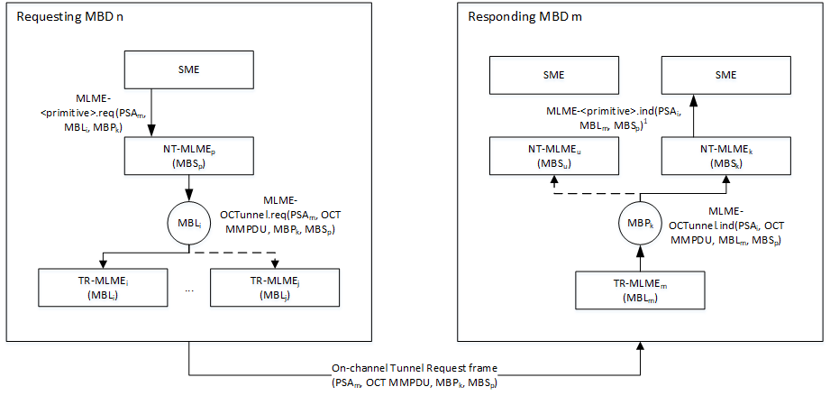
- – Forward path

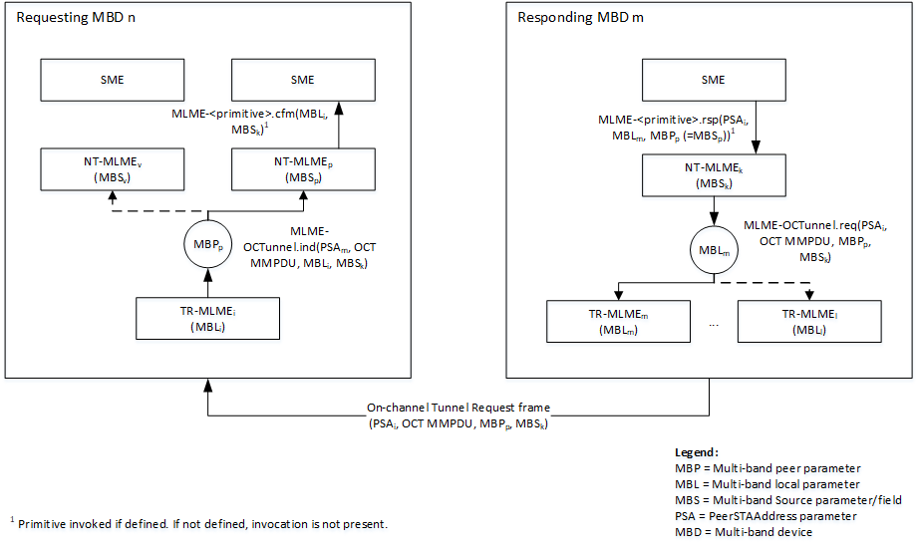
(b) – Return path
Figure YYY – Paths of OCT messages based on OCT parameters

