IEEE P802.11
Wireless LANs
Proposed FD-TIG report text on self-interference cancellation
Date: 2018-07-10
Author(s):
Name | Affiliation | Address | Phone | email
Yan Xin | Huawei Technologies | 303 Terry Fox Dr., Suite 400, Ottawa, ON, Canada |  | yan.xin@huawei.com
Genadiy Tsodik |  |  |  | genadiy.tsodik@huawei.com
Ming Gan |  |  |  | ming.gan@huawei.com
Peiwei Wang |  |  |  | peiwei.wang@huawei.com
Shimi Shilo |  |  |  | shimi.shilo@huawei.com
Doron Ezri |  |  |  | Doron.Ezri@huawei.com
Yaron Ben Arie
Tho Le-Ngoc | McGill University | Room 633, McConnell Engineering Building  3480 University Street  Montreal, Quebec, Canada H3A 0E9 |  | tho.le-ngoc@mcgill.ca
Robert Morawski
Harry Lee
Abstract
This document provides the proposed text on self-interference cancellation to contribute to Sections 4.2.1 and 4.2.2 in the FD TIF report framework [1]. The proposed text is mainly based on the FD TIG presentation [2].

FD Technical Feasibility

A device with wireless Full Duplex (FD) capability can simultaneously transmit and receive wireless signals sharing the same frequency resource. FD feasibility analyses for 802.11 include both PHY and MAC aspects.

FD operations within a BSS

The most challenging work in FD development is probably to efficiently and sufficiently cancel the self-interference (SI) which is transmitted by an FD-capable device and received by the same device through transceiver coupling and multipath reflections.

Self-interference cancellation level
Self-interference produced by the transmitted signal can be very strong and thus has a significant impact on RF and digital properties of the desired signal.

In general, self-interference includes:
- linear components: leakage from Tx to Rx, possible reflections due to antenna/transceiver, and reflections from environment. The main interference signal power could be about the same level of the Tx power;
- nonlinear components: nonlinear distortion due to Tx power amplifier (PA), which is about 30 dB lower than the main signal in linear self-interference [3];
- Tx noise: due to PA noise and phase noise, which is about -50 dBm [3].

Assume that in an indoor environment, noise figure (NF) is 6 dB, bandwidth (BW) is 20 MHz, implementation margin (Io) is 5 dB. Noise floor is calculated as:

Nfloor=10log10BWMHz+NF+Io – 114 dBm = -90 dBm.

If the transmit power equals 20 dBm, it requires an FD receiver to have an SIC ability in a level of 20-(-90) = 110 dB in order to reduce the main interference signal to the noise floor power level.

The self-interference channel impulse response can be appropriately modelled as shown in [2] where the parameters of the linear portion of the self-interference channel impulse response depend on the internal antenna structure. They are quasi-static and can be calculated/estimated based on the antenna structure specifications while the parameters of non-linear portion of the self-interference channel impulse response depend on the external possible reflectors in the surrounding environment and are time-varying.

Potential techniques for self-interference cancellation

General

Due to insufficient receive dynamic range, large self-interference can saturate the Rx LNA/ADC, and the intended Rx signal is compressed / wiped out. It requires antenna isolation/analog circuitry to cancel the self-interference sufficiently in order for the receiver to perform further self-interference cancellation (SIC) in the digital domain. As shown in Figure 1, SIC at the FD receiver is implemented with two stages: analog SIC and digital SIC.
d₁
Variable
delays
…
…
d_{n}
a₁
a_{n}
∑
…
Variable
attenuators
…
+
DAC
&
UC
ADC
&
DC
-
BB/Digital SIC
RF/Analog SIC
Tx
Digital
BB
Rx
Digital
BB
Tx Antenna
Rx Antenna
RFFE isolation

Figure 1 analog and digital SIC.

Example requirements for analog/digital SIC are shown in Figure 2 in which the budgets of analog/digital interference cancellation are illustrated.
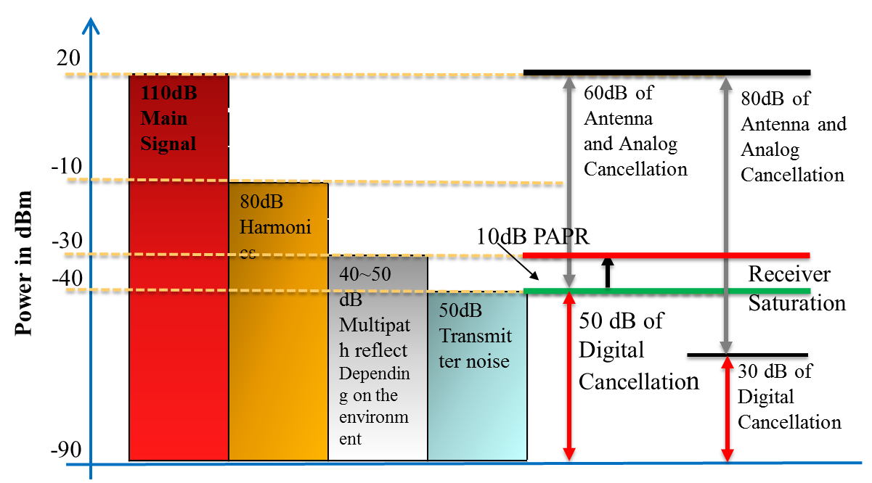
Random noise
Replicas of distorted TX signal

Figure 2 Illustration of requirements for analog/digital SIC.

RF front-end (RFFE) / Analog circuitry SIC
- RF front-end isolation

      - Separate Tx/Rx antennas

Separating multiple antennas into Rx & Tx yields high isolation, however this may limit the MIMO capabilities. A 2x2 MIMO self-interference sounding system using dual-polarized antennas is shown in [4], in which one polarization (e.g., Vertical) for Tx port and the other polarization (e.g., Horizontal) for Rx port. It demonstrates that [4] the V-H isolation of the same antenna can be approximately 45 dB and the cross-polarization coupling from the one polarization (H or V) port of one antenna to another polarization (V or H) port of the other antenna can be -70 dB.

      - Single Tx/Rx antenna

With single antenna, a receiver can use a circulator and/or other alternatives to achieve RF front-end isolation. The combined isolation from the circulator and antenna can be 30 dB [5]. However, a circulator may suffer from high losses, linearity and BW limitations and significant LO leakage. A modified Quadrature Balanced Power Amplifiers (QBPA) method is introduced in [5], which uses dual-mode RFFE isolation instead of circulator and yield competitive performance as circulator.

- Analog circuitry SIC

Multiple RF/Analog Tap “Weighted” Delay Lines [6] and Two RF Tap Delay Lines “Weighted” & Tunable [7] are considered to be practical for Wi-Fi chipsets, in which the analog canceller is implemented like an analog filter with time delay circuit and variable gain amplifier. It is reported [6] [7] that analog SIC circuitry can suppress 40-50 dB interference.

Digital SIC
Digital self-interference cancellation is the last step of defence against self-interference. However, as discussed above, it is limited by ADC dynamic range. Currently, 12-bit ADC with 11-bit ENOB is widely implemented in 802.11ac chips, yielding an effective dynamic range of 6.02*(11-2)=54.18dB with one bit to budget an additional headroom of 6 dB (depending on the received PAPR) and one bit to place the quantization-error floor 6 dB below noisy floor [8].

Assume that the analog SIC can provides interference suppression of 50dB, thus the digital SIC should be capable to mitigate 60dB of the interference. Also assume that the interference consists of linear and non-linear components (5th and 7th order) and the residual interference (linear component) at input to digital SIC is around -30dBm (nonlinear component is 30 dB below linear components). The incoming desired Rx signal (to be detected) is assumed to be limited by -67 dBm. Figure 3 shows a power diagram of the assumptions and requirements above.

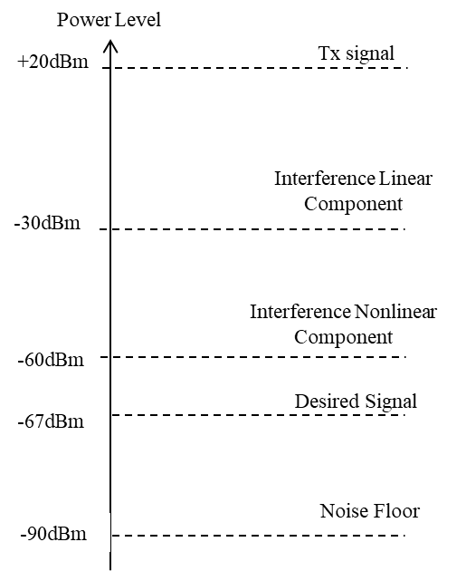

Figure 3 Full Duplex Power Diagram after Analog SIC

As discussed in [2], a self-interference signal (produced by the Tx side) includes linear and non-linear components (of 3rd and 5th orders). Assume non-linearity components are memoryless. Thus, every non-linear component depends only on the signal transmitted at the same time-sample. The Tx signal including non-linear components is transformed by analog reflections, multipath channel and also an analog SIC.

The fact that non-linear components are at least 30dB below the linear part suggests a two-step process [2] to solve a problem that requires to estimate both impulse response taps and the parameters of the non-linear components.

Step 1: Consider non-linear components as a noise and estimate the linear transfer function parameters

Step 2: Subtract the estimated linear part from the received signal and estimate the parameters of the non-linear components

A simulation of the two-step solution is carried out, in which the following parameters are provided in [2]. The simulation results demonstrates that for all the Rx signals in the assumed range -72 dBm :-85 dBm, the total digital interference mitigation is larger than 60dB, thus the interference level after digital SIC can be lower than the target level of -90dBm.

References
[1] 11-18-0498-00-00fd-framework-fd-tig-report.
[2] 11-18-0880-00-00fd-self-interference-cancellation-in-full-duplex-for-802-11.
[3] D. Bharadia, E. McMilin and S. Katti, “Full Duplex Radios”, Proc. of the ACM SIGCOMM 2013, Hong Kong, China, Aug. 2013.
[4] Fei Chen, Robert Morawski, Tho Le-Ngoc, “Self-Interference Channel Characterization for Wideband 2x2 MIMO Full-Duplex Transceivers using Dual-Polarized Antennas”, IEEE Transactions on Antennas & Propagation, Vol. 66, No. 4, April 2018.
[5] D. Regev et al, “Modified Re-Configurable Quadrature Balanced Power Amplifiers
for Half and Full Duplex RF Front Ends”, Wireless and Microwave Circuits and Systems (WMCS), 2018 Texas.
[6] T. Zhang et al, “A 1.7-to-2.2GHz Full-Duplex Transceiver System with >50dB Self-Interference Cancellation over 42MHz Bandwidth”, ISSCC 2017.
[7] T. Huusari et al, “Wideband Self-Adaptive RF Cancellation Circuit for Full-Duplex Radio: Operating Principle and Measurements”, 2015 IEEE 81st Vehicular Technology Conference (VTC Spring).
[8] https://www.design-reuse.com/umc/adc-c-78/

