IEEE P802.11  
Wireless LANs

|  |  |  |  |  |
| --- | --- | --- | --- | --- |
| Technical Report on  Full Duplex for 802.11 - FD Architecture | | | | |
| Date: 2018-07-09 | | | | |
| Author(s): | | | | |
| Name | Affiliation | Address | Phone | email |
| Kome Oteri | InterDigital | 9276 Scranton Road, #300, San Diego, CA, 92127 | +1 858 210 4826 | kome.oteri@interDigital.com |
| Rui Yang | InterDigital |  |  |  |
|  |  |  |  |  |
|  |  |  |  |  |
|  |  |  |  |  |
|  |  |  |  |  |

Abstract

This document outlines the potential framework of Technical Report on Full Duplex for IEEE 802.11. It is an update of 11/18-0498r0 [4] with the updates in red. The text is based on 11/18-1224r0 [5].

**Table of Contents**

1. Introduction 3

2. FD use cases 3

3. FD functional requirements 3

3.1 Bands and bandwidths of FD operations 3

3.2 Maximum throughput over an allocated bandwidth 3

3.3 Latency enhancement 4

3.4 FD capability of AP and STA 4

3.5 Backward compatibility and co-existence with legacy 802.11 devices 4

4. FD Technical Feasibility 4

4.1 Technical survey 4

4.2 FD operations within a BSS 4

4.2.1 Self-interference cancellation level 4

4.2.2 Potential techniques for self-interference cancellation 4

4.2.3 Scheduling in FD for 802.11 4

4.3 FD operations over overlapping BSS (OBSS) 4

4.4 Impacts of FD operations on the 802.11 standard 4

4.4.1 Training and preamble 4

4.4.1 FD transmission initiation 5

5. Architecture of FD for 802.11 5

5.1 Asymmetric FD for 802.11 5

5.2 Symmetric FD for 802.11 8

5.3 Impacts of architecture on the 802.11 standard 8

5.3.1 FD Interference Discovery in Asymmetric FD 9

6. Key FD Metrics 10

6.1 Throughput (channel/system) 10

6.2 Latency 10

7. FD Benefits 10

7.1 Throughput gain 11

7.2 Lower latency 11

7.3 Collision reduction 11

7.4 Mitigation of hidden node issue 11

8. Conclusions 11

9. References 11

# ****Introduction****

**Wi-Fi products have been being widespread deployed around world with the facts of more than** three billion Wi-Fi device estimated to be shipped in 2017 and more than eight billion Wi-Fi devices currently in use [1] in order to satisfy the fast growth in user demands on data communications through, for example, home/enterprise networks, services for the public (e.g., airports, aircraft, train (stations), shopping centers and meetings, etc.), Augmented/Virtual Reality (AR/VR) and Internet of Things (IoT), and so on. **Dense deployment of Wi-Fi devices and potential high demands on data throughputs per device require the advanced Wi-Fi systems to operate with high spectrum efficiency and good performance.**

**Full Duplex (FD) is a technology to allow a device to simultaneously transmit and receive signals using the same time-frequency resource. FD can significantly increase the throughput for each allocated channel and furthermore improve the total system capacity. In addition, the inherent capability of FD can provide an opportunity to reduce round-trip latency for data transmission, which is due to transmission of ACK or feedback information and to implement an in-band relay system. Standardization of FD technology for 802.11 is considered in [2].**

This technical report on FD for IEEE 802.11 presents some key discussion results achieved in the FD TIG, which include FD use cases, FD functional requirements, technical feasibility of FD for 802.11, architecture of FD for 802.11, key FD metrics, and benefits of FD deployment.

# FD use cases

*Note: In this report, a few FD use cases such as multi-channel AP, FD mesh and multi-RAT presented in [2] and/or others should be justified as the appropriate applications of FD to satisfy the high-demanding requirements of the future 802.11.*

# FD functional requirements

## Bands and bandwidths of FD operations

*Note: The bands and the bandwidths for FD operations should be investigated in FD TIG and reported in the FD TIG technical report.*

## Maximum throughput over an allocated bandwidth

*Note: FD technology allows simultaneous transmit and receive over the same frequency spectrum. Compared to the existing Wi-Fi systems, theoretically FD can double the data throughput per channel over the same time and frequency resource. The FD TIG technical report should identify the practical maximum throughput over an allocated bandwidth. Furthermore, the FD TIG technical report should identify practical maximum system throughput to justify the advantages of FD deployment in dense scenarios.*

## Latency enhancement

*Note: FD provides an opportunity to reduce the latency in the link level or the system level. Latency enhancement should be investigated in the FD TIG and reported in the FD TIG technical report.*

## FD capability of AP and STA

*Note: FD capability of AP and STA should be discussed in the FD TIG and reported in the FD TIG technical report.*

## Backward compatibility and co-existence with legacy 802.11 devices

*Note: As an amendment, the issues of backward compatibility and co-existence with legacy 802.11 devices should be taken into account in FD-capable 802.11.*

# FD Technical Feasibility

## Technical survey

## FD operations within a BSS

### Self-interference cancellation level

### Potential techniques for self-interference cancellation

*Note: Potential techniques are to be discussed in order to achieve the desired self-interference cancellation level.*

### Scheduling in FD for 802.11

## FD operations over overlapping BSS (OBSS)

## Impacts of FD operations on the 802.11 standard

The introduction of FD operation will affect multiple elements of the 802.11 standard. These elements include:

* Training and Preamble
* FD transmission initiation

### Training and preamble

A FD training sequence/preamble is needed to train the FD PHY. This training sequence/preamble should be flexible enough to support which ever potential techniques are used for self-interference cancellation as discussed in Section 4.2.2.

The FD preamble may be specified as a FD standalone training frame (as shown in Figure 1(a)) or may be added as an extra preamble to existing frames (as shown in Figure 1(b)).



Figure 1: FD Training sequence

### FD transmission initiation

The 802.11 specification should include specific ways to initiate the FD transmission. This may include an element that informs the specific STAs of the start and duration of the FD transmission in the case of an explicitly synchronized FD transmission. It may also include information that may inform a specific STA about the start and duration of a transmission when the FD transmission is opportunistic.

# Architecture of FD for 802.11

This section discusses the effect of FD on the physical components of the network, their configuration and channel access for each configuration.

## Asymmetric FD for 802.11

In Asymmetric FD operation, usually the APs are FD-capable while the STAs are half-duplex devices i.e. only the AP can transmit and receive at the same time. Usually, three or more nodes are involved in the FD transmission with the transmission comprising an AP and two or more STAs. This is illustrated in Figure 2.

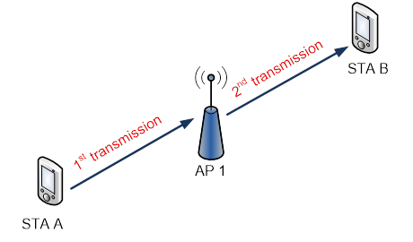

Figure 2: Asymmetric FD Architecture

The transmission may be synchronized, in which the transmission to and from the AP occur at pre-determined times, or may be opportunistic, in which the transmission in the uplink/downlink occurs once another transmission is occurring in the downlink/uplink.



Figure 3: Synchronized Asymmetric FD transmission Frame Exchange

In synchronized asymmetric FD transmission (illustrated in Figure 3), the uplink and downlink FD transmissions are synchronized and the AP controls the entire FD transmission. The AP may indicate the start of FD transmission to STA B and reception of data from STA A.



Figure 4: Opportunistic Downlink, Asymmetric FD transmission Frame Exchange

In opportunistic downlink, asymmetric FD transmission (illustrated in Figure 4), the AP transmission is opportunistic to STA B based on the specific STA A transmitting to it. As such, the AP starts the downlink transmission to STA B based on reception of data from STA A. Note that as STA A is already transmitting, the AP has to communicate the start of its transmission to STA B only.

**Opportunistic Uplink Asymmetric FD**



Figure 5: Opportunistic Uplink, Asymmetric FD transmission Frame Exchange

In opportunistic uplink, asymmetric FD transmission (illustrated in Figure 5), the AP reception from STA A is opportunistic based on the specific STA B it is transmitting to. As such, STA A starts the uplink transmission to the AP based on transmission of data from the AP to STA B. Note that as the AP is already transmitting, a mechanism is needed to identify the start of the transmission from STA A.

## Symmetric FD for 802.11

*.*

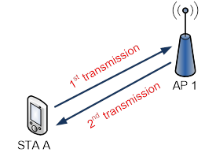

Figure 6: Symmetric FD transmission

In pairwise symmetric FD operation, both the APs and STAs are FD-capable. Usually, two or more nodes are involved in the FD transmission with the nodes transmitting and receiving at the same time. This is illustrated in Figure 6.



Figure 7: Symmetric FD transmission Frame Exchange

In symmetric FD transmission (illustrated in Figure 7) the AP starts DL transmission to STA A and receives uplink transmission from STA A. The transmission may also be synchronized or opportunistic.

## Impacts of architecture on the 802.11 standard

The FD architecture may have some impact on the 802.11 specifciation. These elements include:

* FD Interference Discovery in Asymmetric FD

### FD Interference Discovery in Asymmetric FD

For asymmetric FD architectures (see Section 5.1), the data from the uplink transmission to the AP (STA1 in Figure 8) may affect the downlink transmission from the AP (STA 2 in Figure 8).

As such there is a need for interference discovery procedures to ensure that potential interference from STA 1 to STA 2 in Figure 8 is minimized. These procedures will enable the AP to identify FD compatible STAs i.e. STAs that may be transmitted to/from in an asymmetric FD configuration with minimal or no interference.

As an example, a simple 4-STA network is shown in Figure 9 with the associated FD compatibility illustrated in Table 1. The STAs not linked by “X” are identified as FD compatible. As such, the procedure should identify STA1 and STA3 as FD compatible and STA2 with STA4 as FD compatible.

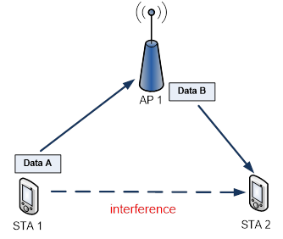

Figure 8: Interference in Asymmetric FD transmission

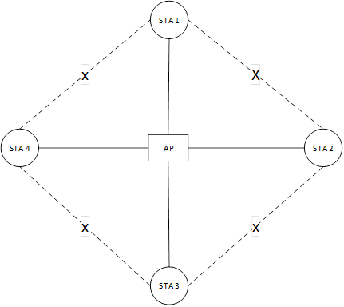

Figure 9: Network illustrating FD compatibility

Table 1: FD Compatibility

|  |  |  |  |  |
| --- | --- | --- | --- | --- |
|  | STA 1 | STA 2 | STA 3 | STA 4 |
| STA 1 | N/A | Not FD compatible | FD compatible | Not FD compatible |
| STA 2 | Not FD compatible | N/A | Not FD compatible | FD compatible |
| STA 3 | FD compatible | Not FD compatible | N/A | Not FD compatible |
| STA 4 | Not FD compatible | FD compatible | Not FD compatible | N/A |

# Key FD Metrics

## Throughput (channel/system)

*Note: Both channel-level and system-level throughputs should be investigated.*

## Latency

*Note: Both STA-level and network-level latency should be investigated.*

# FD Benefits

*Note: Some of benefits listed below are considered in the FD TIG contribution [3].*

## Throughput gain

## Lower latency

## Collision reduction

## Mitigation of hidden node issue

# Conclusions

# References

[1] Wi-Fi Alliance press, January 2017.

[2] IEEE 802.11: 11-18-0191-01-0wng-full-duplex-for-802-11.

[3] IEEE 802.11: 11-18-0448-00-00fd-full-duplex-benefits-and-challenges.

[4] IEEE 802.11: 11-18-0498-00-00fd-framework-fd-tig-report.docx

[5] IEEE 802.11: 11-18-1224-00-00-fd- FD Architecture in 802.11