IEEE P802.11  
Wireless LANs

|  |  |  |  |  |
| --- | --- | --- | --- | --- |
| **Spec. text change on error correction of STBC** | | | | |
| Date: 2018-07-01 | | | | |
| Author(s): | | | | |
| Name | Affiliation | Address | Phone | Email |
| Jianhan Liu | Mediatek |  |  | Jianhan.liu@mediatek.com |
| Shengquan Hu |  |  |

Abstract:

Fix the error of number of spatial streams for STBC.

**Discussions:**

In D3.0, spec. page 431, it says that STBC applied only for single spatial stream:

cid:image002.jpg@01D414FD.01667400

But in page 526, it says STBC can be applied to 2 spatial streams.

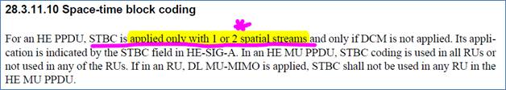

The contradiction needs to be resolved. In 11ax, STBC is applied to only one spatial stream.

***TGax Editor: Please make the following text change (changed texts are in red) for page 526 line 61 in section* 28.3.11.10 *of D3.0***:

For an HE PPDU, STBC is applied only with 1 ~~or 2~~ spatial stream~~s~~ and only if DCM is not applied. Its appli-cation is indicated by the STBC field in HE-SIG-A.