802.11ba Draft Specification

Proposed Spec Text for clause 32.2.12
Date: 2018-07-09
Author(s):
Name | Affiliation | Address | Phone | email
Shahrnaz Azizi | Intel Corp | 220 Mission College Blvd. Santa Clara, CA 95054 |  | shahrnaz.azizi@intel.com
Thomas Kenney | Intel Corp
Vinod Kristem | Intel Corp
Abstract
This submission proposes the spec text to be incorporated in IEEE802.11ba D1.0 related to the following clauses 32.2.12 WUR transmit procedure

Revision History:
- Rev 0: Initial version of the document

Editing instructions formatted like this are intended to be copied into the TGba Draft (i.e. they are instructions to the 802.11 editor on how to merge the text with the baseline documents).

TGba Editor: Editing instructions preceded by “TGba Editor” are instructions to the TGba editor to modify or insert material in the TGba draft. As a result of adopting the changes, the TGba editor will execute the instructions rather than copy them to the TGba Draft.

TGba Editor: Instruction: Add the following content under 32.2.12 WUR transmit procedure
32.2.12 WUR transmit procedure

There are three options for the PHY transmit procedure. The two options, for which typical transmit procedures are shown in Figure 32-xx1 and Figure 32-xx2, are selected if the FORMAT field of the PHY –START.request(TxVector) is set to LDR (Low Data Rate) or HDR (High Data Rate), respectively.

The third option is for the optional FDMA to transmit at a wider bandwidth if the CH_BANDWIDTH parameter is CBW40 or CBW80 and PHY–START.request(TxVector) Format is set to FDMA. In this option WUR PPDU is simultaneously generated and transmitted on each of the 20 MHz channels.

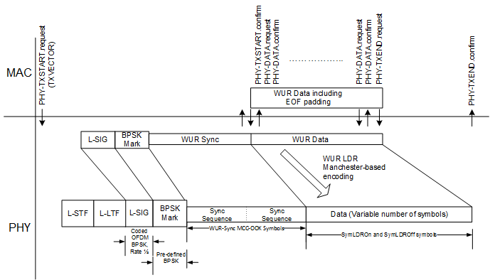
Figure 32-xx1 – PHY transmit Procedure for an LDR WUR PPDU

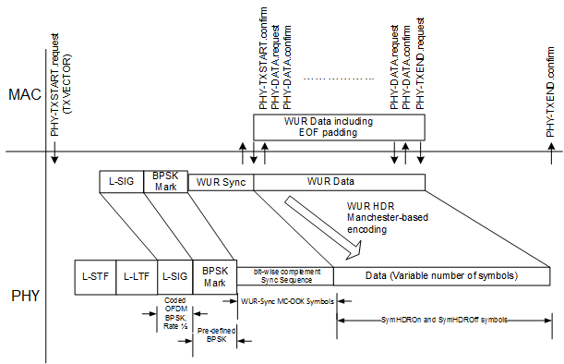
Figure 32-xx2 – PHY transmit Procedure for an HDR WUR PPDU

In all three options, in order to transmit data, the MAC generates a PHY-TXSTART.request primitive, which causes the PHY entity to enter the transmit state. Further, the PHY is set to operate at the appropriate frequency through station management via the PLME, as specified in 32.3 (WUR PLME). Other transmit parameters, such transmit power, are set via the PHY-SAP using the PHYTXSTART.request(TXVECTOR) primitive, as described in 32.1.2 WUR_TXVECTOR and WUR_RXVECTOR parameters.

The PHY indicates the state of the primary channel and other channels for FDMA case via the PHY-CCA.indication primitive (see 32.2.11.5 (CCA sensitivity) and 8.3.5.12 (PHY-CCA.indication)). Transmission of the PPDU shall be initiated by the PHY after receiving the PHY-TXSTART.request(TXVECTOR) primitive. The TXVECTOR elements for the PHY-TXSTART.request primitive are specified in Table 32-1 WUR_TXVECTOR and WUR_RXVECTOR parameters.

After the PHY legacy preamble transmission is started, the PHY entity immediately initiates BPSK-Mark transmission and performs any required scrambling and data encoding if needed as defined by parameters of the TXVECTOR, as described in 32.1.2. After BPSK-Mark transmission is started, the PHY entity initiates transmission of Sync field according to the data rate defined in TXVECTOR. The Sync transmission is followed by Manchester encoding of data field as described in 32.2.3. The data shall be exchanged between the MAC and the PHY through a series of PHY-DATA.request(DATA) primitives issued by the MAC, and PHY-DATA.confirm primitives issued by the PHY. In FDMA case, PHY padding bits are appended to each 20 MHz channel to make the length of PPDU equal to the Length indicated in L-SIG.

Transmission can be prematurely terminated by the MAC through the PHY-TXEND.request primitive.
WUR transmission is terminated by receiving a PHY-TXEND.request primitive. Each PHYTXEND.request primitive is acknowledged with a PHY-TXEND.confirm primitive from the PHY. In a signle channel WUR transmission, normal termination occurs after the transmission of the final bit of the last WUR octet, according to the number of WUR octets indicated by N_{octet} (see 32.3.2). In FDMA WUR transmission, normal termination occurs after the transmission of the final bit of the last WUR octet, according to the number of WUR octets indicated by N_{max_octet} (see 32.3.2).

When the WUR transmission is completed the PHY entity enters the receive state.

A typical state machine implementation of the transmit PHY for a WUR transmission is provided in
Figure 32-yy. Request (.request) and confirmation (.confirm) primitives are issued once per state as shown.

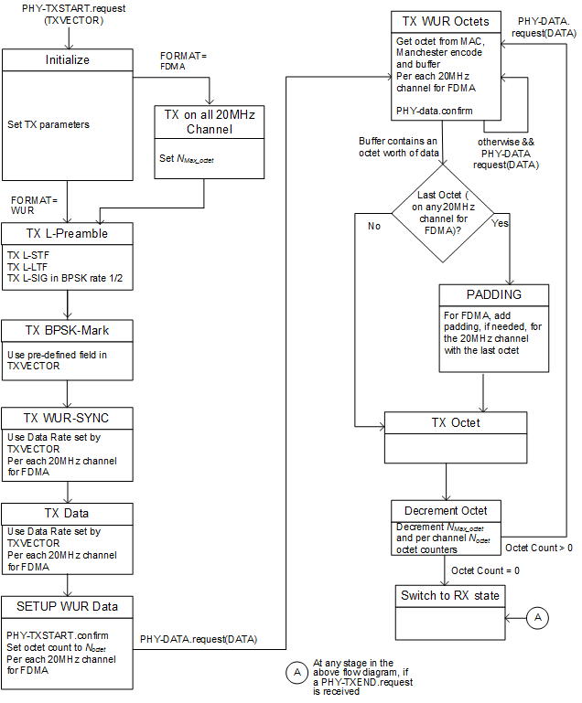

Figure 32-yy –PHY transmit state machine

