IEEE P802.11
Wireless LANs
Consecutive transmission of EDMG BRP packet in TDD SP
Date: 2018-07-09
Author(s):
Name | Affiliation | Address | Phone | email
SungJin Park | LG Electronics | Yangjae-daero 11gil, Seocho-gu, Seoul,  137-893, Korea |  | allean.park@lge.com
JinMin Kim | LG Electronics |  |  | jinmin1230.kim@lge.com
Saehee Bang | LG Electronics |  |  | saehee.bang@lge.com
SunWoong Yun | LG Electronics |  |  | sunwoong.yun@lge.com
Jinsoo Choi | LG Electronics |  |  | js.choi@lge.com
Sanggook Kim | LG Electronics | San Diego  /California/US |  | sanggook.kim@lge.com
Abstract
This document proposes draft changes that the consecutive transmission of EDMG BRP packet in the TDD SP.

- Discussion
In TDD SP, the EDMG BRP packet is used for the SU-MIMO beamforming training.
In current draft, the consecutive transmission of each EDMG BRP packet shall be separated by SIFS.
However, this rule is not suitable for TDD SP when the AP/STA cannot transmit all of EDMG BRP packets which need to complete intended beamforming training within an assigned TDD slot.
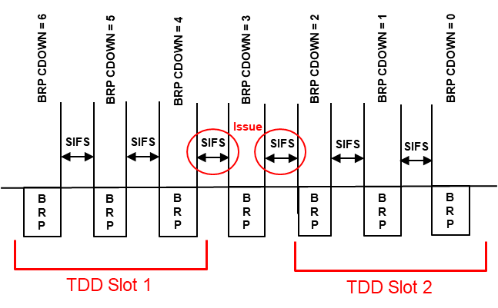
- The number of BRP packets is 7.
- During an assigned TDD slot, only 3 EDMG BRP packets can be transmitted.
- The EDMG BRP packet with the BRP CDOWN field set to 4 is the last EDMG BRP packet which can be transmitted within an assigned TDD slot.
- After the EDMG BRP packet with the BRP CDOWN field set to 4 is transmitted, the EDMG BRP packet with the BRP CDOWN field set to 3 cannot be transmitted after a SIFS.

Therefore, the consecutive transmission of EDMG BRP packet in the TDD SP should be modified to fit the TDD slot structure.
We proposes that the TDD slot can be used by more than one in order to transmit all of EDMG BRP packets and if additional TDD slot is needed, this TDD slot is the earliest assigned TDD slots.

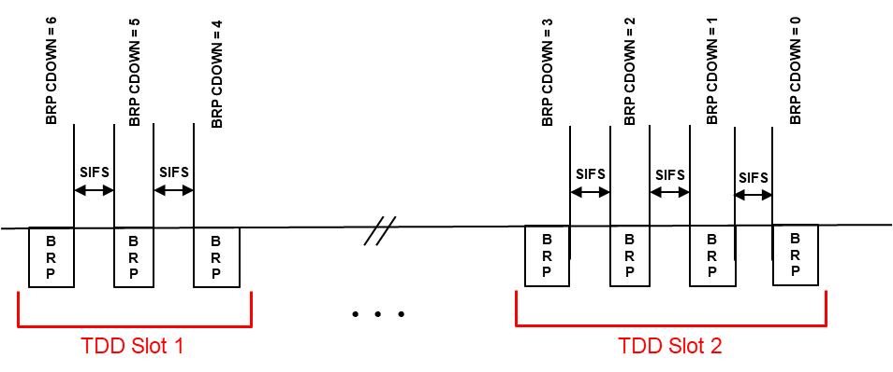
When an assigned TDD slot duration is not enough to accommodate all of EDMG BRP packets, parts of EDMG BRP packets are transmitted within an assigned TDD slot and then the remaining EDMG BRP packets are transmitted within the earliest assigned TDD slot.

- Proposed changes of the Draft
Add the paragraphs in subclause 10.38.9.2.2.3.2 (Non-reciprocal MIMO phase) as follows

10.39.9.2.2.3.2 Non-reciprocal MIMO phase
When the MIMO phase is performed outside of a TDD SP, the initiator shall initiate the initiator SMBT subphase an MBIFS following the reception of the MIMO BF Setup frame from the responder. When the MIMO phase is performed in a TDD SP, upon reception of the MIMO BF Setup frame from the responder, the initiator shall initiate the initiator SMBT subphase within the earliest occurring TDD slot the initiator is assigned to with access permission of the TDD slot, and with slot category of the TDD slot set to Basic TDD slot as indicated in the TDD Slot Schedule element.
In the initiator SMBT subphase, the initiator shall transmit EDMG BRP-RX/TX packets to the responder. Each EDMG BRP-RX/TX packet shall be separated by SIFS. If there is not enough time within the current TDD slot to transmit all EDMG BRP-RX/TX packets, parts of the EDMG BRP-RX/TX packets are transmitted within the current TDD slot and then the remaining EDMG BRP-RX/TX packets are transmitted within the earliest occurring TDD slot the initiator is assigned to with access permission of the TDD slot, and with slot category of the TDD slot set to Basic TDD slot as indicated in the TDD Slot Schedule element. Each transmitted EDMG BRP-RX/TX packet is used to train one or more transmit sectors and, for each transmit sector, a number of receive AWVs. In each EDMG BRP-RX/TX packet, the initiator shall include, for each selected transmit sector, TRN subfields in the TRN field of the PPDU for the responder to perform receive AWV training. For each EDMG BRP-RX/TX packet, the TXVECTOR parameter EDMG_TRN_LEN shall be set to a value greater than zero, and the parameters RX_TRN_PER_TX_TRN and EDMG_TRN_M shall be set to the values of the L-TX-RX and Requested EDMG TRN-Unit M fields in the MIMO BF Setup frame received from the responder, respectively. The initiator may transmit each EDMG BRP-RX/TX packet to train multiple TX DMG antennas simultaneously by using the TRN subfields defined in 29.9.2.2.6 and, therefore, reduce training time. The TX Antenna Mask field of each EDMG BRP-RX/TX packet shall indicate the TX DMG antenna(s) which is being used by the initiator to transmit the EDMG BRP-RX/TX packet. The BRP CDOWN field of each EDMG BRP-RX/TX packet shall indicate the number of remaining EDMG BRP RX/TX packets to be transmitted by the initiator in the initiator SMBT subphase.
In the MIMO phase outside of a TDD SP, the responder shall initiate the responder SMBT subphase an MBIFS following the reception of an EDMG BRP-RX/TX packet with the BRP CDOWN field set to from the initiator. In the MIMO phase in a TDD SP, upon reception of an EDMG BRP-RX/TX packet with the BRP CDOWN field set to 0 from the initiator, the responder shall initiate the responder SMBT subphase within the earliest occurring TDD slot the responder is assigned to with access permission of the TDD slot, and with slot category of the TDD slot set to Basic TDD slot as indicated in the TDD Slot Schedule element.
In the responder SMBT subphase, the responder shall transmit EDMG BRP-RX/TX packets to the initiator. Each EDMG BRP-RX/TX packet shall be separated by SIFS. If there is not enough time within the current TDD slot to transmit all EDMG BRP-RX/TX packets, parts of the EDMG BRP-RX/TX packets are transmitted within the current TDD slot and then the remaining EDMG BRP-RX/TX packets are transmitted within the earliest occurring TDD slot the responder is assigned to with access permission of the TDD slot, and with slot category of the TDD slot set to Basic TDD slot as indicated in the TDD Slot Schedule element. For each EDMG BRP-RX/TX packet, the TXVECTOR parameter EDMG_TRN_LEN shall be set to a value greater than zero, and the parameters RX_TRN_PER_TX_TRN and EDMG_TRN_M shall be set to the values of the L-TX-RX and Requested EDMG TRN-Unit M fields in the MIMO BF Setup frame received from the initiator in the SU-MIMO BF setup subphase, respectively. The responder may transmit each EDMG BRP-RX/TX packet to train multiple TX DMG antennas simultaneously by using the TRN subfields defined in 29.9.2.2.6 and, therefore, reduce training time. The TX Antenna Mask field of each EDMG BRP-RX/TX packet shall indicate the TX DMG antenna(s) which is being used by the responder to transmit the EDMG BRP-RX/TX packet. The BRP CDOWN field of each EDMG BRP-RX/TX packet shall indicate the number of remaining EDMG BRP RX/TX packets to be transmitted by the responder in the responder SMBT subphase

Straw Poll & Motion:
Do you agree to include the text changes proposed in (11-18-1142-00-00ay-Consecutive transmission in TDD SP) to the spec draft?

