IEEE P802.11
Wireless LANs
Proposed CSD: Real-time mobile game service optimization
Date: 2018-06-27
Author(s):
Name | Affiliation | Address | Phone | email
Kate Meng | Tencent | KexingScience Park,Keyuan Road,No.15,Middle Zone,Science&Technology Park,Nanshan District,Shenzhen City | +86 166-7516-1765 | katemeng@tencent.com
Binhui, Ning | Tencent Holdings Limited | KexingScience Park,Keyuan Road,No.15,Middle Zone,Science&Technology Park,Nanshan District,Shenzhen City | +86 177-2269-0746 | famousning@tencent.com
Liuteng, Li | Tencent Holdings Limited | KexingScience Park,Keyuan Road,No.15,Middle Zone,Science&Technology Park,Nanshan District,Shenzhen City | +86 177-2269-0382 | landerli@tencent.com
Abstract
This document contains a draft proposed Criteria for Standards Development (CSD) for Real-time mobile game service optimization.

Abbreviations
3GPP 3rd Generation Partnership Project
CAGR Compound Annual Growth Rate
MOBA Multiplayer Online Battle Arena
QoS Quality of Services
Wi-Fi Wireless Fidelity
WLAN Wireless Local Area Network
AC Access category

Five Criteria

1. Broad Market Potential

A standards project authorized by IEEE 802 LMSC shall have a broad market potential. Specifically, it shall have the potential for:

- Broad sets of applicability.

According to Newzoo’s 2018 global games market report ^{[1]}, the global games market will reach $137.9 billion in 2018 with mobile games taking 51% market share. And the mobile games market is growing rapidly with an estimated CAGR (2012-2021) of 11% to obtain 59% of the market share by 2021. According to our analysis of the habits of the tens of millions of game players, mobile games usage in WiFi scenarios accounts for more than 50%. With customized QoS mechanism for mobile games in WiFi scenarios, the user experience of mobile games especially MOBA would be improved significantly.

b) Multiple vendors and numerous users.

Many chipset vendors such as Broadcom, Qualcomm and MediaTek offer WLAN chipset or SoC providing wireless connection solution. Furthermore, according to Newzoo’s 2017 global games market report, The number of mobile gaming (including smartphones and tablet PCs) users has reached 2.2 billion^{[2]}, while smarphone based users account for the majority part.

c) Balanced costs (LAN versus attached stations).

The proposed amendment to IEEE 802.11e is expected to lead to similar improvement cost between WLAN station and network infrastructure (e.g. access points) to that of previous WLAN options. And mobile game players tend to play in WiFi rather than cellular network scenarios, because the wifi cost less, or even free since it is provided in shopping mall, restaurants to attract guests.
- 2. Compatibility

IEEE 802 LMSC defines a family of standards. All standards should be in conformance with IEEE Std 802, IEEE Std 802.1D, and IEEE Std 802.1Q. If any variances in conformance emerge, they shall be thoroughly disclosed and reviewed with the IEEE 802.1 Working Group. In order to demonstrate compatibility with this criterion, the Five Criteria statement must answer the following questions:
- Does the PAR mandate that the standard will comply with IEEE Std 802, IEEE Std 802.1D, and IEEE Std 802.1Q?
Yes
(b) If not, how will the Working Group ensure that the resulting draft standard is compliant or, if not, receives appropriate review from the IEEE 802.1 Working Group?
- 3. Distinct Identity

Each IEEE 802 LMSC standard shall have a distinct identity. To achieve this, each authorized project shall be:
a) Substantially different from other IEEE 802 LMSC standards.

The proposed amendment of 802.11e QoS mechanism is slightly different. Currently, as the 802.11e standard specified, only video/audio traffic can get reliable and guaranteed network connections now while games traffic being completely ignored. The proposed amendment will take the games traffic into consideration from QoS perspective, and ensure the coexistence with previous IEEE 802.11e.

b) One unique solution per problem (not two solutions to a problem).

The proposed amendment to 802.11e will provide an enhanced solution for the games experience.

c) Easy for the document reader to select the relevant specification.

The title provides the document reader sufficient information to identify the amendment topic.

- 4. Technical Feasibility

For a project to be authorized, it shall be able to show its technical feasibility. At a minimum, the proposed project shall show:
a) Demonstrated system feasibility.

There have been WLAN devices supported 802.11e in the market. The amendment aims to add a new Access Category (AC) which represents games traffic to the existing 802.11e QoS mechanism.

b) Proven technology, reasonable testing.

IEEE 802.11e are widely implemented and successful in the market.

c) Confidence in reliability.

As we know, bandwidth of router which provide WLAN signal is far bigger than cellular network. While the bandwidth of router is beyond need of real-time mobile game, network stability becomes primary concern.
According to QCI characteristics of 3GPP, the packet error loss rate can be lower than 0.1% with packet delay budget lower than 50ms for real-time gaming [3], which can be seen in the first table below. So the QoS performance of cellular network is better than WiFi network and the user experience of real-time mobile game under 4G is better than WiFi coverage scenarios in China. Actually 802.11 have not taken into account of real-time mobile game in terms with AC mappings. From the second table below we can see that the voice traffic takes the highest priority even though voice is not always the most important services for end users in mobile Internet era.^{[4]}.

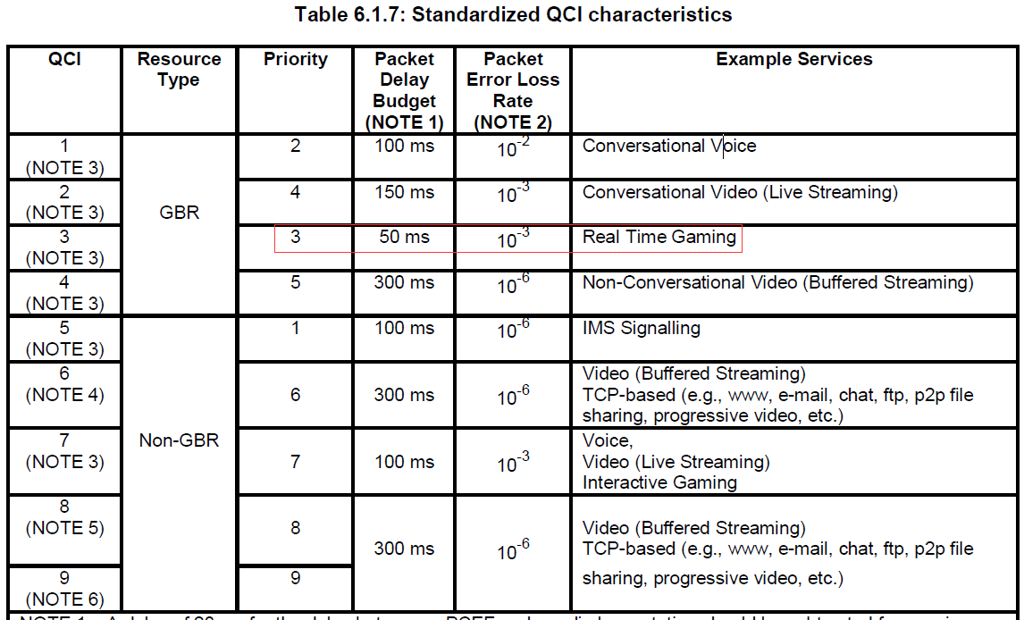

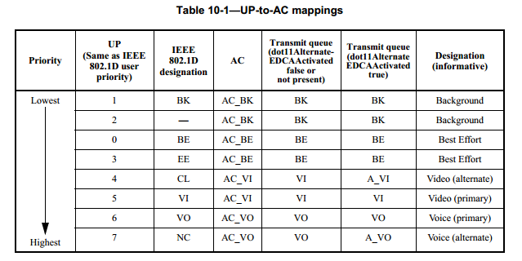
d) Coexistence of IEEE 802 LMSC wireless standards specifying devices for unlicensed operation

A coexistence assurance document is not necessary for the amendment. The amendment will not change the IEEE 802.11 channel access mechanism (i.e. CSMA/CD).
- 5. Economic Feasibility

For a project to be authorized, it shall be able to show economic feasibility (so far as can reasonably be estimated) for its intended applications. At a minimum, the proposed project shall show:
a) Known cost factors, reliable data.

Support of the proposed amendment will require both chipset vendors and WLAN devices manufacturers to develop a modified MAC QoS mechanism. This project doesn’t introduce additional required hardware costs. The additional software should be able to run compatibly on existing hardware, which is as similar as the evolution from 802.11ac to 802.11ax.

b) Reasonable cost for performance.

The cost of upgrading software and configuring the protocol is reasonable, given the gained improvement in network stability.

c) Consideration of installation costs.

The cost of installing enhanced software, in exchange for improved network performance, is familiar to vendors and users of IEEE 802.11.

References:
- https://newzoo.com/insights/articles/global-games-market-reaches-137-9-billion-in-2018-mobile-games-take-half/
- https://www.statista.com/statistics/748089/number-mobile-gamers-world-platform/
- 3GPP TS 23.203 v8.9.0 (2010-03) 3rd Generation Partnership Project-Technical Specification Group Services and System Aspects-Policy and charging control architecture (Release 8)
- IEEE Std 802.11-2016 IEEE Standard for Information Technologu-Local and Metropolitan Area Networks-Specific Requirements Part 11: Wireless LAN Medium Access Control (MAC) and Physical Layer (PHY) Specifications

