IEEE P802.11
Wireless LANs
ARC SC Teleconference Minutes June 21 2018
Date: 2018-06-21
Author(s):
Name | Affiliation | Address | Phone | email
Joseph Levy | InterDigital Communications, Inc. | 2 Huntington Quadrangle  4th floor, South Wing  Melville, NY 11747 | +1.631.622.4139 | joseph.levy@interdigital.com
Abstract
This document contains the minutes of the IEEE 802.11 ARC SC Teleconference held on 21 June 2018 at 12:00 EDT.

Note: Highlighted text are action items.

Administration:
Chair: Mark Hamilton, Ruckus/Arris
Vice Chair/Secretary Joseph Levy, InterDigital

Meeting call to order in by Chair 12:02 EDT

Proposed agenda:
- Call to order, Introduction & Policy reminders (see information below)
- Attendance
- Continue discussion on 11ba architectural concepts – prepare for joint session in July
  - Proposed “state machine view” of 11ba:
    - https://mentor.ieee.org/802.11/dcn/18/11-18-1016-01-0arc-wur-state-diagram-proposal-hamilton.vsdx - updated since May 24 call, based on discussion
    - https://mentor.ieee.org/802.11/dcn/18/11-18-1020-00-0arc-discussion-on-wur-802-11ba-states.pptx - review and confirm if we still have open questions
  - STA & AP architecture model of 11ba:
    - https://mentor.ieee.org/802.11/dcn/18/11-18-1017-00-0arc-wur-multi-ap-reference-model.vsd
- AOB
- Adjourn

Introduction & Policy Reminders:
The Chair briefly reviewed the administrative information and pointed out that:
Teleconferences are subject to IEEE policies and procedures, see:
– IEEE Patent Policy
– Patent FAQ
– Letter of Assurance Form
– Affiliation FAQ
– Anti-Trust FAQ
– Ethics
– 802 LMSC P&P
– 802 LMSC OM
– 802 WG P&P
– IEEE802.11 WG OM

Call for Patents:
The Chair reviewed the Patent policy and called for potentially essential patents – there was no response to the call.
Approval of the Agenda:
The Chair reviewed the agenda and called for comments or amendments to the agenda – there was no response to the call.
The proposed agenda was approved by unanimous consent.

Attendance:
Attendance was taken. The following made there their attendance known:
Mark Hamilton (Ruckus/ARIS)
Joseph Levy (InterDigital)
Dick Roy (SRA)
Bo Sun (ZTE)

Continue discussion on 11ba architectural concepts – prepare for joint session in July
Reviewed of the status as of the May CC.

Proposed “state machine view” of 11ba: https://mentor.ieee.org/802.11/dcn/18/11-18-1016-01-0arc-wur-state-diagram-proposal-hamilton.vsdx - updated since May 24 call, based on discussion. (Note this document as posted to mentor was not readable, will correct.) Diagram copied below:
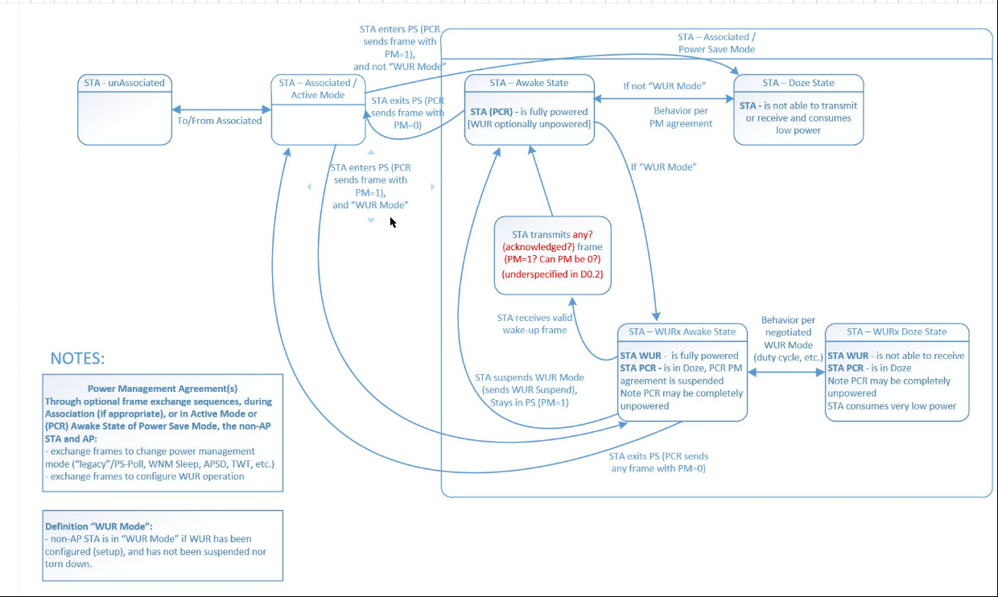

Discussion on the diagram:
Basically, agreed the legacy PS portion of the diagram – but there was a comment on the content of the Doze state box: the STA is not restricted to the behavior – the AP assumes that a STA in doze state cannot receive.

Discussion on the WUR portion:
Discussion on the difference between doze state and WURx Doze state.
Discussion on the how to move between WURx Awake State and Awake State:
Considered adding PCR power-up wait state
Comment that the AP can only confirm awake state only when the AP receives frames from the STA. This is true for both legacy PS and WUR PS. i.e. The awake state is never known to the AP until it receives frames.
It was agreed that we don’t need a timing diagram.
There was some concern that the Waking up State should be known to the AP.
But it was agreed to remove the state box for waking up as the AP has no behavior associated with a waking up state, it behaves as if the STA is not awake. The AP behavior does not change until it receives a frame and knows that the STA is in the awake state.
Text will be added to explain the transition from WURx Awake state to Awake state.

Decided that if we want to put this diagram in the spec – it should probably match the style of figures 11-11 and 11-12 in sections 11.2.7.2.2 and 11.2.7.3.3 respectively (Draft 802.11REVmd_D1.0).

Need a diagram for a non-AP STA WUR/PCR architecture: is there a MAC in a WUR?

Leaning toward the WUR being a PHY with the STAs SME.

Diagram for the AP side –
Choice 1: same radio as today – but can transmit OOK
Choice 2 – legacy and special OOK transmitter.
Comment: The AP sends a special PDU – I don’t see this as two radios – it is just a different MCS.

Short discussion on the dual capability transmitter. No conclusion reached.

Action items – update figure, generate architecture diagrams , and presentation as agreed in the last CC.

Adjourned: 13:30 EDT

