IEEE P802.11
Wireless LANs
Channel BW Configuration CIDs
Date: 2018-06-18
Author(s):
Name | Affiliation | Address | Phone | email
Oren Kedem | Intel |  |  | oren.kedem@intel.com
Abstract
This submission proposes resolutions to 1209, 1706 and 1707 CIDs

CID | Clause | Comment | Proposed change | Resolution
1209 | 9.4.2.251 | Table 6 splits the Channel BW Configuration subfield into two 2-bit unnamed parts, and then enumerates those parts. This shows that the subfield should be split, because they have distinct purposes. | Split the Channel BW Configuration subfield into two named parts. Use those names instead of B0 B1 and B2 B3 column headings. Replace bitstring representation with integer enumeration, noting that the current specification in Table 6 is not in integer order. | Revised  The split to B0 and B1 was removed. Instead a numerical value was placed
1706 | 9.4.2.251 | The Channel BW Configuration table is as clear as mud. The meaning of the terms "single channel", "channel bonding" and "channel aggregation" are not defined. The meaning of 2.16+2.16 is not defined. The relationship between the Channel BW Configuration subfield and the BSS Operating Channels bitmap is not clear at all. | Defne terms. Add rules that constrain Channel BW Configuration subfield settings and channel bitmap. | Revised  single channel", "channel bonding" and "channel aggregation" is defined.  A new table was added to describe the relationship between the Channel BW Configuration subfield and the BSS Operating Channels bitmap
1707 | 9.4.2.251 | This statement not true. Additional constraints are placed on the transmission by the Channel BW Configuration subfield. For example, if Ch1,Ch2,Ch3,Ch4=1111, B0B1B2B3=0100 and Ch1=primary, can you transmit on Ch2, Ch3 or Ch4? | Fix | Revised  Table is not intended to replace link access rules. Transmission rules for a STA are defined in section per rules  defined in 10.22.2.12 and 10.37.11.  Comment was added to the table

Discussion
STA should deduce on which channel numbers it allow to transmit based on:
- BSS Operating Channels
- Channel BW Configuration.
In current definition, BSS Operating Channels and Channel BW Configuration subfields are defined independently of each other. Standard should provide guidance and clarification on how to configure those two subfields in relation.
Contribution suggest to add a table that clarify the allowed Channel BW Configuration per the BSS Operating channel definition.

For example:

Number of subfields set to one in the BSS Operating Channels field | Misconfiguration of Channel BW field
1 | All values between 0101 to 1111 are not relevant to the BSS and if configured will lead to misbehavior of the STA
2 | 0100, 1010,1011,  All values between 1001 to 1111
3 | 1100, 1101, 1110,1111,0101,1011

In case of non-adjacent BSS Operating channel configuration, misconfiguration increases.

 | CH1 | CH2 | CH3 | CH4 | CH5 | CH6 | CH7 | CH8
BSS Operating Channels Example 1 | 1 | 0 | 1 | 0 | 1 | 1 | 0 | 0
BSS Operating Channels Example 2 | 0 | 1 | 1 | 0 | 0 | 1 | 1 | 0
BSS Operating Channels Example 3 | 1 | 0 | 1 | 0 | 1 | 0 | 1 | 0

Example 1
Assuming that CH5 is the primary, standard should restrict the configuration of Channel BW Configuration to possibly include only CB4.32 and CA2.16+2.16,

PPDU Mask may occupy the following

CB4.32 – CH5 & CH6
CA2.16+2.16. – CH5+CH1; CH5+CH3, CH5+CH6

Similarly, standard should restrict the configuration of Channel BW Configuration in case of example 2 to include only CB4.32, CA2.16+2.16 and CA4.32+4.32.

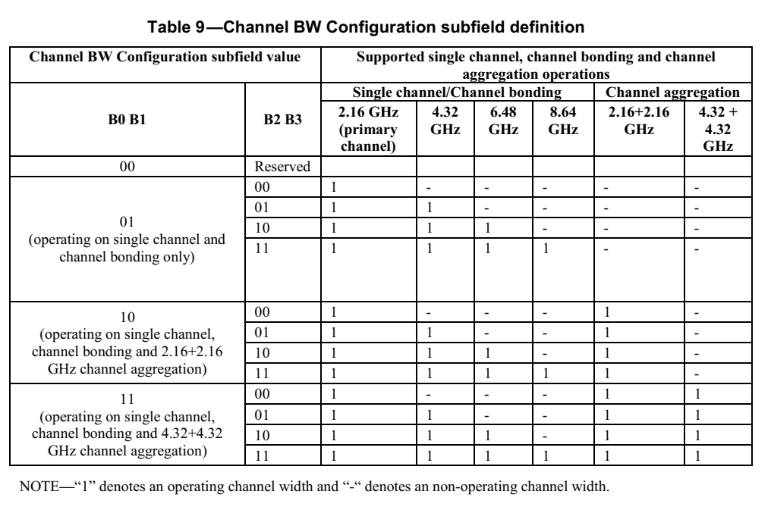

Does the AP can set the Channel BW Configuraiton field to values that does not utilize all the BSS Operating Channels ? (some BSS channels will not be used at all )

Below is D1.3 Draft text

10.37.11.2.1 Channel access rules

The following apply to transmissions performed in an EDMG BSS:
- Transmissions shall not occupy a bandwidth that exceeds the equivalent of four 2.16 GHz channels.
- Transmissions shall be confined to the channel number indicated by the primary channel, the
channels indicated in the EDMG Operation element, and the channels indicated in the EDMG
Capabilities element.
An EDMG STA shall not transmit an EDMG PPDU to a peer EDMG STA over a channel that is not
supported by the peer STA as indicated in the Supported Channels field in the peer STA’s EDMG
Capabilities element.

Per the above, the following is applied:
- Current draft disallow EDMG STA to transmit in BW that are not specified in EDMG Operation IE
- AP advertises its supported channels in EDMG capabilities IE.
- Operation IE specifies the allowed BW in BSS (also for peer to peer communication).

There is no motivation for an AP to set BSS Operating Channels which cannot be used by the stations.
However by doing so, it may cause complication in STA implementation.

For example: AP that want to select its BSS channels it about to utilize will need to look for the BSS channels as well as BW configuration to conclude which channels are likely to be used by the OBSS.

Per the above, 11ay should restrict BW Configurations setting that utilize only subset of the BSS channels.

9.4.2.251 EDMG Operation element
Change sections, Figure 44, Figure 45 and replace Table 6 as follow:

The BSS Operating Channels field is a bitmap that indicates the 2.16 GHz channel(s) that are allowed to be used for
transmissions in the BSS and is formatted as shown in Figure 44. In Figure 44, Ch1 subfield corresponds to channel 1, Ch2 subfield corresponds to channel 2 and so on (channels are defined in Annex E). If a subfield is set to 1, transmission on the indicated channel is allowed; otherwise if the subfield is set to 0, transmission on the indicated channel is not allowed. The subfield corresponding to the primary channel is always set to one and the total number of subfields set to one do not exceed four.

 | B0 | B1 | B2 | B3 | B4 | B5 | B6 | B7
 | CH1 | CH2 | CH3 | CH4 | CH5 | CH6 | CH7 | CH8
Bits | 1 | 1 | 1 | 1 | 1 | 1 | 1 | 1

Figure 44 —BSS Operating Channels field format
The Operating Channel Width field is defined in Figure 45 and indicates each possible bandwidth that a
PPDU transmitted in the BSS can occupy.

 | B0 – B3 | B4-7
 | Channel BW Configuration | Reserved
Bits | 4 | 4

Figure 45 —Operating Channel Width field format
The Channel BW Configuration subfield encodes the allowed channel bandwidth configurations and is
defined in Table 6.

Table 9—Channel BW Configuration subfield definition

Channel BW Configuration subfield value |  | PPDU masks that are allowed to be transmitted in the BSS per rules  defined in 10.22.2.12 and 10.37.11.
 |  | 2.16 GHz | 4.32 GHz | 6.48 GHz | 8.64 GHz | 2.16+2.16 GHz | 4.32+4.32 GHz
Reserved | 0-3
operating on  2.16 GHz, 4.32 GHz,  6.48 GHz and 8.64 GHz only | 4 | 1 | 0 | 0 | 0 | 0 | 0
 | 5 | 1 | 1 | 0 | 0 | 0 | 0
 | 6 | 1 | 1 | 1 | 0 | 0 | 0
 | 7 | 1 | 1 | 1 | 1 | 0 | 0
operating on  2.16 GHz, 4.32 GHz,  6.48 GHz, 8.64 GHz and 2.16+2.16 GHz only | 8 | 1 | 0 | 0 | 0 | 1 | 0
 | 9 | 1 | 1 | 0 | 0 | 1 | 0
 | 10 | 1 | 1 | 1 | 0 | 1 | 0
 | 11 | 1 | 1 | 1 | 1 | 1 | 0
operating on  2.16 GHz, 4.32 GHz,  6.48 GHz, 8.64 GHz, 2.16+2.16 GHz and 4.32+4.32 GHz only | 12 | 1 | 0 | 0 | 0 | 1 | 1
 | 13 | 1 | 1 | 0 | 0 | 1 | 1
 | 14 | 1 | 1 | 1 | 0 | 1 | 1
 | 15 | 1 | 1 | 1 | 1 | 1 | 1

11.1.4 Acquiring synchronization, scanning
11.1.4.4 Initializing a BSS
11.1.4.4.2 Initializing a DMG BSS
Prior to choosing a suitable operating channel and starting a BSS, the SME of a DMG STA should perform
a channel scan to ascertain the quality of each channel that the STA supports. The rules for choosing a
suitable operating channel are implementation specific and might be subject to regulatory requirements.
When a STA’s MAC receives an MLME-START.request primitive, the MAC shall attempt to start a BSS.
The STA may listen for a duration of aMinChannelTime, the listening duration, in the channel specified by
the SME in the request. If the STA determines the channel is suitable for BSS operation at the end of this
listening duration, the STA initializes the BSS by commencing transmission of DMG Beacon frames
according to 11.1.3.3 in the case of a PBSS or an infrastructure BSS and according to 11.1.3.5 in the case of
an IBSS. If AP or PCP clustering is in use on the selected channel, the DMG Beacon frame transmission by
an AP or PCP commences following the additional rules described in 10.37.

In case of EDMG BSS, an AP or PCP shall set the Channel BW Configuration field within the EDMG Operation element to a valid value per the BSS Operating Channel as listed in Table 10.

Table 10— Valid Channel BW Configuration subfield values

EDMG Operation element configuration
Value of BSS Operating Channel subfield in EDMG Operation element |  | Valid Channel BW Configuration subfield value in case Primary channel is not-adjacent to the secondary channel | Valid Channel BW Configuration subfield value in case Primary channel is adjacent to the secondary channel
Total Number of subfields set to one in the BSS Operating Channels field | Number of subfields set to one in the BSS Operating Channels field which are adjacent
1 | No adjacent channels | 4 | -
2, 3 or 4 | No adjacent channels | 8 | -
2, 3 or 4 | Two adjacent channels | 8 | 5, 8, 9
4 | Pair of two adjacent channels | - | 8, 9, 12, 13
3 or 4 | Three adjacent channels | 8 | 6, 8, 9, 10
4 | Four adjacent channels | - | 7, 11,12,13,14 15

SP/M: Do you accept the resolutions given in this document ?

