IEEE P802.11
Wireless LANs
Channel BW Configuration CIDs
Date: 2018-06-18
Author(s):
Name | Affiliation | Address | Phone | email
Oren Kedem | Intel |  |  | oren.kedem@intel.com
Abstract
This submission proposes resolutions to 1209, 1706 and 1707 CIDs

CID | Clause | Comment | Proposed change | Resolution
1209 | 9.4.2.251 | Table 6 splits the Channel BW Configuration subfield into two 2-bit unnamed parts, and then enumerates those parts. This shows that the subfield should be split, because they have distinct purposes. | Split the Channel BW Configuration subfield into two named parts. Use those names instead of B0 B1 and B2 B3 column headings. Replace bitstring representation with integer enumeration, noting that the current specification in Table 6 is not in integer order. | Revised  The split to B0 and B1 was removed. Instead a numerical value was placed
1706 | 9.4.2.251 | The Channel BW Configuration table is as clear as mud. The meaning of the terms "single channel", "channel bonding" and "channel aggregation" are not defined. The meaning of 2.16+2.16 is not defined. The relationship between the Channel BW Configuration subfield and the BSS Operating Channels bitmap is not clear at all. | Defne terms. Add rules that constrain Channel BW Configuration subfield settings and channel bitmap. | Revised  single channel", "channel bonding" and "channel aggregation" is defined.  A new table was added to describe the relationship between the Channel BW Configuration subfield and the BSS Operating Channels bitmap
1707 | 9.4.2.251 | This statement not true. Additional constraints are placed on the transmission by the Channel BW Configuration subfield. For example, if Ch1,Ch2,Ch3,Ch4=1111, B0B1B2B3=0100 and Ch1=primary, can you transmit on Ch2, Ch3 or Ch4? | Fix | Revised  Table is not intended to replace link access rules. Transmission rules for a STA are defined in section per rules  defined in 10.22.2.12 and 10.37.11.  Comment was added to the table

Discussion
STA can know on which channel numbers it allow to transmit based on:
BSS Operating Channels
Channel BW Configuration.
In current definition, BSS Operating Channels and Channel BW Configuration subfields are defined independently of each other. The above might lead to misconfiguration of the two subfields.
Contribution suggest to add a table that clarify the allowed Channel BW Configuration per the BSS Operating channel definition.

For example:

Number of subfields set to one in the BSS Operating Channels field | Misconfiguration of Channel BW field
1 | All values between 0101 to 1111 are not relevant to the BSS and if configured will lead to misbehavior of the STA
2 | 0100, 1010,1011,  All values between 1001 to 1111
3 | 1100, 1101, 1110,1111,0101,1011

In case of non-adjacent BSS Operating channel configuration, misconfiguration increases.

 | CH1 | CH2 | CH3 | CH4 | CH5 | CH6 | CH7 | CH8
BSS Operating Channels Example 1 | 1 | 0 | 1 | 0 | 1 | 1 | 0 | 0
BSS Operating Channels Example 2 | 0 | 1 | 1 | 0 | 0 | 1 | 1 | 0
BSS Operating Channels Example 3 | 1 | 0 | 1 | 0 | 1 | 0 | 1 | 0

Example 1
Assuming that CH5 is the primary, standard should restrict the configuration of Channel BW Configuration to possibly include only CB4.32 and CA2.16+2.16,

PPDU Mask may occupy the following

CB4.32 – CH5 & CH6
CA2.16+2.16. – CH5+CH1; CH5+CH3, CH5+CH6

Similarly, standard should restrict the configuration of Channel BW Configuration in case of example 2 to include only CB4.32, CA2.16+2.16 and CA4.32+4.32.

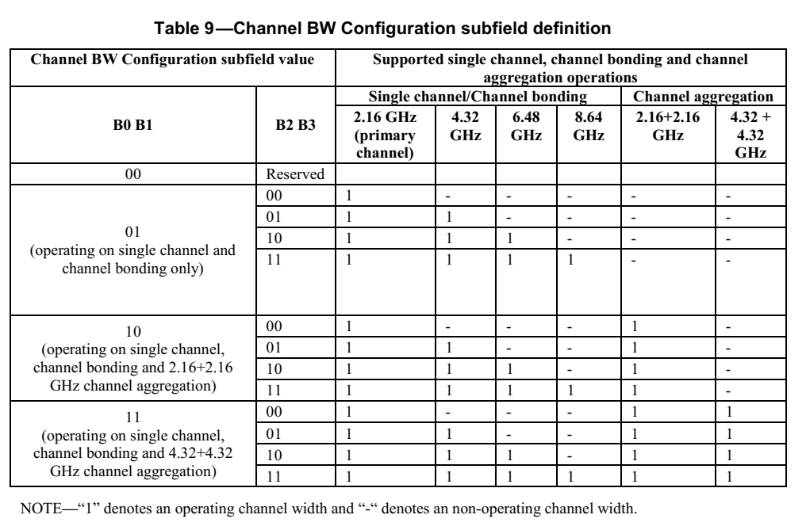
9.4.2.251 EDMG Operation element
Change sections, Figure 44, Figure 45 and replace Table 6 as follow:

The BSS Operating Channels field is a bitmap that indicates the 2.16 GHz channel(s) that are allowed to be used for
transmissions in the BSS and is formatted as shown in Figure 44. In Figure 44, Ch1 subfield corresponds to channel 1, Ch2 subfield corresponds to channel 2 and so on (channels are defined in Annex E). If a subfield is set to 1, transmission on the indicated channel is allowed; otherwise if the subfield is set to 0, transmission on the indicated channel is not allowed. The subfield corresponding to the primary channel is always set to one and the total number of subfields set to one do not exceed four.

 | B0 | B1 | B2 | B3 | B4 | B5 | B6-B7
 | CH1 | CH2 | CH3 | CH4 | CH5 | CH6 | Reserved
Bits | 1 | 1 | 1 | 1 | 1 | 1 | 2

Figure 44 —BSS Operating Channels field format
The Operating Channel Width field is defined in Figure 45 and indicates each possible bandwidth that a
PPDU transmitted in the BSS can occupy.

 | B0 – B3 | B4-7
 | Channel BW Configuration | Reserved
Bits | 4 | 4

Figure 45 —Operating Channel Width field format
The Channel BW Configuration subfield encodes the allowed channel bandwidth configurations and is
defined in Table 6.

Table 9—Channel BW Configuration subfield definition

Channel BW Configuration subfield value |  | PPDU masks that are allowed to be transmitted in the BSS per rules  defined in 10.22.2.12 and 10.37.11.
 |  | Single Channel and Channel Bonding PPDU Mask |  |  |  | Channel Aggregation PPDU Mask
 |  | 2.16 GHz | 4.32 GHz | 6.48 GHz | 8.64 GHz | 2.16+2.16 GHz | 4.32+4.32 GHz
Reserved | 0-3
operating on single channel and  channel bonding only | 4 | 1 | 0 | 0 | 0 | 0 | 0
 | 5 | 1 | 1 | 0 | 0 | 0 | 0
 | 6 | 1 | 1 | 1 | 0 | 0 | 0
 | 7 | 1 | 1 | 1 | 1 | 0 | 0
operating on single channel,  channel bonding and 2.16+2.16  GHz channel aggregation) | 8 | 1 | 0 | 0 | 0 | 1 | 0
 | 9 | 1 | 1 | 0 | 0 | 1 | 0
 | 10 | 1 | 1 | 1 | 0 | 1 | 0
 | 11 | 1 | 1 | 1 | 1 | 1 | 0
operating on single channel,  channel bonding and 4.32+4.32  GHz channel aggregation) | 12 | 1 | 0 | 0 | 0 | 1 | 1
 | 13 | 1 | 1 | 0 | 0 | 1 | 1
 | 14 | 1 | 1 | 1 | 0 | 1 | 1
 | 15 | 1 | 1 | 1 | 1 | 1 | 1

Table 10— Allowed Channel BW Configuration values per BSS Operating Channels value

EDMG Operation element configuration
BSS Operating Channel subfield value |  | Allowed Channel BW Configuration subfield value if Primary channel is not-contiguous to the secondary channel | Allowed Channel BW Configuration subfield value if Primary channel is contiguous to the secondary channel
Total Number of subfields set to one in the BSS Operating Channels field | Number of subfields set to one in the BSS Operating Channels field which are contiguous
1 | No contiguous channels | 4 | -
2, 3 or 4 | No contiguous channels | 4, 8 | -
2, 3 or 4 | Two contiguous channels | 4, 8 | 4, 5, 8, 9
4 | Pair of two contiguous channels | - | 4, 5, 8, 9, 12, 13
3 or 4 | Three contiguous channels | 4, 8 | 4, 5, 6, 8, 9, 10
4 | Four contiguous channels | - | 4 to 15

SP/M: Do you accept the resolutions given in this document ?

