IEEE P802.11
Wireless LANs
Resolution of CIDs
Date: 2018-06-03
Author(s):
Name | Affiliation | Address | Phone | email
Oren Kedem | Intel |  |  | oren.kedem@intel.com
Abstract
This submission proposes resolutions to 1095, 1209, 1261, 1262, 1420, 1421, 1703, 1706, 1707, 1891, 2165, 2197 and 2331 CIDs

CID | Clause | Comment | Proposed change | Resolution
1095 | 3.2 | what does "associated with primary channel" mean? In fact the selection of the secondary channel is not clear. There should be a mechanism to identify the secondary channel and if it is to the left or to the right of the primary channel. I am not even sure if the secondary channel has to be adjacent to the primary. | clarify the procedure used to identify the secondary channel. | Revised per CID 1708
1703 | 3.2 | What is a "non-DMG"? What is a DMG? DMG and non-DMG are adjectives, not nouns. | Use the term "secondary 2.16 GHz channel" and avoid change to this definition. A comment to REVmd might be to replace "secondary channel" with "secondary 20 MHz channel". | Revised  The term non-DMG STA is defined, however the term “non-DMG”, when used by itself, is not defined. It is not the same thing and cannot be substitute.  In practice, “In non-DMG” in the first sentence is redundant and can be omitted. Similarly ”In DMG” is redundant in the second sentence because it says “… used by an EDMG STA”.  Text will not use the above terms hence will be removed.
1891 | 3.2 | should we also consider the 2.16 + 2.16 channel and the 4.32 + 4.32 channels in defining secondary channels ? See Figure 3 on pg 29 line 6 for a discussion of secondary channelse I the 2.16 + 2.16 GHz and 4.32+4.32 GHz cases | modify text " In DMG, a 2.16 GHz channel associated with a primary channel used by enhanced directional multi-gigabit (EDMG) STAs for 15 the purpose of creating a 4.32 GHz, 6.48 GHz, 8.64 GHz, 2.16 + 2.16 GHz or 4.32 + 4.32 channel." | Rejected  2.16 + 2.16 channel and the 4.32 + 4.32 channels options are already defined
2197 | 3.2 | There is no reason to add non-DMG to the beginning of this definition, as the current definition specifically states which non-DMG cases it refers to. it is only necessary to add the new case of a secondary DMG channel. | Change the definition to read:  "secondary channel: A 20 MHz channel associated with a primary channel used by high-throughput (HT) stations (STAs) for the purpose of creating a 40 MHz channel or used by very high throughput (VHT) STAs for the purpose of creating the primary 40 MHz channel; or a 2.16 GHz channel associated with a primary channel used by enhanced directional multi-gigabit (EDMG) STAs for the purpose of creating a 4.32 GHz, 6.48 GHz or 8.64 GHz channel." | Revised per CID 1708  Selection of secondary channels was addressed in CID 1708 which provided the mechanism to define the secondary channels (8.3.5.12.2 Semantics of the service primitive) . The wording "associated with primary channel" was adopted from HT and VHT.

3.2 Definitions specific to IEEE Std 802.11
change below definitions as follow

secondary channel: a 20 MHz channel associated with a primary channel used by high-
throughput (HT) stations (STAs) for the purpose of creating a 40 MHz channel or used by very high
throughput (VHT) STAs for the purpose of creating the primary 40 MHz channel. A 2.16 GHz
channel associated with a primary channel used by enhanced directional multi-gigabit (EDMG) STAs for
the purpose of creating a 4.32 GHz, 6.48 GHz, 8.64 GHz, 2.16+2.16 GHz or 4.32+4.32 GHz channel.

secondary1 channel: a 2.16 GHz channel associated with a primary channel and secondary channel used
by enhanced directional multi-gigabit (EDMG) stations (STAs) for the purpose of creating a 4.32 GHz,
6.48 GHz, 2.16+2.16 GHz or 4.32+4.32 GHz channel.
secondary2 channel: a 2.16 GHz channel associated with a primary channel, secondary channel, and
secondary1 channel used by enhanced directional multi-gigabit (EDMG) stations (STAs) for the purpose of
creating a 8.64 GHz channel, 2.16+2.16 GHz or 4.32+4.32 GHz channel.

CID | Clause | Comment | Proposed change | Resolution
1209 | 9.4.2.251 | Table 6 splits the Channel BW Configuration subfield into two 2-bit unnamed parts, and then enumerates those parts. This shows that the subfield should be split, because they have distinct purposes. | Split the Channel BW Configuration subfield into two named parts. Use those names instead of B0 B1 and B2 B3 column headings. Replace bitstring representation with integer enumeration, noting that the current specification in Table 6 is not in integer order. | Revised
1706 | 9.4.2.251 | The Channel BW Configuration table is as clear as mud. The meaning of the terms "single channel", "channel bonding" and "channel aggregation" are not defined. The meaning of 2.16+2.16 is not defined. The relationship between the Channel BW Configuration subfield and the BSS Operating Channels bitmap is not clear at all. | Defne terms. Add rules that constrain Channel BW Configuration subfield settings and channel bitmap. | Revised
1707 | 9.4.2.251 | This statement not true. Additional constraints are placed on the transmission by the Channel BW Configuration subfield. For example, if Ch1,Ch2,Ch3,Ch4=1111, B0B1B2B3=0100 and Ch1=primary, can you transmit on Ch2, Ch3 or Ch4? | Fix | Revised

Discussion
Per the above comment, existing Table 6 doesn’t make use of the full information of the number of active channels in the BSS Operating channels subfield, and the ambiguity in definition as pointed by the comment bring to a conclusion that table and representation could be optimized as suggested below:

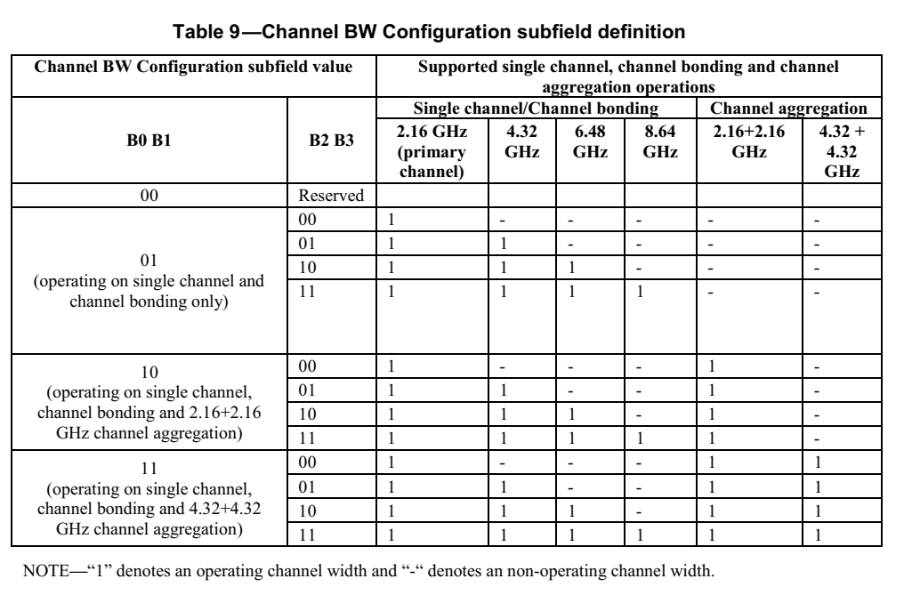
9.4.2.251 EDMG Operation element
Change sections, Figure 44, Figure 45 and replace Table 6 as follow:

The BSS Operating Channels field is a bitmap that indicates the 2.16 GHz channel(s) that are allowed to be used for
transmissions in the BSS and is formatted as shown in Figure 44. In Figure 44, Ch1 subfield corresponds to channel 1, Ch2 subfield corresponds to channel 2 and so on (channels are defined in Annex E). If a subfield is set to 1, transmission on the indicated channel is allowed; otherwise if the subfield is set to 0, transmission on the indicated channel is not allowed. The subfield corresponding to the primary channel is always set to one and the total number of subfields set to one do not exceed four.

 | B0 | B1 | B2 | B3 | B4 | B5 | B6 | B7
 | CH1 | CH2 | CH3 | CH4 | CH5 | CH6 | CH7 | CH8
Bits | 1 | 1 | 1 | 1 | 1 | 1 | 1 | 1

Figure 44 —BSS Operating Channels field format
The Operating Channel Width field is defined in Figure 45 and indicates each possible bandwidth that a
PPDU transmitted in the BSS can occupy.

 | B0 – B2 | B3-7
 | Channel BW Configuration | Reserved
Bits | 3 | 5

Figure 45 —Operating Channel Width field format
The Channel BW Configuration subfield encodes the allowed channel bandwidth configurations and is
defined in Table 6.

Table 9—Channel BW Configuration subfield definition

EDMG operation configuration |  | PPDU masks that are allowed to be transmitted in the BSS
Number of subfields set to one in the BSS Operating Channels field | Channel BW Configuration subfield value | 2.16 GHz | 4.32 GHz | 2.16+2.16 GHz | 6.48 GHz | 8.64 GHz | 4.32+4.32 GHz
1 | 0 | Y | N/A | N/A | N/A | N/A | N/A
 | 1 – 7 | Reserved
2 | 0 | Y | Y | Y | N/A | N/A | N/A
 | 1 | Y | Y | N | N/A | N/A | N/A
 | 2 | Y | N | N | N/A | N/A | N/A
 | 3 – 7 | Reserved
3 | 0 | Y | Y | Y | Y | N/A | N/A
 | 1 | Y | Y | N | Y | N/A | N/A
 | 2 | Y | N | Y | Y | N/A | N/A
 | 3 | Y | N | N | Y | N/A | N/A
 | 4-7 | Reserved
4 | 0 | Y | Y | Y | Y | Y | Y
 | 1 | Y | Y | N | Y | Y | N
 | 2 | Y | N | Y | N | N | Y
 | 3-7 | Reserved

CID | Clause | Comment | Proposed change | Resolution
1261 | 9.3.1.9.1 | The reading of "The Management ACK subfield is set to one to indicate that frames of type Management that are not Action No Ack are acknowledged" is awkward, should it be "...to indicate the type of management frames..."? | correct it or clarify it with better words | Revised
1262 | 9.3.1.9.1 | Why this Management subfield is reserved when the BlackAck variant is not the EDMG Multi-TID BlockAck variant? Shouldn't the non Multi-TID BlockAck be the same rule? | Please clarify it | Rejected  Clarification provided

Discussion
The recipient ability to acknoladge Management frame is achieved only if the recipient supports Multi-TID capability hence it is enabled only if Multi-TID Block Ack is used.

9.3.1.9.1 Overview
Change text as follows
The Management ACK subfield is set to one to indicate that a frame of type Management and subtype that is not
Action No Ack is acknowledged. This subfield is reserved if the BlockAck variant used is not the EDMG
Multi-TID BlockAck variant.

CID | Clause | Comment | Proposed change | Resolution
1420 | 10.3.2.3.4 | To be more precise, the requirement for an EDMG STA to perform CCA on secondary channels prior to transmission should be restated as suggested | An EDMG STA shall perform CCA detection in the secondary 2.16 GHz, 4.32 GHz, and 6.48 GHz channels before transmitting a 4.32 GHz, 6.48 GHz, 8.64 GHz, 2.16+2.16 GHz, or 4.32+4.32 GHz mask PPDU using the EDCA channel access mechanism, as described in 10.22.2 | Rejected  Rule follows the existing rules methodology, “secondary 2.16 GHz, 4.32 GHz, and 6.48 GHz channels” term is not accurate.
1421 | 10.3.2.3.4 | It appears that this paragraph attempts to define the requirement for a STA that uses PIFS to start a transmission after performing the CS procedure. For better clarity, it should be stated as suggested. | In addition to the requirement to perform CCA in the secondary channel (where the timing is defined in 11.16.9 for an HT STA and defined in 10.36.11.2 for an EDMG STA), a STA using PIFS may start its transmission after its CS mechanism (see 10.3.2.1) determines that the medium is idle at the TxPIFS slot boundary, as defined in 10.3.7 and 10.22.2.4. | Rejected  Wording was taken from legacy standard

Discussion

10.3.2.3.4 PIFS
No change is needed, text here just for reference
⎯ An EDMG STA performing CCA in the secondary, secondary1, and secondary2 channels before
transmitting a 4.32 GHz, 6.48 GHz, 8.64 GHz, 2.16+2.16 GHz, or 4.32+4.32 GHz mask PPDU using EDCA channel access, as described in 10.22.2

With the exception of performing CCA in the secondary channel (where the timing is defined in 11.16.9 for an HT STA and defined in 10.37.11.2 for an EDMG STA), a STA using PIFS starts its transmission after its CS mechanism (see 10.3.2.1) determines that the medium is idle at the TxPIFS slot boundary, as defined in 10.3.7 and 10.22.2.4.

CID | Clause | Comment | Proposed change | Resolution
2165 | 9.2.4 | It is necessary to define the maximum data sizes and durations for the EDMG PPDU. | "The contents of the EDMG PPDU should be added to the table of maximum data sizes and durations. (Draft P802.11REVmc_D8.0 Table 9-19 Maximum data unit sizes (in octets) and and durations (in microseconds)) | Rejected

Discussion
Table 9-19 Maximum data unit sizes (in octets) set the maximum transmitted MSDU or MPDU size. The maximum PPDU duration is set to 2ms. Those values are not changed by the SAR feature hence no need to redefine those in the table.

CID | Clause | Comment | Proposed change | Resolution
2331 | 10.3.2.14 | "To provide complete bandwidth signaling information, the EDMG STA should include a control trailer in the transmitted RTS frame using the procedure specified in 10.36.11.5."  What is a complete bandwidth signaling information?  Also, a spec has to say that the Control trailer carried in a RTS frame shall include the complete bandwidth signaling information. | As in comment. | Resolved in CID 2254

SP/M: Do you accept the resolutions given in this document ?

