IEEE P802.11
Wireless LANs
CID 14078
Date: 5/8/2018
Author(s):
Name | Affiliation | Address | Email
Sigurd Schelstraete | Quantenna | 1704 Automation Pkwy,  San Jose, CA 95131 | sigurd@quantenna.com
Abstract
This submission proposes resolutions for CID 14078
CID 166

Discussion and proposed resolutions
14078 | 424.05 | 5 | 28.3.10.8.3 | What is "signaling"? | Clarify the meaning of "the signaling is carried in both HE-SIG-B content channels placed  in the order of the absolute subcarrier index." | Revised: Make text modifications as shown in 802.11-18/0936

Discussion
The sentence referred to in CID 14078 is shown below in context.
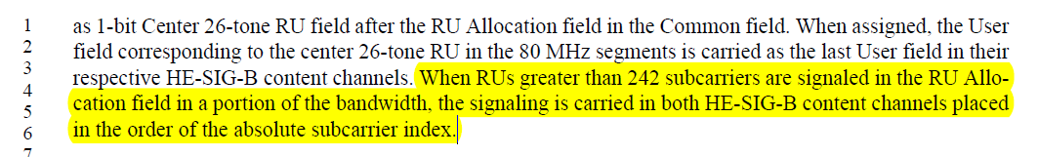
The text deals with the case of an RU that overlaps with two (or more) of the 20 MHz segments. In that case, there should be an RU allocation subfield entry in each of the content channels. Note that the text above specifically deals with 160 MHz. For 80 MHz, the corresponding text has already been cleaned up and modified. It reads:
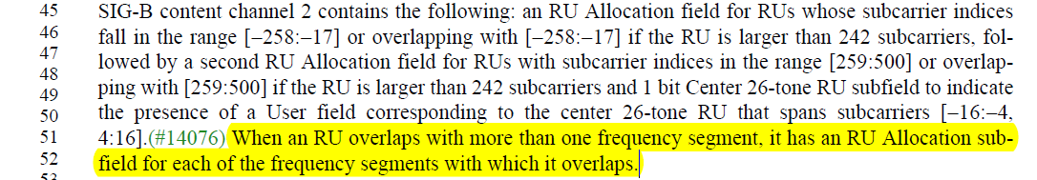
So, some effort has already been made to improve the wording for the case of an 80 MHz PPDU, but even there, the reference to frequency segment may not be appropriate. We propose to modify the language of the 80 MHz case and then use similar, consistent language for 160 MHz.
The proposed text update is shown below.
Proposed text modifications (page 468, line 22 to page 469, line 3 of D2.3)
The 80 MHz PPDU contains two HE-SIG-B content channels each of which are duplicated once as shown in Figure 28-28 (Mapping of the two HE-SIG-B content channels and their duplication in an 80 MHz PPDU when the SIGB Compression field in the HE-SIG-A field of an HE MU PPDU is set to 0(#11438)). HE-SIG-B content channel 1 occupies the 20 MHz frequency segment that is lowest in frequency and is duplicated on the 20 MHz frequency segment that is third lowest in frequency. HE-SIG-B content channel 2 occupies the 20 MHz frequency segment that is second lowest in frequency and is duplicated on the 20 MHz frequency segment that is fourth lowest in frequency. (#13368, #11408)
The first HE-SIG-B content channel appearing in the 20 MHz segments of the 80 MHz PPDU carries a Common field and User Specific field corresponding to RUs signaled in the Common field.with subcarriers indices that overlap those frequency segments. The Common field of HE-SIG-B content channel 1 contains the following: an RU Allocation subfield for RUs with subcarrier indices in the range [-500:-259] or overlapping with [-500:-259] if the RU is larger than 242 subcarriers, followed by a second RU Allocation subfield for RUs with subcarrier indices in the range [17:258] or overlapping with [17:258] if the RU is larger than 242 subcarriers and, followed by a 1 bit Center 26-tone RU subfield to indicate the presence of the User field corresponding to the center 26-tone RU that spans subcarriers [-16:-4, 4:16].(#13465, #14076)
The second HE-SIG-B content channel of the 80 MHz PPDU carries a Common field and User Specific field corresponding to RUs signaled in the Common field with subcarrier indices that fall in those segments. The Common field of HE-SIG-B content channel 2 contains the following: an RU Allocation field for RUs whose subcarrier indices fall in the range [-258:-17] or overlapping with [-258:-17] if the RU is larger than 242 subcarriers, followed by a second RU Allocation field for RUs with subcarrier indices in the range [259:500] or overlapping with [259:500] if the RU is larger than 242 subcarriers and, followed by a 1 bit Center 26-tone RU subfield to indicate the presence of a User field corresponding to the center 26-tone RU that spans subcarriers [-16:-4, 4:16].(#14076) When an RU overlaps with more than one frequency segment, it has an RU Allocation sub-field for each of the frequency segments with which it overlaps.
If a single RU overlaps with more than one of the tone ranges [-500:-259], [-258:-17], [17:258] or [259:500], the corresponding RU allocation subfield(s) in the respective content channels shall all refer to the same RU.
Each signaling for the presence of the User field corresponding to a center 26-tone RU of the 80 MHz PPDU carries the same value in both HE-SIG-B content channels. When assigned, the User field corresponding to the center 26-tone RU that spans subcarriers [-16:-4, 4:16] is carried as the last User field in the HE-SIG-B content channel 1.(#14077, #11409, #13369)
(…)
The 160 MHz PPDU contains two HE-SIG-B content channels each of which are duplicated four times as shown in Figure 28-29 (Mapping of the two HE-SIG-B content channels and their duplication in a 160 MHz PPDU when the SIGB Compression field in the HE-SIG-A field of an HE MU PPDU is set to 0(#11439)). HE-SIG-B content channel 1 occupies the 20 MHz frequency segment that is lowest in frequency and is duplicated on the 20 MHz frequency segments that are third, fifth and seventh lowest in frequency. HE-SIG-B content channel 2 occupies the 20 MHz frequency segment that is second lowest in frequency and is duplicated on the 20 MHz frequency segments that are fourth, sixth and eighth lowest in frequency.(#13368, #11410)
The first HE-SIG-B content channel of a 160 MHz PPDU carries a Common field and User Specific field corresponding to RUs signaled in the Common field. The Common field of HE-SIG-B content channel 1 contains the following: an RU Allocation subfield for RUs with subcarrier indices in the range [-1012:-771] or overlapping with [-1012:-771] if the RU is larger than 242 subcarriers, followed by a second RU Allocation subfield for RUs with subcarrier indices in the range [-495:-254] or overlapping with [-495:-254] if the RU is larger than 242 subcarriers, followed by a third RU Allocation subfield for RUs with subcarrier indices in the range [12:253] or overlapping with [12:253] if the RU is larger than 242 subcarriers, followed by a fourth RU Allocation subfield for RUs with subcarrier indices in the range [529:770] or overlapping with [529:770] if the RU is larger than 242 subcarriers, followed by 1 bit Center 26-tone RU subfield to indicate the presence of the User field corresponding to the center 26-tone RU that spans subcarriers [-528:-516, -508:-496].
The second HE-SIG-B content channel 1 of a 160 MHz PPDU carries a Common field and User Specific field corresponding to RUs signaled in the Common field. The Common field of HE-SIG-B content channel 2 contains the following: an RU Allocation subfield for RUs with subcarrier indices in the range [-770:-529] or overlapping with [-770:-529] if the RU is larger than 242 subcarriers, followed by a second RU Allocation subfield for RUs with subcarrier indices in the range [-253:-12] or overlapping with [-253:-12] if the RU is larger than 242 subcarriers, followed by a third RU Allocation subfield for RUs with subcarrier indices in the range [254:495] or overlapping with [254:495] if the RU is larger than 242 subcarriers, followed by a fourth RU Allocation subfield for RUs with subcarrier indices in the range [771:1012] or overlapping with [771:1012] if the RU is larger than 242 subcarriers, followed by 1 bit Center 26-tone RU subfield to indicate the presence of the User field corresponding to the center 26-tone RU that spans subcarriers [496:508, 516:528].
If a single RU overlaps with more than one of the tone ranges [-1012:-771], [-770:-529], [-495:-254], [-253:-12], [12:253], [254:495], [529:770] or [771:1012], the corresponding RU allocation subfield(s) in the respective content channels shall all refer to the same RU.
RU allocation signaling for RUs that overlap the 20 MHz frequency segments in which the HE-SIG-B content channel 1 is carried. The HE-SIG-B con-tent channel 2 carries RU allocation signaling for RUs that overlap the 20 MHz frequency segments in which the HE-SIG-B content channel 2 is carried.(#13469) The signaling for the presence of the User field corresponding to a center 26-tone RU in the 80 MHz segment with the lower subcarrier index is carried in HE-SIG-B content channel 1 as a 1-bit Center 26-tone RU field after the RU Allocation field in the Common field. Similarly, signaling for the center 26-tone RU in the 80 MHz segment with the higher subcarrier index is carried in HE-SIG-B content channel 2 as 1-bit Center 26-tone RU field after the RU Allocation field in the Common field. When assigned, the User field corresponding to the center 26-tone RU in the 80 MHz segments is carried as the last User field in their respective HE-SIG-B content channels. When RUs greater than 242 subcarriers are signaled in the RU Allocation field in a portion of the bandwidth, the signaling is carried in both HE-SIG-B content channels placed in the order of the absolute subcarrier index.
Resolution
Revised: Make text modifications as shown in 802.11-18/0936

