IEEE P802.11
Wireless LANs
D2.0 PHY Comment Resolution – CID 13974
Date: 2018-05-08
Author(s):
Name | Affiliation | Address | Phone | email
Youhan Kim | Qualcomm | 1700 Technology Dr.  San Jose, CA 95110 |  | youhank@qti.qualcomm.com

Abstract
This submission proposes resolutions for the following comments from the letter ballot on P802.11ax D2.0:

13974

NOTE – Set the Track Changes Viewing Option in the MS Word to “All Markup” to clearly see the proposed text edits.

Revision History:

R0: Initial version.

CID | Clause | Page | Comment | Proposed Change
13974 | 27.6.5 | 269.62 | HE PHY Capabilities allows beamformees to declare different capability on the Beeamformee STS for NDPs w/ <= 80 MHz and NDPs w/ > 80 MHz (see D2.0 P142L43-60, P269L62-P270L7). When an HE beamforee is being sounded by an HE beamformer, then the same capability distinction should be applied even for VHT sounding. Note that the proposed change is on 10.34.6 of the baseline IEEE 802.11-2016, but the comment was submitted to 27.6.5 because 10.34.6 does not exist in the 11ax draft yet, thus there is no page number associate to it. | Add 10.34.6 to TGax draft, with the following content:  "10.34.6 (Insert the following after the second paragrah) This paragraph applies when a STA with dot11HEOptionImplemented set to true is transmitting a VHT NDP where at least one of the intended recipient STAs of the VHT NDP has dot11HEOptionImplemented set to true. When the channel width of an VHT NDP is less than or equal to 80 MHz, the number of space-time streams sounded and as indicated by the NUM_STS parameter shall not exceed the value indicated in the Beamformee STS <= 80 MHz field in the HE Capabilities element of any intended recipient of the VHT NDP with dot11HEOptionImplemented set to true. When the channel width of an VHT NDP is greater than 80 MHz, the number of space-time streams sounded and as indicated by the NUM_STS parameter shall not exceed the value indicated in the Beamformee STS > 80 MHz field in the HE Capabilities element of any intended recipient of the VHT NDP with dot11HEOptionImplemented set to true."

Context
11ax D2.3 P160 – HE PHY Capabilities Information field:
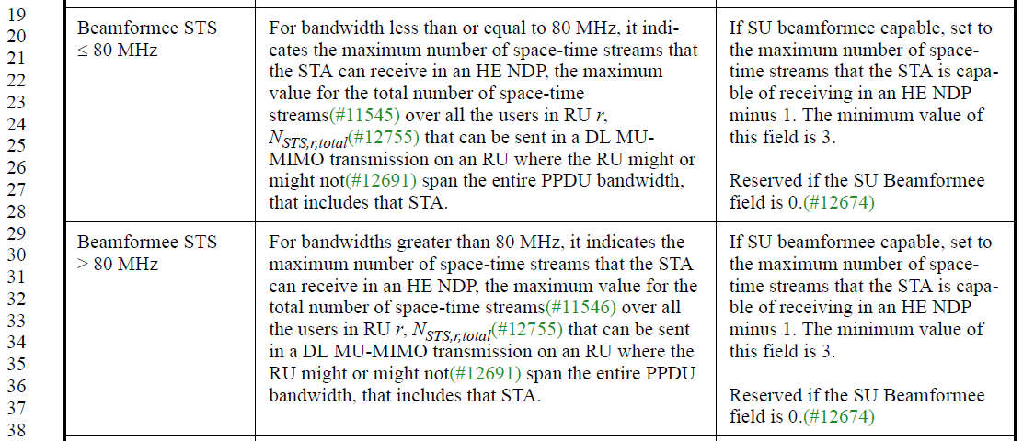

IEEE 802.11-2016 P1097 – VHT Capabilities Information field:
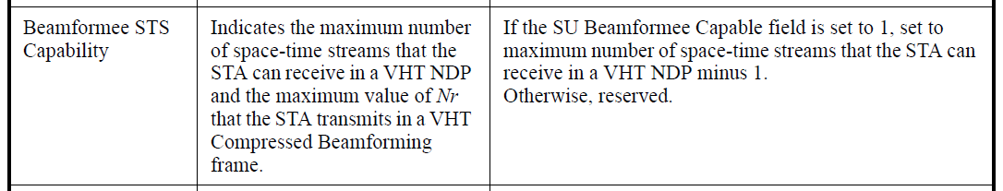

Proposed Resolution: CID 13974
Revised.
Agree with the commenter in principle. Proposed text update in 11-18/0935r0 implements the proposed text update with some minor editorial changes.
Instruction to Editor: Implement the proposed text update for CID 13974 in 11-18/0935r0.

Proposed Text Updates: CID 13974

TGax Editor: Add the following at D2.3 P232L1.

10.34.6 Transmission of a VHT NDP

Insert a new paragraph after the 2nd paragraph as follows:

This paragraph applies when an HE STA is transmitting a VHT NDP where at least one of the intended recipient STAs of the VHT NDP is an HE STA. When the channel width of an VHT NDP is less than or equal to 80 MHz, the number of space-time streams sounded as indicated by the NUM_STS parameter shall not exceed the value indicated in the Beamformee STS ≤ 80 MHz field in the HE Capabilities element of any intended recipient of the VHT NDP which is an HE STA. When the channel width of an VHT NDP is greater than 80 MHz, the number of space-time streams sounded as indicated by the NUM_STS parameter shall not exceed the value indicated in the Beamformee STS > 80 MHz field in the HE Capabilities element of any intended recipient of the VHT NDP which is an HE STA.

[End of File]

