IEEE P802.11
Wireless LANs
CID 1189 updating EDCA default parameters in OCB
Date: May 1, 2018
Author(s):
Name | Affiliation | Address | Phone | email
James Lepp | BlackBerry | 1001 Farrar Road, Ottawa, Canada | +1-613-595-4156 | jlepp@blackberry.com

Abstract
This document contains proposed changes to 11md for CID 1189 to harmonize the EDCA paramater table for dot11OCBactivated with values specified in SAE J2945/1.

Discussion

The following is a summary of EDCA Parameters from various standards.
Wi-Fi Alliance WMM 1.2
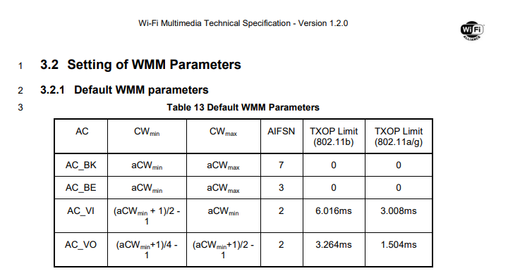

IEEE Std 802.11-2007
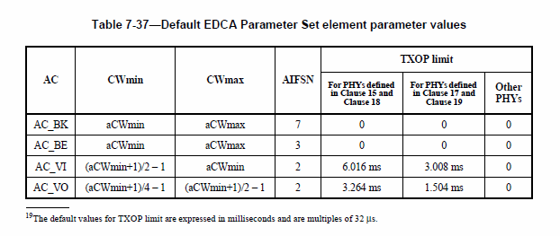
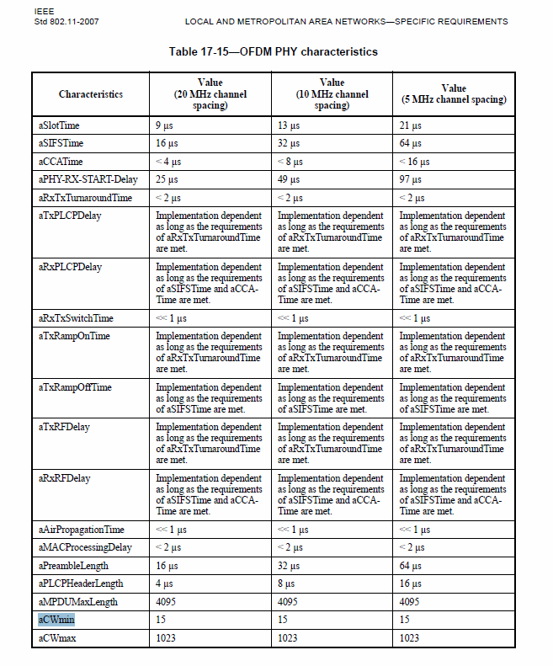

IEEE Std 802.11-2012
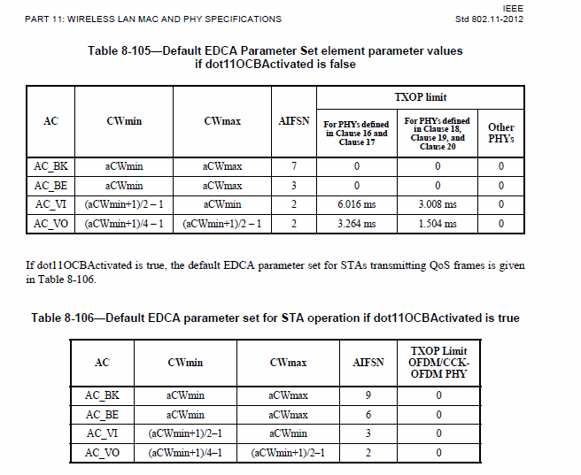

IEEE Std 802.11-2016
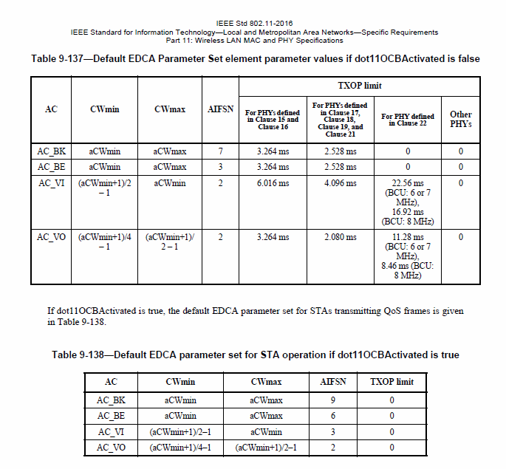

SAE J2945/1 (2016-03)
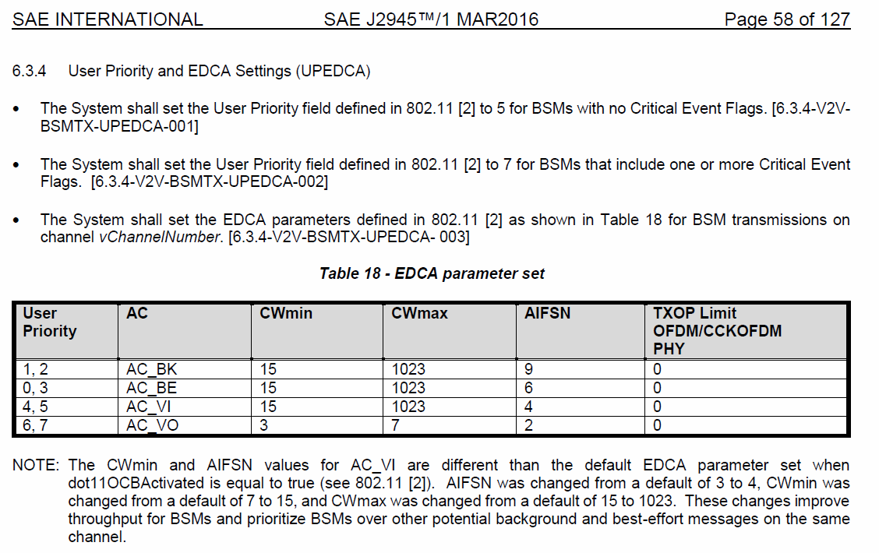
The difference between the SAE table and IEEE or WFA is that they specify actual values and not a reference (based on aCWmin, aCWmax) to a PHY-specific table elsewhere in the document. In the change below, I propose values that fit both the SAE result and the IEEE PHY-specific table.

Proposed Changes
Proposed changes for MD (this is based on CWmin being 15 and CWmax being 1023 which is set elsewhere in the document for the OFDM PHY).

Table 9-138—Default EDCA parameter set for STA operation if dot11OCBActivated is true
AC | CWmin | CWmax | AIFSN | TXOP limit
AC_BK | aCWmin | aCWmax | 9 | 0
AC_BE | aCWmin | aCWmax | 6 | 0
AC_VI | (aCWmin+1)/2-1  aCWmin | aCWmin  aCWmax | 3  4 | 0
AC_VO | (aCWmin+1)/4 -1 | (aCWmin+1)/2 -1 | 2 | 0

