IEEE P802.11
Wireless LANs
TGax PAR Extension Request
Date: 2018-07-11
Author(s):
Name | Affiliation | Address | Phone | email
Osama Aboul-Magd | Huawei Technologies |  |  | Osama.aboulmagd@huawei.com
Abstract
This submission includes the TGax PAR extension Reuest.

R1: Updates the PAR with edits per 802 review and includes the comments received and responses to the received comments.

R2: added response to out of date reference and correct a typo

R3: Remove change to number of meetings to 3.3 and added explanation. Added copy of list of revisions from http://www.ieee802.org/11/private/Draft_Standards/11ax/index.html .

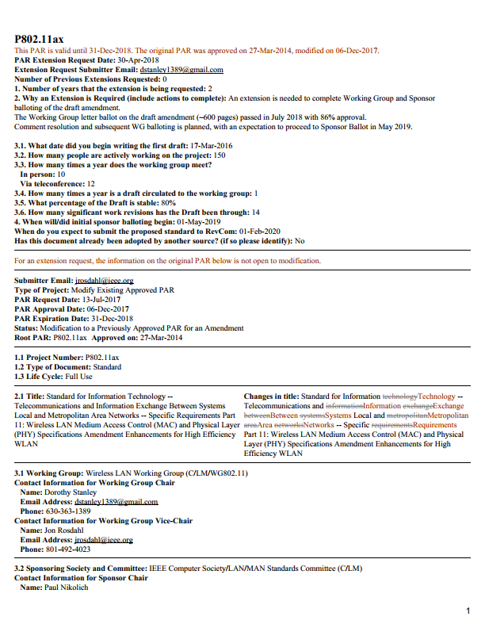
Comments (from 802.3) and responses:

Amendment: High Efficiency WLAN
PAR Extension
- 2. – Perhaps you have an update for the stated May 2018 planned ballot. Recommend you delete the sentence and update only the number of ballots in the preceding sentence.
  - Response: Changes made to section 2 to reflect the recent initial Working Group Letter Ballot approval.
  - New text (redline): “An extension is needed to complete WG and Sponsor ballotting of the draft amendment.
The Working Group letter ballot on the draft amendment (600 pages) passed in July 2018 with 86% approval.
Comment resolution and subsequent WG balloting is planned, with an expectation to proceed to Sponsor Ballot in May 2019. ”
  - New Text (clean): “An extension is needed to complete Working Group and Sponsor balloting of the draft amendment.
The Working Group letter ballot on the draft amendment (~600 pages) passed in July 2018 with 86% approval.
Comment resolution and subsequent WG balloting is planned, with an expectation to proceed to Sponsor Ballot in May 2019.

- 3.x – Your numbers don’t make sense and are not sure if mix 802.1 and TG meetings in responses. We can’t come up with 10 for 3.3, the answer to 3.4 does not seem right and needs more explanation to make sense, and does not evidence that a two year extension will be sufficient. 3.4 drafts per year =1 and 4 years since PAR approval do not produce 3.6=14.
  - Response below.
  - 3.3 The intent of the question is to asses the level of activity in on the project. We do not distinguish between TG/WG for this question, as all WG members are TG members. The TG meets 3 times in Plenary, 3 Interims, and often meet the week prior to either the Plenary or Interim. The group has meet about 10 times in person per year. Similarly for teleconferences, the number indicates the approximate number of teleconferences related to P802.11ax development.
  - 3.4 The draft has been circulated by WG Letter ballot 2016, 2017, and 2018 - once per year.
The draft is expected to be circulated more frequently going forward.

  - 3.6 The number of 14 reflects significant work revisions that the TG has reviewed and worked on in preparing to send to the WG. See a list of the drafts at http://www.ieee802.org/11/private/Draft_Standards/11ax/index.html , copied below:
- 2018-06-01 | Draft P802.11ax_D3.0.pdf | Draft P802.11ax_D3.0 Redline Compared to D2.0.pdf | Draft P802.11ax_D3.0 rtf and visio.zip  11-17-1682-13-00ax-comments-on-tgax-d2-0.xlsx
2018-04-18 | Draft P802.11ax_D2.3.pdf | Draft P802.11ax_D2.3 Redline Compared to D2.2.pdf | Draft P802.11ax_D2.3 rtf and visio.zip  11-17-1682-09-00ax-comments-on-tgax-d2-0.xlsx
2018-02-15 | Draft P802.11ax_D2.2.pdf | Draft P802.11ax_D2.2 Redline Compared to D2.1.pdf | Draft P802.11ax_D2.2 rtf and visio.zip  11-17-1682-07-00ax-comments-on-tgax-d2-0.xlsx
2018-01-06 | Draft P802.11ax_D2.1.pdf | Draft P802.11ax_D2.1 Redline Compared to D2.0.pdf | Draft P802.11ax_D2.1 rtf and visio.zip  11-17-1682-04-00ax-comments-on-tgax-d2-0.xlsx
2017-10-04 | Draft P802.11ax_D2.0.pdf | Draft P802.11ax_D2.0 Redline Compared to D1.0.pdf | Draft P802.11ax_D2.0 rtf and visio.zip  11-17-0010-14-00ax-comments-on-tgax-d1-0.xlsx
2017-08-18 | Draft P802.11ax_D1.4.pdf | Draft P802.11ax_D1.4 Redline Compared to D1.3.pdf | Draft P802.11ax_D1.4 rtf and visio.zip  11-17-0010-13-00ax-comments-on-tgax-d1-0.xlsx
2017-06-05 | Draft P802.11ax_D1.3.pdf | Draft P802.11ax_D1.3 Redline Compared to D1.2.pdf | Draft P802.11ax_D1.3 rtf and visio.zip  11-17-0010-12-00ax-comments-on-tgax-d1-0.xlsx
2017-04-14 | Draft P802.11ax_D1.2.pdf | Draft P802.11ax_D1.2 Redline Compared to D1.1.pdf | Draft P802.11ax_D1.2 rtf.zip  11-17-0010-11-00ax-comments-on-tgax-d1-0.xlsx
2017-02-10 | Draft P802.11ax_D1.1.pdf | Draft P802.11ax_D1.1 Redline Compared to D1.0.pdf | Draft P802.11ax_D1.1 rtf.zip  11-17-0010-07-00ax-comments-on-tgax-d1-0.xlsx
2016-12-01 | Draft P802.11ax_D1.0.pdf | Draft P80211ax_D1.0 Redline Compared to D0.5.pdf | Draft P802.11ax_D1.0 rtf.zip  11-16-0535-10-00ax-comments-on-tgax-d0-1.xlsx
2016-10-01 | Draft P802.11ax_D0.5.pdf | Draft P802.11ax_D0.5 Redline Compared to D0.4.pdf | Draft 802.11ax_D0.5 rtf.zip  11-16-0535-08-00ax-comments-on-tgax-d0-1.xlsx
2016-08-30 | Draft P802.11ax_D0.4.pdf | Draft P802.11ax_D0.4 Redline Compared to D0.3.pdf | Draft P802.11ax_D0.4 rtf.zip
2016-08-15 | Draft P802.11ax_D0.3.pdf | Draft P802.11ax_D0.3 Redline Compared to D0.2.pdf | Draft P802.11ax_D0.3 rtf.zip
2016-06-06 | Draft P802.11ax_D0.2.pdf | Draft P802.11ax_D0.2 Redline Compared to D0.1.pdf | Draft P802.11ax_D0.2 rtf.zip
2016-03-17 | Draft P802.11ax_D0.1.pdf |  | Draft P802.11ax_D0.3 rtf.zip

CSD Modification
  - General – Since you are modifying, you need to bring the text up to date (current text is predicting things in the past).
    - Response:
    - Out of date references were deleted. The surrounding text is left and is still valid.
  - 1.2.4, last paragraph, Distinct Identity – Putting a title on something doesn’t distinguish it when the amendment is merged at the first revision following approval.
  - Response:
  - 1.2.4 – Note that the comment references 1.2.3 Distinct Identity, not 1.2.4.
  - Change made: delete the last sentence

- 1.2.5, Technical feasibility – We find having to chase links user hostile and not an acceptable substitute for an appropriate summary of feasibiity.
  - Response:
  - 1.2.5 – Summary text is there, and the detail is in the referenced links.

References:

