IEEE P802.11  
Wireless LANs

|  |  |  |  |  |
| --- | --- | --- | --- | --- |
| **Spec. change on Receiver minimum input sensitivity on 1024-QAM for 20MHz bandwidth** | | | | |
| Date: 2018-05-01 | | | | |
| Author(s): | | | | |
| Name | Affiliation | Address | Phone | Email |
| Jianhan Liu | Mediatek |  |  | Jianhan.liu@mediatek.com |
| Tung-Sheng Yang |  | Tung-Sheng.Yang@mediatek.com |

Abstract:

Fix the error in the Receiver minimum input sensitivity on 1024-QAM for 20MHz bandwidth.

**Discussions:**

In D2.2, spec. mentioned **BCC is NOT used for MCS 10/11 (see below)**

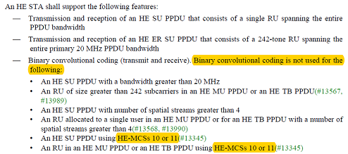

But in minimum required RX sensitivity section, spec. said using BCC for 20M bandwidth (see below).

In table 28-46 20M M10/11 spec. -54/-52 is said for BCC for 20MHz. The contradiction needs to be fixed.

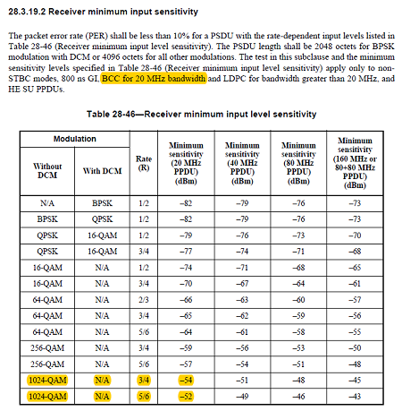

***TGax Editor: Please make the following text change (changed texts are in red) for page 548 line 43-47 in section* 28.3.19.2 *of D2.3***:

The test in this subclause and the minimum sensitivity levels specified in Table 28-47 (Receiver minimum input level sensitivity) apply only to non- STBC modes, 800 ns GI, BCC for 20 MHz bandwidth except for 1024-QAM modulation and LDPC for bandwidth greater than 20 MHz or 20MHz bandwidth with 1024-QAM modulation, and HE SU PPDUs.