IEEE P802.11
Wireless LANs
Comment Resolution for EDMG Channel Access CIDs
Date: 2018-05-07
Author(s):
Name | Affiliation | Address | Phone | email
SungJin Park | LG Electronics | Yangjae-daero 11gil, Seocho-gu, Seoul,  137-893, Korea |  | allean.park@lge.com
JinMin Kim | LG Electronics |  |  | jinmin1230.kim@lge.com
Saehee Bang | LG Electronics |  |  | saehee.bang@lge.com
SunWoong Yun | LG Electronics |  |  | sunwoong.yun@lge.com
Jinsoo Choi | LG Electronics |  |  | js.choi@lge.com
Sanggook Kim | LG Electronics | San Diego  /California/US |  | sanggook.kim@lge.com
Abstract
This document proposes resolutions for EDMG channel access CIDs. The text used as reference is D1.0.

CID | Page | Clause | Comment | Proposed Change
1010 | 113.27 | 10.22.2.12 | Idle channel In Table 20 is incorrect. | Change "Primary" to "None", "First secondary channel" to "Primary channel", "Second secondary channel" to "Primary channel and first secondary channel", and "Third secondary channel" to "Primary channel, first secondary channel and second secondary channel".
1012 | 114.20 | 10.22.2.12 | If the action d) is allowed even if secondary or secondary1 channel is busy, for example, primary and secondary2 are idle whereas secondary and secondary1 is busy, the channel-list parameter should be extended to define exact busy/idle patterns of all subchannels. | Define additional channel-list parameters. For example, define "secondary_secondary1" which indicates that the secondary and the secondary1 are busy, and the primary and the secondary2 are idle. Similarly, "secondary_secondary2", "secondary1_secondary2" and "secondary_secondary1_secondary2" might have to be defined. In that case, the channel-list parameter "secondary" should indicate that only the secondary 2.16GHz channel is busy, i.e. the primary, secondary1 and secondary2 are idle.  Alternatively, bitmap-type channel-list parameter may be used, like per20MHzbitmap in 802.11ax-D2.0.

Proposed resolution: revised
Discussion: The following examples of BSS operating channel show the relationship of the channel-list parameter elements. However, the current channel-list parameter elements defined in D1.0 cannot support all kind of the possible channels for transmission.
The channel-list parameter element for 4.32 GHz, 6.48 GHz and 8.64 GHz channel width when primary and secondary channels are contiguous

When primary and secondary channels are contiguous, the channels indicated idle by the channel-list parameter are as follows. This is similar with 11ac.
PHY-CCA.indication primitive channel-list element | Idle channels
Primary | None
Secondary | Primary channel
secondary1 | Primary channel and first secondary channel
secondary2 | Primary channel, first secondary channel and second secondary channel

The channel-list parameter element for 4.32 GHz, 6.48 GHz and 8.64 GHz channel width when primary and secondary1 channels are contiguous

When primary and secondary1 channels are contiguous, the channels indicated idle by the channel-list parameter which is primary, secondary, secondary1 and secondary2 are same when primary and secondary channels are contiguous. Two channel-list parameters need to be defined to include the cases (Primary+Secondary1 and Primary+Secondary1+Secondary2).
PHY-CCA.indication primitive channel-list element | Idle channels
Primary | None
Secondary | Primary channel
secondary1 | Primary channel and first secondary channel
secondary2 | Primary channel, first secondary channel and second secondary channel
offset_6.48_secondary  (6.48GHz BSS operating channel) | Primary channel and second secondary channel
offset_8.64_secondary  (8.64GHz BSS operating channel) | Primary channel and second secondary channel and third secondary

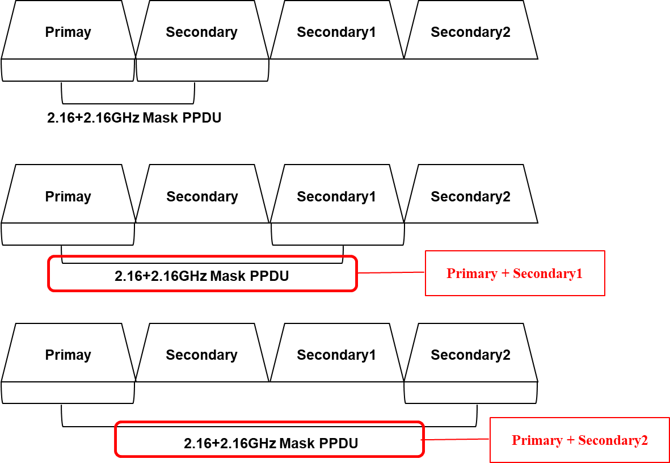
The channel-list parameter element for 2.16+2.16 GHz channel width

In 2.16+2.16GHz and 4.32+4.32GHz, some channel-list parameters need to be defined.
PHY-CCA.indication primitive channel-list element | Idle channels
Primary | None
secondary | Primary channel
secondary1 | Primary channel and first secondary channel
secondary_secondary1 | Primary channel and second secondary channel
secondary_secondary2 | Primary channel and third secondary channel

Modification: modify Table 20 (Channels indicated idle by the channel-list parameter) and Table 8-5 (The channel-list parameter elements).
Change the Table 20 as follows
Table 20—Channels indicated idle by the channel-list parameter
PHY-CCA.indication primitive channel-list  element | Idle channels
Primary | None
secondary | Primary channel
secondary1 | Primary channel and first secondary channel
secondary2 | Primary channel, first secondary channel and second secondary channel
offset_6.48_secondary | Primary channel and second secondary channel
offset_8.64_secondary | Primary channel and second secondary channel and third secondary
secondary_secondary1 | Primary channel and third secondary channel
secondary_secondary2 | Primary channel and second secondary channel

Change Table 8-5 as follows
channel-list parameter | Meaning
primary | In an HT STA that is not a VHT STA, indicates that the primary 20 MHz channel is busy.  In a VHT STA, indicates that the primary 20 MHz channel is busy according to the rules specified in 21.3.18.5.3.  In a TVHT STA, indicates that the primary channel is busy according to the rules specified in 22.3.18.6.3.  In an EDMG STA, indicates that the primary 2.16 GHz channel is busy.
secondary | In an HT STA that is not a VHT STA, indicates that the secondary channel is busy.  In a VHT STA, indicates that the secondary 20 MHz channel is busy according to the rules specified in 21.3.18.5.4.  In a TVHT STA, indicates that the secondary channel is busy according to the rules specified in 22.3.18.6.4.  In an EDMG STA, indicates that the secondary 2.16 GHz channel is busy.
secondary40 | Indicates that the secondary 40 MHz channel is busy according to the rules specified in 21.3.18.5.4.  In a TVHT STA, indicates that the secondary TVHT_2W channel is busy according to the rules specified in 22.3.18.6.4.
secondary80 | Indicates that the secondary 80 MHz channel is busy according to the rules specified in 21.3.18.5.4.
secondary1 | Indicates that the second secondary 2.16 GHz channel is busy.
secondary2 | Indicates that the third secondary 2.16 GHz channel is busy.
offset_6.48_secondary | Indicates that the first secondary 2.16 GHz channel is busy and the second secondary 2.16 GHz channel is idle.
offset_8.64_secondary | Indicates that the first secondary 2.16 GHz channel is busy and the second secondary 2.16 GHz channel is idle and the third secondary 2.16 GHz channel is idle.
secondary_secondary1 | Indicates that the first secondary 2.16 GHz channel and second secondary 2.16 GHz channel are busy.
secondary_secondary2 | Indicates that the first secondary 2.16 GHz channel and third secondary 2.16 GHz channel are busy.

CID | Page | Clause | Comment | Proposed Change
1011 | 114.04 | 10.22.2.12 | "IDLE" and "PHY-CCA.indication (BUSY)" are inappropriate because PHY-CCA.indication (BUSY, secondary/secondary1/secondary2) should be considered for primary idle condition. | "Change ""the STATE parameter of the most recent PHY-CCA.indication primitive was IDLE"" to ""the most recent PHY-CCA.indication primitive was PHY-CCA.indication (IDLE) or PHY-CCA.indication (BUSY, secondary/secondary1/secondary2)"".

Proposed resolution: reject
Discussion: “IDLE” means the primary channel is idle and “no PHY-CCA.indication (BUSY) occurred during the period of PIFS” is about the secondary channel. This paragraph talks about the transmission through idle channels including both primary channel and secondary channel. Therefore, original text is correct. Besides, this paragraph is just duplicated from VHT in REVmd.

CID | Page | Clause | Comment | Proposed Change
1082 | 114.20 | 10.22.2.12 | Why does d) needed? Isn't the 2.16+2.16 GHz mask PPDU already covered by c)? From Figure 3, c) seems to be correct. | Delete case d).
2128 | 114.20 | 10.22.2.1.2 | "Transmit a 2.16+2.16 GHz mask PPDU if the secondary, secondary1 or secondary2 channel was idle during an interval of PIFS immediately preceding the start of the TXOP" How would this apply to secondary channel width? Remove it | As suggested
2332 | 114.16 | 10.22.2.12 | Remove "2.16+2.16 GHz mask PPDU" from an item c because it is redundant with an item d. | As in comment.

Proposed resolution: revised
Discussion: transmission of BW mask PPDU depending on the channel width which is 2.16GHz, 4.32GHz, 6.48GHz, 8.64GHz, 2.16+2.16GHz and 4.32+4.32GHz was already resolved in “11-18-0377-03-00ay-CCA Indication CIDs” as follows:
10.22.2.12 EDCA channel access in an EDMG BSS
Modify after the fifth paragraph as follow:

- Transmit a 8.64 GHz mask PPDU, if primary, secondary, secondary1 and secondary2 channels are contiguous and secondary, secondary1 and secondary2 were idle during an interval of PIFS immediately preceding the start of the TXOP.

- Transmit a 4.32+4.32 GHz mask PPDU if primary and secondary are contiguous, secondary1 and secondary2 channels are contiguous and secondary, secondary1 and secondary2 channels were idle during an interval of PIFS immediately preceding the start of the TXOP

- Transmit a 6.48 GHz mask PPDU if primary, secondary and secondary1 channels are contiguous and secondary and secondary1 were idle during an interval of PIFS immediately preceding the start of the TXOP or if primary, secondary1 and secondary2 channels are contiguous and secondary1 and secondary2 were idle during an interval of PIFS immediately preceding the start of the TXOP

- Transmit a 4.32 GHz mask PPDU if primary and secondary channels are contiguous and secondary channel was idle during an interval of PIFS immediately preceding the start of the TXOP or if primary and secondary1 channels are contiguous and the secondary1 channel was idle during an interval of PIFS immediately preceding the start of the TXOP

- Transmit a 2.16+2.16 GHz mask PPDU if the secondary, secondary1 or secondary2 channel was idle during an interval of PIFS immediately preceding the start of the TXOP

- Transmit a 2.16 GHz mask PPDU on the primary channel

- Restart the channel access attempt by invoking the backoff procedure as specified in 10.22.2 (HCF contention based channel access (EDCA)) as though the medium is busy on the primary channel as indicated by either physical or virtual CS and the backoff timer has a value of 0

CID | Page | Clause | Comment | Proposed Change
1216 | 113.27 |  | "channel-list element" - it's not an element | Change "element" to "parameter"

Proposed resolution: reject
Discussion: the terminologies in Table 20 (Channel indicated idle by the channel-list parameter) are common terminologies in REVmd.

CID | Page | Clause | Comment | Proposed Change
1733 | 113.19 | 10.22.2.12 | This seems contradictory with P27L8, which states that a PHY-CCA(IDLE) with the channel list absent means all channels are free. The text here says if the PHY-CCA has a channel list present, then the channels are considered idle. And, surely this is only true if the PHY-CCA.indication had an IDLE STATE parameter. This sentence is just very confusing. | Fix this sentence, or delete, because 8.3.5.12.2 already said everything that needs to be said.

Proposed resolution: reject
Discussion: the mentioned paragraph is as follows:
If the MAC receives a PHY-CCA.indication primitive with the channel-list parameter present, the channels considered idle are defined in Table 20.
The Table 20 shows which channels are considered idle if the PHY-CCA.indication primitive with the channel-list parameter present. The cannel-list parameter is absent when all channels are idle or CCA is determined by a single channel. Besides, this paragraph is just duplicated from VHT in REVmd.

SP/M: Do you accept the resolutions given in this document?

