IEEE P802.11
Wireless LANs
Comment Resolution on Channel Measurement for TDD Slot
Date: 2018-05-07
Author(s):
Name | Affiliation | Address | Phone | email
SungJin Park | LG Electronics | Yangjae-daero 11gil, Seocho-gu, Seoul,  137-893, Korea |  | allean.park@lge.com
JinMin Kim | LG Electronics |  |  | jinmin1230.kim@lge.com
Saehee Bang | LG Electronics |  |  | saehee.bang@lge.com
SunWoong Yun | LG Electronics |  |  | sunwoong.yun@lge.com
Jinsoo Choi | LG Electronics |  |  | js.choi@lge.com
Sanggook Kim | LG Electronics | San Diego  /California/US |  | sanggook.kim@lge.com
Abstract
This document proposes resolution on the channel measurement for TDD slot. The text used as reference is D1.0.

CID | Page | Clause | Comment | Proposed Change
1637 | 135.02 | 10.36.6.2.2 | Channel measurement protocol is needed for interference management and sheduling optimization in the TDD channel access. | As in comment

Proposed resolution: revised

Discussion: the TDD SP structure is composed of multiple TDD slots. When the DN schedules TDD slots to CNs, it is helpful that the DN knows the result of CN’s channel measurement as a unit of a TDD slot. However, the existing unit of duration of channel measurement is TU(1024usec) and the unit of duration of the TDD slot is 1usec. Therefore, the channel measurement as a unit of 1usec is suitable to the TDD slot structure. By modifying the existing Directional Channel Quality request and Directional Channel Quality report, the proper granularity of channel measurement for TDD slot can be achieved.

Modification: the DMG STA can support channel measurement in unit of 1us (TU/1024) during the TDD SP as following modifications.

9.4.2.20.16 Directional Channel Quality request
The Measurement Request field corresponding to a Directional Channel Quality request is shown in
Figure 9-207 (Measurement Request field format for Directional Channel Quality request). This
Measurement Request is transmitted from a Requesting STA to a Requested STA to perform measurements
toward a Target STA.
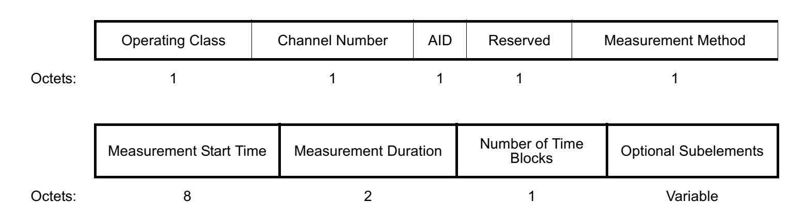
Figure 9-207—Measurement Request field format for Directional Channel Quality request
The Operating Class field indicates the channel set for which the measurement request applies. Operating
Class and Channel Number together specify the channel frequency and spacing for which the measurement
request applies. Valid values of Operating Class are shown in Annex E.
Channel Number field indicates the channel number for which the measurement request applies. Channel
Number is defined within an Operating Class as shown in Annex E.
The AID field indicates the Target STA.
The Measurement Method field indicates the method that is to be used by the Requested STA to carry out
this measurement request and report back in the measurement report. If this field is set to 0, it indicates
ANIPI. If this field is set to 1, it indicates RSNI. If this field is set to 2, it indicates ANIPI during the duration of the requested measurement, in units of 1 µs. If this field is set to 3, it indicates RSNI during the duration of the requested measurement, in units of 1 µs. Other values are reserved.
The Measurement Start Time field is set to the TSF timer at the time at which the requested measurement
starts. A value of 0 indicates that the measurement starts immediately.
The Measurement Duration field is set to the preferred or mandatory duration of the requested measurement,
in units of TUs. See 11.10.4 (Measurement Duration). If the Measurement Method field is set to 2 or 3, The Measurement Duration field is set to the duration of the requested measurement, in units of 1 µs (TU/1024).
The Number of Time Blocks field indicates the number of time blocks within the Measurement Duration.
The ratio (Measurement Duration/Number of Time Blocks) provides the duration of an individual
measurement unit

9.4.2.21.15 Directional Channel Quality report
The format of the Measurement Report field of a Directional Channel Quality report is shown in
Figure 9-269 (Measurement report field format for Directional Channel Quality report).
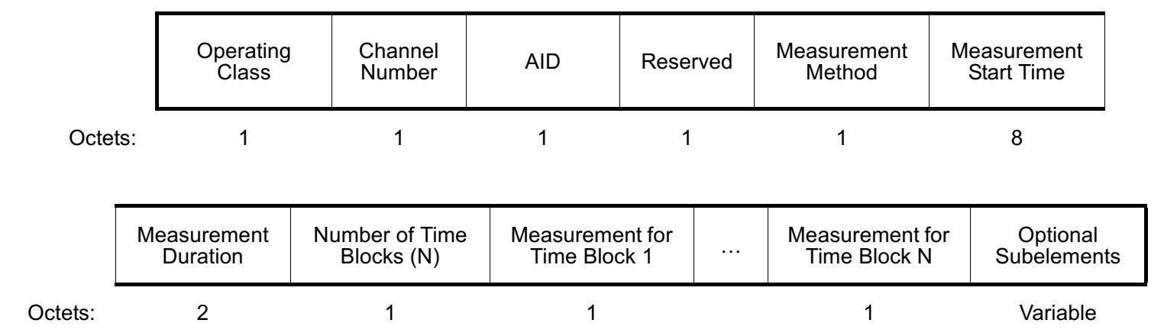
Figure 9-269—Measurement report field format for Directional Channel Quality report
Operating Class field indicates the channel set for which the measurement report applies. Operating Class
and Channel Number together specify the channel frequency and spacing for which the measurement report
applies. Valid values of Operating Class are shown in Annex E.
Channel Number field indicates the channel number for which the measurement report applies. Channel
Number is defined within an Operating Class as shown in Annex E.
The AID field indicates the Target STA.
The Measurement Method field indicates the method used by the STA to carry out this measurement request
and the format of the Measurement for Time Block field(s). If this field is set to 0, it indicates that the
Measurement for Time Block fields are expressed in ANIPI. If this field is set to 1, it indicates that the
Measurement for Time Block fields are expressed in RSNI. If this field is set to 2, it indicates that the Measurement for Time Block fields are expressed in ANIPI during the duration of the requested measurement, in units of 1 µs. If this field is set to 3, it indicates that the Measurement for Time Block fields are expressed in RSNI during the duration of the requested measurement, in units of 1 µs. Other values are reserved.
Measurement Start Time field is set to the value of the measuring STA’s TSF timer at the time the
measurement started.
The Measurement Duration field is set to the duration of the measurement, in units of TUs. If the Measurement Method field is set to 2 or 3, The Measurement Duration field is set to the duration of the requested measurement, in units of 1 µs (TU/1024).
The Number of Time Blocks field indicates the number of time blocks within the measurement duration.
The ratio (Measurement Duration/Number of Time Blocks) provides the duration of an individual
measurement unit.

Straw Poll & Motion:
Do you agree the comment resolution to include the text changes proposed in (11-18-0839-00-00ay- Comment Resolution on Channel Measurement for TDD Slot) to the spec draft?

