IEEE P802.11
Wireless LANs
HE-SIG-B CIDs
Date: 5/1/2018
Author(s):
Name | Affiliation | Address | Email
Sigurd Schelstraete | Quantenna | 1704 Automation Pkwy,  San Jose, CA 95131 | sigurd@quantenna.com
Abstract
This submission proposes resolutions for CIDs 14075, 14078, 14079 and 14083.
CID 166

Introduction
CID | Page/  Line | Section | Comment | Proposed Change | Proposed Resolution
14075 | 423.01 | 28.3.10.8.3 | HE-SIG-B of an 80 MHz PPDU has total 256 tones including DC and guard tones. So, saying that HE-SIG-B occupies tones [-500:-259] and duplicated on [17:258] is incorrect. Similar comment on P423L54. | Either fix the tone indices used by HE-SIG-B content channels. | Revised:  resolved by changes in D2.3. See resolution of CIDs 13368 and 11408.
14078 | 424.05 | 28.3.10.8.3 | What is "signaling"? | Clarify the meaning of "the signaling is carried in both HE-SIG-B content channels placed  in the order of the absolute subcarrier index." | Revised:  Make text modifications as shown in 802.11-18/0815r0
14079 | 424.46 | 28.3.10.8.3 | What does "punctured 20 MHz channels removed" mean? For example, in case of BW field = 4 in HE-SIGA for HE MU PPDU, do the two HE-SIG-B content channels both have two RU Allocation tables? Similar comment on P424L53. | Clarify what "punctured 20 MHz channels removed" means. | Revised:  Make text modifications as shown in 802.11-18/0815r0
14083 | 432.32 | 28.3.10.8.6 | What does "load balancing for RUs" mean? | Clarify what "load balancing" is. | Revised:  resolved by CID 11496.

Discussion and proposed resolutions

CID 14075
14075 | 423.01 | 1 | 28.3.10.8.3 | HE-SIG-B of an 80 MHz PPDU has total 256 tones including DC and guard tones. So, saying that HE-SIG-B occupies tones [-500:-259] and duplicated on [17:258] is incorrect. Similar comment on P423L54. | Either fix the tone indices used by HE-SIG-B content channels.
Discussion
The commenter is correct. The text seems to confuse the tones occupied by HE-SIG-B (which uses “legacy” tone width) with the tones that correspond to 242-tone RUs. The same mistake appears in several places in this section and in Figures 28-26, 28-27, 28-28 and 28-29.
However, the text has been updated between draft 2.0 and draft 2.3 to remove references to the tones [-500:-259], [17:258], etc …
The same section now reads:
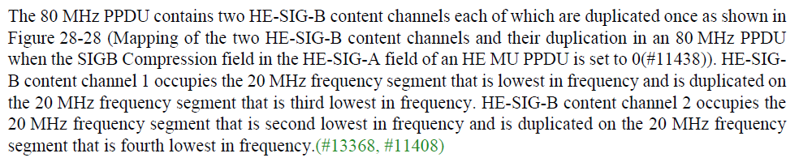
References to tones have also been removed from Figures 28-26, 28-27, 28-28 and 28-29.
Resolution
Revised: resolved by changes in D2.3. See resolution of CIDs 13368 and 11408.

CID 14078
14078 | 424.05 | 5 | 28.3.10.8.3 | What is "signaling"? | Clarify the meaning of "the signaling is carried in both HE-SIG-B content channels placed  in the order of the absolute subcarrier index."

Discussion
The sentence referred to in CID 14078 is shown below in context.
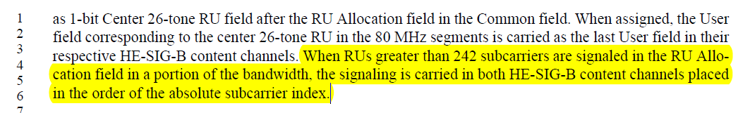
The text deals with the case of an RU that overlaps with two (or more) of the 20 MHz segments. In that case, there should be an RU allocation subfield entry in each of the content channels. Note that the text above specifically deals with 160 MHz. For 80 MHz, the corresponding text has already been cleaned up and modified. It reads:
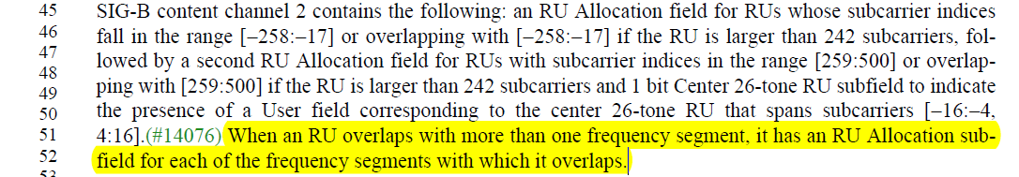
So, some effort has already been made to improve the wording for the case of an 80 MHz PPDU, but even there, the reference to frequency segment may not be appropriate. We propose to modify the language of the 80 MHz case and then use similar, consistent language for 160 MHz.
The proposed text update is shown below.
Proposed text modifications (page 468, line 22 to page 469, line 3 of D2.3)
The 80 MHz PPDU contains two HE-SIG-B content channels each of which are duplicated once as shown in Figure 28-28 (Mapping of the two HE-SIG-B content channels and their duplication in an 80 MHz PPDU when the SIGB Compression field in the HE-SIG-A field of an HE MU PPDU is set to 0(#11438)). HE-SIG-B content channel 1 occupies the 20 MHz frequency segment that is lowest in frequency and is duplicated on the 20 MHz frequency segment that is third lowest in frequency. HE-SIG-B content channel 2 occupies the 20 MHz frequency segment that is second lowest in frequency and is duplicated on the 20 MHz frequency segment that is fourth lowest in frequency. (#13368, #11408)
The first HE-SIG-B content channel appearing in the 20 MHz segments of the 80 MHz PPDU carries a Common field and User Specific field corresponding to RUs signaled in the Common field.with subcarriers indices that overlap those frequency segments. The Common field of HE-SIG-B content channel 1 contains the following: an RU Allocation subfield for RUs with subcarrier indices in the range [-500:-259] or overlapping with [-500:-259] if the RU is larger than 242 subcarriers, followed by a second RU Allocation subfield for RUs with subcarrier indices in the range [17:258] or overlapping with [17:258] if the RU is larger than 242 subcarriers and, followed by a 1 bit Center 26-tone RU subfield to indicate the presence of the User field corresponding to the center 26-tone RU that spans subcarriers [-16:-4, 4:16].(#13465, #14076)
The second HE-SIG-B content channel of the 80 MHz PPDU carries a Common field and User Specific field corresponding to RUs signaled in the Common field with subcarrier indices that fall in those segments. The Common field of HE-SIG-B content channel 2 contains the following: an RU Allocation field for RUs whose subcarrier indices fall in the range [-258:-17] or overlapping with [-258:-17] if the RU is larger than 242 subcarriers, followed by a second RU Allocation field for RUs with subcarrier indices in the range [259:500] or overlapping with [259:500] if the RU is larger than 242 subcarriers and, followed by a 1 bit Center 26-tone RU subfield to indicate the presence of a User field corresponding to the center 26-tone RU that spans subcarriers [-16:-4, 4:16].(#14076) When an RU overlaps with more than one frequency segment, it has an RU Allocation sub-field for each of the frequency segments with which it overlaps.
If a single RU overlaps with more than one of the tone ranges [-500:-259], [-258:-17], [17:258] or [259:500], it shall have an RU allocation subfield in the respective content channels for each of the ranges with which it overlaps.
Each signaling for the presence of the User field corresponding to a center 26-tone RU of the 80 MHz PPDU carries the same value in both HE-SIG-B content channels. When assigned, the User field corresponding to the center 26-tone RU that spans subcarriers [-16:-4, 4:16] is carried as the last User field in the HE-SIG-B content channel 1.(#14077, #11409, #13369)
(…)
The 160 MHz PPDU contains two HE-SIG-B content channels each of which are duplicated four times as shown in Figure 28-29 (Mapping of the two HE-SIG-B content channels and their duplication in a 160 MHz PPDU when the SIGB Compression field in the HE-SIG-A field of an HE MU PPDU is set to 0(#11439)). HE-SIG-B content channel 1 occupies the 20 MHz frequency segment that is lowest in frequency and is duplicated on the 20 MHz frequency segments that are third, fifth and seventh lowest in frequency. HE-SIG-B content channel 2 occupies the 20 MHz frequency segment that is second lowest in frequency and is duplicated on the 20 MHz frequency segments that are fourth, sixth and eighth lowest in frequency.(#13368, #11410)
The first HE-SIG-B content channel of a 160 MHz PPDU carries a Common field and User Specific field corresponding to RUs signaled in the Common field. The Common field of HE-SIG-B content channel 1 contains the following: an RU Allocation subfield for RUs with subcarrier indices in the range [-1012:-771] or overlapping with [-1012:-771] if the RU is larger than 242 subcarriers, followed by a second RU Allocation subfield for RUs with subcarrier indices in the range [-495:-254] or overlapping with [-495:-254] if the RU is larger than 242 subcarriers, followed by a third RU Allocation subfield for RUs with subcarrier indices in the range [12:253] or overlapping with [12:253] if the RU is larger than 242 subcarriers, followed by a fourth RU Allocation subfield for RUs with subcarrier indices in the range [529:770] or overlapping with [529:770] if the RU is larger than 242 subcarriers, followed by 1 bit Center 26-tone RU subfield to indicate the presence of the User field corresponding to the center 26-tone RU that spans subcarriers [-528:-516, -508:-496].
The second HE-SIG-B content channel 1 of a 160 MHz PPDU carries a Common field and User Specific field corresponding to RUs signaled in the Common field. The Common field of HE-SIG-B content channel 2 contains the following: an RU Allocation subfield for RUs with subcarrier indices in the range [-770:-529] or overlapping with [-770:-529] if the RU is larger than 242 subcarriers, followed by a second RU Allocation subfield for RUs with subcarrier indices in the range [-253:-12] or overlapping with [-253:-12] if the RU is larger than 242 subcarriers, followed by a third RU Allocation subfield for RUs with subcarrier indices in the range [254:495] or overlapping with [254:495] if the RU is larger than 242 subcarriers, followed by a fourth RU Allocation subfield for RUs with subcarrier indices in the range [771:1012] or overlapping with [771:1012] if the RU is larger than 242 subcarriers, followed by 1 bit Center 26-tone RU subfield to indicate the presence of the User field corresponding to the center 26-tone RU that spans subcarriers [496:508, 516:528].
If a single RU overlaps with more than one of the tone ranges [-1012:-771], [-770:-529], [-495:-254], [-253:-12], [12:253], [254:495], [529:770] or [771:1012], it shall have an RU allocation subfield in the respective content channels for each of the ranges with which it overlaps.
RU allocation signaling for RUs that overlap the 20 MHz frequency segments in which the HE-SIG-B content channel 1 is carried. The HE-SIG-B con-tent channel 2 carries RU allocation signaling for RUs that overlap the 20 MHz frequency segments in which the HE-SIG-B content channel 2 is carried.(#13469) The signaling for the presence of the User field corresponding to a center 26-tone RU in the 80 MHz segment with the lower subcarrier index is carried in HE-SIG-B content channel 1 as a 1-bit Center 26-tone RU field after the RU Allocation field in the Common field. Similarly, signaling for the center 26-tone RU in the 80 MHz segment with the higher subcarrier index is carried in HE-SIG-B content channel 2 as 1-bit Center 26-tone RU field after the RU Allocation field in the Common field. When assigned, the User field corresponding to the center 26-tone RU in the 80 MHz segments is carried as the last User field in their respective HE-SIG-B content channels. When RUs greater than 242 subcarriers are signaled in the RU Allocation field in a portion of the bandwidth, the signaling is carried in both HE-SIG-B content channels placed in the order of the absolute subcarrier index.
Resolution
Revised: Make text modifications as shown in 802.11-18/0815r0

CID 14079
14079 | 424.46 | 46 | 28.3.10.8.3 | What does "punctured 20 MHz channels removed" mean? For example, in case of BW field = 4 in HE-SIGA for HE MU PPDU, do the two HE-SIG-B content channels both have two RU Allocation tables? Similar comment on P424L53. | Clarify what "punctured 20 MHz channels removed" means.

Discussion
The sentence referred to in CID 14079 is shown below in context.
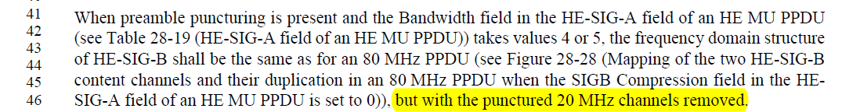
It looks like the intended interpretation is that the HE-SIG-B content is prepared exactly as if no puncturing was done. The only difference is that in the frequency domain, the segments corresponding to the punctured part of the preamble will not be transmitted. We can make this clear by distinguishing between the bit content and the frequency domain content of HE-SIG-B. A text proposal is given below.
Proposed text modification (page 470, lines 44 to 57 of D2.3)
When preamble puncturing is present and the Bandwidth field in the HE-SIG-A field of an HE MU PPDU (see Table 28-19 (HE-SIG-A field of an HE MU PPDU)) takes values 4 or 5, the content of Content Channel 1 and 2 the frequency domain structure of HE-SIG-B shall be constructed in the same way the same as described above for an 80 MHz PPDU without preamble puncturing (see Figure 28-28 (Mapping of the two HE-SIG-B content channels and their duplication in an 80 MHz PPDU when the SIGB Compression field in the HE-SIG-A field of an HE MU PPDU is set to 0(#11438))), but with the punctured 20 MHz channels removed. The mapping of the HE-SIG-B content channels to frequency segments shall be the same as for an 80 MHz PPDU (see Figure 28-28 (Mapping of the two HE-SIG-B content channels and their duplication in an 80 MHz PPDU when the SIGB Compression field in the HE-SIG-A field of an HE MU PPDU is set to 0(#11438))), with the exception that punctured 20 MHz channels shall be excluded.
When preamble puncturing is present and the Bandwidth field in the HE-SIG-A field of an HE MU PPDU (see Table 28-19 (HE-SIG-A field of an HE MU PPDU)) takes values 6 or 7, the content of Content Channel 1 and 2 the frequency domain structure of HE-SIG-B shall constructed in the same way the same as described above for an 160 MHz PPDU without preamble puncturing (see Figure 28-29 (Mapping of the two HE-SIG-B content channels and their duplication in a 160 MHz PPDU when the SIGB Compression field in the HE-SIG-A field of an HE MU PPDU is set to 0(#11439))), but with the punctured 20 MHz channels removed. The mapping of the HE-SIG-B content channels to frequency segments shall be the same as for an 80 MHz PPDU (see Figure 28-29 (Mapping of the two HE-SIG-B content channels and their duplication in a 160 MHz PPDU when the SIGB Compression field in the HE-SIG-A field of an HE MU PPDU is set to 0(#11439))), with the exception that punctured 20 MHz channels shall be excluded.

CID 14083
14083 | 432.32 | 32 | 28.3.10.8.6 | What does "load balancing for RUs" mean? | Clarify what "load balancing" is.
Discussion
The sentence referred to in CID 14083 is shown below in context.
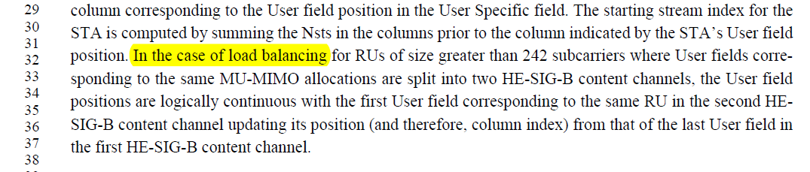
CID 11496 makes a related comment about the use of the term “load balancing”. As a result, the term is no longer in use (at least not in the context of HE-SIG-B) and the new text in D2.3 spells out the case more explicitly:
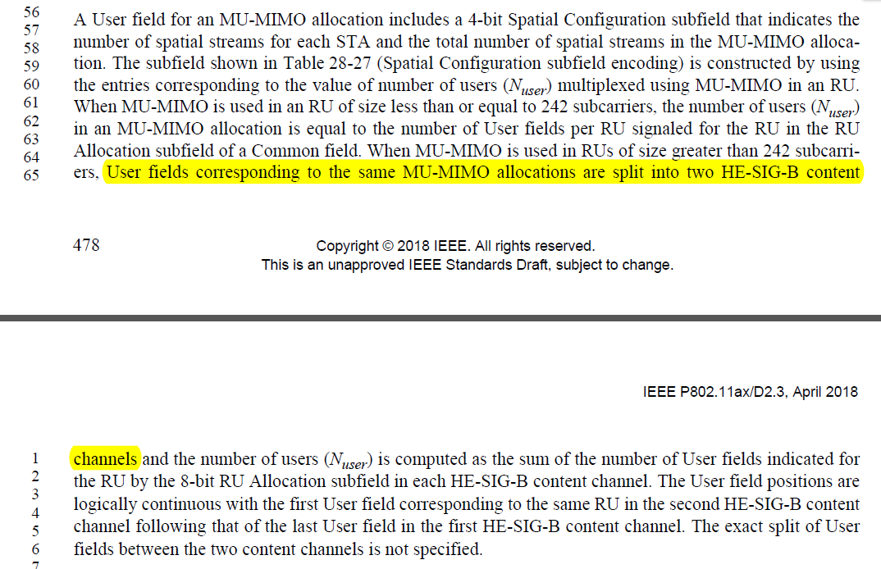
As such, the CID is obsolete following changes that were made in D2.3.
Resolution:
Revised – resolved by CID 11496.

