IEEE P802.11
Wireless LANs
D2.0 DFS Comment Resolution
Date: 2018-05-03
Author(s):
Name | Affiliation | Address | Phone | email
Youhan Kim | Qualcomm | 1700 Technology Dr.  San Jose, CA 95110 |  | youhank@qti.qualcomm.com

Abstract
This submission proposes resolutions for the following comments from the letter ballot on P802.11ax D2.0:

13869, 12999, 11311, 13914, 13912, 13913, 11098, 13829, 13915, 13917, 13951

NOTE – Set the Track Changes Viewing Option in the MS Word to “All Markup” to clearly see the proposed text edits.

Revision History:

R0: Initial version.
R1: Updated during teleconference on 5/3/2018

CID | Clause | Page | Comment | Proposed Change
13869 | 9.4.2.27 | 120.40 | "If operating in an operating class for which the behavior limits set listed in Annex E does not include the DFS_50_100_Behavior then a STA sets the OBSS Narrow Bandwidth RU in UL OFDMA Tolerance Support field to 0."  Even though an AP is not operating in a DFS band, if the AP has a dot11OBSSNarrowBWRUinULOFDMATolerated equal to true, it is better that the AP sets the OBSS Narrow Bandwidth RU in UL OFDMA Tolerance Support field to 1.  Because a DFS band is regionally different. Considering an AP's movement to different DFS regions, the default value should be set based on only the support of the feature if there is no negative impact. | Remove the followings:  "If operating in an operating class for which the behavior limits set listed in Annex E includes the DFS_50_100_Behavior then the following apply:"  "If operating in an operating class for which the behavior limits set listed in Annex E does not include the DFS_50_100_Behavior then a STA sets the OBSS Narrow Bandwidth RU in UL OFDMA Tolerance Support field to 0."
12999 | 9.4.2.27 | 120.39 | When operating in a channel without DFS, why should the bit "OBSS Narrow Bandwidth RU  in UL OFDMA Tolerance Support" be set to 0 and not to 1? Narrow bandwidth RU from an OBSS STA would not cause a false DFS alarm in such case. I understand that in such case, the AP would not consider this bit before sending a TF anyway, but it is strange to say that it is not supported while it is going to be. Please check that this is the intended behavior. | As in comment

Context
D2.3 P131:
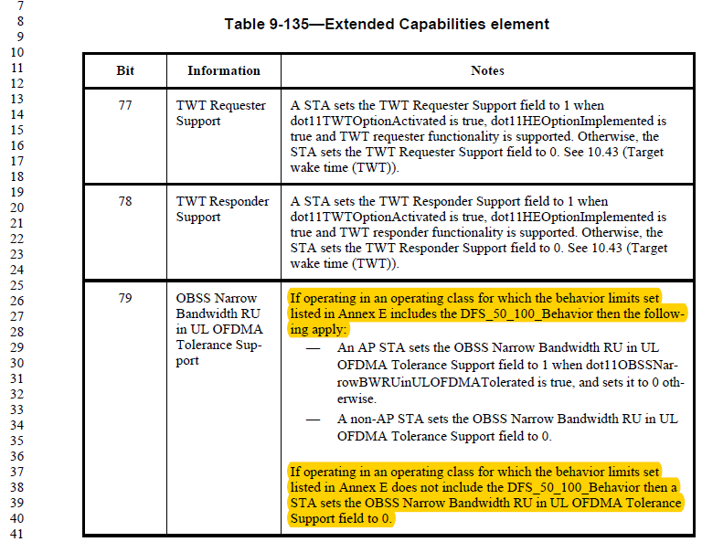

Agree with the commenters that it is more straight forward for APs to indicate their capability regardless of whether they are operating in a DFS channel or not. Other APs will not make use of the OBSS Narrow Bandwidth RU in UL OFDMA Tolernace Support bit when not in DFS channels.

Resolution proposed by CID 13869 removes the yellow highlighted part of the text in the above.

Proposed Resolution: CID 13869
Accepted.

Proposed Resolution: CID 12999
Revised.
Agree in principle with the commenter. Note that the proposed resolution for CID 13869 addresses the same issue.
Note to Editor: There is no additional text change needed for this CID (text change to be done per CID 13869).

CID | Clause | Page | Comment | Proposed Change
11311 | 27.5.3.2.1 | 245.56 | Some commas are missing in this sentence. Spellcheck. | As in comment.
13914 | 27.5.3.2.1 | 245.56 | "An AP operating in an operating class for which the behavior limits set listed in Annex E includes the DFS_50_100_Behavior shall not transmit a Trigger frame"  How long can't the AP transmit a Trigger frame for a 26-tone RU?  For example, if an OBSS AP with dot11OBSSNarrowBWRUinULOFDMATolerated equal to false is detected no more, still can't AP transmit a Trigger frame for a 26-tone RU?  Also, if the AP switches its operating channel to a new channel on which it can't detect an OBSS AP with dot11OBSSNarrowBWRUinULOFDMATolerated equal to false, can't AP transmit a Trigger frame for a 26-tone RU?  Also, if the AP detected an OBSS AP with dot11OBSSNarrowBWRUinULOFDMATolerated equal to false on a primary 80MHz channel, can't AP trigger a 26-tone RU on a secondary 80MHz channel? | Specify the exception condition to allow an AP triggers a 26-tone RU.

Proposed Resolution: CID 11311
Revised.
Proposed text update in 11-18/0807r1 makes the sentence easier to read.
Instruction to Editor: Implement the proposed text update for CIDs 11311 and 13914 in 11-18/0807r1.

Proposed Resolution: CID 13914
Revised.
CID 13970 in 11-18/0546r0 has already defined the time duration (dot11ObssNbRuToleranceTime) over which the AP cannot trigger 26-tone RUs.
Proposed text update in 11-18/0807r1 addresses the remaining comments in this CID.
Instruction to Editor: Implement the proposed text update for CIDs 11311 and 13914 in 11-18/0807r1.

Proposed Text Updates: CIDs 11418, 12580, 12796, 13764

TGax Editor: Update D2.3 P275L40 as shown below.

An AP shall not transmit a Trigger frame or a frame containing a TRS Control subfield that satisfies all of the following conditions:
- The AP is operating in an operating class for which the behavior limits set listed in Annex E includes the DFS_50_100_Behavior (see Table E-1)
- The AP has received at least one Beacon frame from OBSS B within the past dot11ObssNbRuToleranceTime in the current operating channel in which any of the following are true:
- The Extended Capabilities element is not present.
- The OBSS Narrow Bandwidth RU in UL OFDMA Tolerance Support bit in the Extended Capabilities element is not present.
- The OBSS Narrow Bandwidth RU in UL OFDMA Tolerance Support bit in the Extended Capabilities element is 0.
- The Trigger frame or the frame containing a TRS Control subfield allocates at least one 26-tone RU whose location in frequency overlaps with the operating bandwidth of the OBSS B.

CID | Clause | Page | Comment | Proposed Change
13912 | 27.5.3.2.1 | 245.59 | "...subfield indicates a 26-tone RU if the AP has received at least one Beacon frame or Probe Response frame in"  In a DFS band, an active scanning is not allowed. If an AP received a Probe Response frame, it means that the AP operates in a non-DFS band. | Remove "a Probe Response frame".

Proposed Resolution: CID 13912
Revised.
Agree with the commenter. D2.3 has already removed the “a Probe Response frame” as per resolution to CID 13970 in 11-18/0546r0.
Note to Editor: There is no text update needed for this CID.

CID | Clause | Page | Comment | Proposed Change
13913 | 27.5.3.2.1 | 245.59 | "...subfield indicates a 26-tone RU if the AP has received at least one Beacon frame or Probe Response frame in"  What is a behavior of an AP with a dot11OBSSNarrowBWRUinULOFDMATolerated equal to false? Can it trigger a 26-tone RU in a DFS band? | Change as the following:  "...subfield indicates a 26-tone RU if the AP has transmitted or received at least one Beacon frame or Probe Response frame in"

Proposed Resolution: CID 13913
Rejected.
If there are no OBSS which cannot tolerate 26-tone RU in DFS channels, then there is no reason to prohibit an AP to trigger 26-tone RU in UL OFDMA.

CID | Clause | Page | Comment | Proposed Change
11098 | 27.5.3.2.1 | 246.06 | "then the AP is recommended not to allocate 26-tone RU" -- this is a 'should' | Either delete note, or replace 'is recommended not to' with 'should not' and remove 'NOTE--' and promote to body text.

Context
D2.3 P275
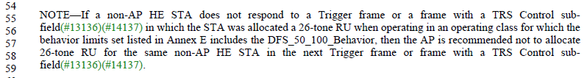

Proposed Resolution: CID 11098
Revised.
Proposed text update in 11-18/0807r1 changes the NOTE into a ‘should’ language.
Instruction to Editor: Implement the proposed text update for CID 11098 in 11-18/0807r1.

Proposed Text Updates: CID 11098

TGax Editor: Update D2.3 P275L54 as shown below.

If a non-AP HE STA does not respond to a Trigger frame or a frame with a TRS Control subfield in which the STA was allocated a 26-tone RU when operating in an operating class for which the behavior limits set listed in Annex E includes the DFS_50_100_Behavior, then the AP should not to allocate 26-tone RU for the same non-AP HE STA in the next Trigger frame or frame with a TRS Control subfield.

CID | Clause | Page | Comment | Proposed Change
13829 | 27.5.3.3 | 248.33 | "A non-AP HE STA operating in an operating class for which the behavior limits set listed in Annex E includes the DFS_50_100_Behavior shall not transmit an HE TB PPDU in response a Trigger frame or a frame with a UMRS Control field that is intended to the STA or is designated for UL OFDMA-based random access if the RU Allocation subfield allocated to the STA or designated for UL OFDMA-based random access indicates 26-tone RU and the non-AP HE STA has received at least one Beacon frame or Probe Response frame in which any of the following are true:"  This text is very confusing.  Conditions that a STA shall not send the HE TB PPDU should be clarified. | As in the comment.

Proposed Resolution: CID 13829
Revised.
D2.3 (P279L34) has already re-written the referenced text for better clarity as per resolution to CID 11318 in 11-18/0367r1.
Note to Editor: There is no text update needed for this CID.

CID | Clause | Page | Comment | Proposed Change
13915 | 27.5.3.3 | 248.38 | "...access indicates 26-tone RU and the non-AP HE STA has received at least one Beacon frame or Probe Response frame in which any of the following are true:..."  In a DFS band, an active scanning is not allowed. If an AP received a Probe Response frame, it means that the AP operates in a non-DFS band. | Remove "a Probe Response frame".

Proposed Resolution: CID 13915
Revised.
D2.3 (P279L34) as already removed “a Probe Response frame” as per resolution to CID 11318 in 11-18/0367r1.
Note to Editor: There is no text update needed for this CID.

CID | Clause | Page | Comment | Proposed Change
13917 | 27.5.3.3 | 248.38 | "...if the RU Allocation subfield allocated to the STA or designated for UL OFDMA-based random access indicates 26-tone RU and..."  Is the HE TB NDP feedback PPDU excluded? Because it doesn't have the RU Allocation subfield.  If it is yes, for a clarification, change "shall not transmit an HE TB PPDU" to "shall not transmit an HE TB PPDU with a PSDU". | As in comment.

Discussion
D2.3 P279:
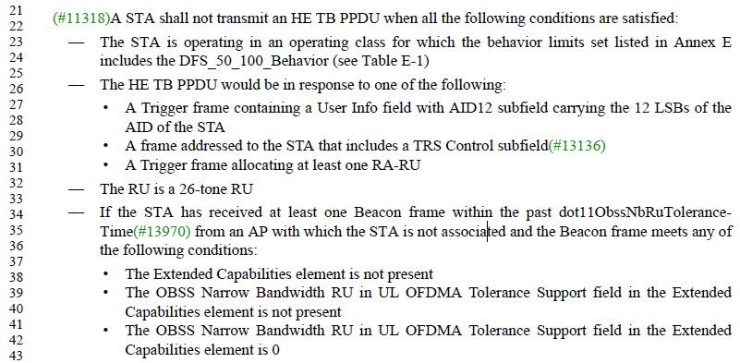

HE TB NDP feedback PPDU has a different tone plan in which tones are spread apart in frequency, thus causing less confusion to radar detectors. Hence, HE TB NDP feedback PPDUs do not need to be subject to the conditions cited above.

Proposed Resolution: CID 13917
Revised.
Proposed text update in 11-18/0807r1 clarifies that HE TB NDP feedback PPDU can be used regardless of the OBSS Narrow Bandwidth RU in UL OFDMA Tolerance Support field indication..
Instruction to Editor: Implement the proposed text update for CID 13917 in 11-18/0807r1.

Proposed Text Updates: CID 13917

TGax Editor: Update D2.3 P279L21 as shown below.
A STA shall not transmit an HE TB PPDU, except for an HE TB NDP feedback PPDU, when all the following conditions are satisfied:

CID | Clause | Page | Comment | Proposed Change
13951 | 28.3.3.2 | 357.60 | "except when a STA is operating in an operating class for which the behavior limits set listed in Annex E includes the DFS_50_100_Behavior (see 27.5.3.2.1 (General) and 27.5.3.3 (STA behavior for UL MU operation))."  80MHz and 160MHz operating classes in Annex E don't have DFS_50_100_Behavior limit. | Update Annex E.

Discussion
D2.3 P400:
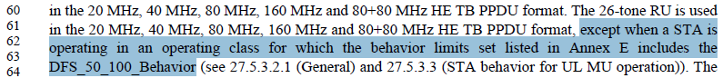

Proposed Resolution: CID 13917
Rejected.
Operating class is indicated in the Country element. To support 20 and 40 MHz devices in the BSS, the Country element needs to first include Operating class for 20/40 MHz. And if the 20/40 MHz operating class requires DFS, then the 80/160/80+80 MHz channels encompassing the 20/40 MHz will require DFS as well. Hence, Annex E does not include the DFS_50_100_Behavior for operating classes for 80/160/80+80 MHz. See 9.4.2.9, 10.21.3 and NOTE 2 on P3287 of IEEE 802.11-2016 for further details.

[End of File]

