### IEEE P802.11 Wireless LANs

|  |  |  |  |  |
| --- | --- | --- | --- | --- |
| Draft Spect Text for FDMA WUR Generation | | | | |
| Date: 2018-05-08 | | | | |
| Author(s): | | | | |
| Name | Affiliation | Address | Phone | Email |
| Junghoon Suh | Huawei |  |  | junghoon.suh@huawei.com |
| Jia Jia | Huawei |  |  | justin.jia@huawei.com |
|  |  |  |  |  |
|  |  |  |  |  |
|  |  |  |  |  |
|  |  |  |  |  |
|  |  |  |  |  |

Abstract

This document proposes a draft spec text on FDMA WUR waveform generation to be incorporated in P802.11ba D0.3 regarding the following motion in SFD.

R.3.5.A: [Assigned D0.3] the concept of FDMA transmission scheme is shown below.

– Each 20MHz only contains one 4MHz sub-channel for wake-up signal transmission.

– Similar to 11ax’s 20MHz only operation, one wake-up receiver can stay in one of the sub-channel in wide bandwidth. [Motion, March 2018]

Revision History:

* Rev 0: Initial version of the document
* Rev 1: Documentation format change
* Rev 2: Update of the figure and text



***Editing instructions formatted like this are intended to be copied into the TGba Draft (i.e. they are instructions to the 802.11 editor on how to merge the text with the baseline documents).***

***TGba Editor: Editing instructions preceded by “TGba Editor” are instructions to the TGba editor to modify or insert material in the TGba draft. As a result of adopting the changes, the TGba editor will execute the instructions rather than copy them to the TGba Draft.***

**TGba Editor: *Instruction*: *Create the following subsections under 32.3.3 and add the spec text and a figure under the section 32.3.3.3***

* Transmitter block diagram

32.3.3.1 WUR-PPDU waveform generation for Sync field and high rate Data field

32.3.3.2 WUR-PPDU waveform generation for low rate Data field

32.3.3.3 WUR-PPDU waveform generation for FDMA transmission

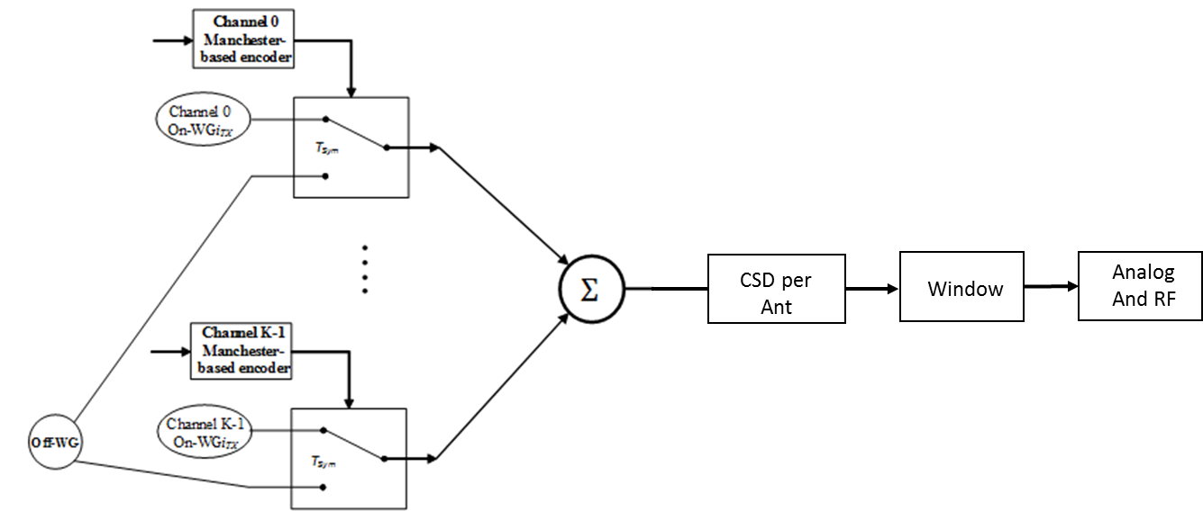

Figure 32-CA WUR signal generator for FDMA transmission of the data field, where K can be 2 or 4 according to 40 MHz or 80 MHz FDMA transmission

Multicarrier based OOK (MC-OOK) ‘On’ symbol for 20 MHz WUR waveform can be generated according to 32.3.3.1 or 32.3.3.2 depending on WUR_DATARATE. The 40 MHz or 80 MHz FDMA WUR PPDU can be generated by shifting a 20 MHz WUR waveform to the corresponding channel.

**TGba Editor: *Instruction*: *Replace TBD by the right Section number in the following sections.***

**32.3.4.2 Construction of the L-STF**

Construction of the L-STF uses the schemes described in either section ~~TBD~~ 17.3.3, 19.3.9.3.3, or 21.3.4.2

**32.3.4.3 Construction of the L-LTF**

Construction of the L-LTF uses the schemes described in either section ~~TBD~~ 17.3.3, 19.3.9.3.4, or 21.3.4.3

**32.3.4.4 Construction of the L-SIG**

Construction of the L-SIG uses the schemes described in either section ~~TBD~~ 17.3.4, 19.3.9.3.5, 21.3.4.4, or 28.3.10.5.

**TGba Editor: *Instruction*: *Add the following spec texts in Section 32.3.4.7 and 32.3.4.8***

**32.3.4.7 Construction of the WUR-Data**

Construct the WUR-Data waveform as follows.

1. Manchester based enoder: Pulse combination is determined according to the input bits as described in 32.3.9.
2. The output of Manchester based encoder determines which samples to take either from On-WG*iTX* or from Off-WG, depending on the WUR_DATARATE. The samples in Off-WG have zero energy. Each symbol duration, *TSym* is 2 usec for high data rate (*TSYM-HDR*) and 4 usec for low data rate (*TSYM-LDR*).
3. Apply the CSD per each Antenna.
4. Apply the windowing as described in *TBD*.
5. Analog and RF: Upconvert the resulting complex baseband waveform associated with each transmit chain to an RF signal based on the center frequency of the desired channel.

**32.3.4.8 Construction of the WUR-Data for the FDMA transmission**

Construct the WUR-Data waveform for the multiband transmission as follows.

1. Manchester based enoder for each 20 MHz Channel: Pulse combination is determined according to the input bits as described in 32.3.9.
2. The output of Manchester based encoder determines which samples to take either from On-WG*iTX* of each 20 MHz Channel or from Off-WG, depending on the WUR_BANDWIDTH and the WUR_DATARATE. The samples in Off-WG have zero energy. Each symbol duration, *TSym* is 2 usec for high data rate (*TSYM-HDR*) and 4 usec for low data rate (*TSYM-LDR*).
3. The outputs of the waveform generator for each 20 MHz Channel are added with the outputs of the other 20 MHz Channels, sample by sample.
4. Apply the Spatial Mapping.
5. Apply the CSD per each Antenna.
6. Apply windowing as described in *TBD*.
7. Analog and RF: Upconvert the resulting complex baseband waveform associated with each transmit chain to an RF signal based on the center frequency of the desired channel.