IEEE P802.11
Wireless LANs
CIDs 1388 and 1359
Date: 19/04/2018
Author(s):
Name | Affiliation | Address | Phone | email
Sigurd Schelstraete | Quantenna |  |  | sschelstraete@quantenna.com

Abstract
This submission proposes resolutions for CIDs 1359 and 1388

Introduction
1359 | 19.3.4 | 2755 | 58 | Figure 19-3 says that "When STBC is used, the STBC block has more outputs than inputs." but the figure shows the opposite (the STBC block has 4 inputs and 4 outputs) | Delete the cited text in the referenced figure
1388 | 19.3.5 | 2759 | 25 | "An HT AP that is not a VHT AP shall support all EQM rates for two spatial streams (MCSs 8 to 15) using a 20 MHz channel width." -- there is no reason a VHT AP should be inferior to an HT AP | Delete "that is not a VHT AP" in the cited text at the referenced location

CID 1359

Discussion
The Context of the comment is Figure 19-3, which is shown below.

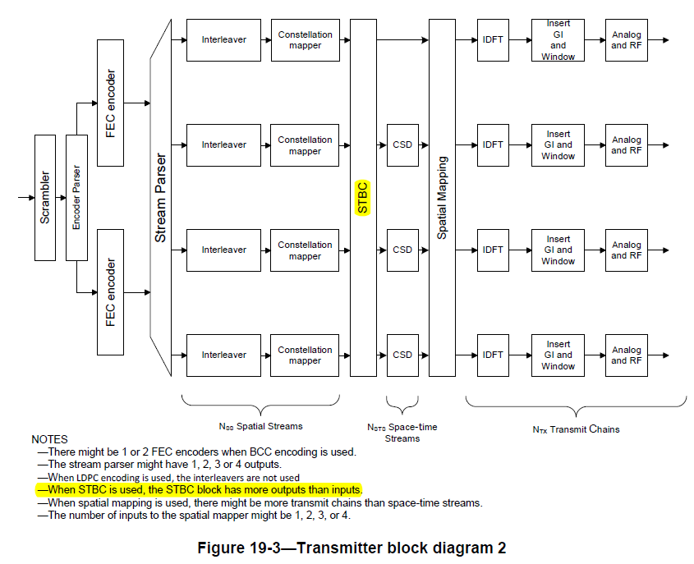
The transmitter block diagram in Figure 19-3 illustrates the signal flow for data transmission. There are many different options for HT transmission, but the figure is not intended to cover them all. The particular case shown in Figure 19-3 has two FEC encoders, 4 streams at the output of the stream parser, BCC coding, no STBC, equal number of transmit chains and space-time streams and 4 streams at the input of the spatial mapper.
The NOTES simply highlight some of the other modes that can be used when transmitting HT and which would result in a transmitter block diagram that looks different from the one shown in Figure 19-3. Each of the bullets listed under “NOTES” would result in changes to the transmitter block diagram of Figure 19-3.
Note that even when STBC is not used, the flow conceptually still goes through the STBC block as explained in clause 19.3.11.9.2 (Space-time block coding). On page 2792, line 41, it says:

Proposed Resolution
Clarify the intended configuration of Figure 19-3, by stating the it in the paragraph starting at line 38, page 2754.

Figure 19-2 (Transmitter block diagram 1) and Figure 19-3 (Transmitter block diagram 2) show example transmitter block diagrams. In particular, Figure 19-2 (Transmitter block diagram 1) shows the transmitter blocks used to generate the HT-SIG of the HT-mixed format PPDU. These transmitter blocks are also used to generate the non-HT portion of the HT-mixed format PPDU, except that the BCC encoder and interleaver are not used when generating the L-STF and L-LTFs. Figure 19-3 (Transmitter block diagram 2) shows the transmitter blocks used to generate the Data field of the HT-mixed format and HT-greenfield format PPDUs. The particular case shown in Figure 19-3 has two FEC encoders, four spatial streams, BCC coding, no STBC and four transmit chains.
A subset of these transmitter blocks consisting of the constellation mapper and CSD blocks, as well as the blocks to the right of, and including, the spatial mapping block, are also used to generate the HT-STF, HTGF-STF, and HT-LTFs. The HT-greenfield format SIGNAL field is generated using the transmitter blocks shown in Figure 19-2 (Transmitter block diagram 1), augmented by additional CSD and spatial mapping blocks.

 |  |  |  | Comment | Proposed Change | Resolution
1359 | 19.3.4 | 2755 | 58 | Figure 19-3 says that "When STBC is used, the STBC block has more outputs than inputs." but the figure shows the opposite (the STBC block has 4 inputs and 4 outputs) | Delete the cited text in the referenced figure | Change the paragraph starting at line 38, page 2754 as shown in 802.11-18/0701r0

CID 1388

Discussion
The Context of the comment is shown below.
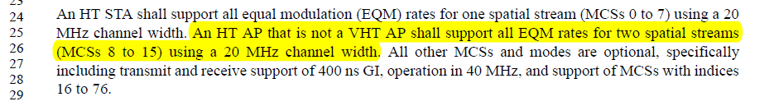
Note that the following are the mandatory requirements for a VHT STA (see clause 21.1.1):
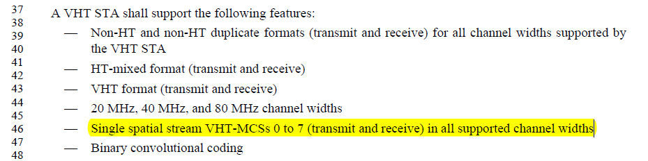
There is no distinction between AP and non-AP STAs in this. Therefore, a compliant VHT STA only has to support a single Spatial Stream, regardless of whether it is a STA or an AP. Since every VHT STA is an HT STA by definition, it appears that the standard needs to make a disctiction between the capabilities of HT APs that are VHT APs and HT APs that are not. As such, the requirement on page 2759, line 25 looks intentional.

Proposed Resolution
Reject the comment as the statement on page 2759, line 25 is needed to guarantee consistency with the mandatory requirements of VHT STAs.

 |  |  |  | Comment | Proposed Change | Resolution
1388 | 19.3.5 | 2759 | 25 | "An HT AP that is not a VHT AP shall support all EQM rates for two spatial streams (MCSs 8 to 15) using a 20 MHz channel width." -- there is no reason a VHT AP should be inferior to an HT AP | Delete "that is not a VHT AP" in the cited text at the referenced location | Reject. This statement is needed to guarantee consistency with the mandatory requirements of VHT STAs.

