IEEE P802.11
Wireless LANs
MAC Comments for Discussion
Date: 2018-11-1
Author(s):
Name | Affiliation | Address | Phone | email
Mark Hamilton | Ruckus/ARRIS | 350 W Java Dr  Sunnyvale, CA 94089 | +1.303.818.8472 | mark.hamtilon2152@gmail.com
Abstract

This submission contains comments on REVmd LB 232, assigned to Mark Hamilton for preparation of proposed resolutions.

The first section contains comments with proposed resolutions ready for review or discussion by TGmd. The latter sections are comments not ready for discussion yet, or already completed.

R0 – initial version. CIDs ready for TGmd review: 1398, 1425, 1381, 1382, 1390.
R1 – Reviewed CIDs 1398, 1425, 1381, 1382, 1390 at FLL F2F, and approved resolutions, with minor modifications (as shown below, with Green highlight status color).
Added proposed resolutions, ready for review, for CIDs: 1394, 1369, 1397, and 1354.
R2 – Reviewed CIDs 1394, 1369, 1397, and 1354 at Warsaw F2F, and approved resolutions (as shown below, with Green highlight status color).
R3 – CIDs ready for TGmd review: 1281, 1400, 1401, 1403, 1405, 1414, 1008, 1282, 1018, 1033, 1114, 1305
R4 – Reviewed CIDs 1281, 1400, 1401, 1403, 1405, 1414, 1008, 1282, 1018, 1033, 1114, 1305. All have approved resolutions.
R5 – Proposed resolutions/discussion on CIDs 1286, 1338, 1343, and 1349.
R6 – Reviewed CIDs 1338 and 1343 at Waikoloa F2F and approved resolutions. Expanded Editor’s instructions for deprecating dot11GDDEnablementValidityTimer in the resolution to CID 1349. (Thanks to Emily QI for these instructions.) Proposed resolutions for CIDs 1273, 1569, 1415, 1536, and 1485.
R7 – TGm reviewed the updated CID 1349, and CIDs 1273, 1536, and 1485, and approved the resolutions as captured here. CID 1569 was considered, but more expert review is needed.
R8 – Proposed resolutions on CIDs: 1587 (after some discussion), 1192, 1396, 1431, 1569, 1553, 1560, 1572, 1573, 1593, 1594, 1614, 1503, 1442, 1448, 1449, 1450, 1454, 1462, 1498 (after checking with WG reflector), and 1500.
R9 – TGm reviewed the updated CIDs: 1587, 1286, 1396, 1431, 1569, 1553, 1560, 1572, 1573, 1593, 1594, 1614, 1503, and approved the resolutions as captured here.
R10 – Proposed resolutions, ready for TG review, on CIDs: 1192, 1454, 1462, 1146, 1370, 1509, 1511, 1519, 1520, 1532 (after TG discussion/straw poll), 1545, 1556, 1620. Removed CID 1415, as that is handled in 11-18/1306.
R11 – Slight changes to resolutions in R10, to clarify/correct errors found in review.

For review by TG:

1192 | 867.08 | 8 | 9.4.1.31 |  | Mention that IEEE RA recommends CID if you want a 24-bit number, but many legacy OUIs are MA-Ls. The IEEE RA doesn't have a product called "OUI" any more. | Update the first three sentances in 9.4.1.31 to: The Organization Identifier field contains a public unique identifier assigned by the IEEE Registration Authority. The order of the Organization Identifier field is described in 9.2.2 (Conventions). The IEEE has assigned organizationally unique identifiers both of 24-bit length (MA-L and CID) and longer length.

Discussion:

Context:

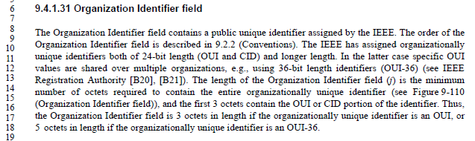

There are two specific changes in the Proposed Changes text:

- Change the first sentence:
The Organization Identifier field contains a public unique identifier assigned by the IEEE Registration Authority.

This seems fine.

- Change the third sentence:
The IEEE has assigned organizationally unique identifiers both of 24-bit length (OUI MA-L and CID) and longer length.

Per IEEE Std 802-2014:
- NOTE 1--The terms OUI and OUI-36 were previously used by the IEEE RA to refer to what are now called MA–L and MA–S, respectively. The acronym OUI without modification was used to refer to the 24-bit field assigned by the IEEE RA.
Thus, this change also seems correct.

Update Oct 30, with proposed changes, based on discussion with RAC members, make these indicated changes to the text in 9.4.1.31:

The Organization Identifier field contains a public unique identifier assigned by the IEEE Registration Authority as a 24-bit OUI, a 24-bit CID, or a 36-bit OUI-36, see IEEE Registration Authority ([B20], [B21]).. The order of the Organization Identifier field is described in 9.2.2 (Conventions). The IEEE has assigned organizationally unique identifiers both of 24-bit length (OUI and CID) and longer length. In the latter case specific OUI values are shared over multiple organizations, e.g., using 36-bit length identifiers (OUI-36) (see IEEE Registration Authority [B20], [B21]).

The length of the Organization Identifier field (j) is the minimum number of octets required to contain the entire organizationally unique IEEE-assigned identifier (see Figure 9-117 (Organization Identifier field)), and the first 3 octets contain the OUI or CID portion of the identifier. Thus, the Organization Identifier field is 3 octets in length if the organizationally unique IEEE-assigned identifier is an OUI or CID, or 5 octets in length if the organizationally unique IEEE-assigned identifier is an OUI-36.

If the length of the organizationally unique IEEE-assigned identifier is not an integer number of octets, the least significant bits of the last octet are specified by the organization identified.

NOTE—For example, for the organizationally unique IEEE-assigned identifier 0x0050C24A4, the Organization Identifier field would contain 0x0050C24A4y where y represents the four least significant bits of the fifth octet of the field. The value of y is specified by the organization whose identifier is 0x0050C24A4.

In Annex A:
Replace reference [B20] with:
[B20] IEEE-SA Registration Authority - FAQs⁵⁴

Replace the URL for footnote [54] with:
https://standards.ieee.org/faqs/regauth.html

Replace reference [B21] with:
[B21] IEEE Standards Registration Authority—Guidelines for Use of Extended Unique Identifier (EUI), Organizationally Unique Identifier (OUI), and Company ID (CID).

Proposed Resolution:

Make changes as shown in 11-18/0669r10 for CID 1192.

1454 | 2019.52 | 52 | 11.3.5 |  | It is not clear what is reset in the case of (re)association to a different AP | At the end of the last step of 11.3.5.2 add "All states, agreements and allocations shall be deleted or reset to initial values."  At the end of the last step of 11.3.5.3 add "All states, agreements and allocations pertaining to the STA that has associated shall be deleted or reset to initial values."  At the end of the last step of 11.3.5.5, add "In the case of reassociation to a different AP, all states, agreements and allocations pertaining to the STA that has reassociated shall be deleted or reset to initial values."

Discussion:

Context:

During REVmc, effort was made to clarify which state variables are reset, and which are maintained when a non-AP STA reassociates to the same AP to which it was already associated. This has been added as a long list of variables in 11.3.5.4(c). Subclause 11.3.5.5(p) was also added at that time, for the AP’s STA to reference the same list (without replicating it) for matching behaviour.

Update Oct 15: Thus, the suggestion to modify 11.3.5.5 is rejected, as this is covered in bullet (p) Not true; the “different AP” case is not covered, and has been added, below.

The changes to 11.3.5.2 and 11.3.5.3 are in the subclauses on association (as opposed to reassociation). These clauses were not updated/clarified in REVmc to include resetting this type of state information upon association.

There is a statement in the reassocaition bullet (c), for the case of reassociation to a different AP:
In the case of reassociation to a different AP (the CurrentAPAddress parameter is not the new AP’s MAC address), all the states, agreements and allocations listed above are deleted or reset to initial values(#179).

For consistency, it seems better to replicate this sentence in the association procedures.

Further, this statement can be added at the point where the Association Request is generated, to maintain the logical flow (rather than at the end of the last step, which only happens for RSNAs, for example. In the case of the initiating STA, all state will be reset regardless of the outcome of the association attempt. In the case of the AP, it only needs to maintain state information corresponding to an associated STA, so this reset only needs to occur if the association attempt is successful. This also handles the scenario of a failure while management frame protection is in use (in which case the AP’s state for the STA should be unchanged).

Proposed Resolution:

Revised.

Add a new bullet in 11.3.5.2 between (a) and (b): “All the states, agreements and allocations listed in both numbered lists in 11.3.5.4 bullet c) are deleted or reset to initial values.”

Add a new bullet in 11.3.5.3 between (j) and (k): “If the ResultCode in the MLME-ASSOCIATE.response primitive is SUCCESS, all the states, agreements and allocations pertaining to the associating STA and listed in both numbered lists in 11.3.5.4 bullet c) are deleted or reset to initial values.”

Change bullet (p) in 11.3.5.5 from “CurrentAPAddress parameter in the MLME-REASSOCIATION.indication primitive had the new AP’s MAC address in the CurrentAPAddress parameter” to “CurrentAPAddress parameter in the MLME-REASSOCIATION.indication primitive is this AP's or PCP’s MAC address” to

Add a new bullet in 11.3.5.5, as bullet (q): “If the ResultCode in the MLME-REASSOCIATE.response primitive is SUCCESS and the CurrentAPAddress parameter in the MLME-REASSOCIATION.indication primitive is not this AP’s or PCP’s MAC address (reassociation to a different AP), all the states, agreements and allocations pertaining to the associating STA and listed in both numbered lists in 11.3.5.4 bullet c) are deleted or reset to initial values.”

1462 |  |  | 9 |  | It is not necessary in Clause 9 to say things are done according to the conventions in 9.2.2. It is confusing to do so, because it implies something unusual is happening | Delete the sentences like "The order of the Organization Identifier field is described in 9.2.2 (Conventions)." or "All fields use the bit convention from 9.2.2 (Conventions)." or " It is encoded following the conventions in 9.2.2 (Conventions)." at [mc/D6.0 references] 685.46, 827.4, 828.41, 881.22, 881.26, 881.62, 882.43, 883.44, 999.59, 999.64, 1007.33, 1083.20, 1101.58, 1101.62, 1130.33, 1144.47. Delete the NOTE at 706.48. Change 880.20 to say "The MDID field contains an arbitrary value." At 951.39 delete ", encoded according to 9.2.2 (Conventions)". At 1085.14 delete " and is encoded following the conventions given in 9.2.2 (Conventions)"

Discussion:

Context:

An example of the first such sentence:

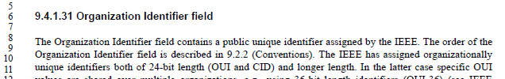

While the commenter is correct that this sentence is not necessary, it is helpful to the reader to note that the Organizationally unique identifiers do have special attention in subclause 9.2.2, which might be otherwise missed.

Similarly, for the second quoted sentence, it might be a surprise to the casual reader that the cipher suites (which are OUIs) are encoded in the opposite byte order than the integer fields in the examples that follow:
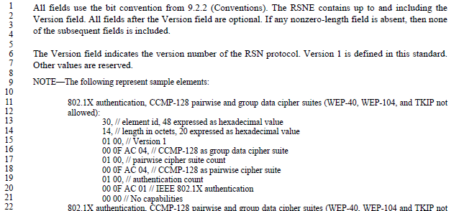

And, continuing the theme, the third sentence appears where nonce values are being described, and again, these have special treatment in 9.2.2, which deserves to be mentioned as a hint to the reader.

Update Oct 30: There are examples that do not need the 9.2.2 reference, however, such as:

From 9.4.1.48.1 (VHT Compresses Beamforming Report field in non-S1G Band):

From 9.4.2.46 (Mobility Domain element):
An aside: This statement is useless. Agreed, we can remove the superfluous reference to 9.2.2. That the field is 2 octets is clear from the adjacent Figure. It would be helpful if this sentence instead actually directed the reader to meaningful semantics for the MDID field values. Sadly, there is little such text to reference (probably should be in clause 12).

From 9.4.2.47 (Fast BSS Transition element):
Another aside: This paragraph, in clause 9, provides no help defining/understanding the format of a PMK-R1 key holder identifier (R1KH-ID) subelement of the FTE. The semantics of this paragraph (even as light as they are) should be in clause 12, and there should be text here that addresses the frame format definition of this subelement, instead.

Also in 9.4.2.47:
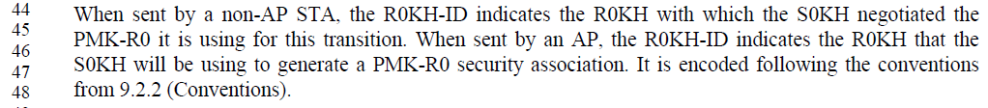

From 9.4.2.48 (Timeout Interval element):

From 9.4.2.77 (QoS Traffic Capability element):

From 9.4.5.1 (General, in Access network query protocol (ANQP) elements):

Also in 9.4.5.1:

The above two cites have nearly identical copies in 9.4.6.1 (General, in Registered location query protocol (RLQP) elements).

There are occurrences of reference to 9.2.2 in clause 12. However, since 9.2.2 describes (arguably) the conventions there as applying to “components (e.g., fields, subfields, elements and subelements) as they appear in the MAC frame and in the order in which they are passed to the physical layer”, it seems best to not assume that the conventions of 9.2.2 apply to clause 12, without explicit statements stating that they do.

Further, the uses in clause 12 fall in these categories:
- ASCII strings (a special case, worth noting)
- Components of WEP or TKIP subclauses, which are deprecated and are no longer maintained
- Specific mention of how certain values are represented when passed to (logical) processing subroutines, where it could be in doubt as to how the routine will expect or handle these values as they are passed to bitstring processing functions (like hashes, etc.), and such special cases are worth noting the expected bit/octet ordering behaviour that is used
- MAC addresses (which are a special case in 9.2.2, and worth noting)
- Nonces (which are a special case in 9.2.2, and worth noting)
- OUIs (which are a special case in 9.2.2, and worth noting)

Therefore, no changes in clause 12 are proposed.

Proposed Resolution:

Revised. The occurrences of “the sentences like” specifically mentioned in the comment are all associated with text that is describing a type of object which is encoded using special rules in 9.2.2. Alerting the reader to such special rules, at the point where they are invoked, is an aid to understanding the Standard correctly.

However, other locations are to be changed, as follows:
- Delete the NOTE at the end of 9.4.1.48.1
- In 9.4.2.46, replace “The MDID field is a 2-octet value that follows the ordering conventions defined in 9.2.2 (Conventions).” with “The MDID field is a 2-octet value that is an identifier that names a mobility domain.”
- In 9.4.2.47, delete both occurrences of “It is encoded following the conventions in 9.2.2 (Conventions).”
- In 9.4.2.48, delete “It is encoded following the conventions in 9.2.2 (Conventions).”
- In 9.4.2.77, delete “encoded according to 9.2.2 (Conventions).”
- In 9.4.5.1, delete “The 2-octet Info ID field is encoded following the conventions given in 9.2.2 (Conventions).”
- In 9.4.5.1, delete “and is encoded following the conventions given in 9.2.2 (Conventions).”
- In 9.4.6.1, delete “The 2-octet Info ID field is encoded following the conventions given in 9.2.2 (Conventions).”
- In 9.4.6.1, delete “and is encoded following the conventions given in 9.2.2 (Conventions).”

1146 | 1657.30 | 30 | 10.19 |  | Please clarify how the PARTIAL_AID is calculated when the Multiple BSSID is used.  For example, do BSSID[39:47], BSSID[44:47], and BSSID[40:43] are derived from a transmitted BSSID or a non-transmitted BSSID?  802.11ah had the same discussion, the following sentence has been added into the spec.  NOTE--When a STA for which dot11MultiBSSIDActivated is true is associated with ith BSSID of an AP, the BSSID means the value of BSSID(i).  If VHT PPDU follows the same rule, please add the same NOTE into the spec. | As in comment.

Discussion:

Context:

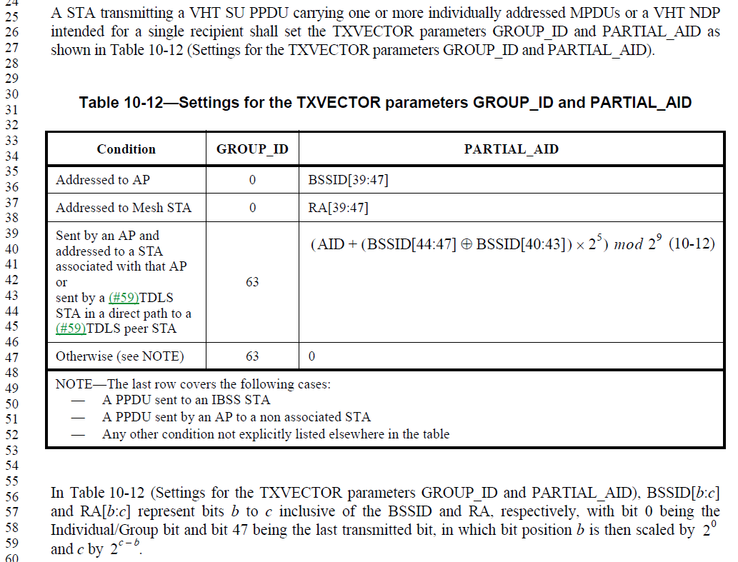

The commenter (and by extension, TGah) seems to be confusing terminology/logical concepts. An AP with dot11MultiBSSIDActivated set to true, is still a single AP with a single STA entity and its included MAC. That AP and MAC behave as if they were standalone within a device, in terms of preparing and encoding any PDUs and exchanging [TR]XVECTORs with the PHY. Thus, the AP will always refer to its own BSSID, in contexts such as Table 10-12. Nothing further needs to be stated The fact that this AP is operating within a device where the Multiple BSSID capability is being used does not affect this behaviour.

To clarify this implicit assumption would involve numerous text changes, to state that every self-referential behaviour of the AP is talking about _this_ AP within the Multiple BSSID Set. This is unnecessary, and would be extremely cluttering to the Standard.

Proposed Resolution:

Revised. At P1661.52, delete the note, “NOTE—When a STA for which dot11MultiBSSIDActivated is true is associated with ith BSSID of an AP, the BSSID means the value of BSSID(i).”

Response to commenter: References used within AP (or STA within an AP) behaviour, when the AP happens to be operating within a Multiple BSSID Set, are not altered from the simple behaviour (when not within a Multiple BSSID Set). Therefore, it is assumed that references to AP attributes (such as BSSID, etc.) are references to this AP’s attributes.

1370 | 1964.60 | 60 | 11.1.7 |  | 11.1.4.6 Operation of Supported Rates and BSS Membership Selectors element and Extended Supported Rates and BSS Membership Selectors element and 11.1.7 Supported rates and extended supported rates advertisement cover the same material | Merge 11.1.7 into 11.1.4.6 then delete 11.1.7

Discussion:

Context:

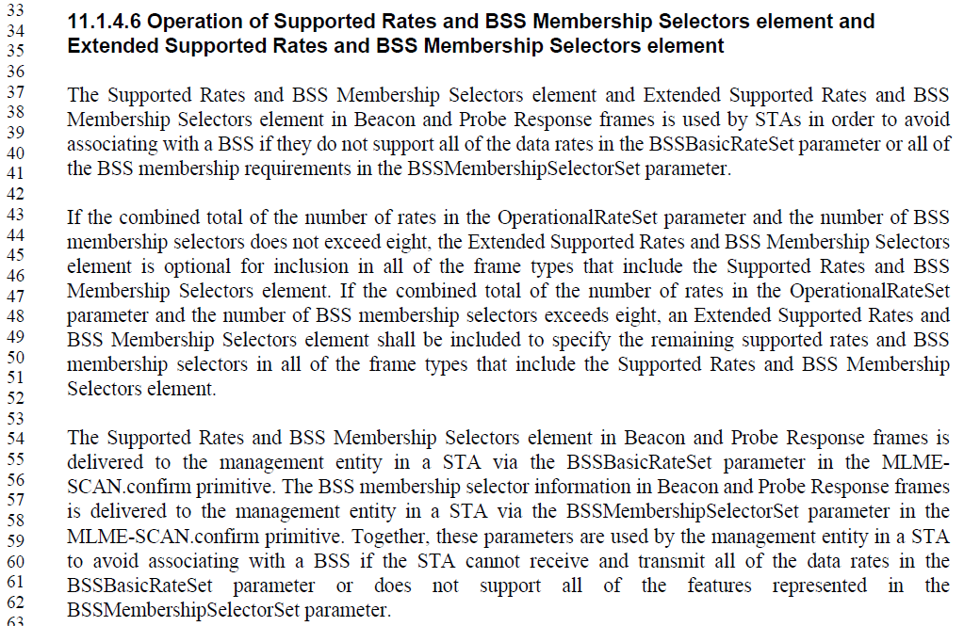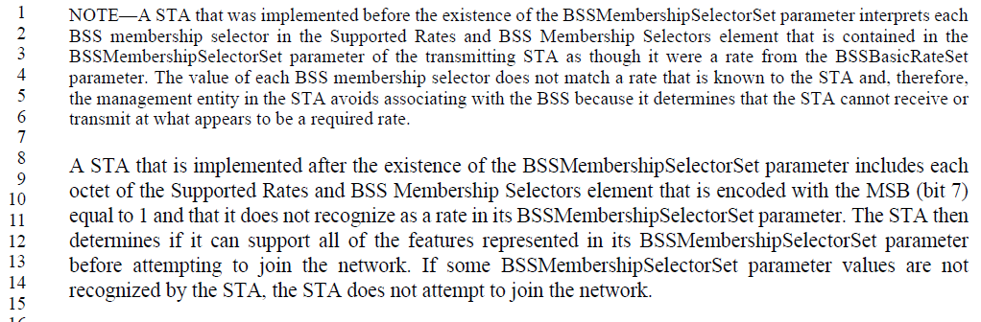

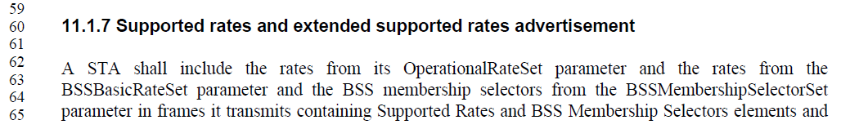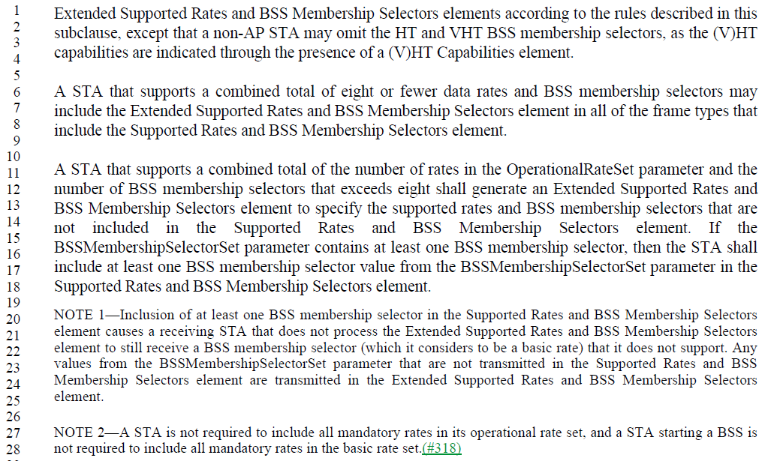

There is considerable duplication of text, or of concepts, in these two subclauses. However, there are some important differences that must be retained in a combined version. The union of logical concepts is:
- The purpose (only in 11.1.4.6):
  - “The Supported Rates and BSS Membership Selectors element and Extended Supported Rates and BSS Membership Selectors element in Beacon and Probe Response frames is used by STAs in order to avoid associating with a BSS if they do not support all of the data rates in the BSSBasicRateSet parameter or all of the BSS membership requirements in the BSSMembershipSelectorSet parameter.”
- The basic requirement, and exception, for transmitting (only in 11.1.7):
  - “A STA shall include the rates from its OperationalRateSet parameter and the rates from the BSSBasicRateSet parameter and the BSS membership selectors from the BSSMembershipSelectorSet parameter in frames it transmits containing Supported Rates and BSS Membership Selectors elements and Extended Supported Rates and BSS Membership Selectors elements according to the rules described in this subclause, except that a non-AP STA may omit the HT and VHT BSS membership selectors, as the (V)HT capabilities are indicated through the presence of a (V)HT Capabilities element.”
- The basic mechanics for encoding into frames (appears in both, with different wording):
  - “A STA that supports a combined total of eight or fewer data rates and BSS membership selectors may include the Extended Supported Rates and BSS Membership Selectors element in all of the frame types that include the Supported Rates and BSS Membership Selectors element.
  - A STA that supports a combined total of the number of rates in the OperationalRateSet parameter and the number of BSS membership selectors that exceeds eight shall generate an Extended Supported Rates and BSS Membership Selectors element to specify the supported rates and BSS membership selectors that are not included in the Supported Rates and BSS Membership Selectors element.”
OR (seems equivalent):
  - “If the combined total of the number of rates in the OperationalRateSet parameter and the number of BSS membership selectors does not exceed eight, the Extended Supported Rates and BSS Membership Selectors element is optional for inclusion in all of the frame types that include the Supported Rates and BSS Membership Selectors element. If the combined total of the number of rates in the OperationalRateSet parameter and the number of BSS membership selectors exceeds eight, an Extended Supported Rates and BSS Membership Selectors element shall be included to specify the remaining supported rates and BSS membership selectors in all of the frame types that include the Supported Rates and BSS Membership Selectors element.”
- A special case rule for encoding for transmission, and a NOTE of explanation of the purpose (only in 11.1.7):
  - “If the BSSMembershipSelectorSet parameter contains at least one BSS membership selector, then the STA shall include at least one BSS membership selector value from the BSSMembershipSelectorSet parameter in the Supported Rates and BSS Membership Selectors element.
  - NOTE 1—Inclusion of at least one BSS membership selector in the Supported Rates and BSS Membership Selectors element causes a receiving STA that does not process the Extended Supported Rates and BSS Membership Selectors element to still receive a BSS membership selector (which it considers to be a basic rate) that it does not support.“
- This last part of the NOTE 1 just above, appears to be redundant, and not needed:
  - “Any values from the BSSMembershipSelectorSet parameter that are not transmitted in the Supported Rates and BSS Membership Selectors element are transmitted in the Extended Supported Rates and BSS Membership Selectors element.”
- Another special rule for encoding for transmission, added via a recent REVmd comment (only in 11.1.7):
  - “NOTE 2—A STA is not required to include all mandatory rates in its operational rate set, and a STA starting a BSS is not required to include all mandatory rates in the basic rate set.(#318)”
- The basic mechanics for receiving the information (only in 11.1.4.6):
  - “The Supported Rates and BSS Membership Selectors element in Beacon and Probe Response frames is delivered to the management entity in a STA via the BSSBasicRateSet parameter in the MLME-SCAN.confirm primitive. The BSS membership selector information in Beacon and Probe Response frames is delivered to the management entity in a STA via the BSSMembershipSelectorSet parameter in the MLME-SCAN.confirm primitive. Together, these parameters are used by the management entity in a STA to avoid associating with a BSS if the STA cannot receive and transmit all of the data rates in the BSSBasicRateSet parameter or does not support all of the features represented in the BSSMembershipSelectorSet parameter.”
- The mechanism by which the purpose is implemented:
  - “NOTE—A STA that was implemented before the existence of the BSSMembershipSelectorSet parameter interprets each BSS membership selector in the Supported Rates and BSS Membership Selectors element that is contained in the BSSMembershipSelectorSet parameter of the transmitting STA as though it were a rate from the BSSBasicRateSet parameter. The value of each BSS membership selector does not match a rate that is known to the STA and, therefore, the management entity in the STA avoids associating with the BSS because it determines that the STA cannot receive or transmit at what appears to be a required rate.
  - A STA that is implemented after the existence of the BSSMembershipSelectorSet parameter includes each octet of the Supported Rates and BSS Membership Selectors element that is encoded with the MSB (bit 7) equal to 1 and that it does not recognize as a rate in its BSSMembershipSelectorSet parameter. The STA then determines if it can support all of the features represented in its BSSMembershipSelectorSet parameter before attempting to join the network. If some BSSMembershipSelectorSet parameter values are not recognized by the STA, the STA does not attempt to join the network.”

Taking the above sorting out of the concepts, and fixing a few errors (and making some editorial changes), we get this combined revised text:

The Supported Rates and BSS Membership Selectors element and Extended Supported Rates and BSS Membership Selectors element in Beacon and Probe Response frames is used by STAs in order to avoid associating with a BSS if they do not support all of the data rates in the BSSBasicRateSet parameter or all of the BSS membership requirements in the BSSMembershipSelectorSet parameter.

A STA shall include the rates from its OperationalRateSet parameter and the rates from the BSSBasicRateSet parameter and the BSS membership selectors from the BSSMembershipSelectorSet parameter in frames it transmits containing Supported Rates and BSS Membership Selectors elements and Extended Supported Rates and BSS Membership Selectors elements according to the rules described in this subclause, except that a non-AP STA may omit the HT and VHT BSS membership selectors, as the (V)HT capabilities are indicated through the presence of a (V)HT Capabilities element.

NOTE 2—A STA is not required to include all mandatory rates in its operational rate set, and a STA starting a BSS is not required to include all mandatory rates in the basic rate set.(#318)

For a STA that supports a combined total of eight or fewer data rates and BSS membership selectors the Extended Supported Rates and BSS Membership Selectors element is optional, and may be included in all of the frame types that include the Supported Rates and BSS Membership Selectors element.

A STA that supports a combined total of the number of rates in the OperationalRateSet parameter and the number of BSS membership selectors that exceeds eight shall include an Extended Supported Rates and BSS Membership Selectors element to specify the supported rates and BSS membership selectors that are not included in the Supported Rates and BSS Membership Selectors element.

If the BSSMembershipSelectorSet parameter contains at least one BSS membership selector, then the STA shall include at least one BSS membership selector value from the BSSMembershipSelectorSet parameter in the Supported Rates and BSS Membership Selectors element.

NOTE 1—Inclusion of at least one BSS membership selector in the Supported Rates and BSS Membership Selectors element causes a receiving STA that was implemented before the existence of the Extended Supported Rates and BSS Membership Selectors element to still receive at least one BSS membership selector, which it will consider to be a basic rate that it does not support, and therefore it will not associate to the BSS.

Upon recipt, the Supported Rates and BSS Membership Selectors element in Beacon and Probe Response frames is delivered to the management entity in a STA via the BSSBasicRateSet parameter in the MLME-SCAN.confirm primitive. The BSS membership selector information in Beacon and Probe Response frames is delivered to the management entity in a STA via the BSSMembershipSelectorSet parameter in the MLME-SCAN.confirm primitive. Together, these parameters are used by the management entity in a STA to avoid associating with a BSS if the STA cannot receive and transmit all of the data rates in the BSSBasicRateSet parameter or does not support all of the features represented in the BSSMembershipSelectorSet parameter.

A STA that is implemented after the existence of the BSSMembershipSelectorSet parameter includes each octet of the Supported Rates and BSS Membership Selectors element that is encoded with the MSB (bit 7) equal to 1 and that it does not recognize as a rate in its BSSMembershipSelectorSet parameter. The STA then determines if it can support all of the features represented in its BSSMembershipSelectorSet parameter before attempting to join the network. If some BSSMembershipSelectorSet parameter values are not recognized by the STA, the STA does not attempt to join the network.

NOTE—A STA that was implemented before the existence of the BSSMembershipSelectorSet parameter interprets each BSS membership selector in the Supported Rates and BSS Membership Selectors element as though it were a rate from the BSSBasicRateSet parameter. These values of BSS membership selectors will not match a rate that is known to the STA and, therefore, the management entity in the STA will not associate with the BSS, because it will determine that the STA cannot receive or transmit at what appears to be a required rate.

Proposed Resolution:

Revised. Replace the text of 11.1.4.6 with the revised text shown in 11-18/0669r10 under CID 1370. (Editor: Please renumber “NOTE”s appropriately.) Delete subclause 11.1.7.

1509 | 2058.01 | 1 | 11.5.4 |  | It is not clear what "corresponding to the TID for which the block ack policy is set" means | Change each of the three instances in the referenced subclause to "with the TID for the block ack agreement"

Discussion:

Context:

The three instances referenced in the comment are here:

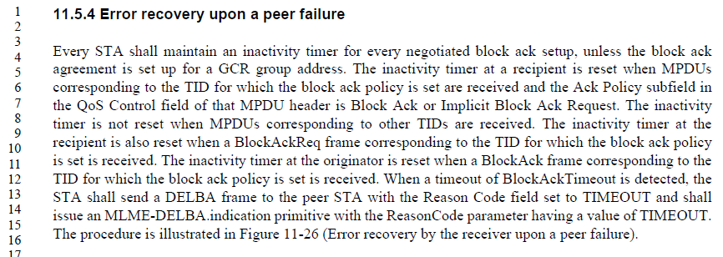

The rewording of these three instances seems to fit and does clarify the connection from the MPDU or frame to the TID.

Proposed Resolution:

Accepted.

1511 | 1644.20 | 20 | 10.7 |  | "For MSDUs or A-MSDUs belonging to the service class of QoSAck when the receiver is a QoS STA, set to Normal Ack or Implicit Block Ack Request, PSMP Ack, or Block Ack." is missing some words (what is set?) | Change the cited text in the referenced location to "For MSDUs or A-MSDUs belonging to the service class of QoSAck when the receiver is a QoS STA, the QoS Data frames that are used to send these MSDUs or A-MSDUs shall have the Ack Policy subfield in the QoS Control field set to Normal Ack or Implicit Block Ack Request, PSMP Ack, or Block Ack."

Discussion:

Context:

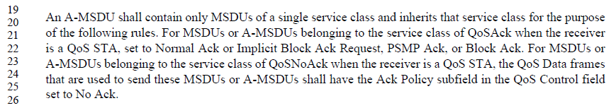

Agree the current text is broken. The proposed change is sensible and consistent with the following sentence.

Proposed Resolution:

Accepted.

1519 | 1066.25 | 25 | 9.4.2.36 |  | "Set to 4 for 80+80 MHz operating channel width" is not consistent with the other sentences | Change the cited text at the referenced location to "Set to 4 for 80+80 MHz BSS bandwidth"

Discussion:

Context:

From 9.4.2.36 (Neighbor Report element):

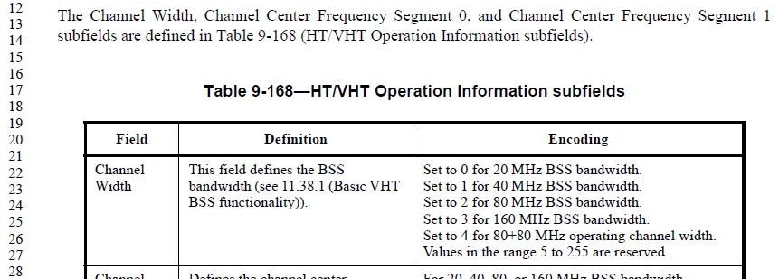

Agree, the wording is inconsistent for the values of this field. Both phrases “BSS bandwidth” and “operating channel width” appear frequently in the Standard. (As does “BSS operating channel width”.) The former seems more like an attribute of the BSS, as controlled/set by the AP. The latter seems more like an attribute of individual STAs, and could be smaller than the BSS’s width in some cases. Thus, the former is probably more appropriate in this context.

Proposed Resolution:

Accepted.

1520 | 1676.63 | 63 | 10.23.2.8 |  | "Note that when transmitting multiple frames in a TXOP using acknowledgment mechanisms other than Normal Ack," -- it is not clear what this means; it seems to be inadvertently omitting implicit BA | Change the cited text at the referenced location to "Note that when transmitting multiple frames in a TXOP using acknowledgment mechanisms other than immediate acknowledgement,"

Discussion:

Context:

From 10.23.2.8 (Multiple frame transmission in an EDCA TXOP):

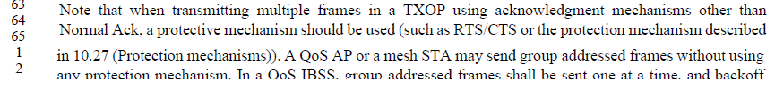

The proposed change, more visibly, is:
Note that when transmitting multiple frames in a TXOP using acknowledgment mechanisms other than immediate acknowledgement,"

It does seem that the intention of this sentence is to explain that the recommendation for RTS/CTS protection is related to getting an immediate and explicit acknowledgment, which is not strictly the same as saying the ack policy is Normal Ack. Note that this pulls on a similar thread to the rationale for CID 1442 changes.

Proposed Resolution:

Accepted.

1532 | 1277.33 | 33 | 9.4.2.179 |  | "0: Reserved, FILS Public Key is undefined." -- this can't be used, nor can any values above 3 | Delete the line at 1277.33 and at the end of the referenced subclause add "Other values are reserved."

Discussion:

Context:

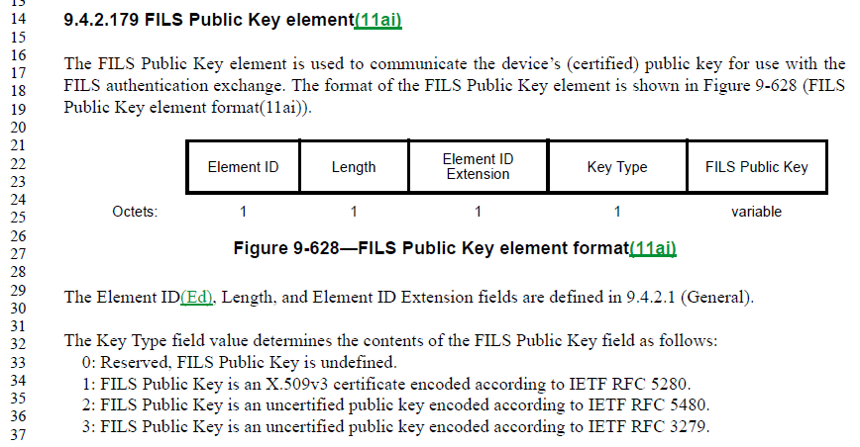

Since the Key Type field is an octet, the Standard does need to indicate that values above 3 are reserved, and this is missing. Once that statement is added, it is not useful to maintain the explicit mention that the value 0 is also reserved, it can just be an “other value”.

To be sure what “other values” are being referenced, the added sentence should be clearly connected to the Key Type field and the existing numbered list, and the meaning (that is, undefined) for the FILS Public Key field needs to be explicitly discussed.

Suggest two alternatives (do we have editorial guidelines on a preferred style, or does the TG have an opinion – straw poll?):
Alt 1:
The Key Type field value determines the contents of the FILS Public Key field as follows (other values of the Key Type field are reserved and the FILS Public Key is reserved for these values):

1: FILS Public Key is an X.509v3 certificate encoded according to IETF RFC 5280.
2: FILS Public Key is an uncertified public key encoded according to IETF RFC 5480.
3: FILS Public Key is an uncertified public key encoded according to IETF RFC 3279.

Alt 2:
The Key Type field value determines the contents of the FILS Public Key field as follows:

1: FILS Public Key is an X.509v3 certificate encoded according to IETF RFC 5280.
2: FILS Public Key is an uncertified public key encoded according to IETF RFC 5480.
3: FILS Public Key is an uncertified public key encoded according to IETF RFC 3279.
Other: Reserved, FILS Public Key is reserved.

Proposed Resolution:

Revised. <Copy one of the above alternatives>

1545 | 137.49 | 49 | 2 |  | The reference to 802.1Q-2003 is obsolete | Replace with the current version of the standard for virtual bridged LANs

Discussion:

As discussed in 11-18/1447, the TCLAS Classifier Type 2 references 802.1Q-2003, and there are technical reasons why this cannot be updated to a newer version of 802.1Q.

As a result of that discussion, Motion #71 deprecated Classifier Type 2. However, Classifier Type 2 remains in the Standard, for now. Thus, the reference to 802.1Q-2003 is still need, for now.

Proposed Resolution:

Rejected. The TCLAS element’s Classifier Type 2 relies on 802.1Q-2003, and that version of 802.1Q specifically. While Classifier Type 2 has been recently deprecated, the reference to 802.1Q-2003 is still needed in the Standard until such time as Classifier Type 2 is completely removed (if ever).

1556 | 2557.57 | 57 | 14.9.2 |  | What is a "test frame" | Replace "[the] test frame" with "a nominal frame". Same thing in Table 14-4, and in 14.9.3 in Table 14-6.

Discussion:

Context:

This concept appears only in the subclause on mesh link metrics computation:

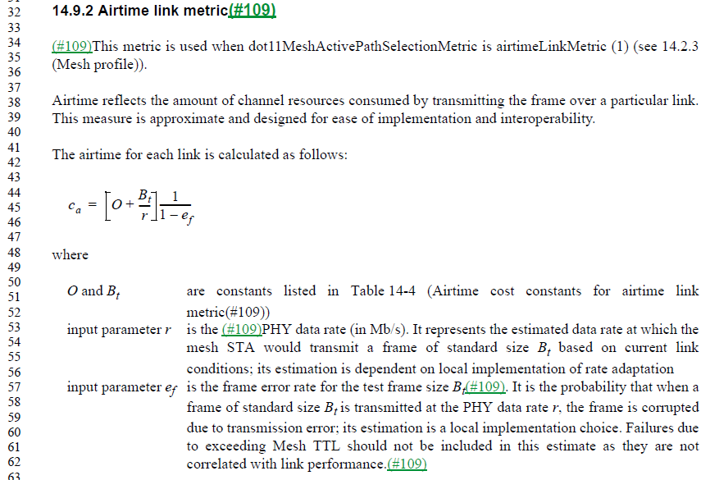

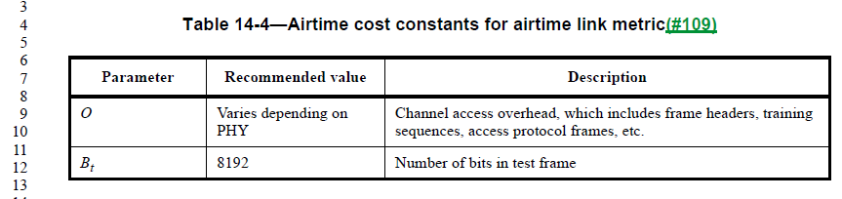
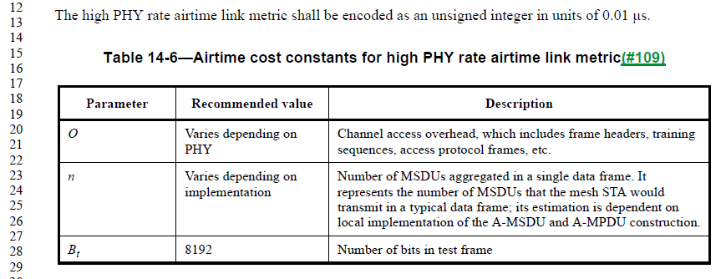

The purpose of the “test frame” is simply to provide a frame size over which a probabilistic frame error rate is computed. There is no description of any special attributes that make this a “test” frame, other than its size. Also, there is no discussion or expectation that this metric is actually tested, rather it is an analytic derived from known device behaviors, and existing conditions. Thus, this is just a nominal size used for purposes of these computations for comparison of links’ capacity/capability.

Proposed Resolution:

Accepted.

1620 | 1298.64 | 64 | 9.4.2.194 |  | Note has normative text "can be set to".... Notes can only contain informative text. | Extract the normative information in the paragraph on line 60.

Discussion:

Context:

This NOTE is in subclause 9.4.2.194 (S1G Sector Operation element):

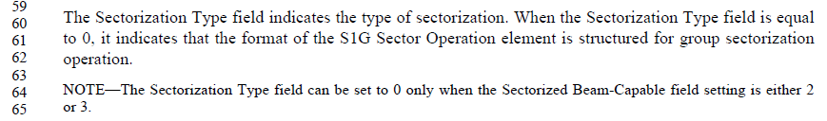

Similar language appears on the next page for the Sectorization Type field being set to 1.

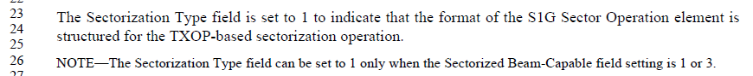

The relationship between the Sectorization Type field in the S1G Sector Operation element and the Sectorized Beam-Capable field in the S1G Capabilities element is described (but not very explicitly) in 10.49 (Sectorized beam operation):

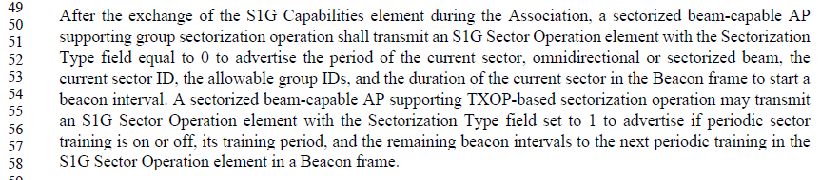
… and …
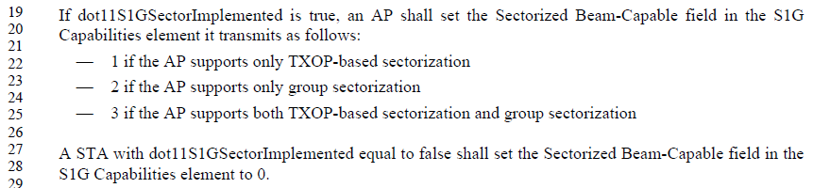

Following all this logic, the rules stated in the above NOTEs can be intuited. As a result, it could be claimed that this requirement is stated in normative text, and hence the NOTEs in clause 9.

Lastly, to address the implication that this NOTE has normative text, because of the use of “can be set to”, it should be noted that our normative verbs are ‘shall’, ‘should’ and ‘may’. ‘Can’ is agreed, per the 802.11 Style Guide to be a non-normative indication that this is an allowed behaviour, per normative statements elsewhere in the Standard.

Proposed Resolution:

Rejected. The material in this NOTE (and the similar one on the next page) is normatively required per behaviour in clause 10. As such, it would create a duplicated normative requirement to change this information to a normative requirement in the cited location. Further, this is a behavioural requirement, where the contents of this frame depend on other information provided earlier in other frame exchange(s). Such behavioural material should be in clauses 10 or 11, not clause 9 – and it is there. Therefore, the use of a NOTE, and the use of ‘can’ are both appropriate for this information.

Not ready for review, yet:

1498 |  |  |  |  | There is no such thing as "DSSS/CCK mode" | Change "DSSS/CCK Mode" (or "mode") to "DSSS/CCK PPDUs" in 9.4.2.55.2 (3x), 11.15.8 (4x), C.3 (1x). Change "dot11RMNeighborReportHTDSSCCKModein40MHz" to "dot11RMNeighborReportHTDSSCCKPPDUsin40MHz" in C.3 (3x)

Discussion:

Context:

This phrase occurs in the HT Capability Information field, and associated text:

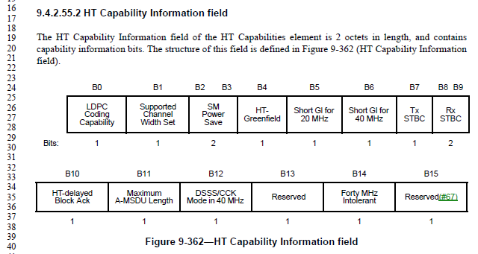

There is no text that describes this as a mode. It is an indication that DSSS/CCK PPDUs are allowed in the BSS when the operating channel width is 40 MHz. The name change does seem to more accurately reflect the purpose.

However, changing the name of a MIB attribute is more complex, as there may be external references to the current name. (Although, in this case, that is doubtful.)

Proposal: Suggest accepting the name change as requested. But, sending a notice to the 802.11 reflector first, asking if anyone is aware of any external references to the MIB attribute dot11RMNeighborReportHTDSSCCKModein40MHz, before finalizing this change.

Straw Poll:
- Make no change
- Accept proposed resolution
- Reword to include use of the word “mode”

- Change like, “if the BSS is operating in a mode that [does not] allow[s] transmission of DSSS/CCK PPDUs when the operating channel width is 40 MHz”

Proposed Resolution:

1557 | 1563.28 | 28 | 10.2.1 |  | HCF doesn't really use DCF architecturally. It 'replaces' DCF. | Change Figure 10-1 to show HCF (EDCA and HCCA) as directly using the PHY. Cleanup text in 10.2, 10.3 and 10.22 to not describe HCF as using DCF.

1609 | 138.08 | 8 | 2 |  | IEEE 802.3 has been updated | Update all clause 2 references for current versions

1043 | 318.60 | 6.3.7.2.2 | DMG Capabilities should be included in MLME-JOIN.request primitive rather than MLME-ASSOCIATE.request as HT Capabilities and VHT Capabilities. | As in the comment.
1044 | 319.03 | 6.3.7.2.2 | S1G Capabilities should be included in MLME-JOIN.request primitive rather than MLME-ASSOCIATE.request as HT Capabilities and VHT Capabilities. | As in the comment.
1045 | 335.64 | 6.3.8.2.2 | DMG Capabilities should be included in MLME-JOIN.request primitive rather than MLME-REASSOCIATE.request as HT Capabilities and VHT Capabilities. | As in the comment.
1046 | 336.06 | 6.3.8.2.2 | S1G Capabilities should be included in MLME-JOIN.request primitive rather than MLME-REASSOCIATE.request as HT Capabilities and VHT Capabilities. | As in the comment.
1329 | 217.08 | 4.3.15 | "A VHT STA is an HT STA that [...] but does not operate in the 2.4 GHz band." -- it needs to be clearer that it only operates in the 5 GHz band | Change "does not operate in the 2.4 GHz band" to "operates only in the 5 GHz band" in the cited text
1417 | 288.49 | 6.3.3.2.2 | OperationalRateSet, HT Capabilities and VHT Capabilities need to be passed in MLME-SCAN.request when ScanType is ACTIVE, since they are in the Probe Request frame | At the end of the table in the referenced subclause, add the OperationalRateSet, HT Capabilities and VHT Capabilities rows from the table in 6.3.4.2.2 (MLME-JOIN.request), adding "Present only if Only present if ScanType = ACTIVE." to the end of the rightmost cell of each added row
1434 | 722.20 | 8.3.5.14.2 | No justification is given for including the RXVECTOR in PHY-RXEND.indication when when dot11RadioMeasurementActivated is true | Delete the last para of the referenced subclause. Delete ",  RXVECTOR" at line 61
1444 | 1535.01 | 9.7.3 | The A-MPDU context tables randomly mix "MPDU" and "frame" | Change "MPDU" to "frame" throughout Tables 9-491 to 9-496, when not preceded by "A-" (i.e. do not change "A-MPDU" to "A-frame")
1507 | 723.43 | 8.3.5.17.2 | The only use of PHY-TXBUSY is as an immediate response to a PHY-TXSTART, where per 10.23.2.2.e) it is used to signal an internal collision. The IDLE state is never used | Delete "(STATE)" in 8.3.5.17.2. Delete the last para of 8.3.5.17.2. Delete "(BUSY)" in 10.23.2.2. Delete the "STATE" row of Table 8-3. Delete "The STATE of the primitive is set to BUSY. " and the last para of 8.3.5.17.3
1525 | 723.57 | 8.3.5.17.2 | The only use of PHY-TXBUSY only applies when there is an MM-SME | Change "The primitive is generated when" to "The primitive is generated when an MM-SME is present and" at the referenced location
1555 | 2646.15 | 15.4.5.11 | This Standard should specify requirements, not tests. | Remove all description of tests for 802.11 equipment. Replace, if/as necessary, with stated requirements for operation, if those are not already stated elsewhere. Potentially, move any lost information into Annex P. Similarly, 15.4.5.9 and 15.4.5.10 are effectively "testing" measurements, without saying so, and could be cleaned up to be clear this is a statement of requirements by not mentioning (for example), "shall be measured", "shall be determined by measuring", "test data" or "test reference receiver system", etc. Same thing in 15.4.5.11, 15.4.6.2, 15.4.6.4, 16.3.7.4, 16.3.7.8, 16.3.7.9, 16.3.7.10, 16.3.8.2, 17.3.9.7.2, 17.3.9.7.3, 17.3.9.8, 17.3.9.9, 17.3.10.3, 17.3.10.4, 18.4.8.3, 19.3.18.2, 19.3.18.7.4, 19.3.18.8, 19.3.19.1, 19.3.19.2, 19.3.19.3, 20.4.4.1.2, 20.5.4.1.1, 20.5.4.1.2, 21.3.17.2, 21.3.17.4.4, 21.3.17.5, 21.3.18, 22.3.17.2, 22.3.17.4.4, 22.3.17.5, 22.3.18.2, 23.3.16.2, 23.3.16.4.4, and 23.3.16.5, 23.3.17. (I'm sure I missed some...)
1558 | 287.54 | 6.3.2.2.3 | The subclauses on "When generated" (in the MLME) generally don't actually say anything about limitations on timing ("when") of using the primitive. | Add description of "timing" (really, mostly sequencing or state requirements) to these subclauses.
1559 | 278.28 | 5.2.2.2 | MA-UNITDATA doesn't have drop_eligible, to match 802.1AC's ISS. Facilities from 802.11aa could use it. | Add drop_eligible as a parameter to the request and indication primitives, and connect it to the DEI field (and to 802.1's parameter by asking 802.1 to remove the "ignored" statements).
1563 | 483.45 | 6.3.56.1 | Why does FTM clearly indicate (in Figure 6-17) the MLME separately from the (local) Antenna, for purposes of showing t1, t2, t3 and t4, but Timing Measurement (Figure 6-16) doesn't? | Show the Antenna connectors in Figure 6-16, similar to the way they appear in Figure 6-17.
1564 | 637.48 | 6.3.98.2.2 | There is no such "Contact Verification Signal element". In general, this primitive is a poster child for some primitives (especially in the GDD area, but elsewhere, too) that provide no value, but rather take the entire frame to be sent (or nearly) as a parameter to the primitive, and send (or indicate recieive of) the frame. WSM element. | Replace the single CVS parameter with a list (and helpful descriptions) of the information that is usefully exchanged with the MLME. Similarly to the other primitives for the CVS function. Similarly, for the FT ("REMOTE-REQUEST"), Mesh peering management, Channel Availability Query, and Network Channel Control functions.
1565 | 415.45 | 6.3.31.2.2 | Saying the LCI Management Request parameter is defined in 9.6.7.32 is pointless and not helpful. 9.6.7.32 actually says that this is a Measurement Request element (defined in 9.4) with most of the fields set to known (constant) values. We should only pass the information that is actually variable to this primitive. | Replace this parameter with two parameters, with column information: "Parallel", "Boolean", "true, false", "As defined in 9.4.2.20.1", and "Optional subelements", "As defined in 9.4.2.20.10", "As listed in Table 9-106", "Zero or more subelements to include in the request".  Same for Location Civic Measurement Request. Same in the Neighbor Report indication. Same in the FTM request and indication, and FTM Request request and indication.
1567 | 507.05 | 6.3.60.2.2 | Request Info is really not an Integer, but is an enumeration of behavior options and a single integer timeout. Packing these together into an 8 octet field makes sense in the protocol (clause 9), but in clause 6 we are trying to describe a logical interface and its purpose/usage. Split these two items apart, and describe each with appropriate semantics. | Replace Request Info with two entries with column values, "Automatic Report Enabled", "Enumeration", "CANCEL, CHANGES_ONLY ,PERIODICALLY_ONLY, PERIODICALLY_AND_CHANGES", "Indicates the requested interference resports, as defined in 9.6.13.13" and "Report Timeout", "Integer", "0 - 63", "Indicates minimum duration between reports, see 9.6.13.13".  Similarly for SCSResponse in MLME-SCS.response and .confirm, and SCS-TERM.request and .indication. Same for TWTFlow in TWTTEARDOWN.request and .indication, and MCSDifference in CONTROLRESPONSEMCS primitives.
1587 | 2893.15 | 21.1.1 | Where does it say VHT operates in 5 GHz (and not 2.4 GHz, for example), other than in clause 4 (not clearly normative - no "shall") and a weak hint in the column label in Table 21-3? | Add to the end of the sec ond paragraph in 21.1.1, "when the STA is operating in the 5 GHz band."

Completed:

CID | Page | Line | Clause | Submission | Comment | Proposed Change
1398 | 2281.10 | 10 | 11.4 |  | "Notify Channel Width frames and elements are used to" -- no such element | Delete "and elements" in the cited text at the referenced location

Discussion:

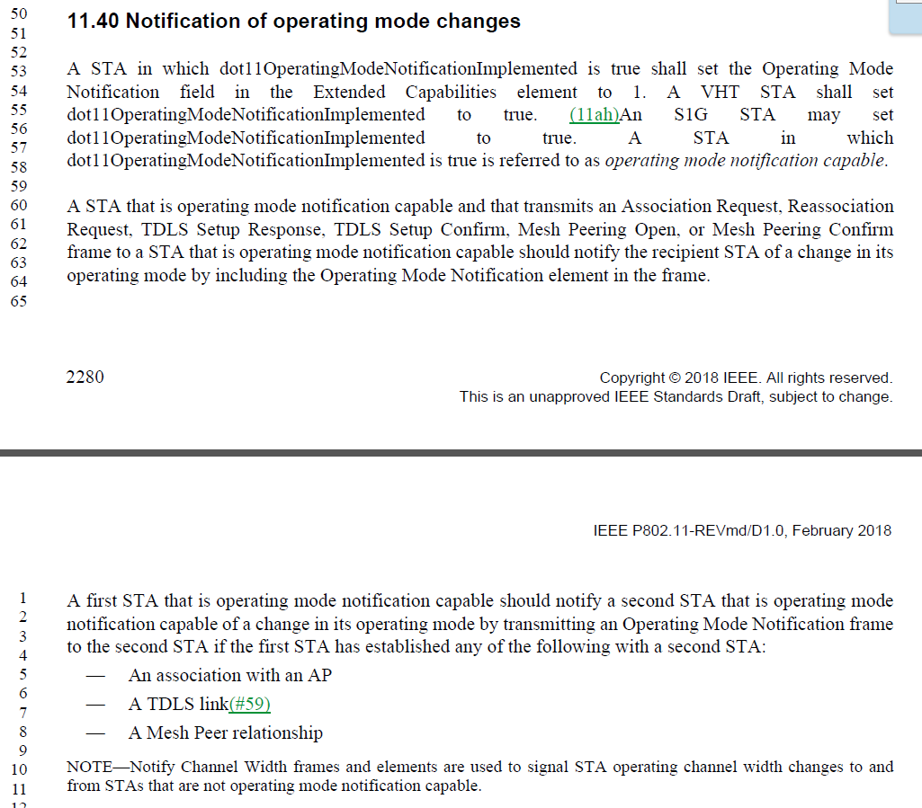

The commenter is correct, there is no such element. Perhaps this meant to say “Notify Channel Width frames and the contained Channel Width field”? In any regard, it seems superfluous.

Proposed Resolution:

Revised. Replace the cited note with: “A Notify Channel Width frame or the STA Channel Width field in the HT Operation element is used to signal STA operating channel width changes to and from STAs that are not operating mode notification capable.”

Editor: note that the clause number is 11.40.

1425 | 1592.15 | 15 | 10.3.2.10 |  | "A non-AP STA shall not transmit an Ack or BlockAck frame in response to a group addressed frame." -- an AP shouldn't ack group-addressed frames (i.e. RA = group) either | Delete "non-AP" in the cited text at the referenced location

Discussion:

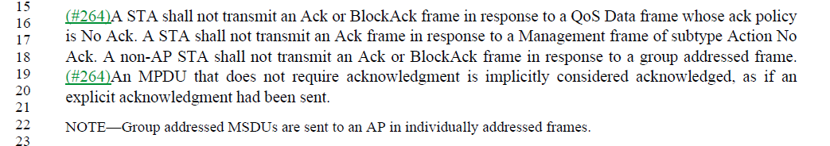

It seems, from the following NOTE, that the intention is that an AP should never receive a group addressed frame (only group addressed MSDUs in individually addressed frames), so the response rules for an AP are moot. Additionally, the filtering rules for Address 1 filtering should prevent an AP from passing any group addressed frame up the stack (to be acknowledged) as the dot11GroupAddressesTable should be null on an AP. From 10.2.7:

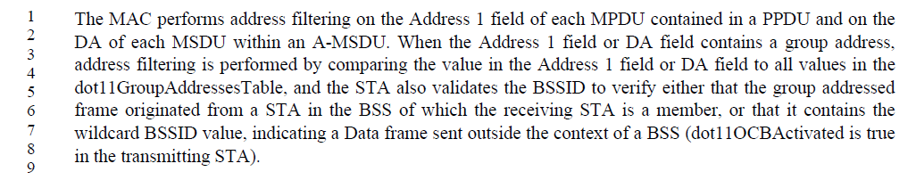

All that said, it doesn’t hurt to state that this rule applies to APs also, and does simply the sentence.

Proposed Resolution:

Accepted.

1381 | 2170.40 | 40 | 11.22.7.1 |  | "A STA  whose dot11BSSTransitionActivated is true shall support BSS transition management and shall set to 1 the  Transition field of the Extended Capabilities elements that it transmits" -- no such field | In the cited text at the referenced location change "Transition" to "BSS Transition"

Discussion:

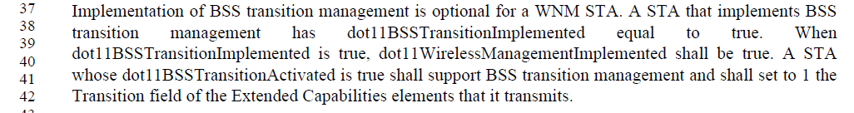

Per the definition of the Extended Capabilites field:
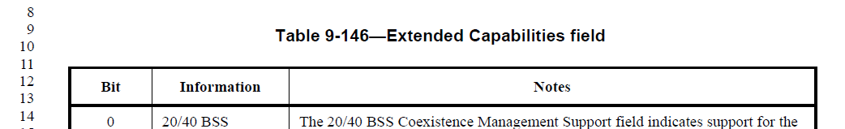

Bit 19 is in fact called “BSS Transition”.

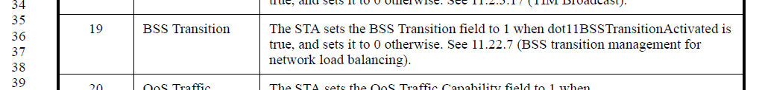

Proposed Resolution:

Accepted.

1382 | 2170.40 | 40 | 11.22.7.1 |  | "A STA  whose dot11BSSTransitionActivated is true shall support BSS transition management and shall set to 1 the  Transition field of the Extended Capabilities elements that it transmits" -- should also have implemented set to true | In the cited text at the referenced location add "shall have dot11BSSTransitionImplemented set to true," after "is true"

Discussion:

While logically both do need to be true, also, logically, there is no way dot11BSSTransitionActivated could be true if the feature were not implemented, hence dot11BSSTransitionImplemented must be true without needing to state so.

Proposed Resolution:

Rejected. For dot11BSSTransitionActivated to be true, logically, dot11BSSTransitionImplemented must also be true without needing to state so.

1390 | 1063.46 | 46 | 9.4.2.36 |  | "The Measurement Pilot Transmission subelement has the same format as the Measurement Pilot Transmission element (see 9.4.2.42 (Measurement Pilot Transmission element)). The Measurement Pilot Interval subelement is not included if" -- last Interval should be Transmission | Change "Interval" to "Transmission" in the cited text at the referenced location

Discussion:

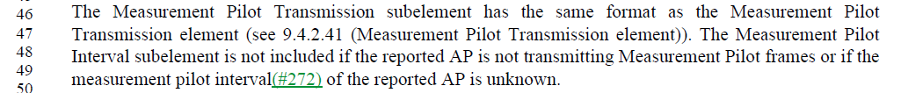

Agree with commenter.

Proposed Resolution:

Accepted. Note to Editor, the change is actually at P1063L48.

CID | Page | Line | Clause | Submission | Comment | Proposed Change
1394 | 1337.37 | 37 | 9.4.3 |  | All the statements of the form "The $blah field contains zero or more subelements. The subelement format and ordering of  subelements are defined in 9.4.3 (Subelements)." are unclear as to whether you can have more than one subelement with the same Subelement ID | Add a para at the end of 9.4.3: "Unless stated otherwise, no more than one subelement with the same Subelement ID is present within an element."

Discussion:

From 9.4.2.20.5:

Many (but not all) of the occurances of the cited statements are of the above form, specifying Optional Sublements, and all of them appear to include the Vendor Specific element. While several other elements (besides Vendor Specific) don’t make sense to include more than one time, there are a few that could potentially be reasonable, and certainly more than one Vendor Specific element could be reasonable. Given this, and the potential for making existing implementations non-compliant if they do include more than one of some element type, the suggestion is not to add this restriction. No clear problem is identified by the commenter for allowing more than one of some element types/IDs.

Proposed Resolution:

Rejected. Adding such a restriction could make existing implementations non-compliant. Further, the comment provides no clear problem that would be solved by such a restriction.

1369 | 1964.60 | 60 | 11.1.7 |  | 11.1.4.6 Operation of Supported Rates and BSS Membership Selectors element and  Extended Supported Rates and BSS Membership Selectors element and 11.1.7 Supported rates and extended supported rates advertisement cover the same material | Delete Subclause 11.1.7

Discussion:

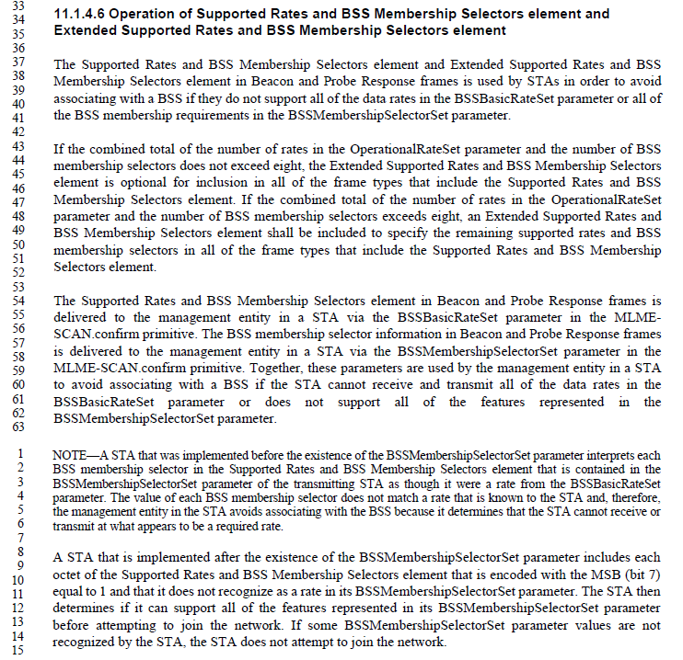

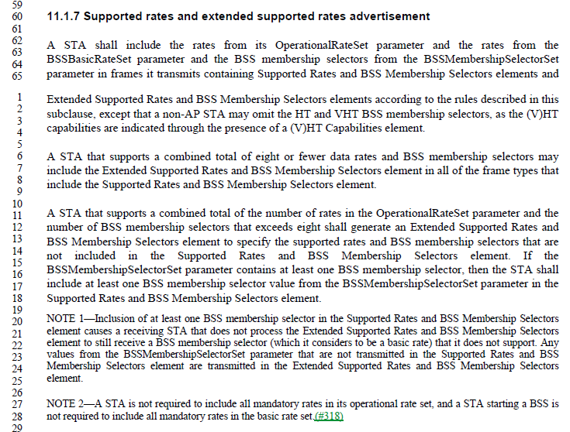

Examining the above, it can be seen that 11.1.7 describes the transmitter of this information (the transmitter of Beacons and Probe Responses), while 11.1.4.6 describes the behavior of a receiver of this information. There is some information that is repeated, and could potentially be trimmed (for example the optional inclusion of an Extended Supported Rates and BSS Membership Selectors element if the total number of supported rates and BSS membership selectors is eight or less). However, this overlap is small, and is helpful to understand the complete scope of what each of the transmitter and receiver needs to accommodate (respectively).

Proprosed Resolution:

Rejected. Subclauses 11.1.4.6 and 11.1.7 describe required behavior for the receiver and transmitter of these elements, respectively. There is minimal duplicated information between these two subclauses, and only where it helps understand the overall behavior expectations of the receiver or transmitter, appropriately.

1397 | 966.46 | 46 | 9.4.2.20.19 |  | "The Randomization Interval field specifies the upper bound of the random delay to be used prior to making the measurement, in units of TUs. See 11.11.3 (Measurement start time)." --- the xref is bogus as 11.11.3 is about radio measurement frames not FTM frames | Delete "See 11.11.3 (Measurement start time)." in the cited text at the referenced location

Discussion:

The cross-reference in 9.4.2.20.19 is actually to 11.10.3:

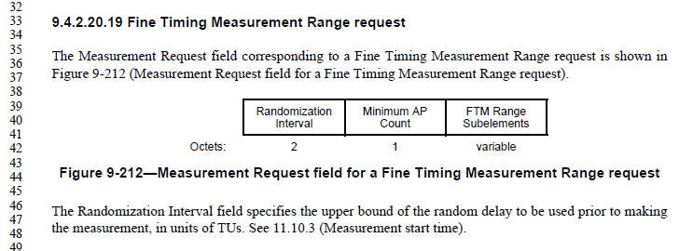

11.10.3 discusses the start time for Radio Measurement Requests, including the randomization interval. This applies to all measurement types listed in 11.10.

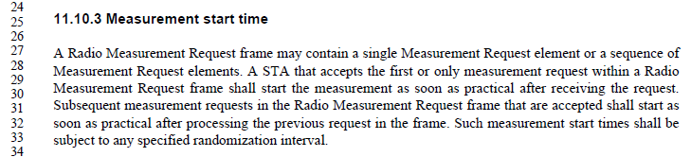

And, finally, 11.10.9.11 lists Fine Timing Measurement Range report as one such request. Also, note this is Fine Timing Measurement *Range* report, which is a request for the receiving STA to start a Fine Timing Measurement procedure (to meaure range to one or more third devices), not an actual/direct use of Fine Timing Measurement between the requesting and receiving STAs.

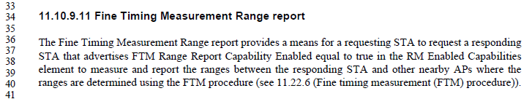

Since this is a request for the receiving STA to perform a measurement, that request can be satisfied using the randomization interval, just like for any other measurement request. Thus, the cross-reference is correct.

Proposed Resolution:

Rejected. The request in 9.4.2.20.19 is for a Fine Timing Measurement Report, not for a Fine Timing Measurement procedure directly. Such a request for a report can use the randomization interval before starting, as specified in 11.10.3. Thus, the cross-reference is correct. See also 11-18/0669 for more detailed discussion.

1354 | 766.25 | 25 | 9.3.1.1 |  | It is not very clear that Figure 9-22 normatively requires most FC subfields in Control frames to be 0 | Below the referenced figure add a "NOTE---The To DS, From DS, More Frag, Retry, Protected Frame and +HTC subfields in the Frame Control field within Control frames carried in a  non-S1G PPDU are reserved."

Discussion:

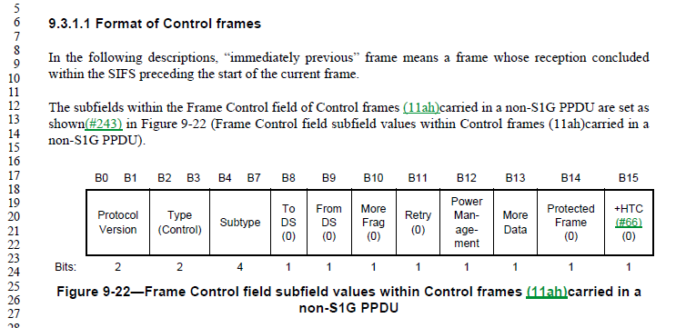

While it is true that these fields are effective reserved (currently) for a non-S1G PPDU Control frame, this is not the usual meaning of reserved. Normally, reserved means the bits are meaningless in a given frame, and so are reserved for future use by “protecting” that they are set to zero in current transmitter implementations, and ignored by current receivers, to future proof a potential use in a later version of the Standard. In this case, they are meaningful bits, which happen to have known and fixed values in the particular context of a non-S1G PPDU Control frame. As such, it can be argued that a receiver is not expected to ignore these fields, but could (potentially) rely on the zero values specified.

Further, this is not the only use of this convention (specifying a fixed value for a field, in a certain context). See Figures 9-33, 9-296, 9-297, 9-895, and others. If any change is made, it should be a description of this nomenclature style, in subclause 9.2.2.

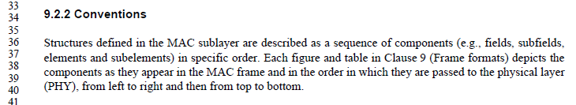

Proposed Resolution:

Revised. Add a sentence to the end of the first paragraph in 9.2.2, “A field or subfield within the figure depiction of a frame format that includes a decimal value within parentheses indicates that this field or subfield is set to the indicated value upon transmission.”

1281 | 839.64 | 64 | 9.4.1.7 |  | In Table 9-51, Reason codes 40-44 are not defined. | Please change the Reason code "45" to "40-45".

Discussion:

Context:
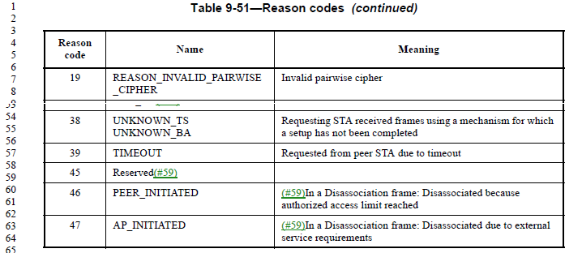

Robert Stacey (ANA coordinator) confirms that these entries were assigned to 802.11e, and were apparently not used. They should be marked as “Reserved” in Table 9-51, and marked appropriately for future use in the ANA database (which Robert will do).

By changing the Reason code column from “45” to “40-45” (as proposed), codes 40 through 44 will become Reserved.

Proposed Resolution:

Accepted.

1400 | 2272.22 | 22 | 11.38.1 |  | "the STA shall indicate support for MCSs 8(n-1) to 8(n-1)+7" should be clearer as to what kind of MCS | On lines 22 and 23 at the referenced page change "MCS" to "HT-MCS"

Discussion:

Context:
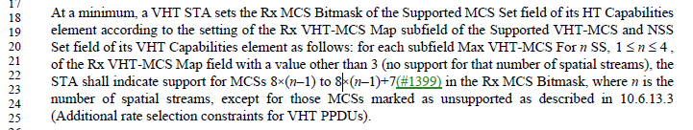

Arguably, it should be apparent that setting bits in the Rx MCS Bitmask contained in the HT Capabilites element, would be indicating HT MCS rates. However, this paragraph is already rather confusing with the number of cross-references between VHT and HT capabilities in the text, there is potential for confusion, so the proposed change seems to cause no harm and might be helpful.

The use of “HT-MCS” (with the hyphen) seems to be limited to “Basic HT-MCS Set” (the fieldname), however. The usage is “HT MCS” where the “HT” is an adjective.

Proposed Resolution:

Revised. On lines 22 and 23 at the referenced page change “MCSs” to “HT MCSs”.

1401 | 1975.43 | 43 | 11.2.3.6 |  | "If the STA has set up to use  unscheduled SPs, the AP shall buffer BUs using delivery-enabled ACs until it has received a trigger  frame using a trigger-enabled AC from the non-AP STA, which indicates the start of an unscheduled  SP. A trigger frame received by the AP from a STA that already has an unscheduled SP underway  shall not trigger the start of a new unscheduled SP. The AP transmits BUs destined for the STA and  using delivery-enabled ACs during an unscheduled SP." -- 1) this seems to be the only specification of trigger frame handling for U-APSD at the AP, but "tramsmits BUs" is vague; 2) it is not clear whether/how/when MMPDUs are "using delivery-enabled ACs" | After the cited text at the referenced location add "NOTE 1---Transmission of BUs during an unscheduled SP is constrained by the max SP length.  NOTE 2---The AC for delivery of an MMPDU (see 10.2.3.2) determines whether it is transmitted using a delivery-enabled AC during an unscheduled SP."

Discussion:

Context: (The text is quoted in the comment, but shown here to make it easier to read, and show the context within 11.2.3.6.)
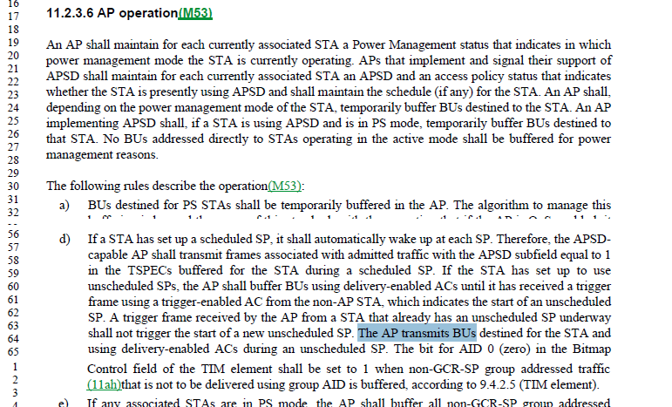

While the statements made in the proposed NOTEs are already made elsewhere, they are correct, and it might be helpful to the reader’s understanding to have those reminders in this context.

Proposed Resolution:

Revised. Make the proposed changes, by adding the NOTEs at the end of bullet (d).

1403 | 2018.42 | 42 | 11.3.4.3 |  | Missing clarification cf. 11.3.4.2 | At the end of step g) add "; the state shall remain unchanged if it was other than State 1"

Discussion:

Context:

11.3.4.3(g) does leave it vague what (if anything) happens to the state after successful Authentication, if was not in State 1. Since it doesn’t say anything is changed, the assumption would be that nothing is changed, but that’s a bit vague.

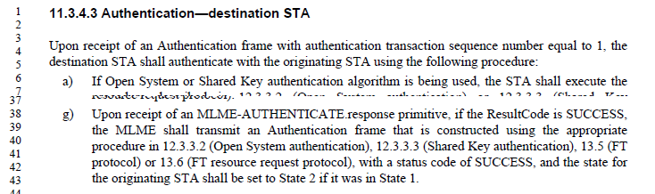

11.3.4.2(c) has this, to make the assumption more explicit:

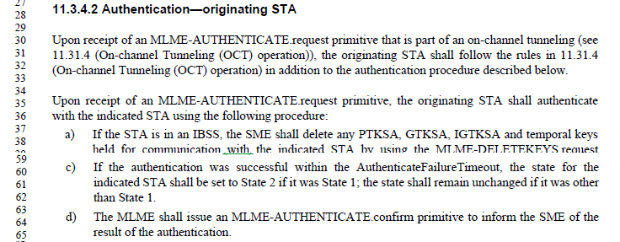

Proposed Resolution:

Accepted.

1405 | 1971.34 | 34 | 11.2.3.5.1 |  | "An unscheduled SP ends after the AP has attempted to transmit at least one BU using a delivery-enabled AC and destined for the STA, but no more than the number indicated in the Max SP Length field of the QoS Capability element of the STA's (Re)Association Request frame if the field has a nonzero value." -- it doesn't necessarily end after the AP has attempted to transmit one BU. It ends when the AP has transmitted an EOSP or the number of BUs reaches Max SP Length | Change the cited text at the referenced location to "An unscheduled SP ends after the AP has attempted to transmit at least one BU using a delivery-enabled AC and destined for the STA, but no more than the number indicated in the Max SP Length field of the QoS Capability element of the STA's (Re)Association Request frame if the field has a nonzero value, where the last BU is transmitted in MPDUs with EOSP subfield set to 1."

Discussion:

Context:

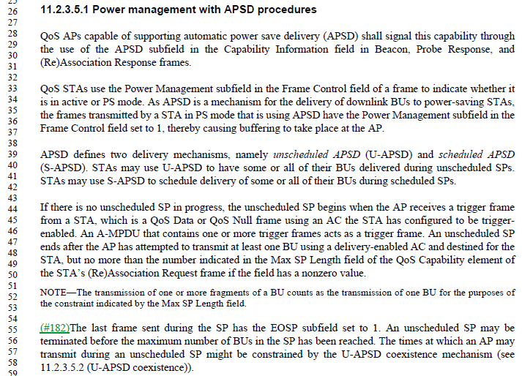

The fourth paragraph does have the quoted text. This paragraph gives a description of the start and end points of the service period. The following paragraph gives the details that the last frame in the SP must have the EOSP set to 1, and that this might be before the Max SP Length has been reached. Thus, all the information requested is present in these two paragraphs, already.

Proposed Resolution:

Rejected. The requested information is already present in the paragraph following the cited text.

1414 | 2127.44 | 44 | 11.15.8 |  | If the DSSS/CCK Mode in 40 MHz subfield is equal to 0 in a beacon/probe response, it is not clear whether the STA is required to set it to 0 in the association request. The description is "An HT STA declares its capability to use DSSS/CCK rates while it has a 40 MHz operating channel width", which is vague (capability to use v. intent to use). However, it seems clear that if the AP says DSSS/CCK Mode in 40 MHz is not allowed, the STA's signal of capability to transmit such is irrelevant | Append "- The DSSS/CCK Mode in 40 MHz subfield transmitted by a (re)associating STA is ignored." at the end of the list in the para after the referenced location

Discussion:

Context:

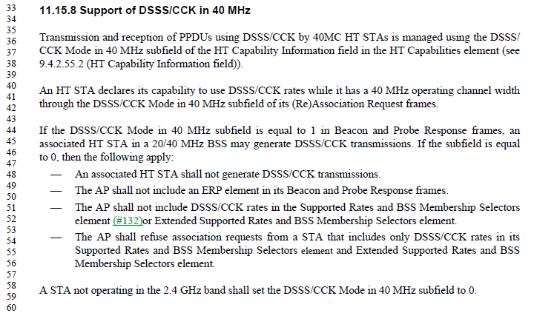

The second paragraph of 11.15.8 makes it clear that an HT (non-AP) STA indicates “its capability to use DSSS/CCK” with 40 MHz channel width, in the DSSS/CCK Mode in 40 MHz subfield in (Re)Association requests to the AP.

The first sentence of the third paragraph makes it clear that an HT AP will indicate support in the same subfield in Beacons and Probe Responses. If the AP supports this, the non-AP STA may generate such transmissions.

If the AP does not support this, the (non-AP) associated HT STA shall not generate such transmissions. However, the bullet list that describes this situation is vacuuous on how the non-AP STA should set the subfield on its (Re)Association Request.

Since the AP will not transmit DSSS/CCK with 40 MHz channel width anyway, it seems irrelevant what the non-AP STA puts in the (Re)Association Request. Thus, the proposed change seems arguably unnecessary, but it does clarify what it currently underspecified in a backwards compatible way.

Proposed Resolution:

Accepted.

1008 | 1337.43 | 43 | 9.4.3 |  | Definition of subelement is not aligned with actual use of it. In relation to Measurement request and Measurement report IE the statement that "Each subelement is assigned a subelement ID that is unique within the containing element or subelement." is not true. The sub elements are defined within the Measurement type. | Add to the sentence as follows:  Each subelement is assigned a subelement ID that is unique within the containing element or subelement, or measurement type of the Measurement Request IE and Measurement Report IE.

Discussion:

Context:

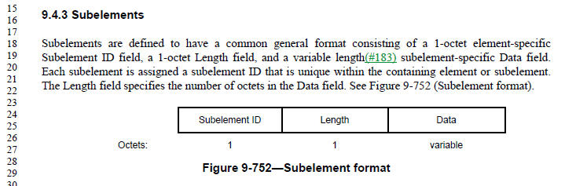

9.4.3 does make the claim as stated, that all subelements are uniquely identified within “the containing element or subelement.”

Looking at the definition of the subfields in a Measurement Request, we turn to the following format definition:

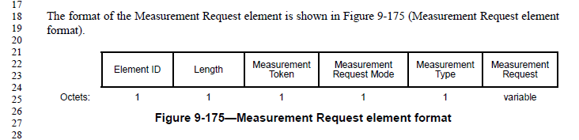

It can be seen that the Measurement Request element has a subfield of Measurement Request. Further the Measurement Request is defined, based on the Measurement Type, by the following descriptions:
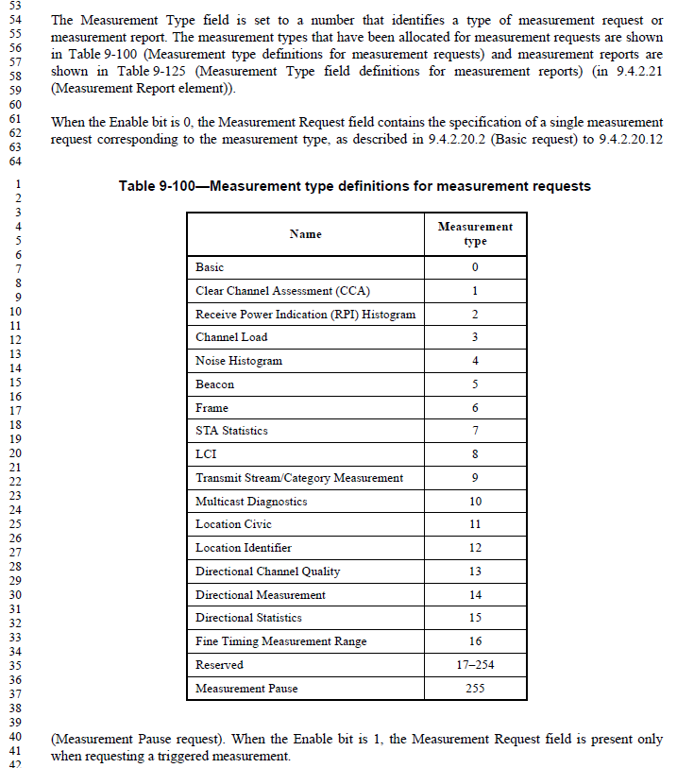

One sudh Measurement Request field is the “Basic request”, defined in 9.4.2.20.2:

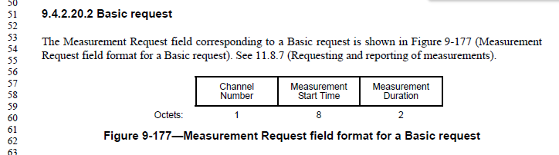

It can be seen that the Basic request is not a sublement, however, and in fact it has no ID at all.

Rather, the interpretation of this construct is that the Measurement Request element is a variable element, where one field (the Measurement Request field) has a format that is dependent on another field (the Measurement Type field). This is no longer a “subelement” construct, as are described in 9.4.3. Thus, 9.4.3 has no error.

Proposed Resolution:

Rejected. The Measurement Request field (of a Measurement Request element) is not itself a subelement, and has no ID at all for which a uniqueness context can be described. Thus, 9.4.3 does not apply to this structure, so this is not a counter-example of the correctness of 9.4.3. No change to 9.4.3 seems necessary. The same logic applies to the Measurement Report structure.

1282 | 847.19 | 19 | 9.4.1.9 |  | In Table 9-52, Status code 123 is double defined. | Please change Status code "114-65535" to "114-122, 124-65535".

Discussion:

Context:

From 802.11REVmd_D1.0:
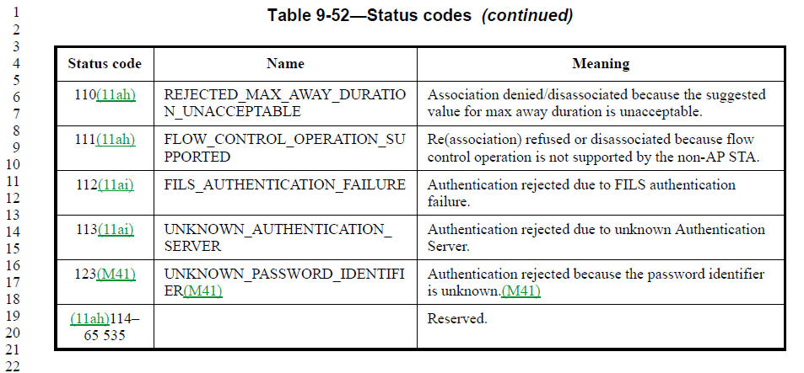

The value 123 is indeed defined individually and also covered by the range 114-65535.

However, from 802.11REVmd_D1.2:

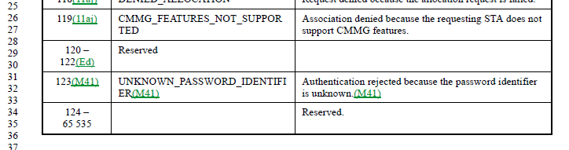

It seems the REVmd editors already caught this error, during the roll-in of 802.11ai, and the error has already been fixed, in a manner consistent with (but not exactly matching) the commenter’s request.

Proposed Resolution:

Revised. Split the Reserved range into two sub-ranges, excluding the value 123.

Note to EDITOR: This change is already made in REVmd-D1.2.

Note to EDITOR: The representation of “Reserved” in this Table is inconsistent, sometimes appearing in the “Name” column and sometimes in the “Meaning” column. The Table should be consistent.

1018 | 1571.58 | 58 | 10.2.7 |  | This section talks about filtering group addressed frames from a STA and  received by the STA relayed back from AP in an infrastructure BSS. It is not clear where  this filtering happens. Is this along with address filtering on Address 1 or later? Where do this reside, say in Figure 5-1  MAC data plane architecture? | It should be done after replay detection for AES and perhaps after MSDU MIC check for TKIP

Discussion:

Context:

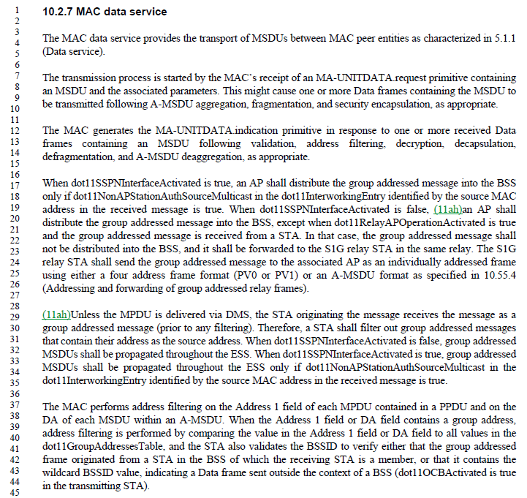

The fourth and fifth paragraphs discuss the behavior when group addressed messages are present in an infrastructure BSS. It is correct that this text prescribes a (non-AP) STA to filter out group addressed messages that contain the STA’s own address as the source address, and that it is not specified where this occurs in the “stack”.

However, it does not seem important where this happens, as the rule is simple, and will be applied to each and every such frame received with the STA’s own address as the source address. It seems there is little harm in doing this very low/early in the receive stack, since the frame will be discarded anyway, so checking the MIC or for retries (which will only discard the frame for other reasons) doesn’t seem to matter. Conversely, if the frame is discarded only higher in the stack, consideration has to be given for DOS attack vectors, etc. However, this frame will never be processed fully up the stack, so again, attacks that cause incorrect discarding (for the wrong reason) have no net effect. Finally, the frame generates no response (no ACK is generated for such group addressed frames, for example), so there is no consideration for the transmitter’s view of the process.

So, it seems this can be entirely an implementation choice, as to where in the stack such frames are discarded, as long as it is accomplished consistently at some point.

Proposed Resolution:

Revised. Append “; the point at which such filtering occurs in the processing of received frames is an implementation choice” to the end of the second sentence of the fifth paragraph of 10.2.7.

1033 | 1945.01 | 1 | 11.1.3.9 |  | The sentence "In the case of an infrastructure BSS, the STA's TSF timer shall then be set to the adjusted value of the timestamp." on Line 1 is redundant, because the sentence on Line 9 covers it. | Delete the cited sentence on Line 1.

Discussion:

Context:

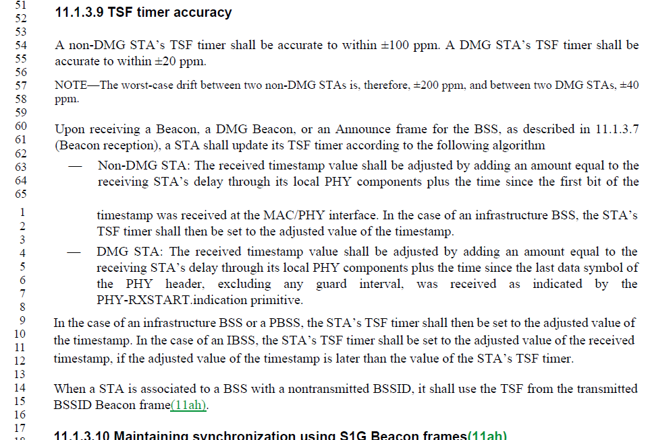

The statement at line 1 is the last step for that bullet, and it does seem to be exactly covered by the following paragraph’s first sentence.

Proposed Resolution:

Accepted. Note to EDITOR: The copy to delete is the one at the end of the first bullet’s text in 11.1.3.9. The copy at the start of the next (non-bulleted) paragraph is to be retained.

1114 | 783.30 | 30 | 9.3.1.19 |  | With the 11ah changes, this statement is now incomplete. | Change to "If the VHT NDP Announcment frame is transmitted by a non-S1G STA, then the format of the STA Info field is shown in Figure 9-55."

Discussion:

Context:

The cited text:

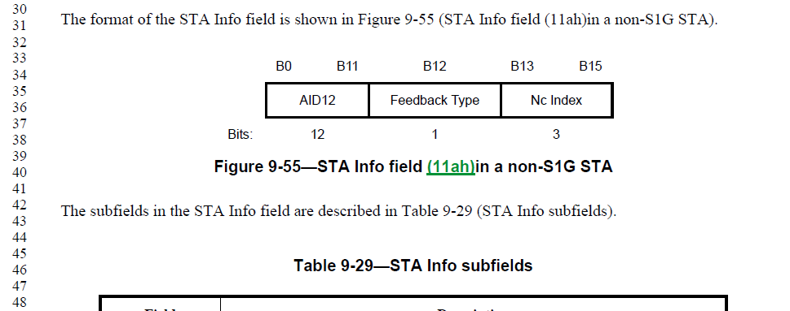

With details of the subfields folling.

Then, after all that, there is new text, added by 11ah:

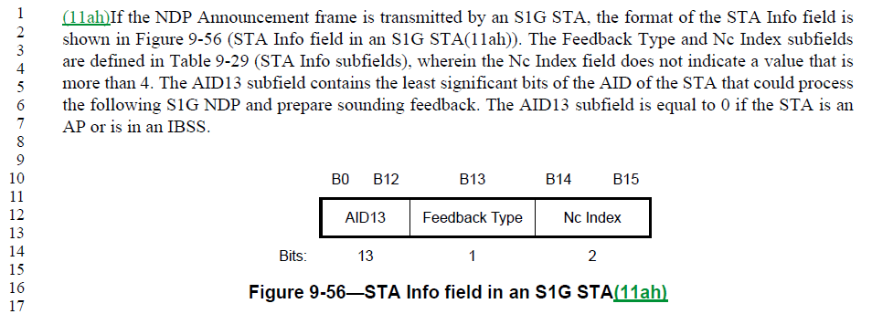

Clearly, 11ah did intend the STA Info field to have a different format for S1G and non-S1G. The proposed change does clarify this.

Proposed Resolution:

Accepted.

1305 | 1565.59 | 59 | 10.2.3.1 |  | Text states "Frames listed in Table 9-376 (HT Action field values)(11ah)," Frames are not listed in these tables. It lists values | Grammar? Should it say "frames using values in tables.......with a value of yes in the "time priority" column....

Discussion:

Context:

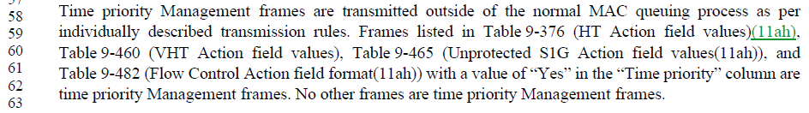

The commenter is correct, in that the referenced Tables list values (used in the Action field, of various Action frame categories), as shown in this example (the others are similar):

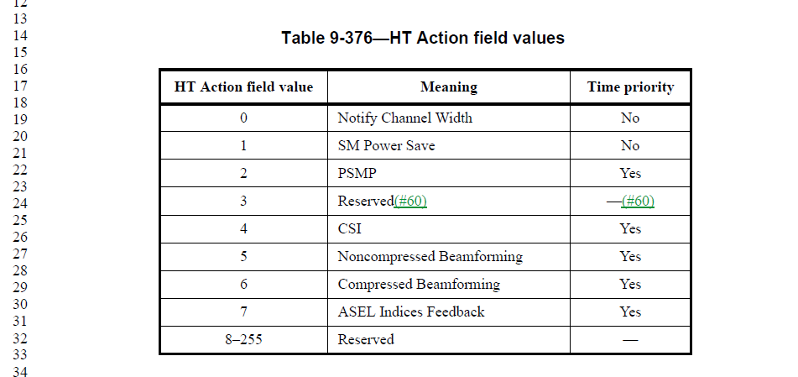

However, there is an (unwritten?) convention that a phrase that means “Action frame with <category> Action field value of <x>” is referenced in the Standard as an “<x> frame”. For example, an HT Action frame with HT Action field value of “PSMP” is called a “PSMP frame”.

So, when the cited text in 10.2.3.1 says “Frames listed in Table 9-376, etc., is this using the same shorthand convention and implicitly means, “Action frames with HT Action field value of PSMP listed in Table 9-376”?

If this convention is sufficiently clear and understood, then no change is needed.

If this convention is unclear/vague enough that clarification is needed, the text could be changed to say “Frames with Action field values of the appropriate category as listed in Table 9-376, etc.” This accomplishes the apparent direction the commenter suggested, without the vague use of “frames using values …”.

Proposed Resolution:

Revised.
Change
“Frames listed in Table 9-376 (HT Action field values)(11ah), Table 9-460 (VHT Action field values), Table 9-465 (Unprotected S1G Action field values(11ah)), and Table 9-482 (Flow Control Action field format(11ah)) with a value of “Yes” in the “Time priority” column are time priority Management frames.”
to
“Time priority Management frames are defined to be those that have a value of “Yes” in the “Time priority” column in Table 9-376 (HT Action field values)(11ah), Table 9-460 (VHT Action field values), Table 9-465 (Unprotected S1G Action field values(11ah)), and Table 9-482 (Flow Control Action field format(11ah))”

1338 | 1285.37 | 37 | 9.4.2.185 |  | " At least one of the bits in FILSC Type field is set to 1. " -- but setting one of the reserved bits would not be helpful (and would be contrary to the definition of "reserved") | Change the cited text at the referenced location to "At least one of the non-reserved bits in FILSC Type field is set to 1."

Discussion:

Context:

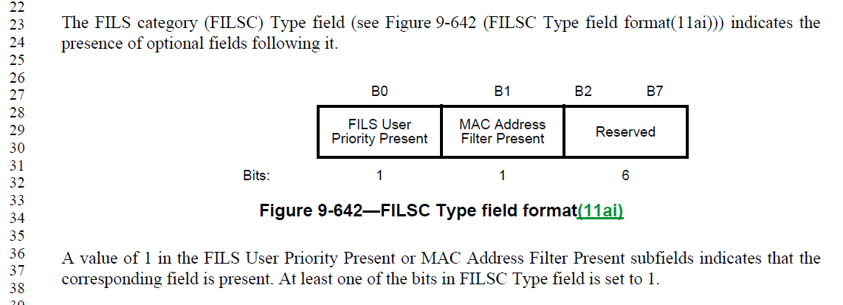

The proposed change would clarify the intent, for the avoidance of any doubt.

Proposed Resolution:

Accepted.

1343 | 1955.16 | 16 | 11.1.4.3.4 |  | "If the next Beacon is not used as a response" is missing "frame" | Add "frame" after "Beacon" in the cited text at the referenced location

Discussion:

Context:

Similarly, on P 1937:

Proposed Resolution:

Revised. Make the change as proposed, and also make the same change at P1937.15.

1349 | 2287.18 | 18 | 11.42.3 |  | "A GDD dependent STA shall cease all transmission when (#172)dot11GDDEnablementValidityTimer has expired" -- a MIB variable cannot expire | Change the cited text in the referenced location to  "A GDD dependent STA shall cease all transmission when the GDD enablement validity timer has expired".  In the para above delete  "by decrementing dot11GDDEnablementValidityTimer".  In Figure 11-51 change "dot11GDDEnablementValidityTimer has expired" to "GDD enablement validity timer has expired".  In 11.42.4.1 change  "it reinitializes the dot11GDDEnablementValidityTimer to"  to  "it reinitializes the GDD enablement validity timer".  In C.3 delete dot11GDDEnablementValidityTimer.  In Tables E-8 and E-11 delete the dot11GDDEnablementValidityTimer row

Discussion:

Context:

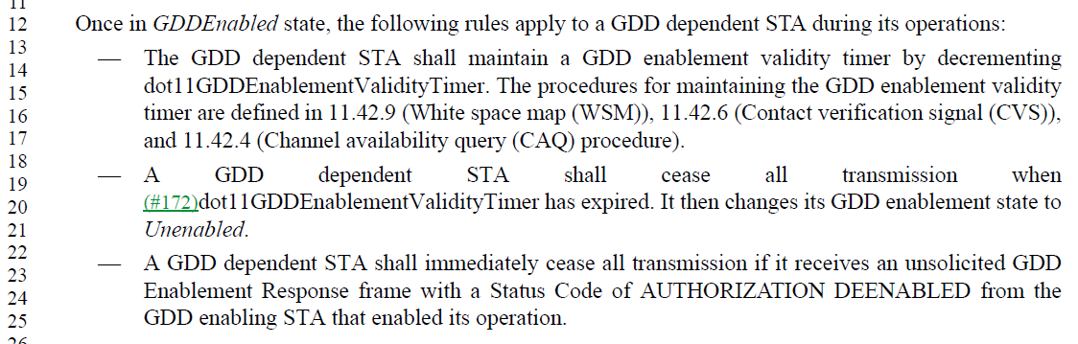

The first bullet introduces the term “GDD enablement validity timer”, and subsequent references to decrementing, reinitializing and expiry should reference this conceptual timer, as there appears no need for a MIB attribute tracking this timer’s value.

Thus, the first two proposed changes appear to be correct.

Context for Figure 11-51:

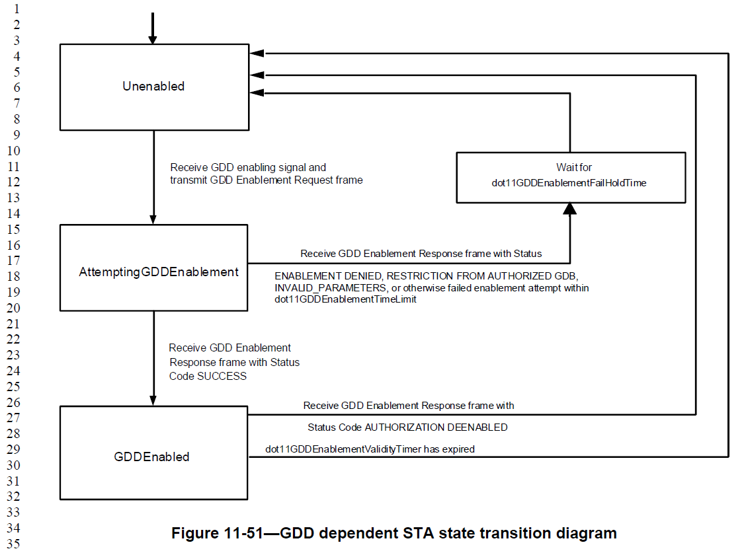

The third proposed change appears correct.

11.42.4.1 context:

The fourth change appears correct in intent. But the replacement text should include the “to” at the end. Thus,
In 11.42.4.1 change
"it reinitializes the dot11GDDEnablementValidityTimer to"
to
"it reinitializes the GDD enablement validity timer to".

C.3 contexts:

The cited location (to be deleted):
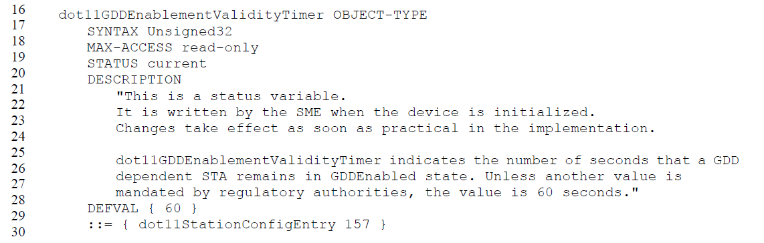

And, the definition for dot11ContactVerificationSignalInterval:

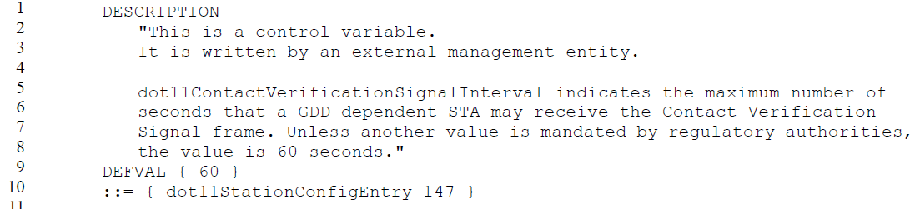

There seem to be a number of issues with these definitions. First, dot11GDDEnablementValidityTimer can’t be a status variable if it is initialized by the SME. But, the proposed resolution is to delete this attribute entirely, and use the conceptual (local) timer instead. Okay, except we don’t delete MIB attributes, we mark them obsolete.

Look next at dot11ContactVerificationSignalInterval, which is the value the timer is reset to, upon each response for its Channel Availability Query frame from the GDD enabling STA. There is no text describing how an external entity sets this attribute, in fact, there are two “shall” statements that this attribute shall be set to 60 seconds in both the US/Canada and Europe. Also, the DESCRIPTION seems to be missing a temporal verb, probably “wait to”.

Suggest to add to the text (with the “shall” statements) introducing Tables E-8 and E-11:
All GDD dependent STAs shall set the dot11GDD timer values as shown in Table E-11 (TVWS GDD timer limits), unless otherwise mandated by regulatory authorities.
and to modify the DESCRIPTION for this MIB attribute as shown:
dot11ContactVerificationSignalInterval indicates the maximum number of
seconds that a GDD dependent STA may wait to receive the Contact Verification
Signal frame before stopping operation in TVWS. Unless another value is mandated by regulatory authorities, the value is 60 seconds."

That leaves the final proposed change to remove the dot11GDDEnablementValidityTimer row from Tables E-8 and E-11. This change seems correct.

Finally, due to a spelling error, two more instances of dot11GDDEnablementValidityTimer, in subclause 11.42.6, were missed in this comment’s proposed resolution. Conext:

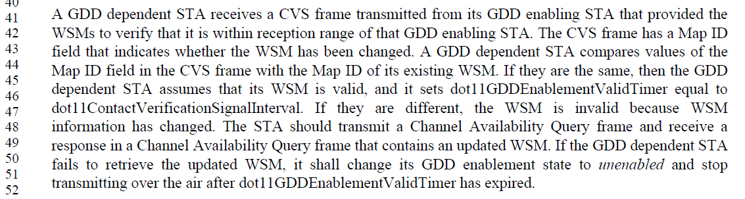

Propose to correct this text, also, by replacing “dot11GDDEnablementValidityTimer” with "the GDD enablement validity timer” in both occurrances.

Proposed Resolution:

Change the cited text in the referenced location to:
"A GDD dependent STA shall cease all transmission when the GDD enablement validity timer has expired".

In the para above, delete:
"by decrementing dot11GDDEnablementValidityTimer".

In Figure 11-51 change "dot11GDDEnablementValidityTimer has expired" to "GDD enablement validity timer has expired".

In 11.42.4.1 change:
"it reinitializes the dot11GDDEnablementValidityTimer to"
to
"it reinitializes the GDD enablement validity timer to".

In Tables E-8 and E-11 delete the dot11GDDEnablementValidityTimer row

In C.3, mark dot11GDDEnablementValidityTimer as deprecated with appropriate collateral changes as follows:
  - Change its STATUS to “Deprecated”.
  - Insert a new first line in the DESCRIPTION: “Deprecated as the related feature has been removed from the standard”.
  - For any reference to the variable in any GROUPs, re-instate this reference.
  - Change the groups STATUS to “Deprecated”.
  - In the DESCRIPTION, insert a new first line: “Superseded by YYYY.” (Note that “YYYY” is the new GROUP name.)
  - For each of the groups noted above, copy the group, set its status to “Current” and increment (or add) a number after the name of the group name (e.g. dot11SMTbase11 -> dot11SMTbase12).
  - Make the corresponding changes (e.g. add or remove MIB varables) in the new group
  - For each reference to one of the noted groups from a compliance statement, update it to refer to the new group.

In the text just before Tables E-8 and E-11 makes changes as shown:
All GDD dependent STAs shall set the dot11GDD timer values as shown in Table E-11 (TVWS GDD timer limits), unless otherwise mandated by regulatory authorities.

In C.3, change the DESCRIPTION of dot11ContactVerificationSignalInterval as shown:
dot11ContactVerificationSignalInterval indicates the maximum number of
seconds that a GDD dependent STA may wait to receive the Contact Verification
Signal frame before stopping operation in TVWS. Unless another value is mandated by regulatory authorities, the value is 60 seconds."

Replace “dot11GDDEnablementValidityTimer” with "the GDD enablement validity timer” in both occurrances in 11.42.6.

1273 | 1019.57 | 57 | 9.4.2.24.1 |  | "AES-128-CMAC" is a name of the integrity protection algorithm used by the cipher that is called "BIP-CMAC-128". However, couple of places that are clearly referring to a cipher are incorrectly using the name of the algorithm rather than the cipher. | Replace "AES-128-CMAC" with "BIP-CMAC-128" at page 1019 line 57 and page 1020 line 27.

Discussion:

Context:

The cited text is here:

. . .
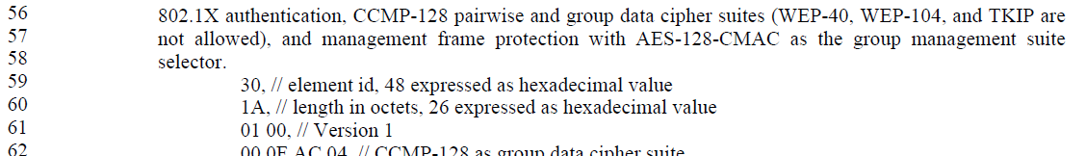

The “BIP-CMAC-128” suite selector is listed in the table of Cipher suite selectors on the next page.

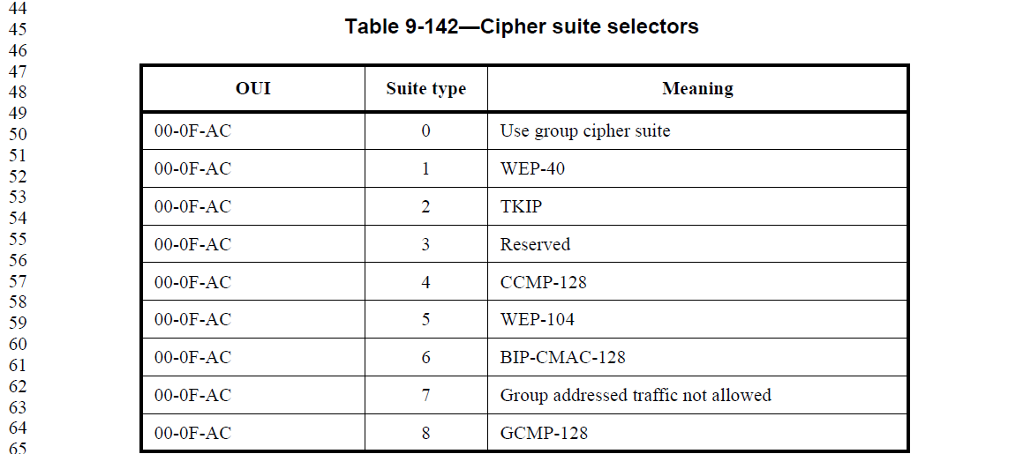
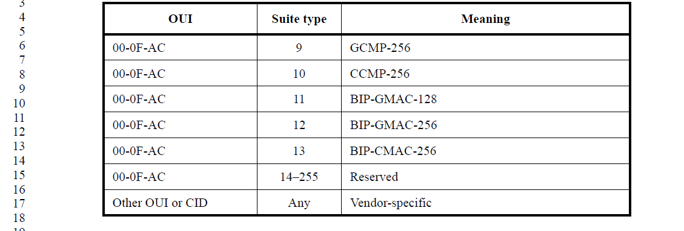

Indeed, AES-CMAC-128 is an algorihm name, not a suite selector, so the change is correct.

Proposed Resolution:

Accepted.

1536 | 1267.56 | 56 | 9.4.2.169.2 |  | " Values of Operating Class are shown in Table E-4 (Global operating classes), of which operating classes that, together with the channel number, indicate the primary channel is valid (see 11.42.8 (Reduced neighbor report))." -- this sentence doesn't make sense | Delete the referenced sentence in the referenced location

Discussion:

Context:

The cited text applies to the Neighbor AP Information field, within the context of a Reduced Neighbor Report:

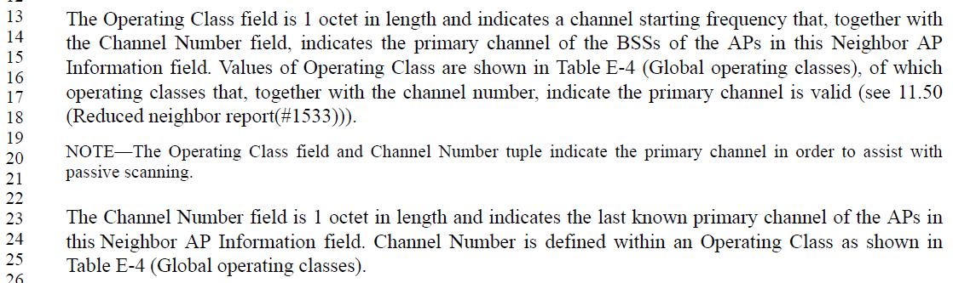

It appears that most of the cited sentence is actually a duplicate of the prior sentence, and is likely an editorial glitch. However, the concept that the “primary channel is valid” is uniquely in the cited sentence. There is no occurance of “valid” in 11.50, so that cross-reference does not actually add to this concept. It’s not clear what this is trying to add, over the simple statement in the prior sentence that the RNR is indicating the primary channel that is being used. Whether that channel is valid, can either be assumed (if it is being used), or is at least outside the scope of what is reported in an RNR. So, this concept seems unnecessary to introduce here.

Thus, the entire cited sentence does appear to be unnecessary, and agree with the commenter that it doesn’t make sense in the current form. So, just delete it.

Proposed Resolution:

Accepted.

1485 | 2084.47 | 47 | 11.10.6 |  | " A STA refusing a measurement request within an individually addressed Radio Measurement Request frame shall respond with a measurement report indicating that it is refusing the measurement request. A STA shall not respond to measurement requests received in Radio Measurement Request frames in this manner." is self-contradictory | Add "group addressed" after "shall not respond to" in the cited text at the referenced location

Discussion:

Context:

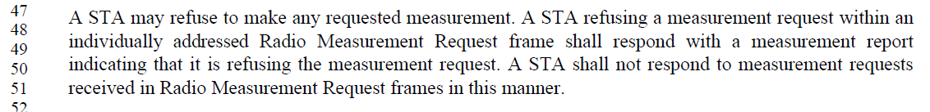

This text comes from 802.11k-2008. It got changed somewhere before 802.11-2012, and has remained as seen above since then.

In 802.11k-2008, we find the following version:

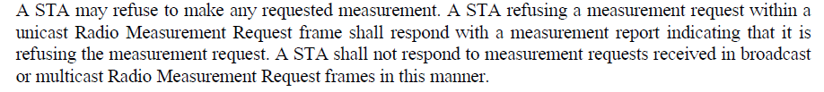

Proposed Resolution:

Revised.
Insert “group addressed” after “received in”, in the cited sentence.

1587 | 2893.15 | 15 | 21.1.1 |  | Where does it say VHT operates in 5 GHz (and not 2.4 GHz, for example), other than in clause 4 (not clearly normative - no "shall") and a weak hint in the column label in Table 21-3? | Add to the end of the sec ond paragraph in 21.1.1, "when the STA is operating in the 5 GHz band."

Discussion:

Context:

Here is the text at the start of clause 21:

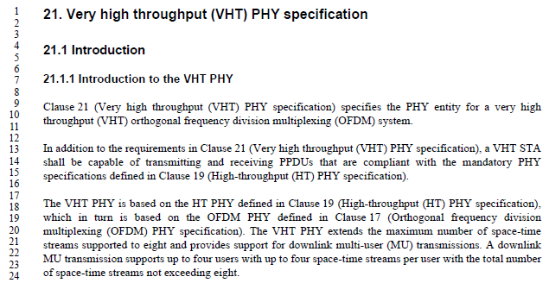

The Proposed Change would result in this as the first two paragraphs:

Clause 21 (Very high throughput (VHT) PHY specification) specifies the PHY entity for a very high throughput (VHT) orthogonal frequency division multiplexing (OFDM) system.

In addition to the requirements in Clause 21 (Very high throughput (VHT) PHY specification), a VHT STA shall be capable of transmitting and receiving PPDUs that are compliant with the mandatory PHY specifications defined in Clause 19 (High-throughput (HT) PHY specification) when the STA is operating in the 5 GHz band.

After discussion on Oct 5th, it was requested to make the 5 GHz-only operation be stated clearly, at the beginning of clause 21.

Proposal 1:

Clause 21 (Very high throughput (VHT) PHY specification) specifies the PHY entity for a very high throughput (VHT) orthogonal frequency division multiplexing (OFDM) system.

In addition to the requirements in Clause 21 (Very high throughput (VHT) PHY specification), a VHT STA shall be capable of transmitting and receiving PPDUs in the 5 GHz band that are compliant with the mandatory PHY specifications defined in Clause 19 (High-throughput (HT) PHY specification).

Proposal 2:

Clause 21 (Very high throughput (VHT) PHY specification) specifies the PHY entity for a very high throughput (VHT) orthogonal frequency division multiplexing (OFDM) system operating in the 5 GHz band.

In addition to the requirements in Clause 21 (Very high throughput (VHT) PHY specification), a VHT STA shall be capable of transmitting and receiving PPDUs that are compliant with the mandatory PHY specifications defined in Clause 19 (High-throughput (HT) PHY specification) in the 5 GHz band.

Proposed Resolution:

Revised. Make the following changes to the first two paragraphs of clause 21:

Clause 21 (Very high throughput (VHT) PHY specification) specifies the PHY entity for a very high throughput (VHT) orthogonal frequency division multiplexing (OFDM) system operating in the 5 GHz band.

In addition to the requirements in Clause 21 (Very high throughput (VHT) PHY specification), a VHT STA shall be capable of transmitting and receiving PPDUs that are compliant with the mandatory PHY specifications defined in Clause 19 (High-throughput (HT) PHY specification) in the 5 GHz band.

1286 | 842.18 | 18 | 9.4.1.8 |  | IEEE Std 802.11-2016 modified the definition of AID field to say "A non-DMG STA assigns the value of the AID in the range of 1 to 2007; the 5 MSBs of the AID field are reserved" while the 802.11-2012 definition said "The value assigned as the AID is in the range 1-2007 and is placed in the 14 LSBs of the AID field, with the two MSBs of the AID field set to 1". This changes behavior in a backwards incompatible manner due to the general convention (see 9.2.2): "Reserved fields and subfields are set to 0 upon transmission and are ignored upon reception.". In other words, this change would imply that the two MSBs are set to 0 instead 1. This results in interoperability issues with deployed devices in particular with (Re)Association Response frames where a non-AP STA may either reject the frame if the two MSBs of the AID are not 1 or there might be undefined behavior when matching the received value against the value used in PS-Poll frames. This type of "cleanup" change is not acceptable and needs to be reverted to avoid interoperability issues with deployed devices. This comment is proposing a change for the 802.11-2012 case. A similar change could be considered for DMG and S1G cases as well, if those are expected to have interoperability issues. Alternatively, the AID field definition could be left as-is and the specific uses of AID field in the relevant frames (at least (Re)Association Response frames) could be specified to set the two MSBs to 1. | Replace  "A non-DMG and non-S1G STA assigns the value of the AID in the range of 1 to 2007; the 5 MSBs of the AID field are reserved."  with  "A non-DMG and non-S1G STA assigns the value of the AID in the range of 1 to 2007. This value is placed in the 14 LSBs of the AID field, with the two MSBs of the AID field set to 1."

Discussion:

Context:

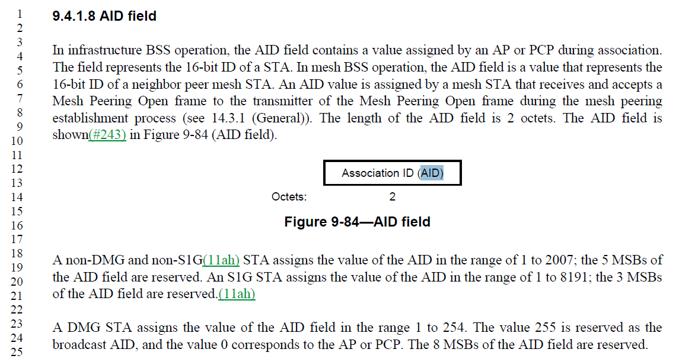

From 802.11-2012:

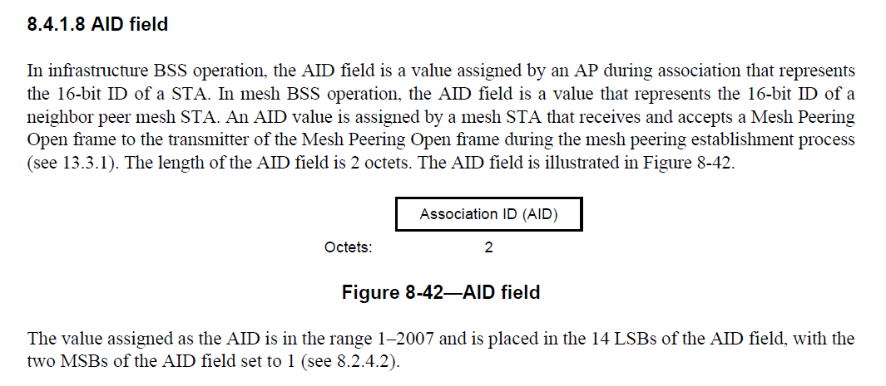

So, the behavior of this subclause has in fact changed. In -2012, the bits would be set to one in frames that included an “AID field”, whereas in -2016 the bits are “reserved” and therefore set to zero on transmit.

Note from the current text, and the -2012 text, that the AID itself is a small(ish) integer, and does not have these high bits set to 1. This is also necessary for the text describing a TIM bitfield to make sense. This is further supported by text in 9.2.4.2:
“In Control frames of subtype PS-Poll other than PS-Poll+BDT frames,(11ah) the Duration/ID field carries the association identifier (AID) of the STA that transmitted the frame in the 14 least significant bits (LSB), and the 2 most significant bits (MSB) both set to 1.(M53)”

So, clearly the upper bits being set is a matter of frame formatting, probably in early usage as a way to disambiguate the Duration/ID field of every frame, and then carried into the “AID field” of other frames just to keep it consistent (thus, implementations didn’t have to mask these off in comparison operations). Such setting of upper bits in any other context is probably a carry-over and unneccesary. But, as the commenter points out, we can’t change these now without breaking backward compatibility.

The proposed change would align with the -2012 approach of specifying the two MSBs are set to one explicitly in the AID field (and not in the AID itself), and therefore in all frames that include the AID field:
(Re)Assocation Response
Mesh Peeting Confirm
AID Response element in (Re)Association Response and AID Switch Response frames
AID Announcement element in a STA Information Annoucement frame
Relay Search Request frame
AID element in TDLS Setup Request and TDLS Setup Response frames
AND MAYBE?:
RLS Request frame, RLS Announcement frame, RLS Teardown frame – the format of AIDs in these frames is unclear.

Need expert opinion on whether all these frames should have the two MSBs set to 1.

Also, see CID 1588 (already resolved) which makes these changes (to remove behavioral text from clause 9):
Change the two sentences:
“In mesh BSS operation, the AID field is a value that represents the 16-bit ID of a neighbor peer mesh STA. An AID value is assigned by a mesh STA that receives and accepts a Mesh Peering Open frame to the transmitter of the Mesh Peering Open frame during the mesh peering establishment process (see 14.3.1 (General)).”
to:
"In mesh BSS operation, the AID field is a value that represents the 16-bit ID of a neighbor peer mesh STA, assigned during mesh peering."

Change
“A non-DMG and non-S1G STA assigns the value of the AID in the range of 1 to 2007; the 5 MSBs of the AID field are reserved. An S1G STA assigns the value of the AID in the range of 1 to 8191; the 3 MSBs of the AID field are reserved. A DMG STA assigns the value of the AID field in the range 1 to 254. The value 255 is reserved as the broadcast AID, and the value 0 corresponds to the AP or PCP. The 8 MSBs of the AID field are reserved.”
to:
“The value of the AID field for a non-DMG and non-S1G STA is in the range of 1 to 2007, and the 5 MSBs of the AID field are reserved. The value of the AID field for an S1G STA is in the range of 1 to 8191, and the 3 MSBs of the AID field are reserved. The value of the AID field for A DMG STA is in the range 1 to 254. The value 255 is reserved as the broadcast AID, and the value 0 corresponds to the AP or PCP. The 8 MSBs of the AID field are reserved.”

Proposed Resolution:

Accepted.

1396 | 1571.15 | 15 | 10.2.6 |  | "A QoS Data frame with a TID matching an existing block ack agreement may be transmitted outside an  A-MPDU with its Ack Policy subfield set to Normal Ack" -- also in an S-MPDU | Append ", or in an S-MPDU" to the cited text at the referenced location

Discussion:

Context:

The cited text is near the end of the subclause on Fragmentation (10.2.6):

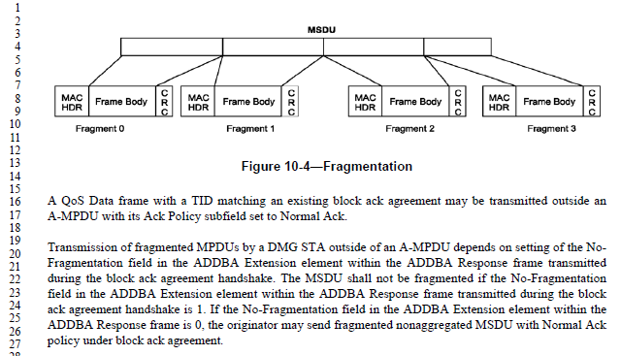

The cited paragraph (the one that starts, “A QoS Data frame with TID matching…”) appears to be a lead-in to the next paragraph that discusses how a DMG STA may framgment such MPDUs which are transmitted outside of an A-MPDU.

- What does “outside of” an A-MPDU mean? The only other occurances of “outside of” in the Standard are either referencing outside of a time window, or outside of a BSS or other particular network.
- Let’s assume “outside of” in this context means, “not in”. That is, such a QoS Data frame may be transmitted not in an A-MPDU with its Ack Policy subfield set to Normal Ack.
- Then, we need to unpack the negative logic of the sentence. Does this mean such a QoS Data frame shall not be transmitted in an A-MPDU with its Ack Policy subfield set to Normal Ack? Surely, not. And, further, there are clearly other types of frames that may be transmitted not in such an A-MPDU. So, this is not attempting to (restrictively) list all the frames types that may be so transmitted.
- Thus, it seems there is no sharp line being drawn by the statement. Rather, we must assume this is just a permissive statement, and tutorial/reminder to the reader that this situation can happen, as a lead-in to the next paragraph describing how it is handled.
- Now, consider the comment and Proposed Change. Does adding the mention that such a QoS Data frame transmission can also occur in an S-MPDU add anything? Is it even relevant to the following paragraph (to which this appears to be a lead-in)?
- If the scenario of the QoD Data frame being transmitted within an S-MPDU is meant to be relevant to the following paragraph, then that paragraph also needs to be adjusted to cover S-MPDU, in addition to “outside of an A-MPDU”. That does not appear to be the scope/intention of the second paragraph.

Proposed Resolution:

Rejected. The cited paragraph is simply an existential statement that this situation can occur, as a lead-in to the following paragraph that describes how it is handled. Adding S-MPDU to the cited sentence expands the scope beyond that covered by the next paragraph, which it is supposed to introduce.

Revised. Change, “outside an A-MPDU” to “in a non-A-MPDU” in the cited paragraph.

1431 | 2249.15 | 15 | 11.31.1 |  | "the Capabilities element, the Operation element" -- there are no such elements. Discussions with 11ad experts suggests the intent is that you use all the elements relevant to the target band/PHY | In the referenced subclause change  "A multi-band capable device shall include, in any transmitted FST Setup Request frame and in any transmitted FST Setup Response frame, the Capabilities element, the Operation element, the EDCA Parameter Set element, Supported Rates and BSS Membership Selectors element, Extended Supported Rates and BSS Membership Selectors element, and Supported Channels element that are applicable to the band and channel number indicated within its most recently transmitted Multi-band element that was transmitted on the same band and channel number on which it is transmitting the FST Setup Request or FST Setup Response frames."  to  "A multi-band capable device shall include, in any transmitted FST Setup Request frame and in any transmitted FST Setup Response frame, all the elements that are applicable to the band, PHY and channel number indicated within its most recently transmitted Multi-band element that was transmitted on the same band and channel number on which it is transmitting the FST Setup Request or FST Setup Response frames."

Discussion:

Context:

Original text from the Standard:

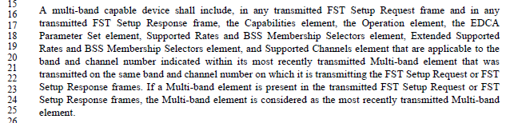

Proposed Changes (as markup):

"A multi-band capable device shall include, in any transmitted FST Setup Request frame and in any transmitted FST Setup Response frame, the Capabilities element, the Operation element, the EDCA Parameter Set element, Supported Rates and BSS Membership Selectors element, Extended Supported Rates and BSS Membership Selectors element, and Supported Channels element all the elements that are applicable to the band and channel number indicated within its most recently transmitted Multi-band element that was transmitted on the same band and channel number on which it is transmitting the FST Setup Request or FST Setup Response frames."

While this change leaves the exact requirement underspecified, it appears to be correct, and better than the explicit list that contains invalid element names and is potentially incomplete.

Proposed Resolution:

Accepted.

1569 | 1236.30 | 30 | 9.4.2.146 |  | What is "A/C power"? Is PoE sufficient? Battery backup? | Change "A/C Power" in the Figure to "Mains power", and in the descriptive text to "Mains or grid power".

Discussion:

Context:

This field is in the Relay Capability Information field of the Relay Capabilities element (for DMG Relays):

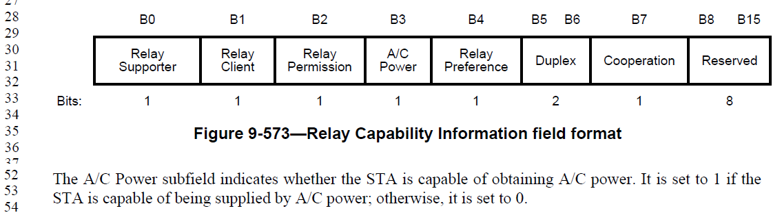

A Google search (definitive research 😊) comes back with the suggestion that one meant “AC Power” (so we should at the very least, delete the “/”), meaning specifically alternating current.

Presumably, the point of this capability being indicated over 802.11 is to let other devices know that this is not a battery powered device, but has a (logically infinite) external power source. This doesn’t seem related to that power being alternating current or not.

The “see also” hints in Wikipedia for “AC Power” suggest that if one means utility-supplied AC power (which seems close to what we mean), use the entry titled “Mains electricity”. That page suggests that for regions that don’t commonly call it “mains”, they call it “grid power”, “wall power” or “domestic power”.

The commenter’s Proposed Change seems to align with, and capture, these same terms.

Straw Poll:

- Change to “The A/C Power subfield indicates whether the STA is using AC power. It is set to 1 if the STA is supplied by AC power, including PoE, wall plug, etc.; otherwise, it is set to 0.”

- Change to “The A/C Power subfield indicates whether the STA is capable of using AC power. It is set to 1 if the STA is capable of being supplied by AC power, including PoE, wall plug, etc.; otherwise, it is set to 0.”

Result 4-4

Original was: The A/C Power subfield indicates whether the STA is capable of obtaining AC power. It is set to 1 if the STA is capable of being supplied by AC power; otherwise, it is set to 0.”

UPDATE

Checked with Carlos Cordeiro, and his belief is that this was intended to indicate whether the relay is _currently_ using external power.

Proposed Resolution:

Revised.

Change to “The A/C Power subfield indicates whether the STA is using AC power, or equivalent. It is set to 1 if the STA is supplied by AC power, including PoE, wall plug, etc.; otherwise, it is set to 0.”

Change to “The A/C Power subfield indicates that the STA is using external power. It is set to 1 if the STA is supplied by external power, including PoE, wall plug, etc.; otherwise, it is set to 0.”

Change to “The A/C Power subfield indicates whether the STA is power constrained or not. It is set to 1 if the STA is not power constrained, i.e., supplied by external power, including PoE, wall plug, etc.; otherwise, it is set to 0.”

1553 | 1953.52 | 52 | 11.1.4.3.4 |  | A Probe Request frame may contain the DSS Parameter Set element regardless of whether the receiving STA has radio measurements activated. As such, the local value of dot11RadioMeasurementActivated should not be used as a condition for using this information when deciding whether to reply to a Probe Request frame. | Replace "The STA has dot11RadioMeasurementActivated equal to true and the Probe Request frame contains a DSSS Parameter Set element" with "The Probe Request frame contains a DSSS Parameter Set element".

Discussion:

Context:

This is in the context of the rules for sending a response to a Probe Request:

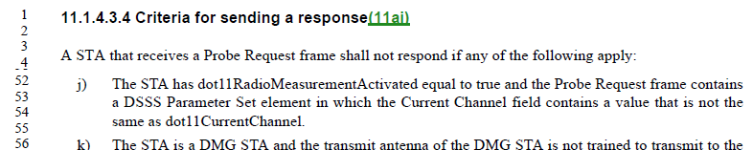

It is logical that a reply not be sent, if the channel indicated by the DSSS Parameter Set does not match the current channel. (This must be an off-channel frame received due to channel overlap, which can happen easily in 2.4 GHz.)

This subclause “Criteria for sending a response” has been modified over the revisions, but started from text in IEEE 802.11k-2008, “Furthermore, a STA with dot11RadioMeasurementEnabled set to true receiving a probe request with a DS Parameter Set element containing a Current Channel field value that is not the same as the value of dot11CurrentChannelNumber shall not respond with a probe response.”

Likely, this text was prefaced with the “with dot11RadioMeasurementEnabled set to true” so as to not make implementations before 802.11k non-compliant with this ‘shall’ statement. There does appear to be no technical justification for the dependency on Radio Measurement, as the Current Channel field of a DS Parameter Set has been in the Standard since 802.11-1997.

Arguably, at this point, the likelihood of making any existing implementation non-compliant is neglible.

Proposed Resolution:

Accepted.

1560 | 1719.60 | 60 | 10.25.5.3 |  | Data MPDU is rarely used. "Data frame" is overwhelmingly preferred. | Change the remaining 5 "data MPDU"s to "data frame"s

Discussion:

Context:

Per the clause 3 Definitions:

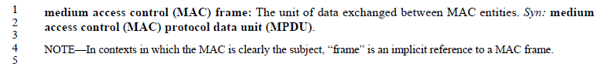

So, the terms ‘MPDU’ and ‘frame’ are explicitly synonymous and equivalent. However, ‘frame’ appears to be preferred, as it is the target of the definition. Also, consistency of usage does make it easier to understand the Standard, and search for terms.

There do appear to be 5 instances of “data MPDU” in D1.0, all in the HT-immeidate scoreboarding discussion in 10.25.5.3 and 10.25. 5.4.

For example, two occurances in this paragraph:

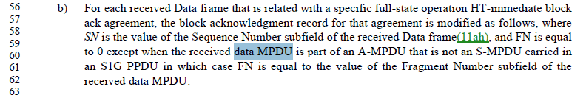

It makes sense that these were written by the same author, who stubled onto the “data MPDU” phrase and used it throughout.

Proposed Resolution:

Accepted. Editor – 11ak has added a sixth occurance, in 4.3.28.1.

Revised. Change 6 occurences (relative to draft 1.6) of “data MPDU” to “Data frame”. Note to Editor, locations are: P252.47, P1844.24, P1844.26, P1844.50 (note, maintain the plural), P1845.43, P1845.45, P1850.43.

1572 | 1360.26 | 26 | 9.4.5.21 |  | Can the NAI Realm field have zero NAI Realm Tuple subfields? If so, what does the AoC element mean? Does the Plan Information have to have valid information including the XML description? | Clarify if the NAI Realm field can be zero length or not, and if it can be, clarify (in 11.23.3.3.12) how the "information is provided on a per NAI realm basis" works.

Discussion:

Context:

The comment references the use of NAI Realm within an Advice of Charge Duple, which is part of an Advice of Charge ANQP-element:

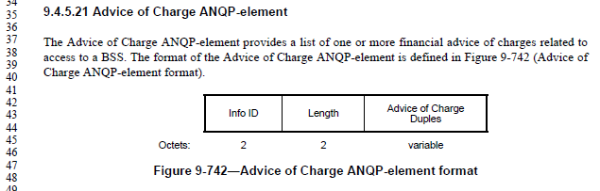
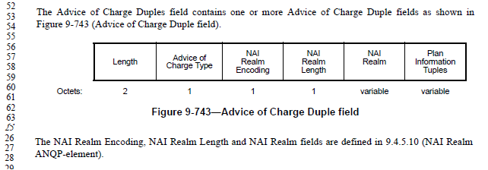

Per 9.4.5.10, the NAI Realm ANQP-element contains zero or more NAI Realm Tuples, which are defined to have subfields that match in name and usage with the subfields in the Advice of Charge Duples:

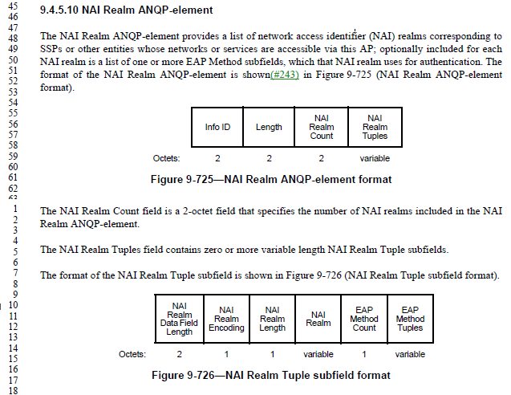
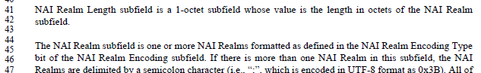

In this context, the NAI Realm subfield is specified to contain “one or more” NAI Realms. The NAI Realm Length subfield is the length of the NAI Realm subfield. So, the NAI Realm Length cannot be zero.

However, it is ambiguous if this same “one or more” specification applies in the context of the Advice of Charge ANQP-element.

Proposed Resolution:

Revised.

At the cited location, replace
“The NAI Realm Encoding, NAI Realm Length and NAI Realm fields are defined in 9.4.5.10 (NAI Realm
ANQP-element).”
with
“The NAI Realm Encoding and NAI Realm Length are defined in 9.4.5.10 (NAI Realm ANQP-element). The NAI Realm subfield is one or more NAI Realms formatted as defined in 9.4.5.10 (NAI Realm ANQP-element).”

1573 | 2211.06 | 6 | 11.23.3.3.12 |  | Consider having a default charge that applies if none of the NAI Realms in the Advice of Charge Duples matches. | Add "Plan information for the special NAI realm "*" is indicated, if none of the explicit NAI realms are currently applicable."

Discussion:

Context:

(See above for Advice of Charge ANQP-element format.)

The usage of Advice of Charge is very brief, and described here:

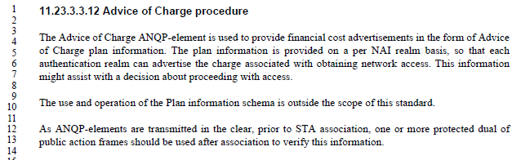

There is no mechanism for a “default” AoC plan. All the plan information must be associated with a specific NAI Realm. However, some scenarios may have no charges involved, if access is not using one of the listed NAI Realm. For example, there could be a list of NAI Realm for “premium” access priveledges using various subscription services, but a lower-tier of service might be offered for all other access.

The proposed mechanism, of specifying an NAI Realm as “*” to indicate a default access seems acceptable, and potentially useful.

Proposed Resolution:

Accepted.

1593 | 809.28 | 28 | 9.3.3.9 |  | In Table 9-36 (the "Reassociation Response frame body"), Order 31 appears twice. Association Response (up about 5 pages) has the same problem, with Order 27. | Renumber the tables with sequential Order

Discussion:

Context:

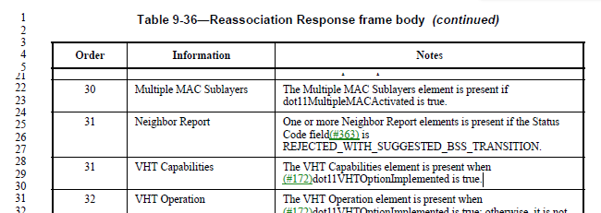

As can be seen, the commenter is correct.

The Order column is not a specified set of values (unlike an element ID or field value), luckily. So, changing these values on existing entries does no harm. From the order that the fields are listed in this table, it is probably a reasonable assumption that implementations currently put the Neighbor Report element(s) before the VHT Capabilities element, when the Response has them both.

Thus, it appears to do no harm, and is a good correction, to renumber the Order column to have non-repeating values.

The Association Response does in fact have the same error on the same elements, in that case with the Order of 27 duplicated.

Proposed Resolution:

Accepted.

[Confirm with Editor that the Proposed Change is sufficiently clear to do both of these tables.]

1594 | 726.06 | 6 | 9.2.2 |  | Things are wrong with this sentence, "An ASCII or UTF-8 string a sequence of ASCII-encoded octets without a terminating null." First, there's no verb. Probably supposed to be "... string _is_ a sequence of ..." Secondly, how can an UTF-8 string be ASCII-encoded? The point of UTF-8 is to encode stuff ASCII can't do. (Yes, extended ASCII could arguably contain the octets of the UTF-8, but that is just confusing things.) | Replace with, "An ASCII or UTF-8 string is a sequence of ASCII or UTF-8 encoded octets without a terminating null."

Discussion:

Context:

The cited sentence appears in the Conventions subclause of clause 9:

Commenter’s points:
- There is no verb.
  - Agreed. Add the missing “is”
- How is a UTF-8 string ASCII-encoded?
  - Agreed. Add that a UTF-8 string is encoded with UTF-8

The proposal has a potential ambiguity with the “or”, however, as discussed in August. So, propose:
Replace with, "An ASCII or UTF-8 string is a sequence of ASCII or UTF-8 encoded octets, respectively, without a terminating null."

Proposed Resolution:

Revised.

Replace the cited sentence with, "An ASCII or UTF-8 string is a sequence of ASCII or UTF-8 encoded octets, respectively, without a terminating null."

Replace the cited sentence with, "An ASCII or UTF-8 string is a sequence of ASCII or UTF-8 encoded code points, respectively, without a terminating null."

1614 | 1286.60 | 60 | 9.4.2.187 |  | Payload of each element is limited to a maximum of 254 or 255 octets. The should be limited to one single value. If it can be either or then clarify the condition for each. | Fix as commented

Discussion:

Context:

The definition of the Fragment element is:
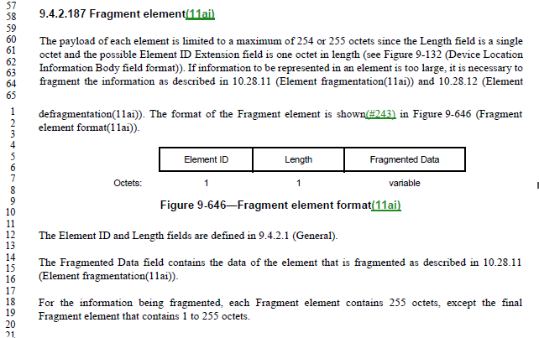

The cited text is part of the introduction to this feature, where it is noted that for elements, in general, the payload is restricted to either 255 or 254 octets, depending on the presence of the Element ID Extension.

Thus, the comment can be construed as requesting for a better explanation of when 255 versus 254 octets are possible.

Suggest the following replacement, of:
The payload of each element is limited to a maximum of 254 or 255 octets since the Length field is a single octet and the possible Element ID Extension field is one octet in length (see Figure 9-132 (Device Location Information Body field format)). If information to be represented in an element is too large, it is necessary to fragment the information as described in 10.28.11 (Element fragmentation(11ai)) and 10.28.12 (Element defragmentation(11ai)). The format of the Fragment element is shown(#243) in Figure 9-646 (Fragment element format(11ai)).
with:
Elements are defined to have a common general format, per 9.4.2.1. The Length field of an Element is one octet, and thus limited to indicate 255 octets of payload in the Information field. However, since the Element ID Extension field is optional and included in the single-octet Length count, the actual Information payload of an Element is limited to 254 octets if the Element ID Extension is present. If the Information to be represented in an element is too large for this 255 or 254 octet limit, it is necessary to fragment the information as described in 10.28.11 (Element fragmentation(11ai)) and 10.28.12 (Element defragmentation(11ai)).

The format of the Fragment element is shown(#243) in Figure 9-646 (Fragment element format(11ai)).

Proposed Resolution:

Revised.

Replace the cited paragraph with two paragraphs:
Elements are defined to have a common general format, per 9.4.2.1. The Length field of an Element is one octet, and thus limited to indicate 255 octets of payload in the Information field. However, since the Element ID Extension field is optional and included in the single-octet Length count, the actual Information payload of an Element is limited to 254 octets if the Element ID Extension is present. If the Information to be represented in an element is too large for this 255 or 254 octet limit, it is necessary to fragment the information as described in 10.28.11 (Element fragmentation(11ai)) and 10.28.12 (Element defragmentation(11ai)).

The format of the Fragment element is shown(#243) in Figure 9-646 (Fragment element format(11ai)).

1503 | 1670.10 | 10 | 10.23.2.4 |  | The precedence of the actions on page 1670 is not clear | At 1670.14 and 1670.22 change "At each" to "Otherwise, at each"

Discussion:

Context:

The cited text is in the context of Obtaining an EDCA TXOP, and operations that happen at each slot boundary. The slot boundaires are specified above, such as:

… and so on.

Within that context, at these slot boundaries the following procedure is described:

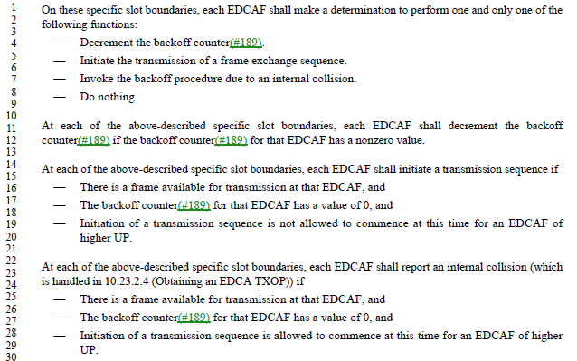

Close examination of these options shows that they are mutually exclusive, thus meeting the requirement stated at the beginning of the list that “one and only one of the following functions” shall happen.

Proposed Resolution:

Rejected. There is a preceding ‘shall’ statement that one and only one of the actions shall occur, and the actions are each subject to conditions, which are mutually exclusive. Thus, there is no precedence relationship.

1442 | 743.45 | 45 | 9.2.4.5.4 |  | The terms "require acknowledgment" or "requires acknowledgment" are not clear, because some ack policies other than 00 do require ack, just not immediate (e.g. Block Ack, PSMP Ack, No Explicit Acknowledgment) | Add "immediate" before "acknowledgement" in "require acknowledgement"/"requires acknowledgement" in 9.3.1.3 (2x), 10.3.2.10 at 1592.24 and 1594.47/51, 10.3.4.4, 10.3.4.5, 11.2.3.6 (4x), 14.14.9.2, G.3 (2x)

Discussion:

Context:

This first change location text is in the CTS frame format subclause:

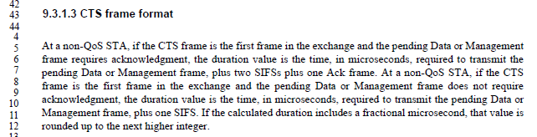

In this example, it can be seen that the duration field of the CTS frame is indeed intended to depend on whether the frame requires an immediate acknowledgement.

The other locations appear to be similar – all describe behaviors that rely on, or react to, an immediate acknowledgement being received or having been missed.

There are some additional locations found that have a similar situation. These include the phrases “requiring acknowledgement” (not every occurance, but those at: P1593.12, P1599.42, P1608.32, P1669.45, P1674.39, P1984.8, P3992.49), and “need acknowledgement” (P3991.24).

Proposed Resolution:

Revised. Add "immediate" before "acknowledgement" in "require acknowledgement"/"requires acknowledgement" in 9.3.1.3 (2x), 10.3.2.10 at 1592.24 and 1594.47/51, 10.3.4.4, 10.3.4.5, 11.2.3.6 (4x), 14.14.9.2, G.3 (2x).

Note to Editor: Not all occurrences of “acknowledgement” in the above cited clauses have the replacement, only those with “require” or “requires” before “acknowledgement”.

Similarly, add “immediate” before “acknowledgement” at P1593.12, P1599.42, P1608.32, P1669.45, P1674.39, P1984.8, P3992.49, and P3991.24

1448 | 1535.51 | 51 | 9.4.3 |  | "The preceding PPDU" is behaviour not format | Move from Clause 9 to Clause 10

Discussion:

Context:

The cited text occurs within 9.7.3 (A-MPDU contents) in the Table that describes the actual A-MPDU legal contents in certain context (the context is described by the preceeding table):

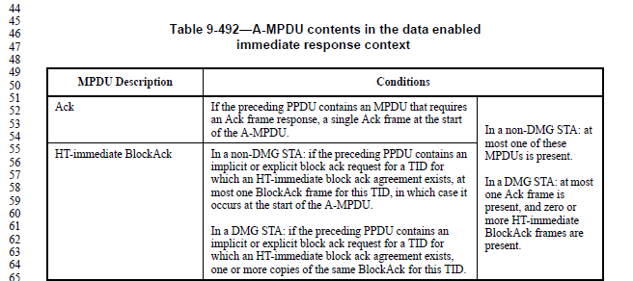

As this table is here to describe the valid contents of subframes of a PPDU, it is format.

Proposed Resolution:

Rejected. Table 9-492 describes the valid contents of the A-MPDU subframes in a PPDU, and thus are part of the format description for A-MPDUs. It is necessary to reference preceding PPDUs to determine these valid contents, but such reference does not make this a behavioural requirement.

1449 | 2095.24 | 24 | 11.10.9.6 |  | "Originator Requesting MAC address field" -- no such field (and bad case) | Change all instances of "Originator Requesting MAC address" to "Originator Requesting STA MAC Address field" throughout the document

Discussion:

Context:

Within 11.10.9.6 LCI report:

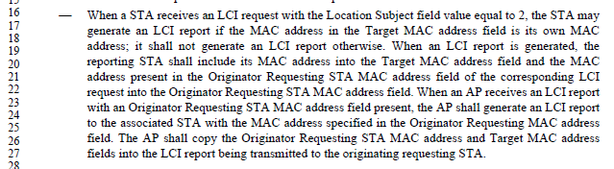

The LCI report frame’s subelements are defined in 9.4.2.21.10 as:
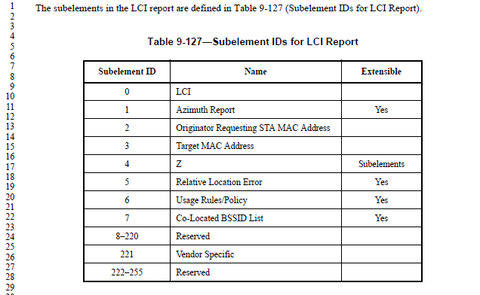
The description of the Originator Requesting STA MAC Address Subelement refers to the definition in Figure 9-192, which is in the LCI request frame subclause.

In the LCI request frame format (9.4.2.20.10) these fields are defined:

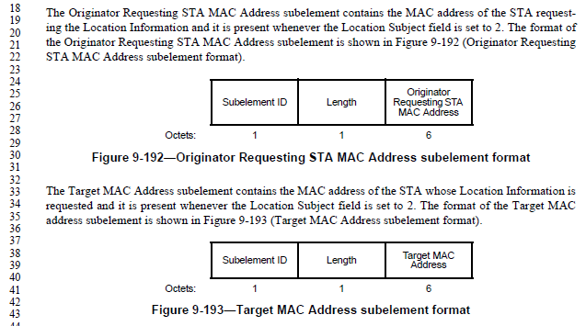

So, it is correct that this field (and the Subelement that contains it) are named “Originator Requesting STA MAC Address throughout.

There are three occurrences of “Originator Requesting MAC Address” in the Standard. These are in the clause 11 description of the behaviour for the LCI report, Location Civic report, and Location Identifier report. The text in these locations is very similar, and this is surely a cut-and-paste of the same error. Thus, the text is referencing frames with the matching names, and all those frames’ definitions in clause 9 have the same Subelement names. All three locations can thus be changed, as requested.

Proposed Resolution:

Revised. Change all instances of "Originator Requesting MAC address" to "Originator Requesting STA MAC Address" throughout the document

1450 | 835.50 | 50 | 9.4.1.4 |  | "An AP sets the ESS subfield to 1 and the IBSS subfield to 0 within transmitted Beacon or Probe Response frames. Otherwise, the ESS and IBSS subfields are reserved. An IBSS STA sets the ESS subfield to 0 and the IBSS subfield to 1 in transmitted Beacon or Probe Response frames. A mesh STA sets the ESS and IBSS subfields to 0 in transmitted Beacon or Probe Response frames."  is either unclear as to the setting for non-AP non-mesh non-IBSS STAs, or self-contradictory for IBSS and mesh STAs | Change the cited text to  "An AP sets the ESS subfield to 1 and the IBSS subfield to 0 within transmitted Beacon or Probe Response frames. An IBSS STA sets the ESS subfield to 0 and the IBSS subfield to 1 in transmitted Beacon or Probe Response frames. A mesh STA sets the ESS and IBSS subfields to 0 in transmitted Beacon or Probe Response frames. Otherwise, the ESS and IBSS subfields are reserved."

Discussion:

Context:

These subfields are in the Capability Information element (9.4.1.4), described as:

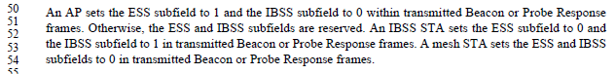

The Proposed Change moves a sentence from the middle of the paragraph, to the end:

An AP sets the ESS subfield to 1 and the IBSS subfield to 0 within transmitted Beacon or Probe Response frames. Otherwise, the ESS and IBSS subfields are reserved. An IBSS STA sets the ESS subfield to 0 and the IBSS subfield to 1 in transmitted Beacon or Probe Response frames. A mesh STA sets the ESS and IBSS subfields to 0 in transmitted Beacon or Probe Response frames. Otherwise, the ESS and IBSS subfields are reserved.

This seems correct, to clarify the logic.

Proposed Resolution:

Accepted.

1500 | 794.18 | 18 | 9.3.3.2 |  | "All fields and elements are mandatory unless stated otherwise and appear in the specified, relative order, with gaps allowed." -- it is not clear what "with gaps allowed" means. It seems to suggest you can just put random filler between fields/elements | Delete ", with gaps allowed" in the cited text at the referenced location

Discussion:

Context:

This text is in the subclause describing the general format of Management frames (9.3.3.2):

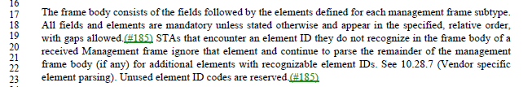

Note that the phrase “with gaps allowed” was added in the previous ballot round, due to CID #185:

Comment:
"Gaps might exist in the ordering of fields and elements within frames. The order that remains is ascending." is not very clear (the order of what?) but assuming it is referring to the order of elements by element ID, the second statement is wrong (e.g. Quiet and TPC Report in beacons, VSIEs in all frames that can take an element with ID > 221, MME/AMPE, etc.)
Resolution:
REVISED (MAC: 2017-09-15 00:50:00Z): At P733L5, Change:
"All fields and elements are mandatory unless stated otherwise and appear in the specified, relative order."
To:
"All fields and elements are mandatory unless stated otherwise and appear in the specified, relative order, with gaps allowed."

Delete the cited paragraph.

Another rewrite can be attempted, to make this as clear as possible.

Proposed Resolution:

Revised.

Replace the cited sentence with:
All fields and elements are mandatory unless stated otherwise. Fields and elements appear in the specified, relative order, skipping fields or elements that are not present.

