IEEE P802.11
Wireless LANs
MAC Comments for Discussion
Date: 2018-04-10
Author(s):
Name | Affiliation | Address | Phone | email
Mark Hamilton | Ruckus/ARRIS | 350 W Java Dr  Sunnyvale, CA 94089 | +1.303.818.8472 | mark.hamtilon2152@gmail.com
Abstract

This submission contains comments on REVmd LB 232, assigned to Mark Hamilton for preparation of proposed resolutions.

The first section contains comments with proposed resolutions ready for review or discussion by TGmd. The latter sections are comments not ready for discussion yet, or already completed.

R0 – initial version. CIDs ready for TGmd review: 1398, 1425, 1381, 1382, 1390.
R1 – Reviewed CIDs 1398, 1425, 1381, 1382, 1390 at FLL F2F, and approved resolutions, with minor modifications (as shown below, with Green highlight status color).
Added proposed resolutions, ready for review, for CIDs: 1394, 1369, 1397, and 1354.

CID | Page | Line | Clause | Submission | Comment | Proposed Change
1394 | 1337.37 | 37 | 9.4.3 |  | All the statements of the form "The $blah field contains zero or more subelements. The subelement format and ordering of  subelements are defined in 9.4.3 (Subelements)." are unclear as to whether you can have more than one subelement with the same Subelement ID | Add a para at the end of 9.4.3: "Unless stated otherwise, no more than one subelement with the same Subelement ID is present within an element."

Discussion:

From 9.4.2.20.5:

Many (but not all) of the occurances of the cited statements are of the above form, specifying Optional Sublements, and all of them appear to include the Vendor Specific element. While several other elements (besides Vendor Specific) don’t make sense to include more than one time, there are a few that could potentially be reasonable, and certainly more than one Vendor Specific element could be reasonable. Given this, and the potential for making existing implementations non-compliant if they do include more than one of some element type, the suggestion is not to add this restriction. No clear problem is identified by the commenter for allowing more than one of some element types/IDs.

Proposed Resolution:

Rejected. Adding such a restriction could make existing implementations non-compliant. Further, the comment provides no clear problem that would be solved by such a restriction.

1369 | 1964.60 | 60 | 11.1.7 |  | 11.1.4.6 Operation of Supported Rates and BSS Membership Selectors element and  Extended Supported Rates and BSS Membership Selectors element and 11.1.7 Supported rates and extended supported rates advertisement cover the same material | Delete Subclause 11.1.7

Discussion:

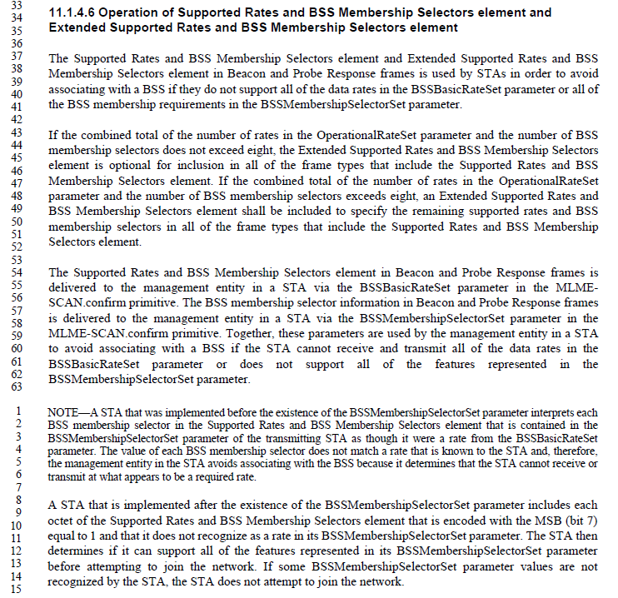

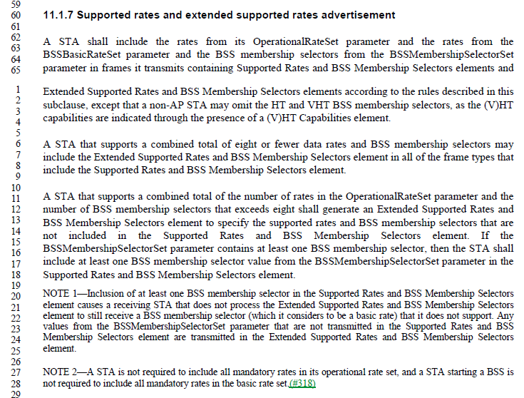

Examining the above, it can be seen that 11.1.7 describes the transmitter of this information (the transmitter of Beacons and Probe Responses), while 11.1.4.6 describes the behavior of a receiver of this information. There is some information that is repeated, and could potentially be trimmed (for example the optional inclusion of an Extended Supported Rates and BSS Membership Selectors element if the total number of supported rates and BSS membership selectors is eight or less). However, this overlap is small, and is helpful to understand the complete scope of what each of the transmitter and receiver needs to accommodate (respectively).

Proprosed Resolution:

Rejected. Subclauses 11.1.4.6 and 11.1.7 describe required behavior for the receiver and transmitter of these elements, respectively. There is minimal duplicated information between these two subclauses, and only where it helps understand the overall behavior expectations of the receiver or transmitter, appropriately.

1397 | 966.46 | 46 | 9.4.2.20.19 |  | "The Randomization Interval field specifies the upper bound of the random delay to be used prior to making the measurement, in units of TUs. See 11.11.3 (Measurement start time)." --- the xref is bogus as 11.11.3 is about radio measurement frames not FTM frames | Delete "See 11.11.3 (Measurement start time)." in the cited text at the referenced location

Discussion:

The cross-reference in 9.4.2.20.19 is actually to 11.10.3:

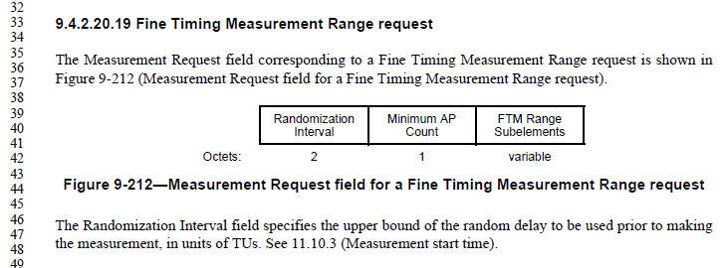

11.10.3 discusses the start time for Radio Measurement Requests, including the randomization interval. This applies to all measurement types listed in 11.10.

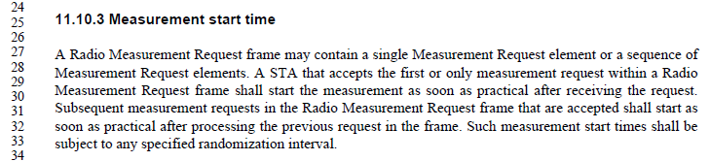

And, finally, 11.10.9.11 lists Fine Timing Measurement Range report as one such request. Also, note this is Fine Timing Measurement *Range* report, which is a request for the receiving STA to start a Fine Timing Measurement procedure (to meaure range to one or more third devices), not an actual/direct use of Fine Timing Measurement between the requesting and receiving STAs.

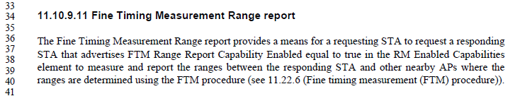

Since this is a request for the receiving STA to perform a measurement, that request can be satisfied using the randomization interval, just like for any other measurement request. Thus, the cross-reference is correct.

Proposed Resolution:

Rejected. The request in 9.4.2.20.19 is for a Fine Timing Measurement Report, not for a Fine Timing Measurement procedure directly. Such a request for a report can use the randomization interval before starting, as specified in 11.10.3. Thus, the cross-reference is correct. See also 11-18/0669 for more detailed discussion.

1354 | 766.25 | 25 | 9.3.1.1 |  | It is not very clear that Figure 9-22 normatively requires most FC subfields in Control frames to be 0 | Below the referenced figure add a "NOTE---The To DS, From DS, More Frag, Retry, Protected Frame and +HTC subfields in the Frame Control field within Control frames carried in a  non-S1G PPDU are reserved."

Discussion:

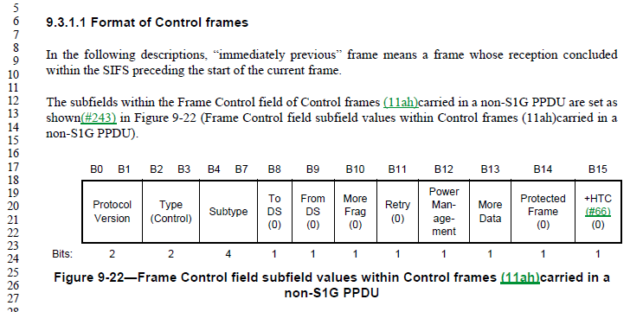

While it is true that these fields are effective reserved (currently) for a non-S1G PPDU Control frame, this is not the usual meaning of reserved. Normally, reserved means the bits are meaningless in a given frame, and so are reserved for future use by “protecting” that they are set to zero in current transmitter implementations, and ignored by current receivers, to future proof a potential use in a later version of the Standard. In this case, they are meaningful bits, which happen to have known and fixed values in the particular context of a non-S1G PPDU Control frame. As such, it can be argued that a receiver is not expected to ignore these fields, but could (potentially) rely on the zero values specified.

Further, this is not the only use of this convention (specifying a fixed value for a field, in a certain context). See Figures 9-33, 9-296, 9-297, 9-895, and others. If any change is made, it should be a description of this nomenclature style, in subclause 9.2.2.

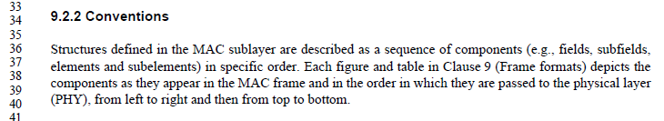

Proposed Resolution:

Revised. Add a sentence to the end of the first paragraph in 9.2.2, “A field or subfield within the figure depiction of a frame format that includes a decimal value within parentheses indicates a required and fixed value for this field or subfield upon transmission.”

Not ready for review, yet:

1400 | 2272.22 | 22 | 11.38.1 |  | "the STA shall indicate support for MCSs 8(n-1) to 8(n-1)+7" should be clearer as to what kind of MCS | On lines 22 and 23 at the referenced page change "MCS" to "HT-MCS"

1401 | 1975.43 | 43 | 11.2.3.6 |  | "If the STA has set up to use  unscheduled SPs, the AP shall buffer BUs using delivery-enabled ACs until it has received a trigger  frame using a trigger-enabled AC from the non-AP STA, which indicates the start of an unscheduled  SP. A trigger frame received by the AP from a STA that already has an unscheduled SP underway  shall not trigger the start of a new unscheduled SP. The AP transmits BUs destined for the STA and  using delivery-enabled ACs during an unscheduled SP." -- 1) this seems to be the only specification of trigger frame handling for U-APSD at the AP, but "tramsmits BUs" is vague; 2) it is not clear whether/how/when MMPDUs are "using delivery-enabled ACs" | After the cited text at the referenced location add "NOTE 1---Transmission of BUs during an unscheduled SP is constrained by the max SP length.  NOTE 2---The AC for delivery of an MMPDU (see 10.2.3.2) determines whether it is transmitted using a delivery-enabled AC during an unscheduled SP."

1403 | 2018.42 | 42 | 11.3.4.3 |  | Missing clarification cf. 11.3.4.2 | At the end of step g) add "; the state shall remain unchanged if it was other than State 1"

1405 | 1971.34 | 34 | 11.2.3.5.1 |  | "An unscheduled SP ends after the AP has attempted to transmit at least one BU using a delivery-enabled AC and destined for the STA, but no more than the number indicated in the Max SP Length field of the QoS Capability element of the STA's (Re)Association Request frame if the field has a nonzero value." -- it doesn't necessarily end after the AP has attempted to transmit one BU. It ends when the AP has transmitted an EOSP or the number of BUs reaches Max SP Length | Change the cited text at the referenced location to "An unscheduled SP ends after the AP has attempted to transmit at least one BU using a delivery-enabled AC and destined for the STA, but no more than the number indicated in the Max SP Length field of the QoS Capability element of the STA's (Re)Association Request frame if the field has a nonzero value, where the last BU is transmitted in MPDUs with EOSP subfield set to 1."

1414 | 2127.44 | 44 | 11.15.8 |  | If the DSSS/CCK Mode in 40 MHz subfield is equal to 0 in a beacon/probe response, it is not clear whether the STA is required to set it to 0 in the association request. The description is "An HT STA declares its capability to use DSSS/CCK rates while it has a 40 MHz operating channel width", which is vague (capability to use v. intent to use). However, it seems clear that if the AP says DSSS/CCK Mode in 40 MHz is not allowed, the STA's signal of capability to transmit such is irrelevant | Append "- The DSSS/CCK Mode in 40 MHz subfield transmitted by a (re)associating STA is ignored." at the end of the list in the para after the referenced location

1008 | 1337.43 | 43 | 9.4.3 |  | Definition of subelement is not aligned with actual use of it. In relation to Measurement request and Measurement report IE the statement that "Each subelement is assigned a subelement ID that is unique within the containing element or subelement." is not true. The sub elements are defined within the Measurement type. | Add to the sentence as follows:  Each subelement is assigned a subelement ID that is unique within the containing element or subelement, or measurement type of the Measurement Request IE and Measurement Report IE.

1396 | 1571.15 | 15 | 10.2.6 |  | "A QoS Data frame with a TID matching an existing block ack agreement may be transmitted outside an  A-MPDU with its Ack Policy subfield set to Normal Ack" -- also in an S-MPDU | Append ", or in an S-MPDU" to the cited text at the referenced location

1282 | 847.19 | 19 | 9.4.1.9 |  | In Table 9-52, Status code 123 is double defined. | Please change Status code "114-65535" to "114-122, 124-65535".

1018 | 1571.58 | 58 | 10.2.7 |  | This section talks about filtering group addressed frames from a STA and  received by the STA relayed back from AP in an infrastructure BSS. It is not clear where  this filtering happens. Is this along with address filtering on Address 1 or later? Where do this reside, say in Figure 5-1  MAC data plane architecture? | It should be done after replay detection for AES and perhaps after MSDU MIC check for TKIP

1033 | 1945.01 | 1 | 11.1.3.9 |  | The sentence "In the case of an infrastructure BSS, the STA's TSF timer shall then be set to the adjusted value of the timestamp." on Line 1 is redundant, because the sentence on Line 9 covers it. | Delete the cited sentence on Line 1.

1114 | 783.30 | 30 | 9.3.1.19 |  | With the 11ah changes, this statement is now incomplete. | Change to "If the VHT NDP Announcment frame is transmitted by a non-S1G STA, then the format of the STA Info field is shown in Figure 9-55."

1146 | 1657.30 | 30 | 10.19 |  | Please clarify how the PARTIAL_AID is calculated when the Multiple BSSID is used.  For example, do BSSID[39:47], BSSID[44:47], and BSSID[40:43] are derived from a transmitted BSSID or a non-transmitted BSSID?  802.11ah had the same discussion, the following sentence has been added into the spec.  NOTE--When a STA for which dot11MultiBSSIDActivated is true is associated with ith BSSID of an AP, the BSSID means the value of BSSID(i).  If VHT PPDU follows the same rule, please add the same NOTE into the spec. | As in comment.

1244 | 2014.03 | 3 | 11.3.2 |  | Figure 11-15 has a "State 5". There doesn't appear to be any text or definition of state 5 in the rest of the draft. I hope this is an editorial error from the IEEE 802.11ai roll-up and I would be quite interested to know where the source material of this figure actually came from (IEEE 802.11ai D7.0 ??). If this is correct, then perhaps other figures from the IEEE 802.11ai roll-up need to be re-examined by the editorial team. | Replace Figure 11-15 with Figure 11-13 from IEEE 802.11ai-2016 (2nd imprint).

1370 | 1964.60 | 60 | 11.1.7 |  | 11.1.4.6 Operation of Supported Rates and BSS Membership Selectors element and  Extended Supported Rates and BSS Membership Selectors element and 11.1.7 Supported rates and extended supported rates advertisement cover the same material | Merge 11.1.7 into 11.1.4.6 then delete 11.1.7

1281 | 839.64 | 64 | 9.4.1.7 |  | In Table 9-51, Reason codes 40-44 are not defined. | Please change the Reason code "45" to "40-45".

1431 | 2249.15 | 15 | 11.31.1 |  | "the Capabilities element, the Operation element" -- there are no such elements. Discussions with 11ad experts suggests the intent is that you use all the elements relevant to the target band/PHY | In the referenced subclause change "A multi-band capable device shall include, in any transmitted FST Setup Request frame and in any  transmitted FST Setup Response frame, the Capabilities element, the Operation element, the EDCA  Parameter Set element, Supported Rates and BSS Membership Selectors element, Extended Supported  Rates and BSS Membership Selectors element, and Supported Channels element that are applicable to the  band and channel number indicated within its most recently transmitted Multi-band element that was  transmitted on the same band and channel number on which it is transmitting the FST Setup Request or FST  Setup Response frames." to "A multi-band capable device shall include, in any transmitted FST Setup Request frame and in any  transmitted FST Setup Response frame, all the elements that are applicable to the  band, PHY and channel number indicated within its most recently transmitted Multi-band element that was  transmitted on the same band and channel number on which it is transmitting the FST Setup Request or FST  Setup Response frames."

1283 | 915.48 | 48 | 9.4.2.1 |  | In Table 9-87, Element ID Extension 44 is double defined. | Please change Element ID Extension "15-32, 35-255" to "15-32, 35-43, 45-255".

1286 | 842.18 | 18 | 9.4.1.8 |  | IEEE Std 802.11-2016 modified the definition of AID field to say "A non-DMG STA assigns the value of the AID in the range of 1 to 2007; the 5 MSBs of the AID field are reserved" while the 802.11-2012 definition said "The value assigned as the AID is in the range 1-2007 and is placed in the 14 LSBs of the AID field, with the two MSBs of the AID field set to 1". This changes behavior in a backwards incompatible manner due to the general convention (see 9.2.2): "Reserved fields and subfields are set to 0 upon transmission and are ignored upon reception.". In other words, this change would imply that the two MSBs are set to 0 instead 1. This results in interoperability issues with deployed devices in particular with (Re)Association Response frames where a non-AP STA may either reject the frame if the two MSBs of the AID are not 1 or there might be undefined behavior when matching the received value against the value used in PS-Poll frames. This type of "cleanup" change is not acceptable and needs to be reverted to avoid interoperability issues with deployed devices. This comment is proposing a change for the 802.11-2012 case. A similar change could be considered for DMG and S1G cases as well, if those are expected to have interoperability issues. Alternatively, the AID field definition could be left as-is and the specific uses of AID field in the relevant frames (at least (Re)Association Response frames) could be specified to set the two MSBs to 1. | Replace "A non-DMG and non-S1G STA assigns the value of the AID in the range of 1 to 2007; the 5 MSBs of  the AID field are reserved." with "A non-DMG and non-S1G STA assigns the value of the AID in the range of 1 to 2007. This value is placed in the 14 LSBs of the AID field, with the two MSBs of the AID field set to 1."

1305 | 1565.59 | 59 | 10.2.3.1 |  | Text states "Frames listed in Table 9-376 (HT Action field values)(11ah)," Frames are not listed in these tables. It lists values | Grammar? Should it say "frames using values in tables.......with a value of yes in the "time priority" column....

1338 | 1285.37 | 37 | 9.4.2.185 |  | " At least one of the bits in FILSC Type field is set to 1. " -- but setting one of the reserved bits would not be helpful (and would be contrary to the definition of "reserved") | Change the cited text at the referenced location to "At least one of the non-reserved bits in FILSC Type field is set to 1."

1343 | 1955.16 | 16 | 11.1.4.3.4 |  | "If the next Beacon is not used as a response" is missing "frame" | Add "frame" after "Beacon" in the cited text at the referenced location

1349 | 2287.18 | 18 | 11.42.3 |  | "A GDD dependent STA shall cease all transmission when  (#172)dot11GDDEnablementValidityTimer has expired" -- a MIB variable cannot expire | Change the cited text in the referenced location to "A GDD dependent STA shall cease all transmission when the GDD enablement validity timer has expired". In the para above delete "by decrementing  dot11GDDEnablementValidityTimer". In Figure 11-51 change "dot11GDDEnablementValidityTimer has expired" to "GDD enablement validity timer has expired". In 11.42.4.1 change "it reinitializes the dot11GDDEnablementValidityTimer to" to "it reinitializes the GDD enablement validity timer". In C.3 delete dot11GDDEnablementValidityTimer. In Tables E-8 and E-11 delete the dot11GDDEnablementValidityTimer row

1273 | 1019.57 | 57 | 9.4.2.24.1 |  | "AES-128-CMAC" is a name of the integrity protection algorithm used by the cipher that is called "BIP-CMAC-128". However, couple of places that are clearly referring to a cipher are incorrectly using the name of the algorithm rather than the cipher. | Replace "AES-128-CMAC" with "BIP-CMAC-128" at page 1019 line 57 and page 1020 line 27.

1569 | 1236.30 | 30 | 9.4.2.146 |  | What is "A/C power"? Is PoE sufficient? Battery backup? | Change "A/C Power" in the Figure to "Mains power", and in the descriptive text to "Mains or grid power".

1415 | 743.03 | 3 | 9.2.4.5.4 |  | The way the ack policy is referred to is confusing/inconsistent. Do you refer to the options indicated by the bit pattern (e.g. "Normal Ack or Implicit Block Ack Request") or do you refer to only the type of ack being requested in the context being requested (e.g. just "Implicit Block Ack Request" in the case of an A-MPDU)? | Change "The Ack Policy subfield is 2 bits in length and identifies the acknowledgment policy that is followed upon  the delivery of the MPDU." to "The Ack Policy subfield is 2 bits in length and identifies, together with other information such as whether it is in the context of an S-MPDU and the value of bit 6 of the Frame Control field, the acknowledgment policy that is followed upon  the delivery of the MPDU." at the referenced location

1536 | 1267.56 | 56 | 9.4.2.169.2 |  | " Values of Operating Class are shown in Table E-4 (Global operating classes), of which  operating classes that, together with the channel number, indicate the primary channel is valid (see 11.42.8  (Reduced neighbor report))." -- this sentence doesn't make sense | Delete the referenced sentence in the referenced location

1485 | 2084.47 | 47 | 11.10.6 |  | " A STA refusing a measurement request within an  individually addressed Radio Measurement Request frame shall respond with a measurement report  indicating that it is refusing the measurement request. A STA shall not respond to measurement requests  received in Radio Measurement Request frames in this manner." is self-contradictory | Add "group addressed" after "shall not respond to" in the cited text at the referenced location

1553 | 1953.52 | 52 | 11.1.4.3.4 |  | A Probe Request frame may contain the DSS Parameter Set element regardless of whether the receiving STA has radio measurements activated. As such, the local value of dot11RadioMeasurementActivated should not be used as a condition for using this information when deciding whether to reply to a Probe Request frame. | Replace "The STA has dot11RadioMeasurementActivated equal to true and the Probe Request frame contains a DSSS Parameter Set element" with "The Probe Request frame contains a DSSS Parameter Set element".

1554 | 2014.18 | 18 | 11.3.2 |  | Figure 11-15 has an extraneous State 5. (And editorial typo from an earlier draft of 802.11ai, perhaps.) | Remove State 5 from Figure 11-15, restoring it to Figure 11-13 from the published 802.11ai-2016.

1528 | 2014.18 | 18 | 11.3.2 |  | There is no State 5 | Delete the State 5 box in Figure 11-15 and all arrows to/from it

1560 | 1719.60 | 60 | 10.25.5.3 |  | Data MPDU is rarely used. "Data frame" is overwhelmingly preferred. | Change the remaining 5 "data MPDU"s to "data frame"s

1526 | 743.03 | 3 | 9.2.4.5.4 |  | The way the ack policy is referred to is confusing/inconsistent. Do you refer to the options indicated by the bit pattern (e.g. "Normal Ack or Implicit Block Ack Request") or do you refer to only the type of ack being requested in the context being requested (e.g. just "Implicit Block Ack Request" in the case of an A-MPDU)? | See 17/1243r6

1572 | 1360.26 | 26 | 9.4.5.21 |  | Can the NAI Realm field have zero NAI Realm Tuple subfields? If so, what does the AoC element mean? Does the Plan Information have to have valid information including the XML description? | Clarify if the NAI Realm field can be zero length or not, and if it can be, clarify (in 11.23.3.3.12) how the "information is provided on a per NAI realm basis" works.

1573 | 2211.06 | 6 | 11.23.3.3.12 |  | Consider having a default charge that applies if none of the NAI Realms in the Advice of Charge Duples matches. | Add "Plan information for the special NAI realm "*" is indicated, if none of the explicit NAI realms are currently applicable."

1586 | 1455.29 | 29 | 9.6.13.1 |  | What is "WNM-Notify Response" in Table 9-396? | Delete this row

1593 | 809.28 | 28 | 9.3.3.9 |  | In Table 9-36 (the "Reassociation Response frame body"), Order 31 appears twice. Association Response (up about 5 pages) has the same problem, with Order 27. | Renumber the tables with sequential Order

1594 | 726.06 | 6 | 9.2.2 |  | Things are wrong with this sentence, "An ASCII or UTF-8 string a sequence of ASCII-encoded octets without a terminating null." First, there's no verb. Probably supposed to be "... string _is_ a sequence of ..." Secondly, how can an UTF-8 string be ASCII-encoded? The point of UTF-8 is to encode stuff ASCII can't do. (Yes, extended ASCII could arguably contain the octets of the UTF-8, but that is just confusing things.) | Replace with, "An ASCII or UTF-8 string is a sequence of ASCII or UTF-8 encoded octets without a terminating null."

1614 | 1286.60 | 60 | 9.4.2.187 |  | Payload of each element is limited to a maximum of 254 or 255 octets. The should be limited to one single value. If it can be either or then clarify the condition for each. | Fix as commented

1557 | 1563.28 | 28 | 10.2.1 |  | HCF doesn't really use DCF architecturally. It 'replaces' DCF. | Change Figure 10-1 to show HCF (EDCA and HCCA) as directly using the PHY. Cleanup text in 10.2, 10.3 and 10.22 to not describe HCF as using DCF.

1503 | 1670.10 | 10 | 10.23.2.4 |  | The precedence of the actions on page 1670 is not clear | At 1670.14 and 1670.22 change "At each" to "Otherwise, at each"

1442 | 743.45 | 45 | 9.2.4.5.4 |  | The terms "require acknowledgment" or "requires acknowledgment" are not clear, because some ack policies other than 00 do require ack, just not immediate (e.g. Block Ack, PSMP Ack, No Explicit Acknowledgment) | Add "immediate" before "acknowledgement" in "require acknowledgement"/"requires acknowledgement" in 9.3.1.3 (2x), 10.3.2.10 at 1592.24 and 1594.47/51, 10.3.4.4, 10.3.4.5, 11.2.3.6 (4x), 14.14.9.2, G.3 (2x)

1448 | 1535.51 | 51 | 9.4.3 |  | "The preceding PPDU" is behaviour not format | Move from Clause 9 to Clause 10

1449 | 2095.24 | 24 | 11.10.9.6 |  | "Originator Requesting MAC address field" -- no such field (and bad case) | Change all instances of "Originator Requesting MAC address" to "Originator Requesting STA MAC Address field" throughout the document

1450 | 835.50 | 50 | 9.4.1.4 |  | "An AP sets the ESS subfield to 1 and the IBSS subfield to 0 within transmitted Beacon or Probe Response  frames. Otherwise, the ESS and IBSS subfields are reserved. An IBSS STA sets the ESS subfield to 0 and  the IBSS subfield to 1 in transmitted Beacon or Probe Response frames. A mesh STA sets the ESS and IBSS  subfields to 0 in transmitted Beacon or Probe Response frames." is either unclear as to the setting for non-AP non-mesh non-IBSS STAs, or self-contradictory for IBSS and mesh STAs | Change the cited text to "An AP sets the ESS subfield to 1 and the IBSS subfield to 0 within transmitted Beacon or Probe Response  frames. An IBSS STA sets the ESS subfield to 0 and  the IBSS subfield to 1 in transmitted Beacon or Probe Response frames. A mesh STA sets the ESS and IBSS  subfields to 0 in transmitted Beacon or Probe Response frames. Otherwise, the ESS and IBSS subfields are reserved."

1454 | 2019.52 | 52 | 11.3.5 |  | It is not clear what is reset in the case of (re)association to a different AP | At the end of the last step of 11.3.5.2 add "All states, agreements and allocations shall be deleted or reset to initial values."  At the end of the last step of 11.3.5.3 add "All states, agreements and allocations pertaining to the STA that has associated shall be deleted or reset to initial values."  At the end of the last step of 11.3.5.5, add "In the case of reassociation to a different AP, all states, agreements and allocations pertaining to the STA that has reassociated shall be deleted or reset to initial values."

1532 | 1277.33 | 33 | 9.4.2.179 |  | "0: Reserved, FILS Public Key is undefined." -- this can't be used, nor can any values above 3 | Delete the line at 1277.33 and at the end of the referenced subclause add "Other values are reserved."

1500 | 794.18 | 18 | 9.3.3.2 |  | "All fields and elements are mandatory unless stated otherwise and appear in the specified, relative order,  with gaps allowed." -- it is not clear what "with gaps allowed" means. It seems to suggest you can just put random filler between fields/elements | Delete ", with gaps allowed" in the cited text at the referenced location

1620 | 1298.64 | 64 | 9.4.2.194 |  | Note has normative text "can be set to".... Notes can only contain informative text. | Extract the normative information in the paragraph on line 60.

1504 | 2232.02 | 2 | 11.26.3 |  | The (non-AP) PeerKey mechanism is obsolete, and the STKSA is not defined | Delete "and STKSA" at 11.26.3

1509 | 2058.01 | 1 | 11.5.4 |  | It is not clear what "corresponding to the TID for which the block ack policy is set" means | Change each of the three instances in the referenced subclause to "with the TID for the block ack agreement"

1511 | 1644.20 | 20 | 10.7 |  | "For MSDUs or A-MSDUs belonging to the service class of QoSAck when the receiver  is a QoS STA, set to Normal Ack or Implicit Block Ack Request, PSMP Ack, or Block Ack." is missing some words (what is set?) | Change the cited text in the referenced location to "For MSDUs or A-MSDUs belonging to the service class of QoSAck when the receiver  is a QoS STA, the QoS Data frames  that are used to send these MSDUs or A-MSDUs shall have the Ack Policy subfield in the QoS Control field set to Normal Ack or Implicit Block Ack Request, PSMP Ack, or Block Ack."

1462 |  |  | 9 |  | It is not necessary in Clause 9 to say things are done according to the conventions in 9.2.2. It is confusing to do so, because it implies something unusual is happening | Delete the sentences like "The order of the  Organization Identifier field is described in 9.2.2 (Conventions)." or "All fields use the bit convention from 9.2.2 (Conventions)." or " It is encoded following the conventions in 9.2.2  (Conventions)." at [mc/D6.0 references] 685.46, 827.4, 828.41, 881.22, 881.26, 881.62, 882.43, 883.44, 999.59, 999.64, 1007.33, 1083.20, 1101.58, 1101.62, 1130.33, 1144.47. Delete the NOTE at 706.48. Change 880.20 to say "The MDID field contains an arbitrary value." At 951.39 delete ", encoded according to 9.2.2 (Conventions)". At 1085.14 delete " and is encoded following the  conventions given in 9.2.2 (Conventions)"

1519 | 1066.25 | 25 | 9.4.2.36 |  | "Set to 4 for 80+80 MHz operating channel width" is not consistent with the other sentences | Change the cited text at the referenced location to "Set to 4 for 80+80 MHz BSS bandwidth"

1520 | 1676.63 | 63 | 10.23.2.8 |  | "Note that when transmitting multiple frames in a TXOP using acknowledgment mechanisms other than  Normal Ack," -- it is not clear what this means; it seems to be inadvertently omitting implicit BA | Change the cited text at the referenced location to "Note that when transmitting multiple frames in a TXOP using acknowledgment mechanisms other than immediate acknowledgement,"

1498 |  |  |  |  | There is no such thing as "DSSS/CCK mode" | Change "DSSS/CCK Mode" (or "mode") to "DSSS/CCK PPDUs" in 9.4.2.55.2 (3x), 11.15.8 (4x), C.3 (1x). Change "dot11RMNeighborReportHTDSSCCKModein40MHz" to "dot11RMNeighborReportHTDSSCCKPPDUsin40MHz" in C.3 (3x)

Completed:

CID | Page | Line | Clause | Submission | Comment | Proposed Change
1398 | 2281.10 | 10 | 11.4 |  | "Notify Channel Width frames and elements are used to" -- no such element | Delete "and elements" in the cited text at the referenced location

Discussion:

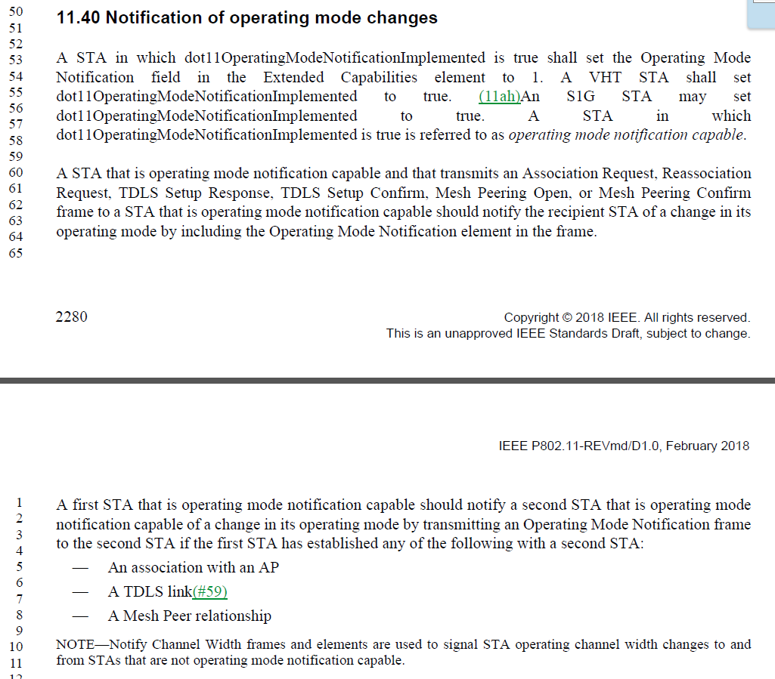

The commenter is correct, there is no such element. Perhaps this meant to say “Notify Channel Width frames and the contained Channel Width field”? In any regard, it seems superfluous.

Proposed Resolution:

Revised. Replace the cited note with: “A Notify Channel Width frame or the STA Channel Width field in the HT Operation element is used to signal STA operating channel width changes to and from STAs that are not operating mode notification capable.”

Editor: note that the clause number is 11.40.

1425 | 1592.15 | 15 | 10.3.2.10 |  | "A non-AP STA shall not transmit an Ack or BlockAck frame in response to a group addressed frame." -- an AP shouldn't ack group-addressed frames (i.e. RA = group) either | Delete "non-AP" in the cited text at the referenced location

Discussion:

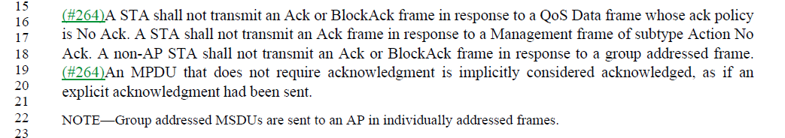

It seems, from the following NOTE, that the intention is that an AP should never receive a group addressed frame (only group addressed MSDUs in individually addressed frames), so the response rules for an AP are moot. Additionally, the filtering rules for Address 1 filtering should prevent an AP from passing any group addressed frame up the stack (to be acknowledged) as the dot11GroupAddressesTable should be null on an AP. From 10.2.7:

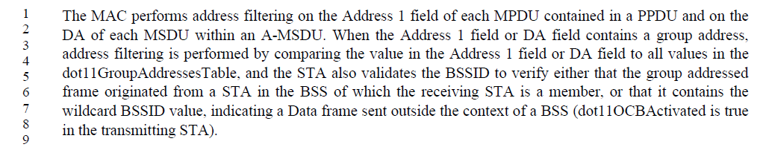

All that said, it doesn’t hurt to state that this rule applies to APs also, and does simply the sentence.

Proposed Resolution:

Accepted.

1381 | 2170.40 | 40 | 11.22.7.1 |  | "A STA  whose dot11BSSTransitionActivated is true shall support BSS transition management and shall set to 1 the  Transition field of the Extended Capabilities elements that it transmits" -- no such field | In the cited text at the referenced location change "Transition" to "BSS Transition"

Discussion:

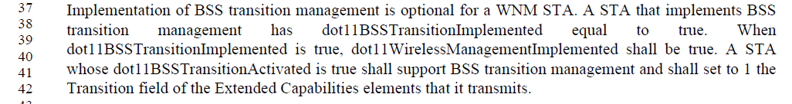

Per the definition of the Extended Capabilites field:
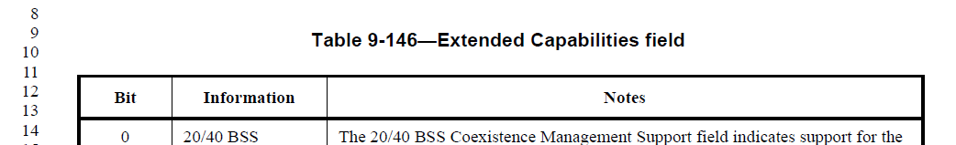

Bit 19 is in fact called “BSS Transition”.

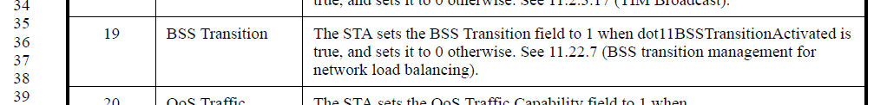

Proposed Resolution:

Accepted.

1382 | 2170.40 | 40 | 11.22.7.1 |  | "A STA  whose dot11BSSTransitionActivated is true shall support BSS transition management and shall set to 1 the  Transition field of the Extended Capabilities elements that it transmits" -- should also have implemented set to true | In the cited text at the referenced location add "shall have dot11BSSTransitionImplemented set to true," after "is true"

Discussion:

While logically both do need to be true, also, logically, there is no way dot11BSSTransitionActivated could be true if the feature were not implemented, hence dot11BSSTransitionImplemented must be true without needing to state so.

Proposed Resolution:

Rejected. For dot11BSSTransitionActivated to be true, logically, dot11BSSTransitionImplemented must also be true without needing to state so.

1390 | 1063.46 | 46 | 9.4.2.36 |  | "The Measurement Pilot Transmission subelement has the same format as the Measurement Pilot Transmission element (see 9.4.2.42 (Measurement Pilot Transmission element)). The Measurement Pilot Interval subelement is not included if" -- last Interval should be Transmission | Change "Interval" to "Transmission" in the cited text at the referenced location

Discussion:

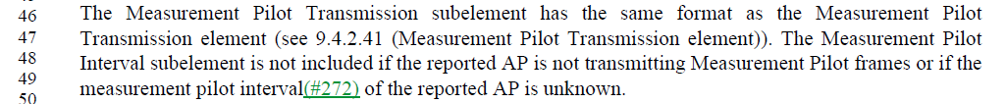

Agree with commenter.

Proposed Resolution:

Accepted. Note to Editor, the change is actually at P1063L48.

