IEEE P802.11
Wireless LANs
CR for CID 11682
Date: 2018-03-06
Author(s):
Name | Affiliation | Address | Phone | email
Jarkko Kneckt | Apple | Cupertino, CA |  | jkneckt@apple.com
Abstract
The submission provides a comment resolution for CID 11682.

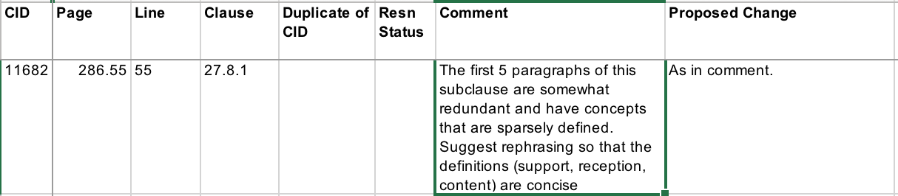

Resolution:

Revised. Agree in principle with the commenter.
Please implement the changes as shown in submission 11-18-557r1.

27.8 Operating mode indication

Instructions to the ax Editor: Change the order of the first five paragraphs and make the changes as shown below.
27.8.1 General
OMI is a procedure used between an OMI initiator and an OMI responder. An HE STA that transmits a frame including an OM Control subfield is defined as an OMI initiator. An HE STA with dot11OMIOptionImplemented equal to true(#12838) that receives a frame including an OM Control subfield is defined as an OMI responder.
An HE STA with dot11OMIOptionImplemented equal to true shall set the OM Control Support subfield in the HE MAC Capabilities Information field of the HE Capabilities element it transmits to 1. An HE AP shall set dot11OMIOptionImplemented to true and the HE AP shall implement the reception of the OM Control subfield.(#11378)

An OMI initiator may send to an OMI responder an individually addressed QoS Data, QoS Null or Class 3 Management frame after association that contains the OM Control subfield that solicits an immediate acknowledgment and is addressed to OMI responder to indicate a change in its receive operating mode (ROM) and/or transmit operating parameters (TOM) as defined in 27.8.2 (Receive operating mode (ROM) indication) and 27.8.3 (Transmit operating mode). An OMI Responder implements the reception of an individually addressed QoS Data, QoS Null or Class 3 Management frame that contains the OM Control subfield that indicates a change in ROM and/or TOM parameters.(#11378, #12839)
The OMI initiator shall indicate a change in its ROM parameters by including the OM Control subfield in a QoS Data, QoS Null or Class 3 Management frame that solicits an immediate acknowledgment(#11208) and is addressed to the OMI responder as defined in 27.8.2 (Receive operating mode (ROM) indication).
NOTE 1—Frames that solicit an immediate acknowledgment(#11208) are, for example, QoS Null frames and QoS Data frames with ack policy Normal Ack or Implicit Block Ack Request and Action frames.

An HE STA can change its operating mode setting using either operating mode notification (#14275)as described in 11.42 (Notification of operating mode changes), or the operating mode indication (OMI) proce- dure described in this subclause. An HE STA should not transmit an OM Control subfield and an Operating Mode field in the same PPDU. When a STA transmits both an OM Control subfield(#14137) and Operating Mode field in the same PPDU, then the OMI responder shall use the channel width and the Rx NSS of the most recently OM Control subfield(#14137) or Operating Mode field from the OMI initiator.(#12840, #11997)

References:

