IEEE P802.11
Wireless LANs
D2.0 PHY Comment Resolution – Part 2
Date: 2018-03-05
Author(s):
Name | Affiliation | Address | Phone | email
Youhan Kim | Qualcomm | 1700 Technology Dr.  San Jose, CA 95110 |  | youhank@qti.qualcomm.com

Abstract
This submission proposes resolutions for the following comments from the letter ballot on P802.11ax D2.0:

11723, 14049, 13067, 13066, 13399, 14054, 13302, 13304, 13432, 14058, 14160, 12760, 13435, 11441, 13642, 13592, 13442, 14061, 13632, 13593, 11168, 13594, 13443, 13595

NOTE – Set the Track Changes Viewing Option in the MS Word to “All Markup” to clearly see the proposed text edits.

Revision History:

R0: Initial version.

CID | Clause | Page | Comment | Proposed Change
11723 | 28.3.3.2 | 358.44 | For Table 28-6 to 28-8, it is good to add note explaining the most negative indices refer to the lowest frequency. | Add note to explain what negative index mean in terms of frequency position

Context

D2.2 P378L42:
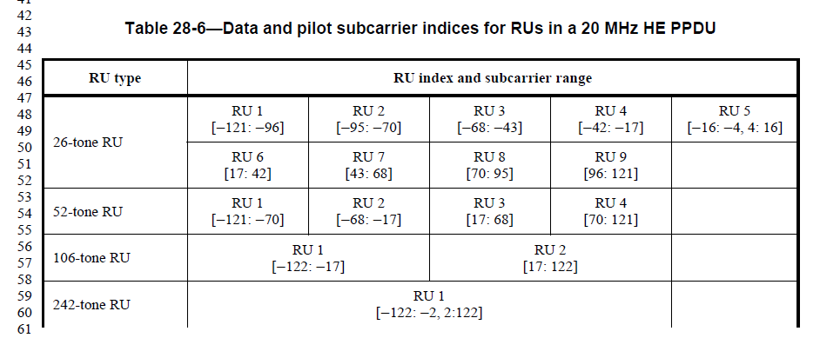

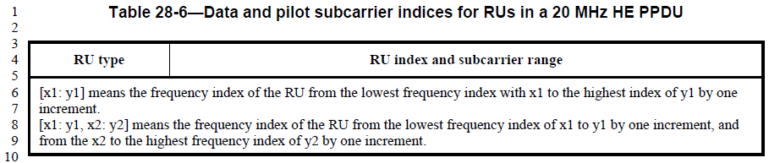

Proposed Resolution: CID 11723
Revised. Agree in principle with the commenter. Instruction to editor: Add the following at the end of the bottom row of Tables 28-6, 28-7 and 28-8.
“A tone index of 0 corresponds to the DC tone. Negative tone indices correspond to tones with frequency lower than the DC tone, and positive tone indices correspond to tones with frequency higher than the DC tone.”

CID | Clause | Page | Comment | Proposed Change
14049 | 28.3.3.3 | 365.03 | Location for null subcarriers for 160/80+80 MHz PPDUs are missing. | Add a sentence saying that the null subcarrier locations in each 80 MHz segments of an 160/80+80 MHz PPDUs follow that of the 80 MHz PPDU.

Background:
D2.2 P385:
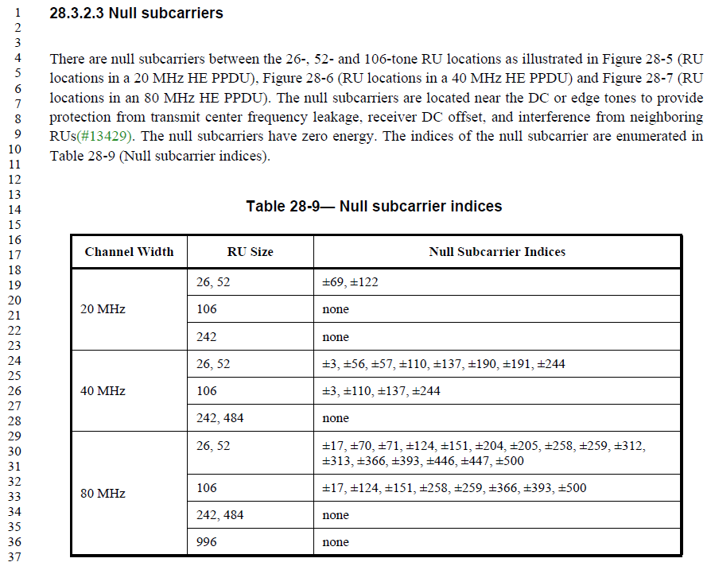

Proposed Resolution: CID 14049
Revised. Agree in principle.
Instruction to Editor: Add the following sentence at D2.2 P385L38.
“The null subcarriers locations for 160 MHz or 80+80 MHz HE PPDUs shall follow those of 80 MHz PPDUs in each 80 MHz portions.”

CID | Clause | Page | Comment | Proposed Change
13067 | 28.3.3.5 | 366.16 | The tem "20 MHz operating" need to be defined. So is the "80 MHz operating" | as in comment

Discussion:
Note that D2.2 already has a definition for a 20 MHz operating non-AP HE STA in Section 3.2.
D2.2 P37L19:

But a definition for an 80 MHz operating non-AP HE STA is missing in Section 3.2. Following are the current descriptions related to an 80 MHz operating non-AP HE STAs in D2.2.

D2.2 P389L13:
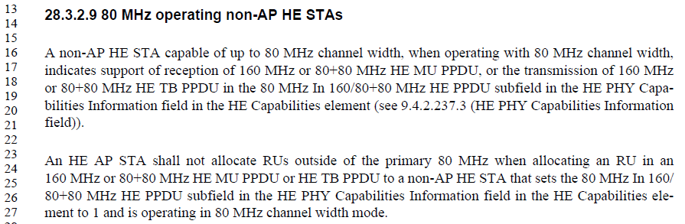

D2.2 P149L14 (HE PHY Capabilities Information field)
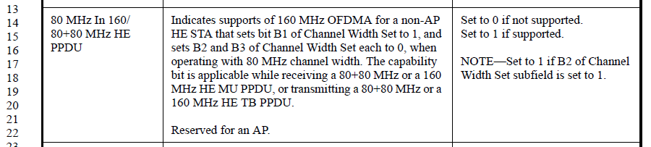

Proposed Resolution: CID 13067
Revised. D2.2 already has a definition for a 20 MHz operating non-AP HE STA at P37L19.
Instruction to Editor: Add the following definition in section 3.2.
“80 MHz operating non-access-point (non-AP) high efficiency STA (HE STA): A non-AP HE STA that is
operating in 80 MHz channel width mode, and has set the 80 MHz In 160/80+80 MHz HE PPDU subfield in the HE PHY Capabilities Information field to 1.”

CID | Clause | Page | Comment | Proposed Change
13066 | 28.3.3.5 | 366.19 | The terma "20 MHz-only" and "20 MHz operating" are used to refer to the same entity. My suggestion is to try to harmonize the reference and use a single term and delete the other. | as in comment

Proposed Resolution: CID 13066
Rejected. A “20 MHz-only non-AP HE STA” and a “20 MHz operating non-AP HE STA” are two different entities. A “20 MHz-only non-AP HE STA” is a STA which sets the B1 of the Channel Width Set subfield of the HE PHY Capabilities Information field to 1. I.e., a “20 MHz-only non-AP HE STA” is only capable of transmitting and receiving 20 MHz PPDUs at any time. A “20 MHz operating non-AP HE STA”, on the other hand, includes both a “20 MHz-only non-AP HE STA” as well as a STA which is capable of transmitting/receiving 40 or 80 MHz PPDUs (i.e., has set the B1 of the Channel Width Set subfield of the HE PHY Capabilities Information field to 0), but has temporarily reduced the current operating bandwidth mode to 20 MHz (e.g. using OMI).

CID | Clause | Page | Comment | Proposed Change
13399 | 28.3.3.5 | 366.25 | Minor typo: "20 MHz In 160 MHz PPDU subfield in the HE PHY Capabilities Information field..." should be "20 MHz  In 160/80+80 MHz PPDU subfield in the HE PHY Capabilities Information field..." | Revise as suggested

Context:
D2.2 P388L15:
A 20 MHz operating non-AP HE STA indicates support of tone mapping of 26-tone RU, 52-tone RU, and
106-tone RU for 80+80 MHz and 160 MHz HE PPDU in the 20 MHz In 160 MHz HE PPDU subfield in the
HE PHY Capabilities Information field in the HE Capabilities element (see 9.4.2.237.3 (HE PHY Capabilities
Information field)).

D2.2 P149L6 (HE PHY Capabilities Information field):
20 MHz In 160/80+80 MHz HE PPDU | Indicates support of 26-, 52-, and 106-tone mapping for a 20 MHz operating non-AP HE STA that is the receiver of a 80+80 MHz or a 160 MHz HE MU PPDU, or the transmitter of a 80+80 MHz or 160 MHz HE TB PPDU.  Reserved for an AP. | Set to 0 if not supported.  Set to 1 if supported.  NOTE—Set to 1 if B2 of Channel Width Set subfield is set to 1.

Proposed Resolution: CID 13399
Revised. Agree with the commenter.
Instruction to Editor: Change “20 MHz In 160 MHz HE PPDU” to “20 MHz In 160/80+80 MHz HE PPDU” at D2.2 P388L17.

CID | Clause | Page | Comment | Proposed Change
14054 | 28.3.3.5 | 366.59 | Missing the exception for RUs specified in 28.3.3.6 | Add language that RUs restricted by the list in 28.3.3.6 are not supported

Discussion:
D2.2 P388L1:
A 20 MHz operating non-AP HE STA indicates support of tone mapping of 26-tone RU, 52-tone RU, and 106-tone RU for a 40 MHz HE PPDU (see Table 28-7 (Data and pilot subcarrier indices for RUs in a 40 MHz HE PPDU)) in the 2.4 GHz frequency band in the 20 MHz In 40 MHz HE PPDU In 2.4 GHz Band subfield in the HE PHY Capabilities Information field in the HE Capabilities element (see 9.4.2.237.3 (HE PHY Capabilities Information field)).
A 20 MHz operating non-AP HE STA shall support tone mapping of 26-tone RU, 52-tone RU, and 106-tone RU, for 40 MHz HE PPDU (see Table 28-7 (Data and pilot subcarrier indices for RUs in a 40 MHz HE PPDU)) in the 5 GHz frequency band, and for 80 MHz HE PPDU (see Table 28-8 (Data and pilot subcarrier indices for RUs in an 80 MHz HE PPDU)) in the 5 GHz frequency band with the exception of RUs that are restricted from operation as specified in 28.3.2.8 (RU restrictions for 20 MHz operation).
A 20 MHz operating non-AP HE STA indicates support of tone mapping of 26-tone RU, 52-tone RU, and 106-tone RU for 80+80 MHz and 160 MHz HE PPDU in the 20 MHz In 160 MHz HE PPDU subfield in the HE PHY Capabilities Information field in the HE Capabilities element (see 9.4.2.237.3 (HE PHY Capabilities Information field)).

The commenter is correct that the 1st and 3rd paragraphs shown above are missing the condition that there are some restricted RUs.

Proposed Resolution: CID 14054
Revised. Proposed text update in 11-18/0508r0 adds language that there are some restricted RUs.

Instruction to Editor: Implement the proposed text updates for CID 14054 in 11-18/0508r0.

Proposed Text Updates: CID 14054

TGax Editor: Update D2.2 P388L1 as shown below.

A 20 MHz operating non-AP HE STA indicates support of tone mapping of 26-tone RU, 52-tone RU, and 106-tone RU for a 40 MHz HE PPDU (see Table 28-7) in the 2.4 GHz frequency band in the 20 MHz In 40 MHz HE PPDU In 2.4 GHz Band subfield in the HE PHY Capabilities Information field in the HE Capabilities element (see 9.4.2.237.3), with the exception of RUs that are restricted from operation as specified in 28.3.2.8.

A 20 MHz operating non-AP HE STA shall support tone mapping of 26-tone RU, 52-tone RU, and 106-tone RU, for 40 MHz HE PPDU (see Table 28-7 (Data and pilot subcarrier indices for RUs in a 40 MHz HE PPDU)) in the 5 GHz frequency band, and for 80 MHz HE PPDU (see Table 28-8) in the 5 GHz frequency band with the exception of RUs that are restricted from operation as specified in 28.3.2.8.

A 20 MHz operating non-AP HE STA indicates support of tone mapping of 26-tone RU, 52-tone RU, and 106-tone RU for 80+80 MHz and 160 MHz HE PPDU in the 20 MHz In 160 MHz HE PPDU subfield in the HE PHY Capabilities Information field in the HE Capabilities element (see 9.4.2.237.3), with the exception of RUs that are restricted from operation as specified in 28.3.2.8.

CID | Clause | Page | Comment | Proposed Change
13302 | 28.3.3.6 | 367.14 | Need to specify RU restrictions on STA that reduced its operating BW to 40MHz via OMI | Add the following statements:  An AP shall not assign the following RUs to a non-AP HE STA with a 40 MHz operating channel width:  -- 26-tone RU 10, 19 and 28 of an 80 MHz HE MU PPDU and HE TB PPDU  -- 26-tone RU 10, 19 and 28 of the lower 80 MHz or upper 80 MHz of an 80+80 MHz  and 160 MHz HE MU PPDU  -- 26-tone RU 10, 19 and 28 of the lower 80 MHz or upper 80 MHz of an 80+80 MHz  and 160 MHz HE TB PPDU  -- 52-tone RU 5 and 12 of an 80 MHz HE MU PPDU or HE TB PPDU  -- 52-tone RU 5 and 12 of the lower 80 MHz or upper 80 MHz of an 80+80 MHz and 160 MHz HE MU PPDU  -- 52-tone RU 5 and 12 of the lower 80 MHz or upper 80 MHz of an 80+80 MHz and 160 MHz HE TB PPDU  -- 106-tone RU 3 and 6 of an 80 MHz HE MU PPDU and HE TB PPDU  -- 106-tone RU 3 and 6 of the lower 80 MHz or upper 80 MHz of an 80+80 MHz and 160 MHz HE MU PPDU  -- 106-tone RU 3 and 6 of the lower 80 MHz or upper 80 MHz of an 80+80 MHz and 160 MHz HE TB PPDU  -- 242-tone RU 2 and 3 of an 80 MHz HE MU PPDU and HE TB PPDU  -- 242-tone RU 2 and 3 of the lower 80 MHz or upper 80 MHz of an 80+80 MHz and 160 MHz HE MU PPDU  -- 242-tone RU 2 and 3 of the lower 80 MHz or upper 80 MHz of an 80+80 MHz and 160 MHz HE TB PPDU

Proposed Resolution: CID 13302
Rejected. Supporting STAs operating in 40 MHz bandwidth mode to participate in wider bandwidth OFDMA transmissions requires additional modes in both AP and non-AP STAs because the tone plan for HE40 OFDMA do not align with those of HE80/160/80+80 OFDMA. If a non-AP STA wishes to reduce power consumption by reducing its operating BW, then it would be better to reduce to 20 MHz operating bandwidth mode rather than 40 MHz. Hence, there is not enough justification to require additional burden to STAs required to support 40 MHz operating STAs participating in wider bandwidth OFDMA.

CID | Clause | Page | Comment | Proposed Change
13304 | 28.3.3.6 | 367.47 | The optional support for the 242-tone RU in a STA with 20 MHz operating channel width should apply to both transmit (HE TB PPDU) and receive (HE MU PPDU). Why the prevent an AP from allocating a 242-tone RU? Is the non-AP STA can transmit the AP can try to receive and see how well it works. | Add a new capability bit or at combine with channel widht seting indication.

Proposed Resolution: CID 13304
Rejected. 242-tone RUs in HE MU/TB PPDUs of 40 MHz or wider do not have any null subcarriers at the center of the 242-tone RUs. Hence, the RX DC offset and TX carrier leak directly interfere with the data subcarriers. In case of HE MU PPDU, the receiver knows the location of its RX DC offset, hence may be able to reduce the impact to some degree. In case of HE TB PPDUs, however, receivers do not know the location of the TX carrier leak, hence it is more difficult to reduce the impact.

CID | Clause | Page | Comment | Proposed Change
13432 | 28.3.3.9 | 368.05 | Change "The AP uses the HE MU PPDU for DL MU transmission." to "The AP uses the HE MU PPDU format for DL MU transmission." | See comment

Proposed Resolution: CID 13432
Revised. While the comment is appropriate, the corresponding sentence has been removed in D2.2 per CIDs 13427, 13433, 13441. Hence, there is no further text change needed.

CID | Clause | Page | Comment | Proposed Change
14058 | 28.3.3.9.1 | 368.13 | STAs are required to receive HE MU PPDUs of RU sizes greater or equal to 106 subcarriers even if they do not support partial bandwidth DL MU-MIMO within OFDMA. | Change "shall support reception of an HE MU PPDU with RU sizes greater than or equal to 106 subcarriers." to "shall support receiving RU sizes greater than or equal to 106 subcarriers in which MU-MIMO is employed in an HE MU PPDU."
14160 | 28.3.3.9.1 | 368.15 | "RU size greater than or equal to 106 subcarriers" does not exclude 242 subcarriers even on 20MHz operating channel though its name (Partial Bandwidth DL MU-MIMO subfield) does not mean it. To make it clear, original text could be modified below. For example, ... shall support reception of a DL MU-MIMO transmission on an RU in an HE MU PPDU where the RU does not span the entire PPDU bandwidth. | as in comment

Context:

D2.2 P389L34:
28.3.3.1.1 Supported RU sizes in DL MU-MIMO

A STA that sets the Partial Bandwidth DL MU-MIMO subfield of the HE PHY Capabilities Information field in the HE Capabilities element that it transmits to 1 shall support reception of an HE MU PPDU with RU sizes greater than or equal to 106 subcarriers.

Proposed Resolution: CID 14058, 14160
Revised. Commenter is correct that the Partial Bandwidth DL MU-MIMO subfield of the HE PHY Capabilities Information field applies only to MU-MIMO enabled RUs.

Instruction to Editor: Implement the proposed text update for CID 14058 and 14160 in 11-18/0508r0.

Proposed Text Update: CID 14058, 14160

TGax Editor: Update D2.2 P389L37 as shown below.

A STA that sets the Partial Bandwidth DL MU-MIMO subfield of the HE PHY Capabilities Information field in the HE Capabilities element that it transmits to 1 shall support receiving an RU in an HE MU PPDU where MU-MIMO is employed in the RU, the RU size is greater than or equal to 106-tones, and the RU does not span the entire PPDU bandwidth.

CID | Clause | Page | Comment | Proposed Change
12760 | 28.3.3.9.3 | 368.46 | "A full bandwidth MU-MIMO transmission using the HE MU PPDU format has a value of 1 for the SIGB Compression field in HE-SIG-A" is not strong enough | Change "has" to "shall have"
13435 | 28.3.3.9.3 | 368.46 | "A full bandwidth MU-MIMO transmission using the HE MU PPDU format has a value of 1 for the SIGB Compression field in HE-SIG-A". This is not entirely clear on whether setting SIGB compression is mandatory for full BW MU-MIMO. My recollection is that this should be mandatory. | Change "has a value of 1" to "shall have a value of 1"

Context:

D2.2 P386L32:
A full bandwidth MU-MIMO transmission using the HE MU PPDU format has a value of 1 for the SIGB Compression field in HE-SIG-A and the Common field in HE-SIG-B is not present, and the HE modulated fields of the PPDU consists of one RU whose size spans the entire PPDU bandwidth.

Proposed Resolution: CID 12760, 13435
Revised. Agree with the commenter. Updating the resolution per D2.2 page/line number.
Instruction to Editor: Change “has” to “shall have” at D2.2 P386L32.

CID | Clause | Page | Comment | Proposed Change
11441 | 28.3.3.9.3 | 368.62 | It's the first time the term "HE-SIG-B content channel" is used. It's supposed a brief definition or explanation is introduced for better understanding. | Add a brief or definition to "HE-SIG-B content channel" at the first time it's used.

Context:

D2.2 P386L42:
If the value of SIGB Compression field in HE-SIG-A is 0, then the RU Allocation subfield in the Common field in each HE-SIG-B content channel indicates the combination of RUs in the current PPDU and the number of User fields included in the corresponding HE-SIG-B content channel for each RU. See 28.3.10.8.2 (Encoding and modulation) for a description of the HE-SIG-B content channel.
A 20 MHz HE MU PPDU has one HE-SIG-B content channel, while an HE MU PPDU with greater than 20 MHz PPDU bandwidth has two HE-SIG-B content channels. In each HE-SIG-B content channel, the number of spatial streams for a user in an RU is indicated by the NSTS field in the User field if there is only one User field (see Table 28-25 (User field format for a non-MU-MIMO allocation)) corresponding to the RU in the HE-SIG-B content channel.

Proposed Resolution: CID 11441
Revised. Proposed text update in 11-18/0508r0 provides a brief definition of HE-SIG-B content channel.
Instruction to Editor: Implement the proposed text update for CID 11441 in 11-18/0508r0.

Proposed Text Update: CID 11441

TGax Editor: Update D2.2 P386L42 as shown below.

A full bandwidth MU-MIMO transmission using the HE MU PPDU format has a value of 1 for the SIGB Compression field in HE-SIG-A and the Common field in HE-SIG-B is not present, and the HE modulated fields of the PPDU consists of one RU whose size spans the entire PPDU bandwidth. The number of users in the MU-MIMO group is indicated in the Number Of HE-SIG-B Symbols Or MU-MIMO Users field in HE-SIG-A. The allocated spatial streams for each user and the total number of spatial streams are indicated in the Spatial Configuration field of User field in HE-SIG-B contain-ing the STA-ID of designated MU-MIMO STA as defined in Table 28-27 (Spatial Configuration sub-field encoding).

HE-SIG-B consists of one or two HE-SIG-B content channels, which each HE-SIG-B content channel convey user allocation for one or more 20 MHz subchannels. A 20 MHz HE MU PPDU has one HE-SIG-B content channel, while an HE MU PPDU with greater than 20 MHz PPDU bandwidth has two HE-SIG-B content channels. In each HE-SIG-B content channel, the number of spatial streams for a user in an RU is indicated by the NSTS field in the User field if there is only one User field (see Table 28-25 (User field format for a non-MU-MIMO allocation)) corresponding to the RU in the HE-SIG-B content channel.

If the value of SIGB Compression field in HE-SIG-A is 0, then the RU Allocation subfield in the Common field in each HE-SIG-B content channel indicates the combination of RUs in the current PPDU and the number of User fields included in the corresponding HE-SIG-B content channel for each RU. See 28.3.10.8.2 (Encoding and modulation) for a description of the HE-SIG-B content channel.

CID | Clause | Page | Comment | Proposed Change
13642 | 28.3.3.9.3 | 369.10 | For RU size of 996 subcarriers, there will be 2 RU allocation subfields on each HE-SIG-B content channel, how to split the number of users between the two RU allocation subfields on the same HE-SIG-B content channel need to be clarified. | Add clarification that the second RU allocation subfield for the 996 tone RU on each HE-SIG-B content channel shall set to "01110011" (996-tone RU with no User).

Discussion:

Context: D2.2 P386L55:
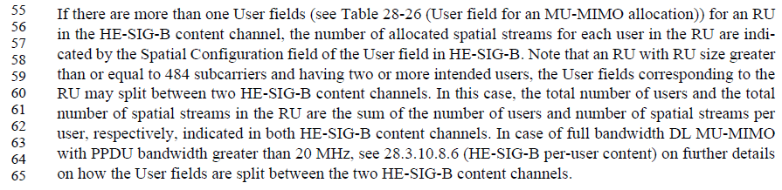

Note that the same clarification has been made in D2.2 in the HE-SIG-B section (28.3.10.3).
D2.2 P446L33:
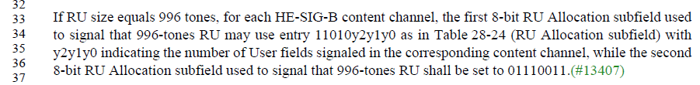

Proposed Resolution: CID 13642
Rejected. Agree with the commenter in principle. However, the same clarification has already been made in D2.2 in the HE-SIG-B section (see P446L33). 28.3.3.9.3 is more of an overview section, and it is not necessary (and not desired) to repeat the detailed rules of HE-SIG-B indications which is already present in 28.3.10.3.

CID | Clause | Page | Comment | Proposed Change
13592 | 28.3.3.11.2 | 369.62 | A STA in IEEE contains both AP STA and non-AP STA. Since UL MU-MIMO Tx is only for a non-AP STA, the clarification is required, e.g., it shall support 'either transmission or reception' not 'transmission and reception' | There are two approaches either describing one paragraph without specifying transmission or reception (non-AP transmission or AP reception is already described in the capability section), or make two independent paragraphs, one is for non-AP's transmission capability, another is for AP's reception capability
13442 | 28.3.3.11.2 | 369.64 | "shall support transmission and reception of an HE TB PPDU". An AP should support reception and non-AP should support transmission. Definitely not all systems should be required to support both. | Clarify the requirement
14061 | 28.3.3.11.2 | 369.64 | STAs are required to transmit HE TB PPDUs of RU sizes greater or equal to 106 subcarriers even if they do not support partial bandwidth UL MU-MIMO within OFDMA. | Change "shall support transmission and of an HE MU PPDU with RU sizes greater than or equal to 106 subcarriers." to "shall support receiving RU sizes greater than or equal to 106 subcarriers in which MU-MIMO is employed in an HE MU PPDU."
13632 | 28.3.3.11.2 | 369.65 | Why STA shall support reception of an HE TB PPDU? | A STA that sets the Partial Bandwidth UL MU-MIMO subfield of the HE PHY Capabilities Information field in the HE Capabilities element that it transmits to 1 shall support transmission and reception of an HE TB PPDU with RU sizes greater than or equal to 106 subcarriers.

Context:
D2.2 P390L18:
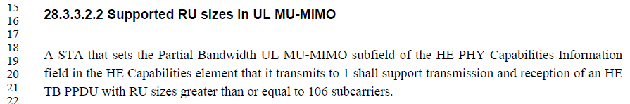

D2.2 P145L50 (HE PHY Capabilities Information field):
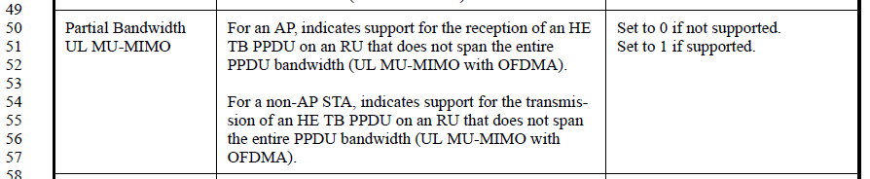

Proposed Resolution: CID 13592, 13442, 14061, 13632
Revised. Proposed text update in 11-18/0508r0 separates out the description for an AP and a non-AP STA.
Instruction to Editor: Implement the proposed text update for CIDs 13592, 13442, 14061 and 13632 in 11-18/0508r0.

Proposed Text Update: CID 13592, 13442, 14061, 13632

TGax Editor: Update D2.2 P145L50 as shown below.

Partial Bandwidth UL MU-MIMO | For an AP, indicates support for receiving an RU in an HE TB PPDU where MU-MIMO is employed in the RU, the RU size is greater than or equal to 106-tones, and the RU does not span the entire PPDU bandwidth (UL MU-MIMO within OFDMA).  For a non-AP STA, indicates support for transmitting an RU in an HE TB PPDU where MU-MIMO is employed in the RU, the RU size is greater than or equal to 106-tones, and the RU does not span the entire PPDU bandwidth (UL MU-MIMO within OFDMA). | Set to 0 if not supported.  Set to 1 if supported.

TGax Editor: Update D2.2 P390L18 as shown below.

28.3.3.2.2 Supported RU sizes in UL MU-MIMO
An AP that sets the Partial Bandwidth UL MU-MIMO subfield of the HE PHY Capabilities Information field in the HE Capabilities element that it transmits to 1 shall support receiving an RU in an HE TB PPDU where MU-MIMO is employed in the RU, the RU size is greater than or equal to 106-tones, and the RU does not span the entire PPDU bandwidth.

A non-AP STA that sets the Partial Bandwidth UL MU-MIMO subfield of the HE PHY Capabilities Information field in the HE Capabilities element that it transmits to 1 shall support transmitting an RU in an HE TB PPDU where MU-MIMO is employed in the RU, the RU size is greater than or equal to 106-tones, and the RU does not span the entire PPDU bandwidth.

In the HE PHY Capabilities Information field, a STA that sets the Partial Bandwidth UL MU-MIMO subfield to 1 shall also set the Full Bandwidth UL MU-MIMO subfield to 1.

CID | Clause | Page | Comment | Proposed Change
13593 | 28.3.3.11.3 | 370.09 | A STA in IEEE contains both AP STA and non-AP STA. Since UL MU-MIMO Tx is only for a non-AP STA, the clarification is required. In addition, since this paragraph only describes the capability of a non-AP STA transmission, the the capability of AP STA reception should be made as well | Change 'A STA' to 'A non-AP STA' and create the new paragraph describing AP STA's reception capability

Context:
D2.2 P390:
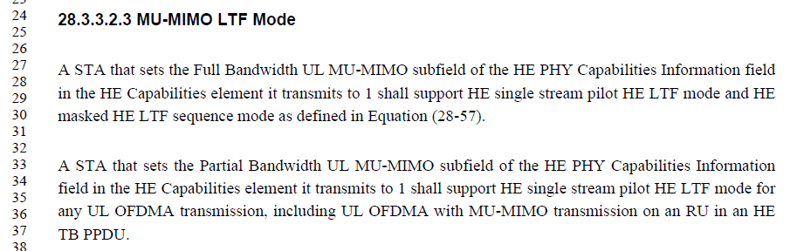

D2.2 P145L50 (HE PHY Capabilities Information field):

Proposed Resolution: CID 13593
Revised. Proposed text update in 11-18/0508r0 separates out the description for an AP and a non-AP STA. It also clarifies when the HE masked HE LTF sequence mode may be used.
Instruction to Editor: Implement the proposed text update for CIDs 13593 in 11-18/0508r0.

Proposed Text Update: CID 13593

TGax Editor: Update D2.2 P390L27 as shown below.
28.3.3.2.3 MU-MIMO LTF Mode
A non-AP STA that sets the Full Bandwidth UL MU-MIMO subfield of the HE PHY Capabilities Information field in the HE Capabilities element it transmits to 1 shall support HE single stream pilot HE LTF mode and HE masked HE LTF sequence mode as defined in Equation (28-57) when transmitting HE TB PPDUs with one RU spanning the entire PPDU bandwidth, and the RU using MU-MIMO.

An AP that sets the Partial Bandwidth UL MU-MIMO subfield of the HE PHY Capabilities Information field in the HE Capabilities element it transmits to 1 shall support receiving HE TB PPDUs using the HE single stream pilot HE LTF mode when the HE TB PPDU uses MU-MIMO in an RU which does not span the entire PPDU bandwidth. .

A non-AP that sets the Partial Bandwidth UL MU-MIMO subfield of the HE PHY Capabilities Information field in the HE Capabilities element it transmits to 1 shall support transmitting HE TB PPDUs using the HE single stream pilot HE LTF mode when the HE TB PPDU uses MU-MIMO in an RU which does not span the entire PPDU bandwidth.

CID | Clause | Page | Comment | Proposed Change
11168 | 28.3.3.11.4 | 370.19 | In this clause it states that a STA supporting UL-MU-MIMO transmissions at full-bandwidth supports 4 space-time streams for HE SU PPDUs and later states supports for 8 streams. The minimum and maximum number of space-time streams needs clarification. | Rewrite the sentence clarifying the number of space-time streams at full-bandwidth.
13594 | 28.3.3.11.4 | 370.19 | A STA in IEEE contains both AP STA and non-AP STA. Since UL MU-MIMO Tx is only for a non-AP STA, the clarification is required | Change 'A STA' to 'A non-AP STA'
13443 | 28.3.3.11.4 | 370.27 | "A STA that supports UL MU-MIMO transmission on full bandwidth supports a total of up to 8 space-time streams" is not clear. Change to e.g. "A STA that supports UL MU-MIMO transmission on full bandwidth shall support transmissions where the total number of streams across all users, as indicated in the preceding Trigger frame, is up to 8." | See comment
13595 | 28.3.3.11.4 | 370.27 | A STA in IEEE contains both AP STA and non-AP STA. Since UL MU-MIMO Tx is only for a non-AP STA, the clarification is required | Change 'A STA' to 'A non-AP STA'

Context:
D2.2 P390:
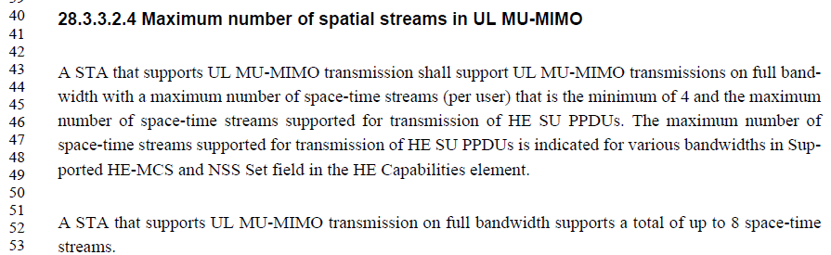

D2.2 P145L50 (HE PHY Capabilities Information field):

Proposed Resolution: CID 11168, 13594, 13443, 13595
Revised. Proposed text update in 11-18/0508r0 clarifies the requirements on spatial streams for UL MU-MIMO.
Instruction to Editor: Implement the proposed text update for CIDs 11168, 13594, 13443 and 13595 in 11-18/0508r0.

Proposed Text Update: CID 11168, 13594, 13443, 13595

TGax Editor: Update D2.2 P390L43 as shown below.
28.3.3.2.4 Maximum number of spatial streams in UL MU-MIMO
A non-AP STA that supports UL MU-MIMO shall support transmitting HE TB PPDUs using MU-MIMO where:
- The number of spatial streams allocated to the non-AP STA ranges from 1 to N, where N is the smaller value between 4 and the maximum number of spatial streams supported by the non-AP STA for transmitting HE SU PPDUs.
- The number of total spatial streams (summed over all users) is up to 8.

Note – The maximum number of spatial streams supported for transmitting HE SU PPDUs is indicated in the Supported HE-MCS and NSS Set field in the HE Capabilities element for various bandwidths.

All the aforementioned requirements in this subclause on the per-user and total number of spatial streams are applicable to both full and partial bandwidth MU-MIMO.

[End of File]

