IEEE P802.11
Wireless LANs
Comment Resolutions on Clause 10.38.7 (Beam Tracking)
Date: 2018-02-28
Author(s):
Name | Affiliation | Address | Phone | email
Kome Oteri | InterDigital | 9710 Scranton Road, San Diego, CA 92121 | +1-858-210-4826 | kome.oteri@interdigital.com
Rui Yang

Abstract
This submission proposes resolutions for the following 2 comments on Clause 10.38.7 (Beam Tracking) of TGay D1.0:
1925, 1926

Revisions:
- Rev 0: Initial version of document

Interpretation of a Motion to Adopt

A motion to approve this submission means that the editing instructions and any changed or added material are actioned in the TGax Draft. This introduction is not part of the adopted material.

Editing instructions formatted like this are intended to be copied into the TGay Draft (i.e. they are instructions to the 802.11 editor on how to merge the text with the baseline documents).

TGay Editor: Editing instructions preceded by “TGay Editor” are instructions to the TGay editor to modify existing material in the TGay draft. As a result of adopting the changes, the TGay editor will execute the instructions rather than copy them to the TGay Draft.

CID | Clause Number | P.L | Comment | Proposed Change | Resolution
1925 | 10.38.7 | 161.04 | "NOTE--If the EDMG_BEAM_TRACKING_TYPE parameter in the RXVECTOR is Baseband Beam Tracking, the baseband beamformers at the initiator and responder can be set to a predetermined orthogonal matrix (e.g., the identity matrix) during the transmission of the appended TRN-R subfields only and the measurement at the initiator is based on the appended TRN-R packets". We can remove the transmitter as the TRN fields do not pass throught the Q matrix (the responder) | Modify text: NOTE--If the EDMG_BEAM_TRACKING_TYPE parameter in the RXVECTOR is Baseband Beam Tracking, the baseband beamformers at the INITIATOR can be set to a predetermined orthogonal matrix (e.g., the identity matrix) during the transmission of the appended TRN-R subfields only and the measurement at the initiator is based on the appended TRN-R packets. | Revised  TGay editor to make the changes shown in 11-18/0500r0 under all headings that include CID 1925
1926 | 10.38.7 | 161.17 | Do not need identity matrix as TRN fields do not go through the Q matrix. | NOTE--If the EDMG_BEAM_TRACKING_TYPE parameter in the TXVECTOR is Baseband Beam Tracking, then EDMG_TRN_LEN TRN units are appended to the PPDU (each with EDMG_TRN_P TRN subfields) and are transmitted using the same AWV as the preamble and Data field of the PPDU. The baseband beamformer for the RESPONDER can be set to a predetermined orthogonal matrix (e.g., the identity matrix) during the transmission of the appended TRN-T subfields only and the measurement is based on the appended TRN-T subfields. | Revised  TGay editor to make the changes shown in 11-18/0500r0 under all headings that include CID 1926

Discussion

The transmitter block diagram for the EDMG portion of the SU PPDU transmission in the EDMG SC mode (Figure 129, pg 283, line11) shows that the TRN builder is placed after the spatial mapper and before the pulse shaping filter as shown below:

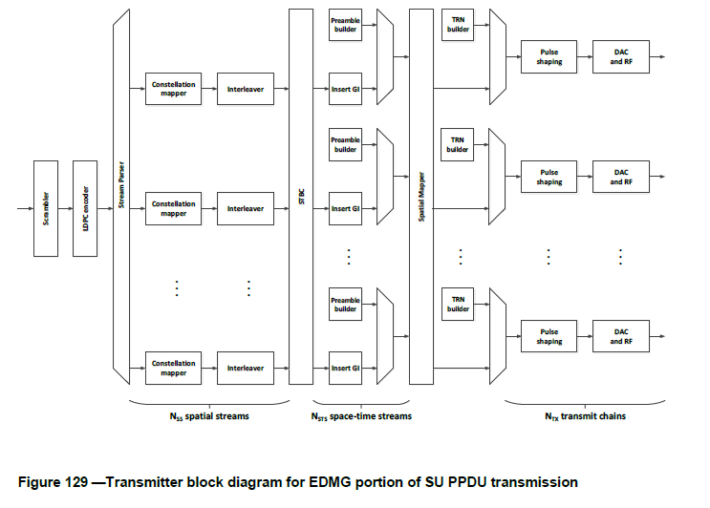

This is the same for the EDMG portion of the MU PPDU Transmission (Figure 130, pg 284, line 3)

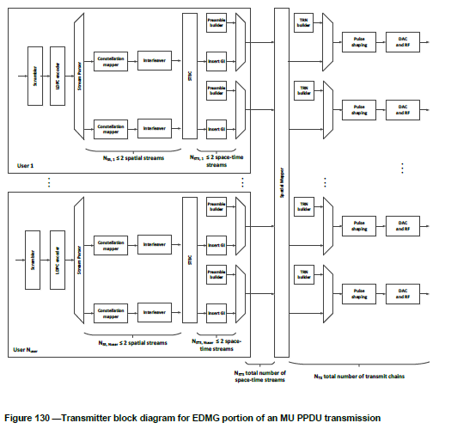

The transmitter block diagram for the EDMG portion of the SU PPDU transmission in the OFDM mode (Figure 147, pg 338, line3) shows that the TRN builder is placed after the spatial mapper and before processing by the IDFT as shown below:

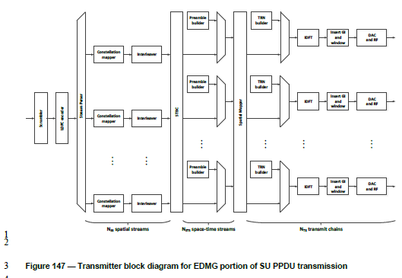

This is the same for the EDMG portion of the MU PPDU Transmission (Figure 148, pg 339, line 3)

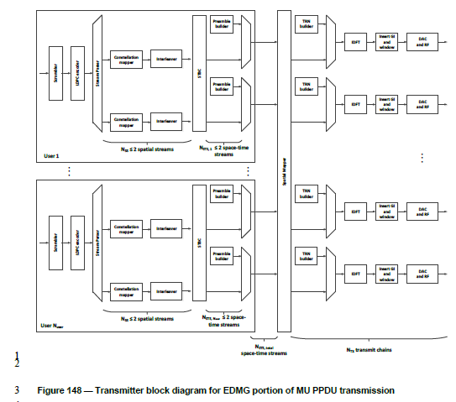

As such, there is no need for the specification to mandate a specific spatial mapper for the TRN fields.

Changes to D1.0

TGay Editor: Please make the following change on Pg 161 line 4 (#1925):

NOTE—If the EDMG_BEAM_TRACKING_TYPE parameter in the RXVECTOR is Baseband Beam Tracking, the baseband beamformers at the initiator and responder (#1295) can be set to a predetermined orthogonal matrix (e.g., the identity matrix) during the transmission of the appended TRN-R subfields only and the measurement at the initiator is based on the appended TRN-R packets.

TGay Editor: Please make the following change on Pg 161 line 17 (#1926):

NOTE—If the EDMG_BEAM_TRACKING_TYPE parameter in the TXVECTOR is Baseband Beam Tracking, then EDMG_TRN_LEN TRN units are appended to the PPDU (each with EDMG_TRN_P TRN subfields) and are transmitted using the same AWV as the preamble and Data field of the PPDU. The baseband beamformer for the initiator and (#1296) responder can be set to a predetermined orthogonal matrix (e.g., the identity matrix) during the transmission of the appended TRN-T subfields only and the measurement is based on the appended TRN-T subfields.

References:
- IEEE P802.11ayTM/D1.0.

