IEEE P802.11  
Wireless LANs

|  |  |  |  |  |
| --- | --- | --- | --- | --- |
| Technical Report on Full Duplex for 802.11 | | | | |
| Date: 2018-08-07 | | | | |
| Contributors: | | | | |
| Name | Affiliation | Address | Phone | email |
| Yan Xin | Huawei Technologies | 303 Terry Fox Dr., Suite 400, Ottawa, ON, Canada K2K 3J1 | +1-613-979-1792 | yan.xin@huawei.com |
| Allen D. Heberling | GenXComm | 1604 San Antonio St. Austin, TX, 78701 |  | Allen.heberling@genxcomminc.com |
| Kome Oteri | InterDigital | 9276 Scranton Road,  # 300, San Diego, CA, 92127 | +1 858.210.4826 | Oghenekome.Oteri@InterDigital.com |
| Ming Gan | Huawei Technologies | F1-17, Huawei Base, Bantian, Longgang District, Shenzhen, China | +86 15889743667 | ming.gan@huawei.com |
| Genadiy Tsodik | Huawei Technologies |  |  | genadiy.tsodik@huawei.com |
| Tho Le-Ngoc | McGill University | Room 633, McConnell Engineering Building 3480 University Street Montreal, QC, Canada H3A 0E9 |  | tho.le-ngoc@mcgill.ca |
| Shimi Shilo | Huawei Technologies |  |  | shimi.shilo@huawei.com |
| Dandan Liang | Huawei Technologies |  |  | dandan.liang@huawei.com |
| Edward Au | Huawei Technologies |  |  | edward.ks.au@huawei.com |
| Rui Yang | InterDigital |  |  | Rui.Yang@InterDigital.com |
| David Xun Yang | Huawei Technologies |  |  | david.yangxun@huawei.com |
| Peiwei Wang | Huawei Technologies |  |  | peiwei.wang@huawei.com |
| Robert Morawski | McGill University |  |  |  |
| Leonid Epstein | Huawei Technologies |  |  | Leonid.epstein@huawei.com |
| Yanchun Li | Huawei Technologies |  |  | liyanchun@huawei.com |
| Doron Ezri | Huawei Technologies |  |  | Doron.Ezri@huawei.com |
| Harry Lee | McGill University |  |  |  |
| Yaron Ben Arie | Huawei Technologies |  |  |  |
| James Gilb | Gilb Consulting |  |  | Gilb_IEEE@yahoo.com |

Abstract

This document is Technical Report on Full Duplex for IEEE 802.11 (r2), which provides description on FD use cases, FD functional requirements, self-interference cancellation techniques, impact on FD operations on 802.11 standard**,** FD architecture, FD benefits and challenges and economy feasibility.

Revision History

r0 – March 5, 2018. Framework of Technical Report on Full Duplex for 802.11.

r1 – July 10, 2018. Modification of r0 with Section 6 Key Metrics removed; section 7 renamed as FD Benefits and challenges.

r2 – August 2, 2018. FD use cases, FD functional requirements, self-interference cancellation techniques, impact on FD operations on 802.11 standard and FD architecture added.

r3 – August 7, 2018. Functional requirements Secs. 3.1 and 3.4 modified; sec. 4.1 technical survey added; Sec. 4.2.1 modified; more evidence added to Sec. 6.1 throughput gains.

**Table of Contents**

1. Introduction 5

2. FD Use Cases in 802.11 5

2.1 High throughput networks 5

2.1.1 Dense network - stadiums 5

2.1.2 Virtual reality (VR) game 6

2.1.3 Augmented reality (AR) shopping 6

2.1.4 Telemedicine 6

2.2 Relay-based network 7

2.3 Security systems 7

3. FD Functional Requirements 7

3.1 Bands and bandwidths of FD operations 8

3.2 Throughput over an allocated bandwidth and effective throughput per BSS 8

3.3 Latency enhancement 8

3.4 FD capability of AP STA and non-AP STA 9

3.5 Backward compatibility and co-existence with legacy 802.11 devices 9

4. FD Technical Feasibility 9

4.1 Technical survey 9

4.1.1 Current instantiations of Full Duplex PHY functionality 9

4.1.2 Current Full Duplex MACs 10

4.1.3 Real world implementation of Full Duplex operation in DOCSIS 3.1-FDX 11

4.2 FD operations within a BSS 13

4.2.1 Self-interference cancellation level 13

4.2.2 Potential techniques for self-interference cancellation 15

4.2.3 Scheduling in FD for 802.11 18

4.3 FD operations over overlapping BSS (OBSS) 18

4.4 Impacts of FD operations on the 802.11 standard 18

4.4.1 Training and preamble 19

4.4.2 FD transmission initiation 19

5. Architecture of FD for 802.11 19

5.1 Asymmetric FD for 802.11 19

5.2 Symmetric FD for 802.11 21

5.3 Impacts of architecture on the 802.11 standard 22

5.3.1 FD interference discovery in asymmetric FD 22

6. FD Benefits and Challenges 24

6.1 Throughput gain over an allocated bandwidth 24

6.1.1 FD Throughput gain without hidden nodes [26] 24

6.1.2 FD Throughput gain with hidden nodes [26] 24

6.2 ~~Lower~~ Latency enhancement 25

6.3 Collision reduction 25

6.3.1 Collision detection 25

6.3.2 Actions based on collision detection 26

6.3.3 Simulation 27

6.4 Mitigation of hidden node issue 27

7. Economic Feasibility 27

8. Recommendations~~Conclusions~~ 29

9. References 29

# ****Introduction****

**Wi-Fi products have been widely deployed around world with ~~the facts of~~ more than** three billion Wi-Fi devices estimated to be shipped in 2017 and more than eight billion Wi-Fi devices currently in use [1] in order to satisfy the fast growth in user demands on data communications through, for example, home/enterprise networks, services for the public (e.g., airports, aircraft, train (stations), shopping centers and conference rooms, etc.), augmented/virtual reality (AR/VR) and Internet of Things (IoT), and so on. **Dense deployment of Wi-Fi devices and potential high demands on data throughputs per device as well as short latency require advanced Wi-Fi systems to operate with high spectrum efficiency and good performance.**

**Full Duplex (FD) for wireless systems [2], [3] is a technology that allows a device to simultaneously transmit and receive wireless signals. FD can significantly increase the throughput for each allocated channel and furthermore improve the total system capacity. In addition, the inherent capability of FD can provide an opportunity to reduce round-trip latency for data transmission, which is due to transmission of ACK or feedback information, and to implement an in-band and out-of-band relay system. The benefits and challenges of applying FD to 802.11 are discussed in [4], [5]. Standardization of FD technology for 802.11 is considered in [4].**

This technical report on full duplex for IEEE 802.11 presents some key discussion results achieved in the FD TIG, which include FD use cases, FD functional requirements, technical feasibility of FD for 802.11, architecture of FD for 802.11 and benefits and challenges of FD deployment. In addition, this report provides recommendations on a way forward of standardization for a full-duplex amendment to 802.11.

# FD Use Cases in 802.11

Potential applications of full duplex to satisfy the high-demanding requirements of the future 802.11 systems are discussed in [6], [7]. High throughput networks and security systems are presented in [6], FD relay and mesh networks are highlighted in [6], [7], multi-channel/multi-RAT FD operations are considered in [7].

## High throughput networks

Dense network may include high-density APs and/or high-density STAs associated to each AP, which operate in the 2.4 GHz, 5 GHz and/or 6 GHz bands, such as those networks in stadiums or shopping malls (high-density APs as well as high-density STAs); or in a lecture hall or a dense-space office (high-density STAs); or in a community environment or a dense apartment building (high-density APs). Full duplex technology can be deployed to meet the high throughput requirements [6].

### Dense network - stadiums

**Use Case**

1. Users receive video show of some preferred football stars in an outdoor stadium;

2. Users access the internet for recreational content, supplemental event content (e.g., game stats) while uploading the recorded lightly compressed match video to the server or sharing it with their friends;

Users may be serviced by one AP for both uplink and downlink traffic at the same time.

Similar use cases can also be identified in other dense networks, such as airports, train stations, and exhibition hall, etc.

### Virtual reality (VR) game

**Use Case**

1. The gamer is wearing his handset to start the game on a VR platform;
2. The gamer moves the game handle left and right, and crouch from time to time or click the button to simulate the battle scenes;
3. Cameras or sensors track the gesture of the player and the movement of the game handle;
4. The motion message is sent to gamming console from cameras;
5. Meanwhile video and interaction behavior are non-disruptively streamed down to the goggle from the gaming console which is about 8 feet in front of the gamer.

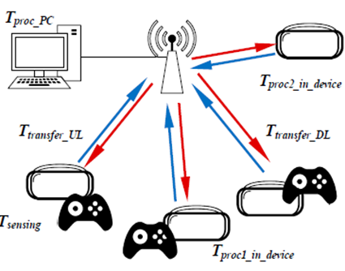

### Augmented reality (AR) shopping

**Use Case**

1. The customer wears her Wi-Fi connected AR glasses and enters the store;
2. The glasses send the video or picture captured by the camera on the glasses to the AP;
3. The AP sends the related information such as the good’s price, the coupon, the related live video, etc. to the customer’s glasses.

### Telemedicine

**Use Case**

1. The user turns on the displays, cameras and WLAN, and prepares all the surgical instruments;
2. Uncompressed video and voice information related to the patient are sent to the AP in the surgery room, and then passed over the internet to the AP in the remote doctor’s office and further displayed in real time;
3. The doctor’s instructions including voice and image are sent to the AP in the doctor office, and then passed over the internet to the AP in the surgery room and further displayed.

Similar use cases are real-time multi-media chat, such as video conference call, skype or wechat video call.

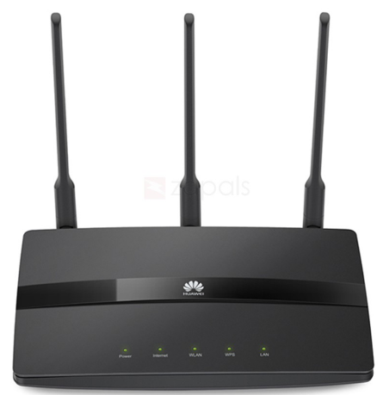

## Relay-based network

**Use Case [6]**

1. A root AP is deployed in the living room and a wireless relay is deployed in the bedroom;

2. Alice opens video app using a mobile phone to watch a movie in the bedroom. The request is sent to wireless relay and forwarded to the root AP;

3. The video stream is downloaded to the root AP, and then is sent to the Wi-Fi relay and forwarded to Alice;

4. At the Wi-Fi relay, data is received and forwarded to the destination simultaneously.

## Security systems

Security system provides the secure communication service using full duplex technology [6].

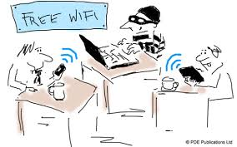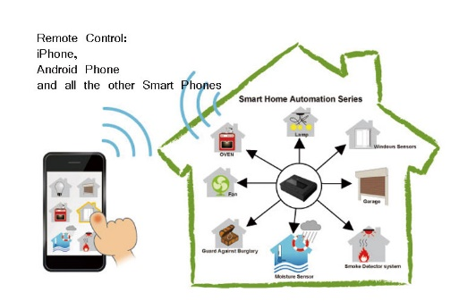

**Public Wi-Fi**

**Smart Home**



**Wi-Fi Monitor**



**Important Meeting**

**Use Case**

1. Parents open the Wi-Fi monitor and watch the baby’s status through their mobile phones;
2. The monitor sends the live video, audio and alerts of the baby to the parents’ mobile phones;
3. While receiving the data from monitor, the parents’ mobile phones send the jamming signal to avoid eavesdropping.

# FD Functional Requirements

Functional requirements of full-duplex for 802.11 are considered in [8], [9].

## Bands and bandwidths of FD operations

* Full-duplex amendment to 802.11 should define operations in frequency bands between 1 GHz and 7.125 GHz.
* Full-duplex amendment to 802.11 should support 20 MHz, 40 MHz and 80 MHz bandwidths, and may support 160 MHz and 320 MHz bandwidths.
* Full-duplex amendment to 802.11 may support different bandwidths for simultaneous transmission and reception during full duplex operations.

Operating classes in different countries are listed in Annex E of [10]. Example channel allocations are illustrated in Figure 1 and Figure 2 in 2.4 GHz and 5 GHz, respectively.

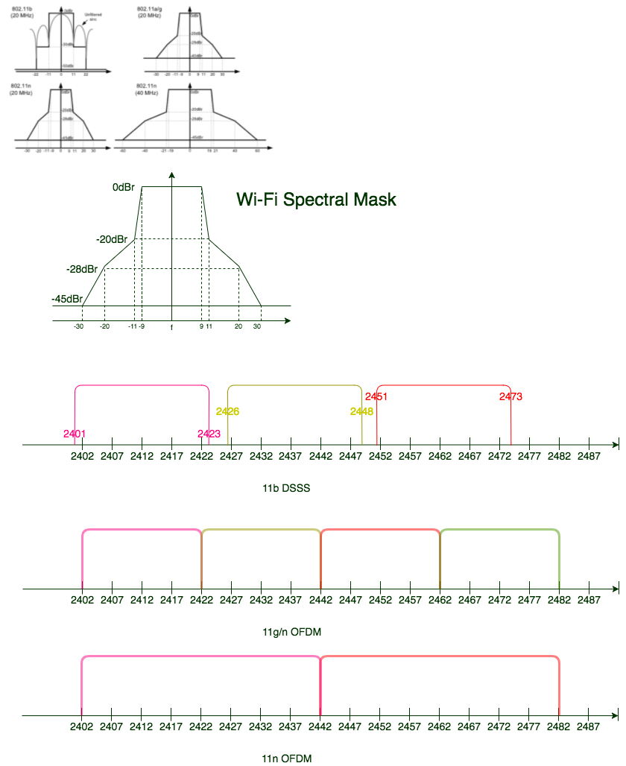

Figure 1 Example channel allocations in the 2.4 GHz band.

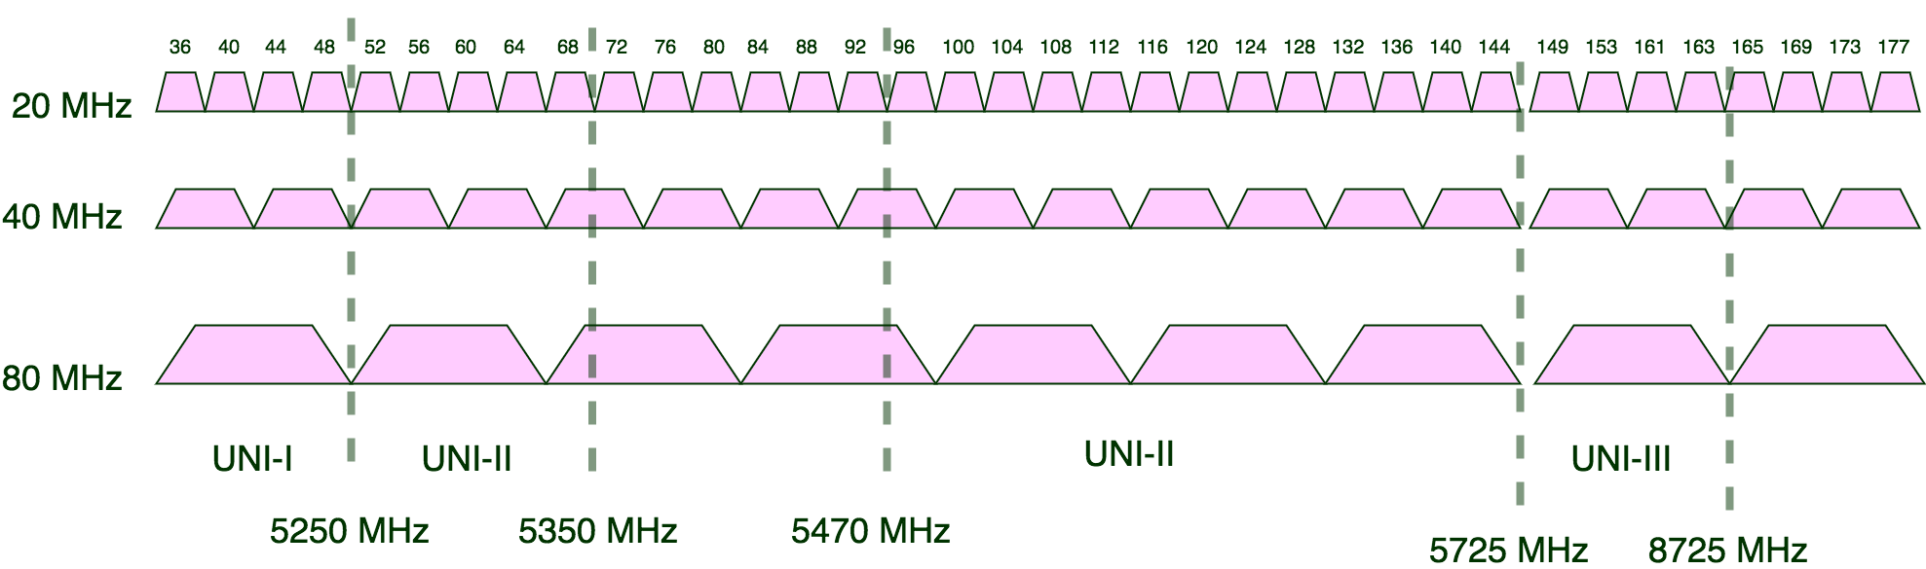

Figure 2 Example channel allocations in the 5 GHz band.

## Throughput over an allocated bandwidth and effective throughput per BSS

* The mechanisms defined in the full-duplex amendment to 802.11 should provide at least one mode of operations capable of achieving up to two-time improvement in terms of throughput per station for an allocated channel bandwidth.
* The mechanisms defined in the full-duplex amendment to 802.11 should improve effective throughput per BSS.

## Latency enhancement

* The mechanisms defined in the full-duplex amendment to 802.11 should provide at least one mode of operations to improve the average transmission latency compared to legacy half-duplex operations.

## FD capability of AP STA and non-AP STA

* Full-duplex amendment to 802.11 should enable an AP STA to cancel certain amount of self-interference to provide sufficient signal-to-interference-plus-noise ratio (SINR) values at receiver in order to achieve throughput gains per station in an allocated channel bandwidth compared to half duplex transmission.
* Full-duplex amendment to 802.11 may enable a non-AP STA to cancel certain amount of self-interference to provide sufficient SINR values at receiver in order to achieve throughput gains per station in an allocated channel bandwidth compared to half duplex transmission.
* Full-duplex amendment to 802.11 should ensure no degradation on throughput for an FD-capable STA when it performs half duplex transmission.
* Full Duplex (FD) capable APs and STAs are required to operate in either of these Basic Service Sets (BSS)s
* A homogeneous BSS in which the AP and all of its associated STAs are FD capable, or
* A heterogeneous BSS in which the AP is FD capable and its associated STAs are either: all Half Duplex (HD) capable or a mixture of FD and HD capable STAs

## Backward compatibility and co-existence with legacy 802.11 devices

* Full-duplex amendment to 802.11 should enable coexistence with legacy IEEE 802.11 devices operating in the same frequency band.
* Full-duplex amendment to 802.11 should enable backward compatibility with legacy IEEE 802.11 devices.

# FD Technical Feasibility

A device with wireless full-duplex (FD) capability can simultaneously transmit and receive wireless signals sharing the same frequency resource. FD feasibility analyses for 802.11 include both PHY and MAC aspects.

## Technical survey

### Current instantiations of Full Duplex PHY functionality

Table 1 lists six approaches and their attributes for enabling full duplex PHY behaviour in a wireless networking system.

Table 1 Comparison of Full Duplex PHY approaches

|  |  |  |  |  |  |  |
| --- | --- | --- | --- | --- | --- | --- |
|  | **Approach 1** | **Approach 2** | **Approach 3** | **Approach 4** | **Approach 5** | **Approach 6** |
|  | Antenna Separation [12] | Meta-materials based circulator [13] | Antenna Polarization [14] | Delay and Subtract [2] | Photonics [15] | Hybrid RF/ Photonic/ Digital Baseband [16] |
| Bandwidth | 5MHz | 1MHz | 20MHz | 20/40MHz | 10MHz | 800MHz |
| Drift  Tolerance | Low | High | Low | Moderate | Moderate | High |
| Scatter Tolerance | No | No | No | No | No | Yes |
| Environ-ment Fluctuation | Intolerant | Intolerant | Intolerant | Intolerant | Intolerant | Tolerant |
| MIMO  capability | Limited | Limited | Yes | Yes | Limited | Yes |
| Form Factor | Antenna spacing | Small | Small | Small | Small | Chip-scale |

### Current Full Duplex MACs

A review of the current technical literature regarding MAC protocols that support the Full Duplex (FD) exchange of packets in an IEEE 802.11 network revealed an extensive bibliography of papers. Out of this extensive list, these, at the moment, three FD capable MAC protocols were selected as indications of the evolving maturity of the full duplex protocols. The criteria used to select these three protocols are listed in the first column labelled Attributes.

Table 2 FD MAC Comparisons

| **Attributes** | **S-CW Full Duplex [26]** | **SRB-MAC [12]** | **STR-MAC [17]** |
| --- | --- | --- | --- |
| Organization | Sabanaci U. | Rice U. | Toshiba Research |
| Modifications of existing Frame Formats | 2 bits in existing MAC Hdr ctrl field; 10 bit *next_bo* field at head of payload | Adds a 13 bit FD Hdr between the MAC Hdr and the Payload | FD Capability Info Field; 1-bit mod of reserved bits in CTS (CTS_FD) |
| New MAC Mechanisms | Synchronized contention window | Shared random backoff; virtual backoff; header snooping | Adaptive Tx & ACK TO |
| Supports Heterogeneous FD/HD WLANS | Yes | If HD Nodes support snooping, then Yes, else No | Yes |
| Supports Homogeneous FD WLAN | Yes | Yes | Yes |
| BiDirectional FD | Yes | Yes | Yes |
| UniDirectional FD | Yes | Yes | Yes |
| Hidden Node Mitigation | Yes via FD & FDmaster bits in MAC Hdr ctrl fld. | Via Snooping | Via RTS/CTS |
| Backwards Compatible w/ HD WiFi | Yes | If HD Nodes support snooping, then Yes, else No | Yes |
| FD,Throughput Gain in a BSS w/o hidden nodes | 1.6x to 2.1x  (40 to 2 nodes) | See note below | See note below |
| FD, Throughput Gain in a BSS w/ hidden nodes | 1.7x to 14.4x  (2 to 40 nodes) | See note below | See note below |

Note: to be provided later

### Real world implementation of Full Duplex operation in DOCSIS 3.1-FDX

DOCSIS 3.1 R-PHY [18] and DOCSIS 3.1-FDX [19] provide yet another example of a wired protocol that borrows heavily from the wireless communications domain (e.g.11n-OFDM and 11ax OFDMA). Both DOCSIS 3.1 documents define the use of a full duplex protocol between cable modems (CM) and cable modem termination systems (CMTS) in a hybrid fiber/coax (HFC) network as illustrated in Figure 3.



Figure 3 Example Cable Network based upon DOCSIS 3.1-FDX.

The goals of this specification are to:

* Increase the capacity (i.e. total available bandwidth) of the current HFC network infrastructure without replacing existing coax to-the-home/business with fiber-to-the-home/business
* Provide backwards compatibility for CMTSs and CMSs based upon earlier versions of DOCSIS specifications (e.g. CMTSs: 3.0, 2.0, and 1.1; CMSs: 3.1, 3.0). For instance, continued support for the 16-QAM, 64-QAM, 128-QAM and 256-QAM downstream modulation schemes and the QPSK, 8-QAM, 16-QAM, 32-QAM and 64-QAM upstream modulation schemes in DOCSIS 3.0 are mandatory and required.
* Improve the scalability of hybrid-fiber-coax (HFC) network infrastructure via
  + higher modulation schemes in both the downstream and upstream data flows as defined in DOCSIS 3.1 R-PHY: For example, the addition of 512-QAM, 1024-QAM, 2048-QAM, and 4096-QAM are new, mandatory modulation schemes that are unique to DOCSIS 3.1 R-PHY and are not present in earlier versions of DOCSIS. In addition, DOCSIS 3.1 R-PHY defines these two new optional modulations 8192-QAM and 16384-QAM
  + new spectrum usage options that increase the amount of available bandwidth, while at the same time maintaining backwards compatibility with earlier versions of DOCSIS.
  + Improved energy efficiency.
* Increase bi-directional peak speeds by enabling symmetrical multi-gigabit per second data rates between the CMTS and CMs in both the downstream and upstream data flows (see Table 3). Key enabling technologies in support of this goal are ***robust echo cancellation, co-channel interference, adjacent channel interference and self-interference mitigation techniques***.

Table 3 The evolution of DOCSIS downstream and upstream data rates

|  |  |  |  |  |  |  |
| --- | --- | --- | --- | --- | --- | --- |
|  | **DOCSIS 1.0** | **DOCSIS 1.1** | **DOCSIS 2.0** | **DOCSIS 3.0** | **DOCSIS 3.1** | **Full Duplex DOCSIS 3.1** |
| Highlights | Initial cable broadband technology | Added VoIP | Increased upstream data rate | Increased capacity & data rates | Continued increases in capacity and data rates | Symmetrical data flows w/ increased upstream data rates |
| Downstream Capacity | 40 Mbps | 40 Mbps | 40 Mbps | 1 Gbps | 10 Gbps | 10 Gbps |
| UpStream Capacity | 10 Mbps | 10 Mbps | 30 Mbps | 100 Mbps | 1-2 Gbps | 10 Gbps |
| Production Date | 1997 | 2001 | 2002 | 2006 | 2013 | 2017 |

A major Multi-system Operator (MSO) is currently field testing a hybrid RF/Photonic analog frontend based upon the requirements described in the DOCSIS 3.1-R-PHY and DOCSIS 3.1-FDX specifications. Key test items of this field test system, as illustrated in Figure 3, are support for:

* Independently configurable downstream OFDM channels in which each channel may occupy a spectrum of up to 192 MHz with either 7680, 25 kHz subcarriers or 3840, 50 kHz subcarriers encompassing the frequency range between 108MHz and 684MHz (e.g. three 192 MHz OFDM channels);
* Independently configurable upstream OFDMA channels in which each channel may occupy a spectrum of up to 95 MHz with either 3800, 25 kHz subcarriers or 1920, 50 kHz subcarriers encompassing the frequency range between 108 MHz and 684 MHz (e.g. six 95 MHz OFDMA channels).
* Full duplex functionality between the CMs and CMTS, which is dependent upon the implementation of effective echo cancellation techniques to mitigate
  + Adjacent Leakage-interference (ALI)
  + Adjacent Channel Interference (ACI)
  + Co-Channel Interference (CCI)
* Backwards compatibility with CMs and CMTSs based upon earlier versions of DOCSIS.

Preliminary results from this field test are indicating that the Hybrid RF/Photonics analog frontend is meeting/exceeding the DOCSIS 3.1-R-PHY requirements for

* Echo cancellation at each CM of at least 35 dBm, which is effectively mitigating the effects of
  + Adjacent Leakage-interference (ALI)
  + Adjacent Channel Interference (ACI)
  + Co-Channel Interference (CCI)

## FD operations within a BSS

The most challenging work in FD development is ~~probably~~ to efficiently and sufficiently cancel the self-interference (SI) which is transmitted by an FD-capable device and received by the same device through transceiver coupling and multipath reflections.

### Self-interference cancellation level

Self-interference produced by the transmitted signal can be a billion times stronger than the desired received signal and thus has a significant impact on RF and digital properties of the desired signal [20].

In general, self-interference includes:

* linear components: leakage from Tx to Rx, possible reflections due to antenna/transceiver, and reflections from environment. The main interference signal power could be about the same level of the Tx power;
* nonlinear components: nonlinear distortion due to Tx power amplifier (PA), which is about 30 dB lower than the main signal in linear self-interference [2];
* Tx noise: due to PA noise and phase noise, which is about -50 dBm [2].

Assume that in an indoor environment, noise figure (NF) is 6 dB; bandwidth (BW) is 20 MHz; and implementation margin (Io) is 5 dB (note: thermal noise Nthermal = k*T*BW, k is Boltzman’s constant (=1.38 x 10-23 J/K), absolute temperature T=290 K, BW is channel bandwidth) The noise floor is calculated as:

$N_{floor}=10\log_{10}BW\left(MHz\right)+NF+I_{o}$– 114 dBm = -90 dBm.

If the transmit power equals 20 dBm, it requires an FD receiver to have an ability to cancel self-interference in a level of 20-(-90) = 110 dB in order to reduce the main interference signal to the noise floor power level.

The self-interference channel impulse response can be appropriately modelled as shown in [20] where the parameters of the internal portion of the self-interference channel impulse response depend on the internal antenna structure. They are quasi-static and can be calculated/estimated based on the antenna structure specifications while the parameters of external portion of the self-interference channel impulse response depend on the external possible reflectors in the surrounding environment and are time-varying.

Figure 4 illustrates the locations of various parasitic self-interference mechanisms present in a full duplex transceiver that need to be mitigated.

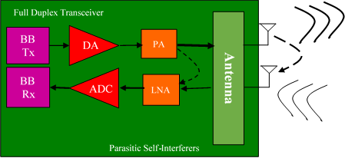

Figure 4 Self interference mechanisms in a Full Duplex transceiver.

Whereas **Figure 5** illustrates the relative magnitudes of the transmitted and received signal levels in a bi-directional full duplex use case along with the relative magnitudes of the interference signal levels after each stage of process.

**Path loss**

Using Friis equation,

$$P_{r}= \frac{P_{t}G_{t}G_{r}λ^{2}}{{\left(4π\right)}^{2}R_{t}^{2}L}$$

where the terms in the equation are:

* Pr — Received power in watts.
* Pt — Peak transmit power in watts.
* Gt — Transmitter gain.
* Gr — Receiver gain.
* λ — operating frequency wavelength in meters.
* L — General loss factor to account for both system and propagation loss.
* R — Range from the transmitter to the receiver.

the received power at the receive antenna can be calculated.

**Self interference path loss**

$$P_{r}= \frac{P_{t}G_{t}G_{r}λ^{2}σ}{{\left(4π\right)}^{3}R_{t}^{2}R_{r}^{2}L}$$

where the terms in the equation are:

* Pr — Reflected received power in watts.
* Pt — Peak transmit power in watts.
* Gt — Transmitter gain.
* Gr — Receiver gain.
* λ — operating frequency wavelength in meters.
* σ — Reflector's non-fluctuating cross section in square meters.
* L — General loss factor to account for both system and propagation loss.
* Rt — Range from the transmitter to the reflector.
* Rr — Range from the receiver to the reflector.

Using the above equation, calculate the values of self-interference Psi1 and Psi2 can be calculated.

|  |  |
| --- | --- |
| Tx1  Rx1  Tx2  Rx2 | |
| **Prsi2**  **Psi2**  **PRx2**  **PTx2**  **Prsi1**  **PTx1**  **Psi1**  **PRx1**  ~35-55 dB  ~40-50 dB | |
| **PTxi =** | Transmit signal power level from each transceiver “i” = 20dBm |
| **PRxi =** | Received signal power level at each transceiver “i” = -45dBm at 10m |
| **Psii =** | Self-interference(SI) power level within each transceiver “i” |
| **Prsii =** | Residual SI level within each transceiver “i” after analog and digital BB cancellations |

Figure 5 Relative signal strengths as measured in two full-duplex transceivers with SIC process.

### Potential techniques for self-interference cancellation

#### General

Self-interference cancellation techniques are discussed in [20]. Due to insufficient receive dynamic range at receiver, large self-interference can saturate the Rx LNA/ADC, and the intended Rx signal is compressed / wiped out. It requires antenna isolation/analog circuitry to cancel the self-interference sufficiently in order for the receiver to perform further self-interference cancellation (SIC) in the digital domain. As shown in Figure 6, SIC at the FD receiver is implemented with two stages: analog SIC and digital SIC.

Example requirements for analog/digital SIC are shown in Figure 7 in which the budgets of analog/digital interference cancellation are illustrated.

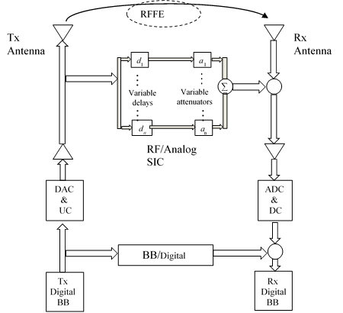

Figure 6 Analog and digital SIC.

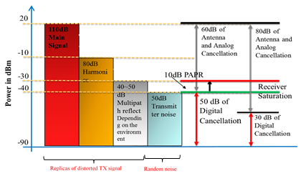

Figure 7 Illustration of requirements for analog/digital SIC.

#### RF front-end (RFFE) / analog circuitry SIC

1. RF front-end isolation
   * + - Separate Tx/Rx antennas

Separating multiple antennas into Rx & Tx yields high isolation, however this may limit the MIMO capabilities. A 2x2 MIMO self-interference sounding system using dual-polarized antennas is shown in [21], in which one polarization (e.g., vertical) for Tx port and the other polarization (e.g., horizontal) for Rx port. It demonstrates that [21] the V-H isolation of the same antenna can be approximately 45 dB and the cross-polarization coupling from the one polarization (H or V) port of one antenna to another polarization (V or H) port of the other antenna can be -70 dB.

* + - * Single Tx/Rx antenna

With single antenna, a receiver can use a circulator and/or other alternatives to achieve RF front-end isolation. The combined isolation from the circulator and antenna can be 30 dB [22]. However, a circulator may suffer from high losses, linearity and BW limitations and significant local oscillator (LO) leakage. A modified Quadrature Balanced Power Amplifiers (QBPA) method is introduced in [22], which uses dual-mode RFFE isolation instead of circulator and yield competitive performance as circulator.

1. Analog circuitry SIC

Multiple RF/Analog Tap “Weighted” Delay Lines [23] and Two RF Tap Delay Lines “Weighted” & Tunable [24] are considered to be practical for Wi-Fi chipsets, in which the analog canceller is implemented such as an analog filter with time delay circuit and variable gain amplifier. It is reported [23], [24] that analog SIC circuitry can suppress 40-50 dB interference.

#### Digital SIC

Digital self-interference cancellation is the last step of defence against self-interference. However, as discussed above, it is limited by ADC dynamic range. Currently, 12-bit ADC with 11-bit ENOB is widely implemented in 802.11ac chips, yielding an effective dynamic range of 6.02*(11-2)=54.18dB with one bit to budget an additional headroom of 6 dB (depending on the received PAPR) and one bit to place the quantization-error floor 6 dB below noisy floor [25].

Assume that the analog SIC can provides interference suppression of 50 dB, thus the digital SIC should be capable to mitigate 60 dB of the interference. Also assume that the interference consists of linear and non-linear components (5th and 7th order) and the residual interference (linear component) at input to digital SIC is around -30dBm (nonlinear component is 30 dB below linear components). The incoming desired Rx signal (to be detected) is assumed to be limited by -72 dBm. Figure 8 shows a power diagram of the assumptions and requirements above.

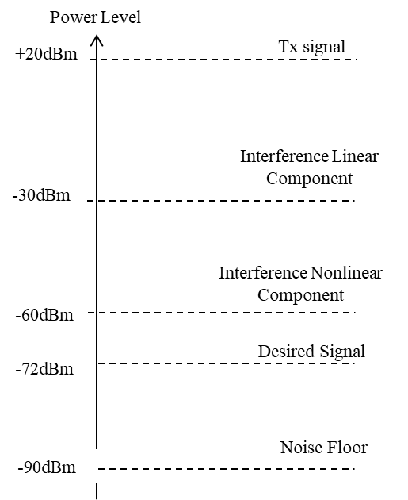

Figure 8 Full duplex power diagram with SIC.

As discussed in [20], a self-interference signal (produced by the Tx side) includes linear and non-linear components. Assume that non-linearity components are memoryless. Thus, every non-linear component depends only on the signal transmitted at the same time-sample. The Tx signal including non-linear components is transformed by analog reflections, multipath channel and also an analog SIC.

The fact that non-linear components are at least 30 dB below the linear part suggests a two-step process [20] to solve a problem that requires to estimate both impulse response taps and the parameters of the non-linear components.

*Step 1:* Consider non-linear components as a noise (30 dB lower than the linear components) and estimate the linear transfer function parameters

*Step 2:* Subtract the estimated linear part from the received signal and estimate the parameters of the non-linear components

Simulation of the two-step solution is carried out in [20]. The simulation results demonstrates that [20] for all the Rx signals in the assumed range -72 dBm : -85 dBm, the total digital interference mitigation is larger than 60 dB, thus the interference level after digital SIC can be lower than the target level of -90 dBm.

### Scheduling in FD for 802.11

## FD operations over overlapping BSS (OBSS)

## Impacts of FD operations on the 802.11 standard

The introduction of FD operation may affect multiple elements of the 802.11 standard. These elements may include:

* Training and Preamble
* FD transmission initiation
* MAC header fields
* Frame formats

### Training and preamble

A FD training sequence/preamble is probably needed to train the FD PHY. This training sequence/preamble should be flexible enough to support which ever potential techniques are used for self-interference cancellation as discussed in Section 4.2.2.

The FD preamble may be specified as a FD standalone training frame (as shown in Figure 9 (a)) or may be added as extra preamble to existing frames (as shown in Figure 9 (b)).



Figure 9 FD Training sequence.

### FD transmission initiation

The 802.11 specification should include specific protocols to initiate the FD transmission. This may include an element that informs the specific STAs that are involved in FD operations of the start and duration of the FD transmission in the case of an explicitly synchronized FD transmission. It may also include information that may inform a specific STA that is involved in FD operations about the start and duration of a transmission when the FD transmission is opportunistic.

# Architecture of FD for 802.11

This section discusses the effect of FD on the physical components of the network, their configuration and channel access for each configuration.

## Asymmetric FD for 802.11

In asymmetric FD operations, usually the APs are FD-capable while the STAs are half-duplex devices i.e. only the AP can transmit and receive at the same time. Three or more nodes are involved in the FD transmission with the transmission comprising an AP and two or more STAs. STA A and the STA B are unable to hear each other. This is illustrated in Figure 10.

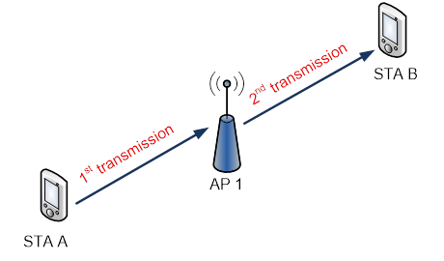

Figure 10 Asymmetric FD architecture.

The transmission may be synchronized, in which the transmission to and from the AP occur at pre-determined times, or may be opportunistic, in which the transmission in the uplink/downlink occurs once another transmission is occurring in the downlink/uplink.

In synchronized asymmetric FD transmission (illustrated in Figure 11), the uplink and downlink FD transmissions are synchronized and the AP controls the entire FD transmission. The AP may indicate the start of FD transmission to STA B and reception of data from STA A. Note that the AP transmission and reception may start at different times.



Figure 11 Synchronized asymmetric FD transmission frame exchange.

In opportunistic downlink, asymmetric FD transmission (illustrated in Figure 12), the AP transmission is opportunistic to STA B based on the specific STA A transmitting to it. As such, the AP starts the downlink transmission to STA B based on reception of data from STA A. Note that as STA A is already transmitting, the AP is required to communicate the start of its transmission to STA B only.



Figure 12 Opportunistic downlink, asymmetric FD transmission frame exchange.

In opportunistic uplink, asymmetric FD transmission (illustrated in Figure 13), the AP reception from STA A is opportunistic based on the specific STA B it is transmitting to. As such, STA A starts the uplink transmission to the AP based on transmission of data from the AP to STA B. Note that as the AP is already transmitting, a mechanism is needed to identify the start of the transmission from STA A.



Figure 13 Opportunistic uplink, asymmetric FD transmission frame exchange.

## Symmetric FD for 802.11

In pairwise symmetric FD operations, both the APs and STAs are FD-capable. Two data flows can be transmitted simultaneously in different directions between two FD-capable devices. Two or more nodes are involved in the FD transmission with the nodes transmitting and receiving at the same time. This is illustrated in Figure 14.

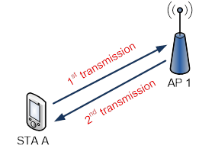

Figure 14 Symmetric FD transmission.

In symmetric FD transmission (illustrated in Figure 15), the AP starts downlink transmission to STA A and receives uplink transmission from STA A. The transmission may also be synchronized or opportunistic.



Figure 15 Symmetric FD transmission frame exchange.

## Impacts of architecture on the 802.11 standard

The FD architecture may have some impacts on the 802.11 specification, one of which is: FD interference discovery in asymmetric FD.

### FD interference discovery in asymmetric FD

For asymmetric FD architectures (see Section 5.1), the data from the uplink transmission to the AP (STA1 in Figure 16) may affect the downlink transmission from the AP (STA 2 in Figure 16).

As such there is a need for interference discovery procedures to ensure that potential interference from STA 1 to STA 2 in Figure 16 is minimized. These procedures will enable the AP to identify FD compatible STAs i.e. STAs that may be transmitted to/from in an asymmetric FD configuration with minimal or no interference.

As an example, a simple 4-STA network is shown in Figure 17 with the associated FD compatibility illustrated in Table 4. The STAs not linked by “X” are identified as FD compatible. As such, the procedure should identify STA1 and STA3 as FD compatible and STA2 with STA4 as FD compatible.

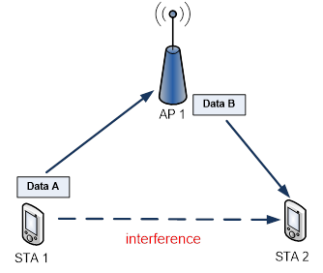

Figure 16 Interference in asymmetric FD transmission.

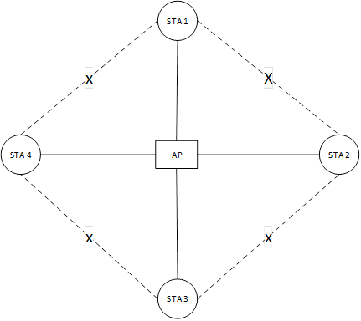

Figure 17 Network illustrating FD compatibility.

Table 4 FD Compatibility

|  |  |  |  |  |
| --- | --- | --- | --- | --- |
|  | STA 1 | STA 2 | STA 3 | STA 4 |
| STA 1 | N/A | Not FD compatible | FD compatible | Not FD compatible |
| STA 2 | Not FD compatible | N/A | Not FD compatible | FD compatible |
| STA 3 | FD compatible | Not FD compatible | N/A | Not FD compatible |
| STA 4 | Not FD compatible | FD compatible | Not FD compatible | N/A |

# FD Benefits and Challenges

## Throughput gain over an allocated bandwidth

Successive interference cancellation (SIC) technique in conjunction with a FD MAC protocol allows simultaneous transmit and receive over the same frequency spectrum. Compared to existing half-duplex (HD) Wi-Fi systems, full-duplex (FD) Wi-Fi systems can approach to double the data throughput per channel in BSSs without hidden nodes. For BSSs with hidden nodes the data throughput per STA can be increased by a factor of 10x or more*.*

### FD Throughput gain without hidden nodes [26]

Table 5 summarizes the results of an extensive series of S-CW FD simulations performed by D. Marlali [26] in which the self-interference cancellation levels are varied from complete cancellation (‘λ = ∞) to a level with only 40% SIC (‘λ = 0.4) in a BSS without any hidden nodes and the number of STAs varied from 40 to 2. Similar FD Gains were reported in [17] for a different FD protocol.

Table 5 FD Gains observed during simulations without hidden nodes

|  |  |  |  |
| --- | --- | --- | --- |
| **SIC Levels** | **Number of Hidden Nodes** | **FD Gain w/ Exponential pkt size Distribution w/ mean=400 octets** | **FD Gain w/ constant pkt size = 1500 octets** |
| ‘λ = ∞ | 0 | 1.27 – 1.59 | 1.56 – 2.10 |
| ‘λ = 0.6 | 0 | 1.27 – 1.47 | 1.46 – 1.90 |
| ‘λ = 0.4 | 0 | 1.06 – 1.04 | 1.20 – 1.30 |
|  |  | *Decreasing number of STAs (40 to 2)* | |

### FD Throughput gain with hidden nodes [26]

Although Table 5 above confirms what critics of single frequency full duplex have been saying for some time, Table 6 provides a more compelling argument for the significant positive impact that a single frequency full duplex protocol operating in a densely populated BSS with hidden nodes can have on Full-duplex Gain. The column labeled FD Gain w/ constant pkt-size=1500 octets indicates that when the number of hidden nodes is equal to 10 and the number of STAs is equal to 40 in a BSS the FD Gain can be greater than 10x for SIC levels varying between 40% to 100%.

Table 6 FD Gains observed during simulations with hidden nodes

|  |  |  |  |
| --- | --- | --- | --- |
| **SIC Levels** | **Number of Hidden Nodes** | **FD Gain w/ Exponential pkt size Distribution w/ mean=400 octets** | **FD Gain w/ constant pkt size = 1500 octets** |
| ‘λ = ∞ | 1 | 1.06 – 1.40 | 1.56 – 2.29 |
|  | 5 | 1.38 – 2.48 | 1.50 – 7.11 |
|  | 10 | 1.27 – 3.63 | 1.68 – **14.36** |
| ‘λ = 0.6 | 1 | 0.99 – 1.37 | 1.49 – 2.17 |
|  | 5 | 1.17 – 2.40 | 1.44 – 6.93 |
|  | 10 | 1.23 – 3.37 | 1.64 – **13.47** |
| ‘λ = 0.4 | 1 | 0.78 – 1.15 | 1.15 – 1.87 |
|  | 5 | 0.95 – 1.90 | 1.21 – 5.63 |
|  | 10 | 1.04 – 2.74 | 1.36 – **10.66** |
|  |  | *Increasing number of STAs (2 to 40)* | |

## ~~Lower~~ Latency enhancement

The FD enhancement improves the latency of 802.11 systems by:

* Improving the random access mechanism for channel access: FD capability in to AP and STA allows for implementation of scheduled-like channel access functions in the network. The frame structures can allow for transmission of control channel from STA to AP while AP is sending data to STA, and vice-versa.
* Collision detection: The listen-while-transmit capability of the FD capable AP and/or STA improves the success of channel access in dense environment.
* Exploiting hidden terminal problem: FD capability at AP can be used to schedule transmissions to/from two hidden terminal. The AP can collect data from STA and form an interference map. The AP can then use this interference map to schedule transmission and reception from the STA to improve the spectrum access efficiency.
* Eliminating need of RTS/CTS frames: Listen-while transmit capability allows for eliminating RTS/CTS frames to avoid collisions. The AP and/or STA can sense the channel during their transmission and can pre-emptively stop transmissions when they sense transmissions from other nodes.

## Collision reduction

Collisions of 802.11 devices using EDCA method happen when the counter reaches zero and the STA start transmitting simultaneously. Full Duplex technology can be used for recognition and efficient resolution of the collisions in a WLAN network [27].

### Collision detection

FD-capable STAs can listen to the media while transmitting, thus they can potentially recognize parallel transmissions caused by single or multiple STAs from the same network. Assuming that WLAN signals can be recognized based on the L-STF field or the L-STF and L-LTF fields which are more robust than the data portion, collisions can be detected in every scenario of WLAN data transmission. Figure 18 shows collision detection based on L-STF.

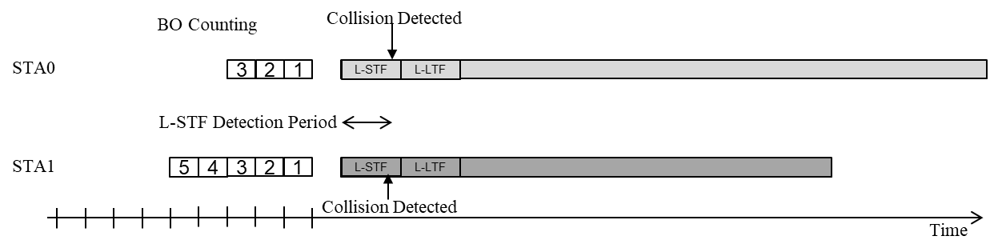

Figure 18 Illustration of collision detection using L-STF in WLAN.

### Actions based on collision detection

#### Initial action

The probability to receive signals involved in the collision is very low due to mutual interference. If nothing is done in case of collision, most likely the time period occupied by the collided STAs will be wasted. Thus upon collision detection, an action can be taken to reduce the time period where no signal can be transmitted or received. The optional procedure is considered as follows:

* A STA detects a collision
* The STA drops its own signal
* The STA waits to ensure medium is free
* If medium is free – the STA starts channel access procedure
* If medium is not free – the STA waits for medium to become free again.

#### EDCA-based procedure

A simple method to resolve channel access is to drop the collided signals and let every STA recognize energy drop, then resolve EDCA-based back-off counting according to existing EDCA rules. As shown in Figure 19, in this case, the smallest time period required to start a new transmission is AIFS plus one slot time. However, since STAs randomly choose the backoff period, this time period may be much longer. All the stations that listen to the medium and recognize energy drop can potentially be the next transmitter, including collided STAs. The average time period can be reduced before new transmission is taken allowing collided STAs to use a very small CW value and finish a new back-off counting very fast. However, it still remains a statistical value limited by AIFS + one slot time period.

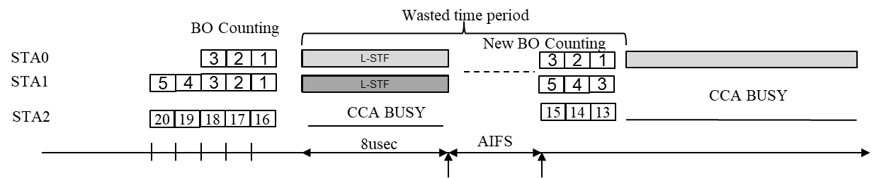

Figure 19 Illustration of EDCA-based procedure to terminate the collided signals.

#### Fast collision resolution

Assume that all the collided STAs recognize the collision and drop their currently-transmitting signals.The STAs can take advantage of knowledge that no STA will transmit within an AIFS period. Due to the fact that STAs are FD-capable, as illustrated in Figure 20 the STAs can perform a very efficient negotiation procedure which resolves which STA, among those who collided, will transmit.

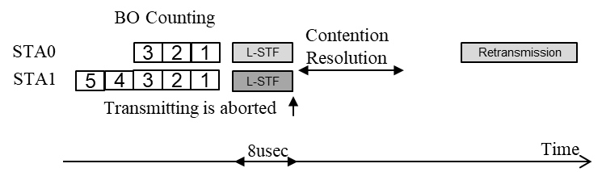

Figure 20 Illustration of fast collision resolution.

Assume that this action can be completed with very high probability within an AIFS period. As shown in [27], simulation on the CDF of action completion verses of AIFS demonstrates effectiveness of the fast contention resolution. Therefore, collided STAs can lead to a faster successful channel access and reduce the time period wasted in case of collisions.

### Simulation

Simulation procedure and results are shown in [27] for comparison among three scenarios: 1) the current existing procedure with no collision detection capabilities; 2) the collision detection followed by EDCA based channel access (with small CW value for collided STAs) and 3) the collision detection with fast contention resolution. Channel utilization rate, which is computed by a ratio between a time of successful transmissions and overall time of the simulation, is used as the criterion for comparison.

The simulation results in [27] demonstrates that FD-assisted collision detection followed by signal drop and EDCA-based channel access leads to a significant improvement of channel utilization rate. The FD-based contention resolution provides additional valuable gains on top of EDCA-based procedure.

## Mitigation of hidden node issue

# Economic Feasibility

Over the past two-plus decades, each IEEE Wi-Fi group that proposed an addition to the IEEE 802 LMSC standard provided evidence for the economic feasibility of their proposal. Evidence such as: balanced costs, known cost factors, installation costs, operational costs and estimated market size. In keeping with that tradition, the FD-TIG provides its perspective for each of these items:

1. Balanced costs (infrastructure versus attached stations)

While there will be an initial small cost increment for each Full Duplex-enabled access point, infrastructure utilization will be increased significantly by the addition of Full Duplex, which will enable each access point to handle more client STAs and thereby either reduce or remove the need to add and install more access points. This savings far outweighs the added cost to purchase and install new access points. For user devices, there will similarly be a small cost increment that will be no different than that encountered during a typical upgrade cycle with performance enhancements such as from 802.11n to 802.11ac or 802.11ac to 802.11ax. Depending upon the implementation, there can also be some component savings (e.g. removal of some filters/diplexers), thus offsetting the total cost when adding full duplex capability.

1. Known cost factors

Support of the proposed standard will likely require manufacturers to develop a modified radio, modem and firmware. This is similar in principle to the transition between IEEE 802.11n and IEEE 802.11ac as well as in previous iterations of IEEE 802.11 enhancements. By utilizing existing high-volume IC wafer, packaging, and testing facilities, devices that implement Full Duplex capable PHYs are expected to be of similar cost to current front end/ filter solutions.

1. Consideration of installation costs

Since Full Duplex AP_s and STA_s are required to be backwards compatible with earlier versions of installed dot_11 devices, the installation of Full Duplex enabled AP_s and STA_s will follow a ramp function instead of a step function thereby minimizing the cost of installation.

1. Consideration of operational costs (e.g. energy consumption)

Devices that implement Full Duplex are expected to require similar physical and electrical connections to existing front end and standard RFIC devices. Power consumption and thermal requirements are also expected to be similar to standard RFIC / filter solutions.

1. Market size [28]

The market size for Full Duplex enabled Wi-Fi chipsets is expected to be 500M units in 2021 and 800M units in 2022, which equates to 20% of the combined 802.11ac and 802.11ax market in 2021 and 30% of the combined market in 2022. These market projections are derived from a WFA sponsored ABI forecast for the volume of Wi-Fi chipsets to be delivered as illustrated in Figure 21. In addition, it is assumed that pre-standard Infrastructure solutions could be available before completion of the standard to help drive market learning, uptake and cost reduction.

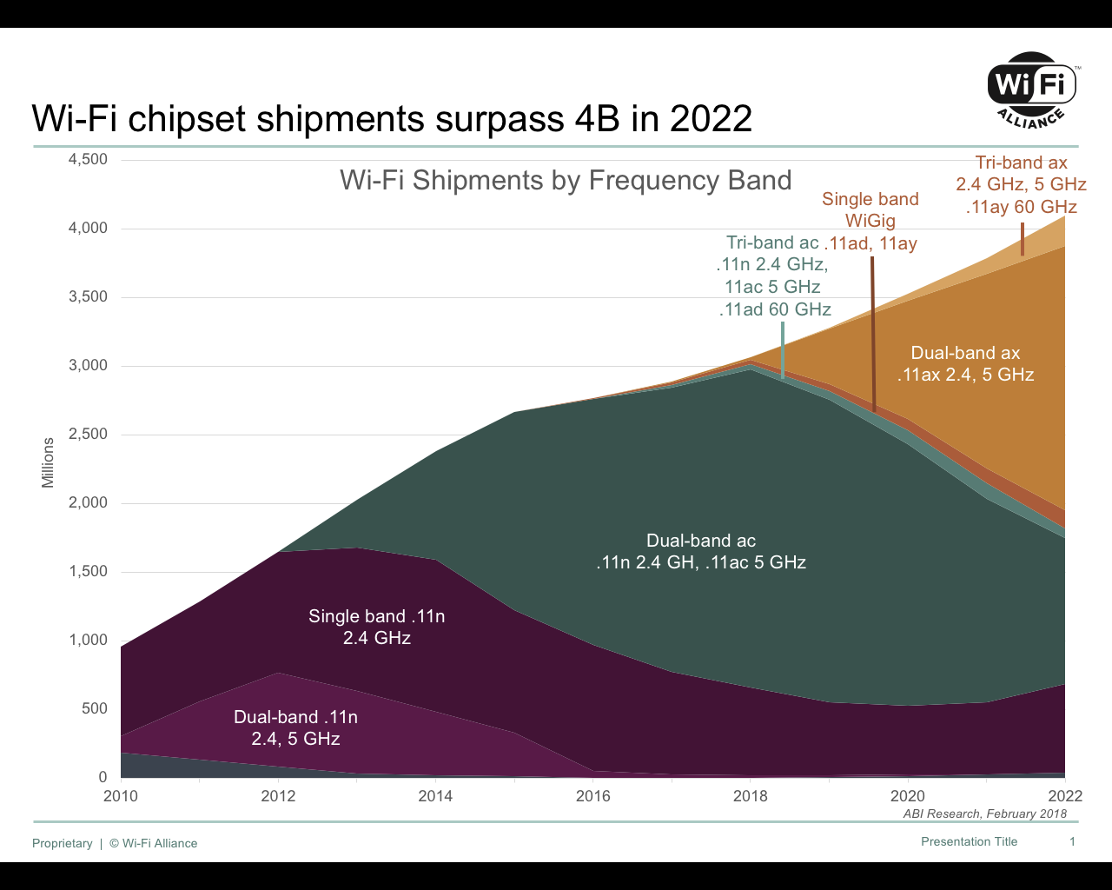

Figure 21 Projected Wi-Fi chipset shipments.

# Recommendations~~Conclusions~~

# References

1. Wi-Fi Alliance press, January 2017.
2. D. Bharadia, E. MaMilin, S. Katti, “Full Duplex Radios”, Proc. of the ACM SIGCOMM’13, Hong Kong, China, August 2013.
3. A. Sabharwal *et al*, “In-Band Full-Duplex Wireless: Challenges and Opportunities”, IEEE JSAC, pp. 1637-1652, Sept. 2014.
4. 11-18-0191-01-0wng-full-duplex-for-802-11.
5. 11-18-0448-00-00fd-full-duplex-benefits-and-challenges.
6. 11-18-0758-00-00fd-full-duplex-usage-model.
7. 11-18-0549-00-00fd-full-duplex-for-802-11.
8. 11-18-1223-01-00fd-proposed-fd-functional-requirements.
9. 11-18-1127-01-00fd-new-text-for-fd-tig-report.
10. IEEE Std 802.11-2016.
11. X. Xie, X. Zhang, “Does Full-Duplex Double the Capacity of Wireless Networks?”, IEEE INFOCOM 2014, pp. 253-261, 2014.
12. A. Sahai, G. Patel and A. Sabharwal, “Pushing the limits of Full-duplex: Design and Real-time Implementation”, Technical Report TREE 1104, Rice University, pp. 1-6, July 2011.
13. N. Reiskarimian, T. Dinc, J. Zhou, T. Chen, M. Baraani Dastjerdi, J. Diakonikolas, G. Zussman, and H. Krishnaswamy, "A One-Way Ramp to a Two-Way Highway: Integrated Magnetic-Free Non-Reciprocal Antenna Interfaces for Full Duplex Wireless," invited and submitted to IEEE Microwave Magazine.
14. T. Dinc, and H. Krishnaswamy, “Architectures, Antennas and Circuits for Millimeter-wave Wireless Full-Duplex Applications”, Thesis, Columbia University, 2018.
15. [M. P. Chang, M. P. Fok, A. Hofmaier, and P. R. Prucnal, “Optical analog self-interference cancellation with electro-absorption modulators,” IEEE Microwave. Wireless Component Letters., vol. 23, no. 2, pp. 99–101, Feb. 2013.](http://ee.princeton.edu/research/prucnal/sites/default/files/06423220.pdf)
16. S. Vishwanath and H. Jain, “Self Interference Cancellation in the Hybrid RF/Photonic and Digital Domains”, Internal Technical Report, GenXcomm, 2017.
17. A. Aijaz and P. Kulkarni, “Simultaneous Transmit and Receive Operation in Next Generation IEEE 802.11 WLANs: A MAC Protocol Design Approach”, IEEE Wireless Communications, pp. 128-135, Dec 2017.
18. Data-Over-Cable Service Interface Specifications DOCSIS 3.1: Physical Layer Specification, Cable Television Laboratories, Inc., Dec 2017.
19. Data-Over-Cable Service Interface Specifications DOCSIS 3.1: MAC and Upper Layer Protocols Interface Specification, Cable Television Laboratories, Inc., May 2018.
20. 11-18-0880-00-00fd-self-interference-cancellation-in-full-duplex-for-802-11.
21. F. Chen, R. Morawski, T. Le-Ngoc, “Self-Interference Channel Characterization for Wideband 2x2 MIMO Full-Duplex Transceivers using Dual-Polarized Antennas”, IEEE Transactions on Antennas & Propagation, Vol. 66, No. 4, April 2018.
22. D. Regev *et al*, “Modified Re-Configurable Quadrature Balanced Power Amplifiers for Half and Full Duplex RF Front Ends”, 2018 IEEE Texas Symposium on Wireless and Microwave Circuits and Systems (WMCS), Waco, Texas, April 2018.
23. T. Zhang *et al*, “A 1.7-to-2.2GHz Full-Duplex Transceiver System with >50dB Self-Interference Cancellation over 42MHz Bandwidth”, 2017 International Solid-State Circuits Conference (ISSCC), San Francisco, CA, Feb. 2017.
24. T. Huusari *et al*, “Wideband Self-Adaptive RF Cancellation Circuit for Full-Duplex Radio: Operating Principle and Measurements”, 2015 IEEE 81st Vehicular Technology Conference (VTC Spring), Glasgow, Scotland, May 2015.
25. https://www.design-reuse.com/umc/adc-c-78/
26. D. Marlali and O. Gurbuz, “Design and performance analysis of a full-duplex MAC protocol for wireless local area networks” Ad Hoc Networks 67, pp. 53-67, Oct 2017.
27. 11-18-1019-01-00fd-improving-system-efficiency-using-full-duplex-based-collision-detection.
28. Wi-Fi Shipments by Frequency Band, Wi-Fi Alliance/ABI Research, Feb. 2018.