IEEE P802.11
Wireless LANs
Corrections to “Number Of HE-LTF Symbols And Midamble Periodicity” subfield
Date: 3/5/2018
Author(s):
Name | Affiliation | Address | Email
Sigurd Schelstraete | Quantenna | 1704 Automation Pkwy,  San Jose, CA 95131 | sigurd@quantenna.com
Abstract
This submission highlights a number of issues with the description of the “Number Of HE-LTF Symbols And Midamble Periodicity” subfield in the Common field of the Trigger frame. A modified text is proposed.
The proposed changes resolve the following CIDs: 13329, 11539, 11540, 11541
CID 166

Introduction
The text on page 89, starting at line 1 of D2.2 describes the “Number Of HE-LTF Symbols And Midamble Periodicity” subfield of the Common Info field of the Trigger frame. The definition of that subfield had to be updated from D1.0 to include the Midamble configuration for TB response frames. In doing so, an error was introduced in the text.
It should also be noted that the original text has several confusing statements. This submission proposes a modified text that fixes the error and provides a general clean-up of the section in question.

Relevant CIDs
CID | Clause | Page |  | Line |  | Comment | Commenter’s proposal | Proposed resolution
13329 | 9.3.1.23 | 88 |  | 13 |  | The text refers to "non-OFDMA". More clear to specify what PPDU type is intended here. | Replace "non-OFDMA" by full bandwidth UL MU-MIMO PPDU. | REJECTED  Non-OFDMA has an explicit definition in the definition section. We term can now be used without ambiguity.  Note that text in question was moved to the HE-LTF section.
11539 | 9.3.1.23 | 88 |  | 14 |  | I can't find a definition or equation for N_STS,total. And include a reference to how to specifically calculate the number of HE-LTF symbols. | as in comment | REVISED  See changes proposed in document 802.11-18/0483r2. Text has been moved to the HE-LTF clause. The term N_STS,total is no longer used.
11540 | 9.3.1.23 | 88 | 18 |  | "...the number of HE-LTF symbols is greater than or equal to the maximum...", can be misinterpreted as any value greater. |  | Better to say "the number of HE-LTF symbols is a function of the total number of space-time streams, NSTS,total and the encoding of the Number Of HE-LTF Symbols And Midamble Periodicity subfield is defined in Table 21-13." | REVISED  See changes proposed in document 802.11-18/0483r2. Text has been moved to the HE-LTF clause. Wording was changed.
11541 | 9.3.1.23 | 88 |  | 18 |  | I can't find a definition or equation for N_STS,total. And include a reference to how to specifically calculate the number of HE-LTF symbols. | as in comment | REVISED  See changes proposed in document 802.11-18/0483r2. Text has been moved to the HE-LTF clause. The term N_STS,total is no longer used.

Discussion
The text describing the subfield (then called “HE-LTF Symbols subfield”) in Draft 1.0 reads as follows:
Draft 1.0:
The Number Of HE-LTF Symbols subfield of the Common Info field indicates the number of HE-LTF symbols present in the HE trigger-based PPDU response. The number of HE-LTF symbols is a function of the total number of space-time streams. For non-OFDMA PPDUs, the encoding of the Number Of HE-LTF Symbols subfield is defined in Table 22-13. For OFDMA PPDUs, the number of HE-LTFs is greater than or equal to the maximum across RUs of the total number of space time streams. The encoding of the Number Of HE-LTF Symbols subfield is the same as the Number of HE-LTF Symbols in HE-SIG-A2, which is defined in Table 28-18 (HE-SIG-A field of an HE trigger-based PPDU).
The underlined parts of the text have issues, which are discussed below:
- “the encoding of the Number Of HE-LTF Symbols subfield is defined in Table 22-13”. This is not correct. First of all, Table 22-13 should be Table 21-13 (This has been corrected in D2.0). However, Table 21-13 only specifies how many LTF symbols are needed for a given number of space-time streams: 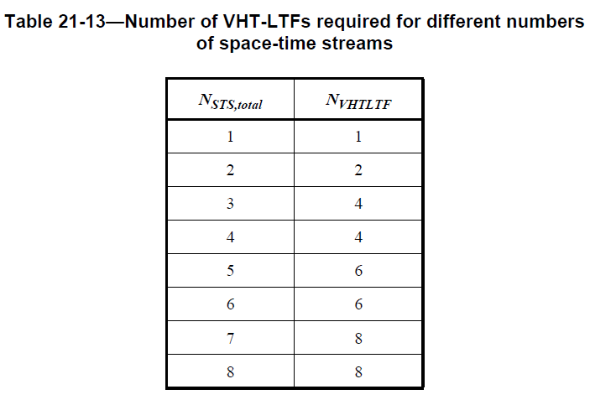
The encoding of that number presumably should follow the encoding used for the Number of HE-LTF Symbols in HE-SIG-A2 (see Table 28-19):
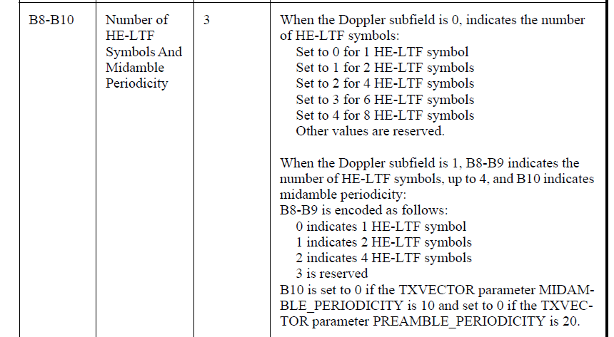
- “the number of HE-LTFs is greater than or equal to the maximum across RUs of the total number of space time streams”. This sentence could certainly be clarified. Our interpretation is the following: Based on the total number of streams in an RU, each RU requires a certain number of HE-LTF symbols. Since the number of HE-LTF symbols has to be the same for all transmitted TB response frames, the final number should accommodate the largest value of N_HE-LTF needed for any RU, but it is allowed to be higher as well. The current text does not correctly reflect this, since it talks about the maximum number of space time streams across RUs, rather than the maximum number of HE-LTF symbols across RUs.
Both of these issues are addressed in the new text proposal.

In Draft 2.0, the name of the subfield “HE-LTF Symbols” was changed to “Number Of HE-LTF Symbols And Midamble Periodicity” and its signaling now also includes information about midamble. The current text in Draft 2.2 reads:
Draft 2.2:
If the Doppler subfield of the Common Info field is 0, then the Number Of HE-LTF Symbols And Midamble Periodicity subfield of the Common Info field indicates the number of HE-LTF symbols present in the HE TB PPDU that is the response to the Trigger frame minus 1.
If the Doppler subfield of the Common Info field is 1, then B23-B24 of the Number Of HE-LTF Symbols And Midamble Periodicity subfield indicates the number of HE-LTF symbols present in the HE TB PPDU that is the response to the Trigger frame, and B25 of the Number OF HE-LTF Symbols And Midamble Periodicity subfield indicates midamble periodicity in the same HE TB PPDU.
For a non-OFDMA PPDU, the number of HE-LTF symbols is a function of the total number of space-time streams, NSTS defined in Table 28-15 (Frequently used parameters), and the encoding of the Number Of HE-LTF Symbols And Midamble Periodicity subfield is defined in Table 28-19 (HE-SIG-A field of an HE MU PPDU).
For an OFDMA PPDU, the number of HE-LTF symbols is greater than or equal to the maximum NSTS,r,total defined in Table 28-15 (Frequently used parameters) across all allocated RUs and the encoding of the Number Of HE-LTF Symbols And Midamble Periodicity subfield is the same as the Number of HE-LTF Symbols field defined in Table 28-19 (HE-SIG-A field of an HE MU PPDU).
The underlined parts of the text have issues:
- “indicates the number of HE-LTF symbols present in the HE TB PPDU that is the response to the Trigger frame minus 1”. This is not the correct encoding for the number of HE-LTF symbols. Instead Table 28-19 should be used.
- the number of HE-LTF symbols is a function of the total number of space-time streams, NSTS defined in Table 28-15 (Frequently used parameters). This does not specify how the number of HE-LTFs depends on NSTS.
- the number of HE-LTF symbols is greater than or equal to the maximum NSTS,r,total. Not exactly correct. We should determine the number of HE-LTf for each NSTS,r,total and take the maximum over the number of HE-LTF.
Additionally, it was suggested that the kind of behavioral requirements are not appropriate in this section.

Proposed resolution
The following changes to the text (starting at line 1, page 89 of Draft 2.2) are proposed to address the issues listed above:
If the Doppler subfield of the Common Info field is 0, then the Number Of HE-LTF Symbols And Midamble Periodicity subfield of the Common Info field indicates the number of HE-LTF symbols present in the HE TB PPDU and is encoded as follows: that is the response to the Trigger frame minus 1.
0 for 1 HE-LTF symbol
1 for 2 HE-LTF symbols
2 for 4 HE-LTF symbols
3 for 6 HE-LTF symbols
4 for 8 HE-LTF symbols
5-7 is reserved
If the Doppler subfield of the Common Info field is 1, then the Number Of HE-LTF Symbols And Midamble Periodicity subfield indicates the number of HE-LTF symbols and the periodicity of the midamble and is encoded as follows: then B23-B24 of the Number OF HE-LTF Symbols And Midamble Periodicity subfield indicates the number of HE-LTF symbols present in the HE TB PPDU that is the response to the Trigger frame, and B25 of the Number OF HE-LTF Symbols And Midamble Periodicity subfield indicates midamble periodicity in the same HE TB PPDU.
0 for 1 HE-LTF symbol and 10 symbol midamble periodicity
1 for 2 HE-LTF symbols and 10 symbol midamble periodicity
2 for 4 HE-LTF symbols and 10 symbol midamble periodicity
4 for 1 HE-LTF symbol and 20 symbol midamble periodicity
5 for 2 HE-LTF symbols and 20 symbol midamble periodicity
6 for 4 HE-LTF symbols and 20 symbol midamble periodicity
3 and 7 are reserved
For a non-OFDMA PPDU, the number of HE-LTF symbols is a function of the total number of space-time streams, NSTS defined in Table 28-15 (Frequently used parameters), and the encoding of the Number Of HE-LTF Symbols And Midamble Periodicity subfield is defined in Table 28-19 (HE-SIG-A field of an HE MU PPDU).
For an OFDMA PPDU, the number of HE-LTF symbols is greater than or equal to the maximum NSTS,r,total defined in Table 28-15 (Frequently used parameters) across all allocated RUs and the encoding of the Number Of HE-LTF Symbols And Midamble Periodicity subfield is the same as the Number of HE-LTF Symbols field defined in Table 28-19 (HE-SIG-A field of an HE MU PPDU).
The following changes are proposed to section 28.3.10.10:
28.3.10.10 HE-LTF
The HE-LTF field provides a means for the receiver to estimate the MIMO channel between the set of constellation mapper outputs (or, if STBC is applied, the STBC encoder outputs) and the receive chains. In an HE SU PPDU, HE ER SU PPDU and HE MU PPDU, the transmitter provides training for N_{STS,r,total} space-time streams (spatial mapper inputs) used for the transmission of the PSDU(s) in the r-th RU. In an HE TB PPDU, the transmitter of user u in the r-th RU provides training for N_{STS,r,u} space-time streams used for the transmission of the PSDU. For each tone in the r-th RU, the MIMO channel that can be estimated is an N_{RX} x N_{STS,r,total} matrix. An HE transmission has a preamble that contains HE-LTF symbols, where the data tones of each HE-LTF symbol are multiplied by entries belonging to a matrix P_{HE-LTF}, to enable channel estimation at the receiver. The pilot subcarriers of each HE-LTF symbol are multiplied by the entries of a matrix R_{HE-LTF} defined in the following text. The multiplication of the pilot subcarriers in the HE-LTF symbol by the R_{HE-LTF} matrix instead of the P_{HE-LTF} matrix allows receivers to track phase and frequency offset during MIMO channel estimation using the HE-LTF. In an HE SU PPDU, HE ER SU PPDU and HE MU PPDU with a single RU (the RU having an MU-MIMO allocation or an SU allocation), the number of HE-LTF symbols, N_{HE-LTF}, is a function of the total number of space-time streams N_{STS} as shown in Table 21- 13 (Number of VHT-LTFs required for different numbers of space-time streams) in 21.3.8.3.5 (VHT-LTF definition), replacing N_{VHT-LTF} by N_{HE-LTF}. In an HE TB PPDU, N_{HE-LTF} is indicated in the Trigger frame that triggers the transmission of the PPDU. In an HE MU PPDU, N_{HE-LTF} is indicated in the HE-SIG-A field. In an HE MU PPDU with more than one RU and in an HE TB PPDU, N_{HE-LTF} may take any value among one, two, four, six or eight, which is greater than or equal to the maximum value of the initial number of HE-LTF symbols for each RU r, which is calculated as a function of N_{STS,r,tota}l, separately based on Table 21-13 (Number of VHT-LTFs required for different numbers of space-time streams) in 21.3.8.3.5 (VHT-LTF definition), replacing N_{VHT-LTF} by N_{HE-LTF}.
In a non-OFDMA HE TB PPDU, the number of HE-LTF symbols, N_{HE-LTF}, is a function of the total number of space-time streams N_{STS} as shown in Table 21- 13 (Number of VHT-LTFs required for different numbers of space-time streams) in 21.3.8.3.5 (VHT-LTF definition), replacing N_{VHT-LTF} by N_{HE-LTF}. For an OFDMA HE TB PPDU N_{HE-LTF} may take any value among one, two, four, six or eight, which is greater than or equal to the maximum value of the initial number of HE-LTF symbols for each RU r, which is calculated as a function of N_{STS,r,tota}l, separately based on Table 21-13 (Number of VHT-LTFs required for different numbers of space-time streams) in 21.3.8.3.5 (VHT-LTF definition), replacing N_{VHT-LTF} by N_{HE-LTF}.

