IEEE P802.11
Wireless LANs
Corrections to “Number Of HE-LTF Symbols And Midamble Periodicity” subfield
Date: 2/1/2018
Author(s):
Name | Affiliation | Address | Email
Sigurd Schelstraete | Quantenna | 1704 Automation Pkwy,  San Jose, CA 95131 | sigurd@quantenna.com
Abstract
This submission highlights a number of issues with the description of the “Number Of HE-LTF Symbols And Midamble Periodicity” subfield in the Common field of the Trigger frame. A modified text is proposed.
CID 166

Introduction
The text on page 88, starting at line 1 of D2.0 describes the “Number Of HE-LTF Symbols And Midamble Periodicity” subfield of the Common Info field of the Trigger frame. The definition of that subfield had to be updated from D1.0 to include the Midamble configuration for TB response frames. In doing so, an error was introduced in the text.
It should also be noted that the original text has several confusing statements. This submission proposes a modified text that fixes the error and provides a general clean-up of the section in question.

Discussion
The text describing the subfield (then called “HE-LTF Symbols subfield”) in Draft 1.0 reads as follows:
Draft 1.0:
The Number Of HE-LTF Symbols subfield of the Common Info field indicates the number of HE-LTF symbols present in the HE trigger-based PPDU response. The number of HE-LTF symbols is a function of the total number of space-time streams. For non-OFDMA PPDUs, the encoding of the Number Of HE-LTF Symbols subfield is defined in Table 22-13. For OFDMA PPDUs, the number of HE-LTFs is greater than or equal to the maximum across RUs of the total number of space time streams. The encoding of the Number Of HE-LTF Symbols subfield is the same as the Number of HE-LTF Symbols in HE-SIG-A2, which is defined in Table 28-18 (HE-SIG-A field of an HE trigger-based PPDU).
The underlined parts of the text have issues, which are discussed below:
- “the encoding of the Number Of HE-LTF Symbols subfield is defined in Table 22-13”. This is not correct. First of all, Table 22-13 should be Table 21-13 (This has been corrected in D2.0). However, Table 21-13 only specifies how many LTF symbols are needed for a given number of space-time streams: 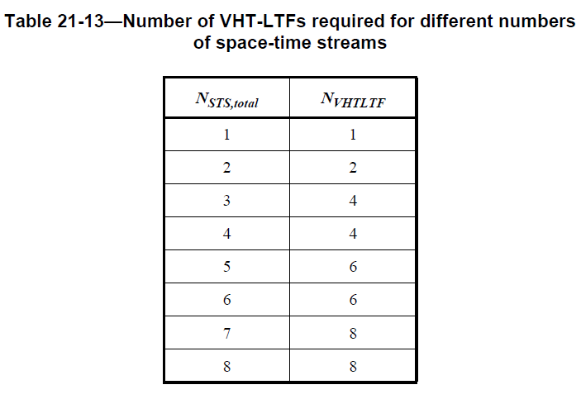
The encoding of that number presumably should follow the encoding used for the Number of HE-LTF Symbols in HE-SIG-A2 (see Table 28-19):
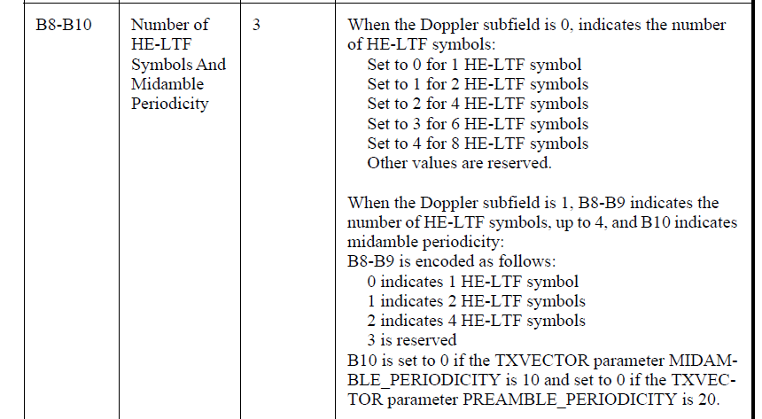
- “the number of HE-LTFs is greater than or equal to the maximum across RUs of the total number of space time streams”. This sentence could certainly be clarified. Our interpretation is the following: Based on the total number of streams in an RU, each RU requires a certain number of HE-LTF symbols. Since the number of HE-LTF symbols has to be the same for all transmitted TB response frames, the final number should accommodate the largest value of N_HE-LTF needed for any RU, but it is allowed to be higher as well. The current text does not correctly reflect this, since it talks about the maximum number of space time streams across RUs, rather than the maximum number of HE-LTF symbols across RUs.
Both of these issues are addressed in the new text proposal.

In Draft 2.0, the name of the subfield “HE-LTF Symbols” was changed to “Number Of HE-LTF Symbols And Midamble Periodicity” and its signaling now also includes information about midamble. The current text in Draft 2.0 reads:
Draft 2.0:
If the Doppler subfield of the Common Info field is 0, then the Number Of HE-LTF Symbols And Midamble Periodicity subfield of the Common Info field indicates the number of HE-LTF symbols present in the HE TB PPDU that is the response to the Trigger frame minus 1.
If the Doppler subfield of the Common Info field is 1, then B23-B24 of the Number OF HE-LTF Symbols And Midamble Periodicity subfield indicates the number of HE-LTF symbols present in the HE TB PPDU that is the response to the Trigger frame, and B25 of the Number OF HE-LTF Symbols And Midamble Periodicity subfield indicates midamble periodicity in the same HE TB PPDU.
For a non-OFDMA PPDU, the number of HE-LTF symbols is a function of the total number of space-time streams, NSTS,total and the encoding of the Number Of HE-LTF Symbols And Midamble Periodicity subfield is defined in Table 21-13.
For an OFDMA PPDU, the number of HE-LTF symbols is greater than or equal to the maximum NSTS,total across all allocated RUs and the encoding of the Number Of HE-LTF Symbols And Midamble Periodicity subfield is the same as the Number of HE-LTF Symbols field defined in Table 28-19 (HE-SIG-A field of an HE MU PPDU).
The underlined parts of the text have issues:
- “indicates the number of HE-LTF symbols present in the HE TB PPDU that is the response to the Trigger frame minus 1”. This is not the correct encoding for the number of HE-LTF symbols. Instead Table 28-19 should be used.
- The other two issues are carried over from Draft 1.0

Proposed resolution
The following changes to the text (starting at line 1, page 88 of Draft 2.0) are proposed to address the issues listed above:
If the Doppler subfield of the Common Info field is 0, then the Number Of HE-LTF Symbols And Midamble Periodicity subfield of the Common Info field indicates the number of HE-LTF symbols present in the HE TB PPDU that is the response to the Trigger frame minus 1.
If the Doppler subfield of the Common Info field is 1, then B23-B24 of the Number OF HE-LTF Symbols And Midamble Periodicity subfield indicates the number of HE-LTF symbols present in the HE TB PPDU that is the response to the Trigger frame, and B25 of the Number OF HE-LTF Symbols And Midamble Periodicity subfield indicates midamble periodicity in the same HE TB PPDU.
For a non-OFDMA PPDU, the number of HE-LTF symbols is a function of the total number of space-time streams, NSTS,total and the encoding of the Number Of HE-LTF Symbols And Midamble Periodicity subfield is defined in Table 21-13.
For an OFDMA PPDU, the number of HE-LTF symbols is greater than or equal to the maximum NSTS,total across all allocated RUs and the encoding of the Number Of HE-LTF Symbols And Midamble Periodicity subfield is the same as the Number of HE-LTF Symbols field defined in Table 28-19 (HE-SIG-A field of an HE MU PPDU).
The number of HE-LTF symbols as indicated in the subfield is a function of the total number of space-time streams:
- For non-OFDMA PPDUs Table 21-13 is used to determine the value of the number of HE-LTF symbols for a given value of N_{STS} (as defined in Table 28-15).
- For OFDMA PPDUs, each RU r has its own value of N_{STS,r,total} (see Table 28-15), for which a value N_{HE_LTF,r} can be derived from Table 21-13. The number of HE-LTFs shall be equal to or greater than the maximum value of all N_{HE_LTF,r}.
The encoding of the Number Of HE-LTF Symbols subfield is identical to the encoding used in the field “Number of HE-LTF Symbols And Midamble Periodicity” in HE-SIG-A2, which is defined in Table 28-19 (HE-SIG-A field of an HE MU PPDU).

