IEEE P802.11  
Wireless LANs

|  |  |  |  |  |
| --- | --- | --- | --- | --- |
| Comment resolution on CIDs on Clause 28.3.18.1 for signal leakage to preamble punctured channels | | | | |
| Date: 2018-02-16 | | | | |
| Author(s): | | | | |
| Name | Affiliation | Address | Phone | Email |
| Jianhan Liu | Mediatek |  |  | Jianhan.liu@mediatek.com |
| Ron Porat | Broadcom |  |  | ron.porat@broadcom.com |

Abstract:

This document contains comment resolution on the following CIDs for 28.3.18.1 and the proposed specification changes are in draft 2.2:

11358 and 13200.

|  |  |  |  |  |  |  |
| --- | --- | --- | --- | --- | --- | --- |
| **CID** | **Clause** | **Page** | **Line** | **Comment** | **Proposed Change** | **Resolution** |
| |  | | --- | | 11358 | | 28.3.18.1 | 489 | 58 | |  | | --- | | Preamble puncturing doesn't make much sense with the current spectral mask definitions, because puncturing is not garanteed with these masks | | |  | | --- | | Remove preamble puncturing from the draft, or define spectral mask requirements for preamble puncturing. | | Revised.  11ax editor, please see the discussion for instructions for CID 11358 in doc IEEE 802.11-18/0476r1. |
| 13200 | 28.3.18.1 | 489 | 55 | When preamble puncturing is used, the spectral mask stays the same as for the total bandwidth. This effectively means that preamble puncturing is useless. | Define some mask requirement for preamble puncturing or remove preamble puncturing completely. | Revised.  11ax editor, please see the discussion for instructions for CID 13200 in doc IEEE 802.11-18/0476r1. |

**Discussions for CID 11358 and 13200:**

In 11ax, 4 preamble puncturing modes are defined.

1. Preamble puncturing in 80 MHz, where in the preamble only the secondary 20 MHz is punctured.
2. Preamble puncturing in 80 MHz, where in the preamble only one of the two 20 MHz sub-channels in secondary 40 MHz is punctured.
3. Preamble puncturing in 160 MHz or 80+80 MHz, where in the primary 80 MHz of the preamble only the secondary 20 MHz is punctured.
4. Preamble puncturing in 160 MHz or 80+80 MHz, where in the primary 80 MHz of the preamble the primary 40 MHz is present.

However, the interferences caused by preamble puncturing transmission can be pretty large due to the following three facts:

1. The preamble punctured transmission and the transmission on the punctured sub-channels are not synchronized therefore the interferences introduced by the other transmission are not orthogonal;

2. There is spectural mask applied to the preamble puncture transmission to mitigate the interferences;

3. The tone plan of 11ax leaves small protect band to punctured sub-channels.



Both sides have 5 or 6 guard tones: total 11tones

Only One side has 5 or 6 guard tones

The evaluation has been conducted for a preamble puncture case as shown in the following figure in which the secondary 20MHz channel are punctured channel.



The evaluation that includes actual analog and RF impairment models shows that the 20dB down point is about 5 tones away.

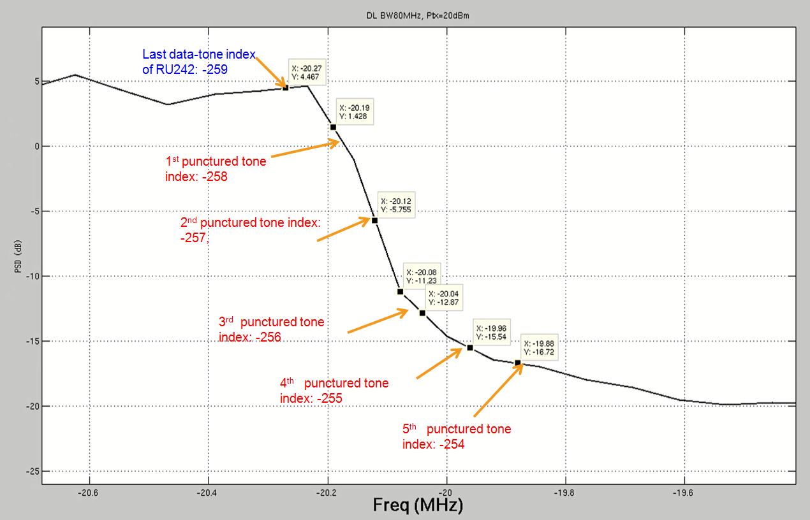

To avoid extra complexity for implementation and to avoid too much interference to the punctured channels, a simple transmit spectral mask for preamble puncturing is defined as follows:

The signal leakage to the punctured 20MHz or 40MHz channel shall be 20dB down after 0.5MHz away from the punctured 20MHz or 40MHz channel boundary.

***TGax Editor: Please add the following text after the line 8, page 514 of D2.2:***

For preamble puncture, the signal leakage to the preamble punctured channel from the occupied subchannels shall be less than or equal to -20dBr (dB relative to the maximum spectral density of the signal) starting 0.5MHz from the boundry of the preamble punctured channel. $N$ is the number of 20MHz punctured channels.



**Figure 28-50—Example transmit spectral mask for the $N×20$ MHz preamble punctured channel with transmissions on both upper and lower sub-channels**



**Figure 28-51—Example transmit spectral mask for the $N×20$ MHz preamble punctured channel with transmissions on the lower sub-channel**



**Figure 28-51—Example transmit spectral mask for the $N×20$ MHz preamble punctured channel with transmissions on the upper sub-channel**