IEEE P802.11
Wireless LANs
CR for CID 11499 and 14324
Date: 2018-03-05
Author(s):
Name | Affiliation | Address | Phone | email
Kiseon Ryu | LG | Yangae 11gil, Seocho-gu, Seoul, Republic of Korea | +82-10-2356-6164 | kiseon.ryu@lge.com
Alfred Asterjadhi | Qualcomm

Abstract
This submission proposes resolutions for multiple comments related to TGax D2.0 with the following CIDs (2 CIDs):
- Provided the resolutions for CID 11499, 14324

Revisions:
- Rev 0: Initial version of the document.

Interpretation of a Motion to Adopt

A motion to approve this submission means that the editing instructions and any changed or added material are actioned in the TGax Draft. This introduction is not part of the adopted material.

Editing instructions formatted like this are intended to be copied into the TGax Draft (i.e. they are instructions to the 802.11 editor on how to merge the text with the baseline documents).

TGax Editor: Editing instructions preceded by “TGax Editor” are instructions to the TGax editor to modify existing material in the TGax draft. As a result of adopting the changes, the TGax editor will execute the instructions rather than copy them to the TGax Draft.

CID | Page.Line | Comment | Proposed Change | Resolution | Comment Group
11499 | 254.49 | The Queue size High and Queue Size All in the BSR Control is poorly designed. It doesn't provide sufficient information of UL OFDMA/MIMO scheduling. Need a better design. | as in the comment | Revised.  TGax editor to make change in 11-18/0454r0 under 14265. | MU operation
14324 | 254.49 | The Queue size High and Queue Size All in the BSR Control is poorly designed. It doesn't provide sufficient information of UL OFDMA/MIMO scheduling. Need a better design. | as in the comment | Revised.  TGax editor to make change in 11-18/0454r0 under 14265. | MU operation

Discussion: None.

Propose:
Revised for CID 11499, 14324 per discussion and editing instructions in 11-18/0454r0.

TGax editor: Modify the sentence as below

- BSR Control
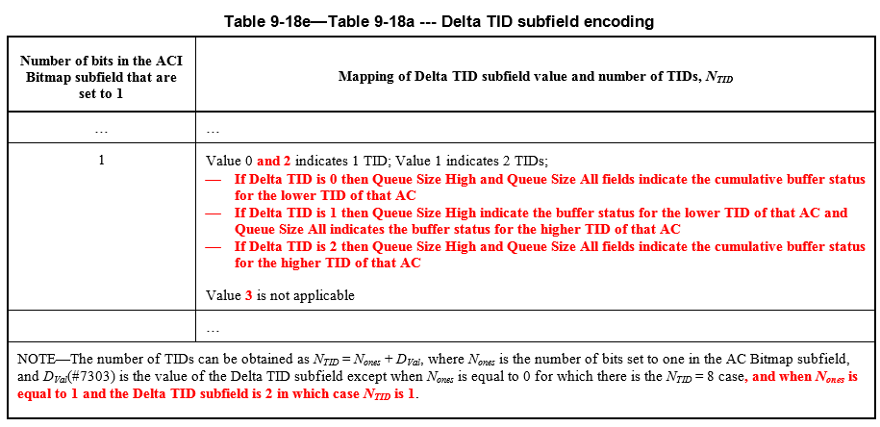
- HE buffer status feedback operation for UL MU
…
A non-AP STA reports its buffer status (unsolicited BSR) to the AP to which it is associated using either the QoS Control field or the BSR Control field(#4727) of frames it transmits as defined below:
…
- The HE STA shall set the Delta TID subfield according to Table 9-18e (Delta TID subfield encoding), and the Scaling Factor subfield as defined in 9.2.4.6.4.5 (BSR Control). If the STA sets only one bit to non-zero in the ACI Bitmap subfield, it shall report the buffer status for the lower TID (when Delta TID subfield is set to 0) or for the higher TID (when Delta TID subfield is set to 2) or both (when Delta TID subfield is set to 1 or 3) TIDs of that AC as defined in 9.2.4.6.4.5 (BSR Control).

An AP can also solicit one or more associated non-AP STAs for their BSR(s) by sending a BSRP Trigger frame (see 9.3.1.23 (Trigger frame format)). The non-AP STA responds (solicited BSR) as defined below:
- The BSR Control field with the Queue Size All subfield indicating the queue size for all the ACs, indicated by the ACI Bitmap subfield, for which the STA has buffer status to report to the AP when the AP has indicated its support in the BSR Support subfield of its HE Capabilities element. The STA shall set Delta TID, SF, ACI High and Queue Size High subfields of the BSR Control field as defined in 9.2.4.6.4.5 (BSR Control). If the STA sets only one bit to non-zero in the ACI Bitmap subfield, it shall report the buffer status for the lower TID (when Delta TID subfield is set to 0) or for the higher TID (when Delta TID subfield is set to 2) or both (when Delta TID subfield is set to 1 or 3) TIDs of that AC as defined in 9.2.4.6.4.5 (BSR Control).

