IEEE P802.11
Wireless LANs
CID 177
Date: 1/17/2018
Author(s):
Name | Affiliation | Address | Phone | Email
Sigurd Schelstraete | Quantenna |  |  | sigurd@quantenna.com
Abstract
This submission provides discussion and proposed resolution for CID 177.
CID 166

Discussion
177 | Mark RISON | 6.5.4.2 | 648 | 17 | Every PHY needs to define what is covered by "PHY header" so that aPHYHeaderLength is defined | Define the HT PHY header in Clause 19 as being the L-SIG, if present. Define the VHT PHY header in clause 21 as being the L-SIG

It appears that aPHYHeaderLength is already defined for HT. See:
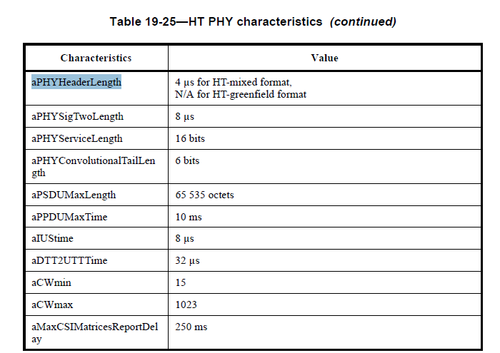

There is a corresponding Table of VHT PHY characteristics that does not contain aPHYHeaderLength explicitly. However, the following text appears ahead of this table:
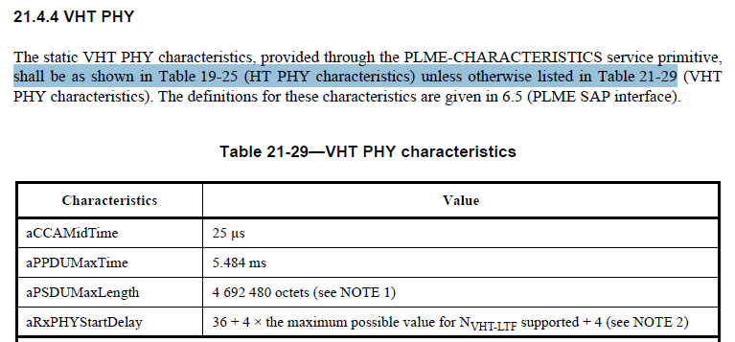

This would mean that the value of aPHYHeaderLength for VHT is inherited from HT and does not need to be specified explicitly.
A similar statement exists for TVHT PHY characteristics.

The one remaining thing to note is that aPHYHeaderLength does not appear in the Table of DMG PHY characteristics. It’s not clear whether it should be or not.

Proposed resolution:
Reject
Rejection reason:
A value for aPHYHeaderLength is given for HT and VHT in Table 19-25 and Table 21-29 respectively. While this does not provide a “definition of PHY header” as suggested by the commenter, only the numerical value is needed for interpreting the spec and those values are provided by the current text.

