IEEE P802.11
Wireless LANs
Allows Different Channel Width Capabilities Advertised in VHT and HE PHY Modes
Date: 2018-01-18
Author(s):
Name | Affiliation | Address | Phone | email
Huizhao Wang | Quantenna Communications | Quantenna Communications, Inc.  1704 Automation Parkway,  San Jose, CA 95131, USA |  | hwang@quantenna.com
Sigurd Schelstraete | Quantenna Communications |  |  | sschelstraete@quantenna.com
Abstract
This submission recommends to TGax group to allow different channel width capabilities advertised in VHT and HE Capabilities elements in 11ax Draft 2.0
Discussion
Currently in D2.0 document, it requires VHT mode advertising the same channel width capabilities of HE mode in clause 27.16.1 Basic HE BSS functionality:
“A STA transmitting an HT Capabilities element and HE Capabilities element shall set the Supported Channel Width Set subfield of the HT Capabilities element to 1 when either B0 or B1 of the Channel Width Set subfield of the HE Capabilities element is 1, except when the STA is a 20 MHz-only non-AP HE STA in which case the Supported Channel Width Set subfield of the HT Capabilities element is 0. STA transmitting a VHT Capabilities element and HE Capabilities element shall set the Supported Channel Width Set subfield of the VHT Capabilities element to a value that indicates the same channel width capability as the channel width capability indicated in the HE Capabilities element, except when the STA is a 20 MHz-only non-AP HE STA in which case the Supported Channel Width Set subfield of the VHT Capabilities element is reserved.”

But there are cases that network operators may want to set different bandwidth capabilities advertised in VHT and HE modes. So, we recommend to allow such flexibility in 11ax spec text, while still recommend to set the same bandwidth capability advertised in VHT and HE modes.

Resolution:
11ax Editor: Modify 27.16.1 Basic HE BSS functionality as below:

A STA transmitting an HT Capabilities element and HE Capabilities element shall set the Supported Channel Width Set subfield of the HT Capabilities element to 1 when either B0 or B1 of the Channel Width Set subfield of the HE Capabilities element is 1, except when the STA is a 20 MHz-only non-AP HE STA in which case the Supported Channel Width Set subfield of the HT Capabilities element is 0. STA transmitting a VHT Capabilities element and HE Capabilities element may set the Supported Channel Width Set subfield of the VHT Capabilities element to a value that indicates the same channel width capability as the channel width capability indicated in the HE Capabilities element, except when the STA is a 20 MHz-only non-AP HE STA in which case the Supported Channel Width Set subfield of the VHT Capabilities element is reserved.
A STA transmitting an HT Capabilities element and HE Capabilities element shall set the Supported Channel Width Set subfield of the HT Capabilities element to 1 when either B0 or B1 of the Channel Width Set subfield of the HE Capabilities element is 1, except when the STA is a 20 MHz-only non-AP HE STA in which case the Supported Channel Width Set subfield of the HT Capabilities element is 0. STA transmitting a VHT Capabilities element and HE Capabilities element shall may set the Supported Channel Width Set subfield of the VHT Capabilities element to a value that indicates the same channel width capabilitu as the channel width capability indicated in the HE Capabilities element, except when the STA is a 20 MHz-only non-AP HE STA in which case the Supported Channel Width Set subfield of the VHT Capabilities element is reserved.

An HE STA shall not transmit HE PPDU to a second HE STA using a bandwidth that is not indicated as supported in the Channel Width Set subfield in the HE Capabilities element received from that HE STA

Straw Poll
Do you agree to allow different channel width capabilities advertisements in VHT and HE Capabilities elements, and the resultion text presented in this contribution?
Y/N/A

Background Information:
VHT and HE already have two separate mechanisms of signaling channel width + NSS capacities:
VHT channel width + NSS capacity encoding is depicted in:
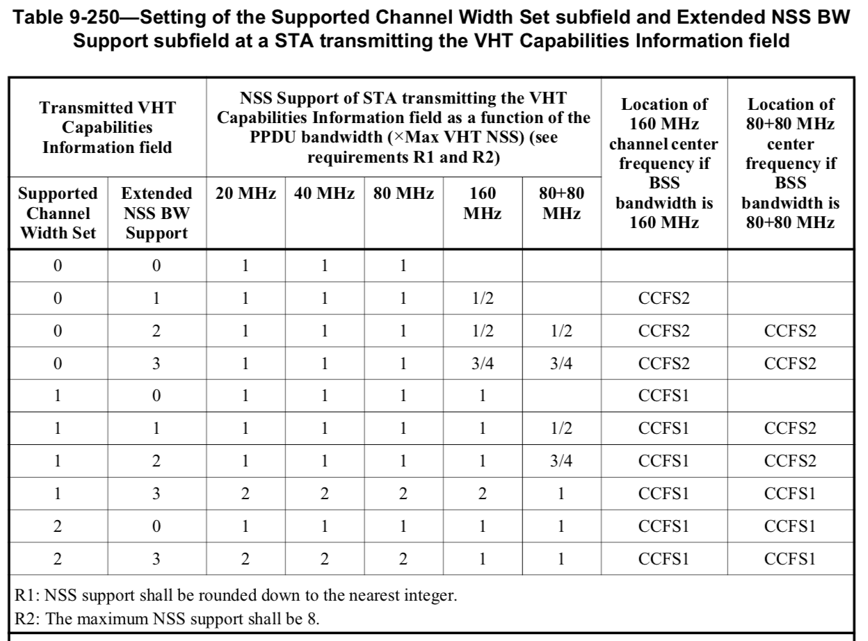
HE channel width + NSS capacity encoding is depicted in HE-MCS And NSS Set field in HE Capabilities element:
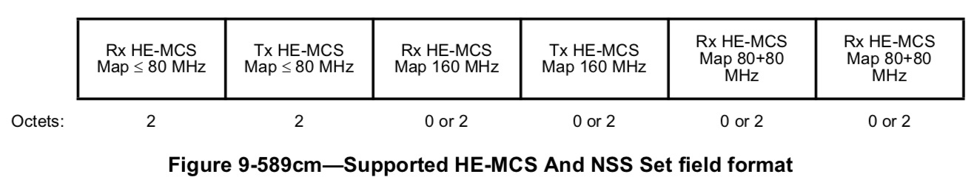
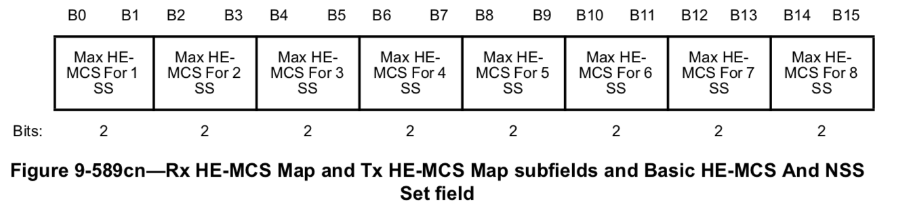
VHT and HE also have their own mechanisms of signaling channel bandwidth:
VHT uses Operation Mode Notification element to signaling runtime channel width, Rx NSS:
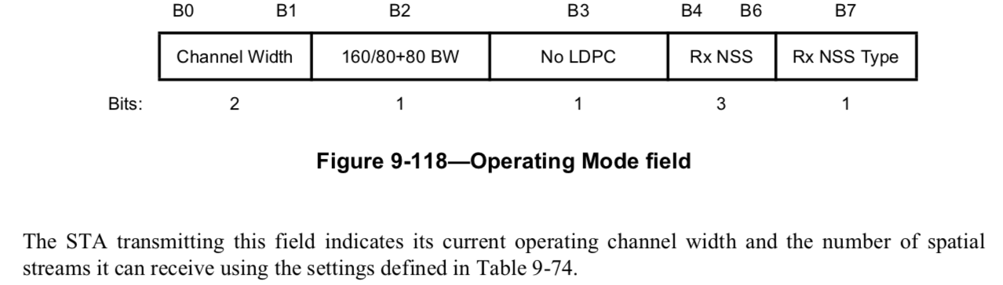
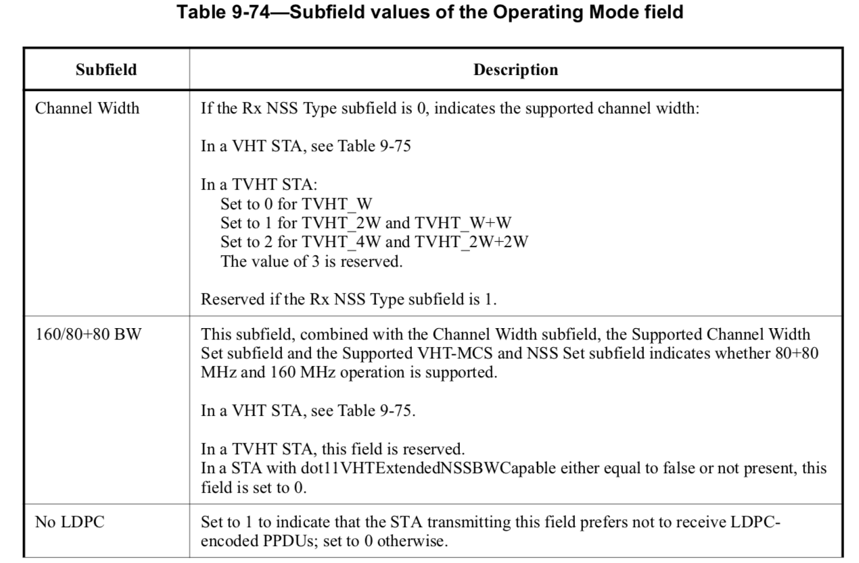
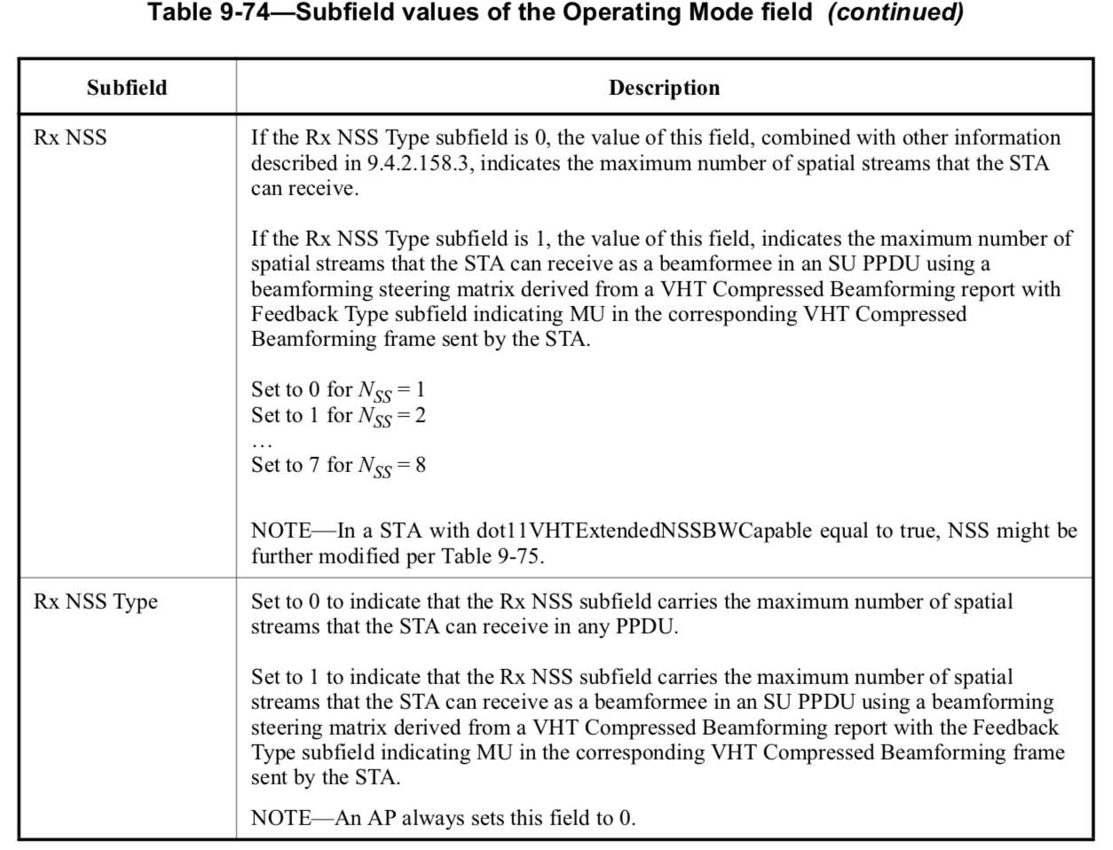
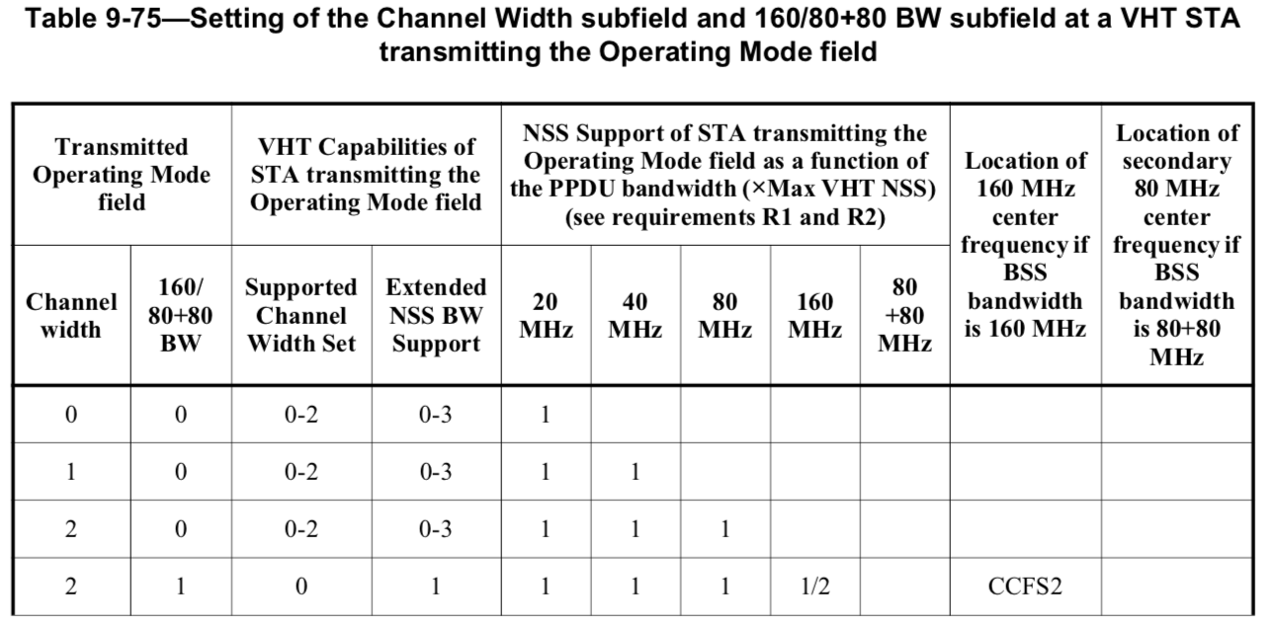
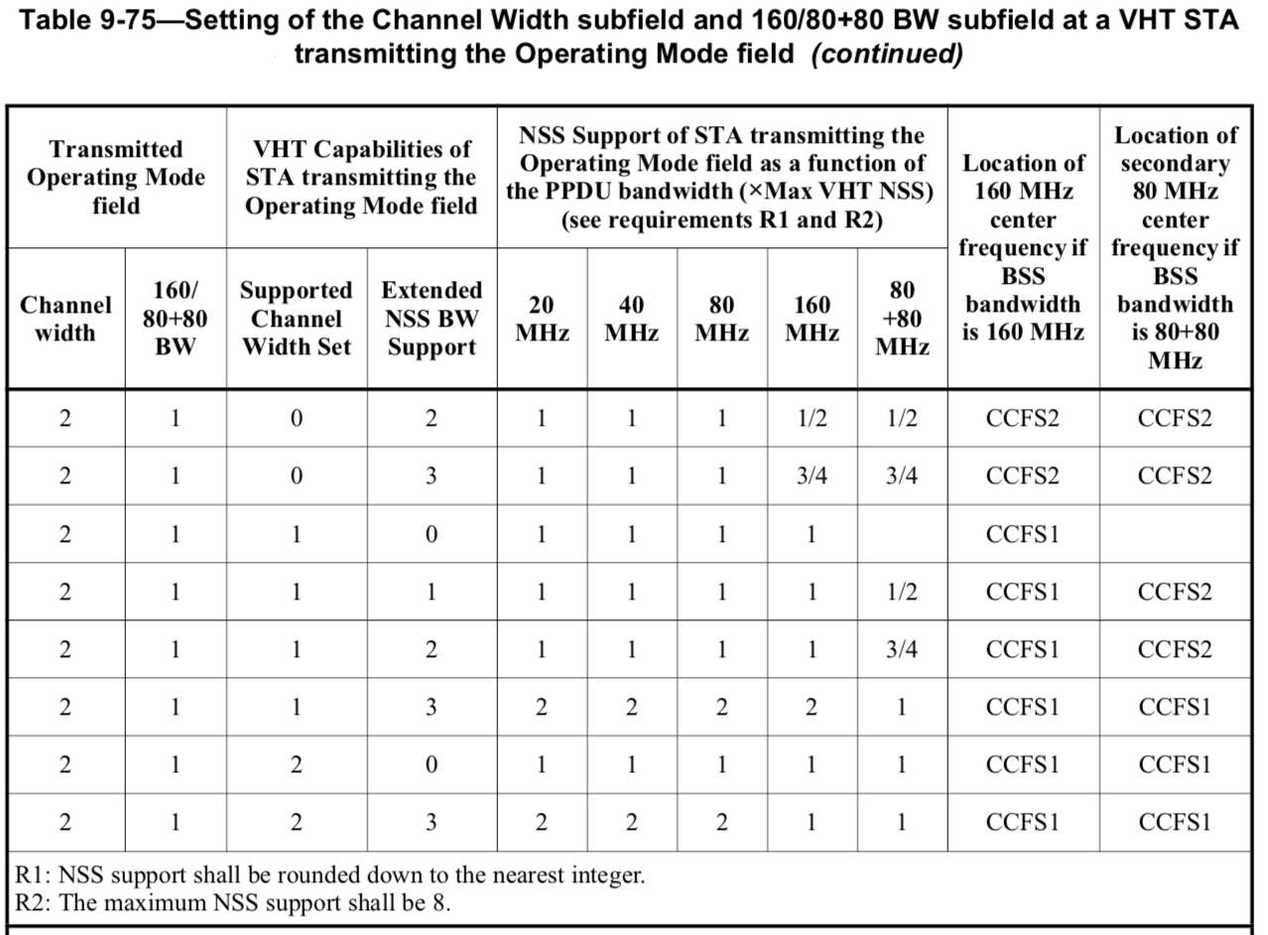
HE uses OM Control field to signal runtime channel width + Tx/Rx NSS changes:
