IEEE P802.11
Wireless LANs
Decouple Channel Width Capabilities between VHT and HE PHY Mode
Date: 2018-01-18
Author(s):
Name | Affiliation | Address | Phone | email
Huizhao Wang | Quantenna Communications | Quantenna Communications, Inc.  1704 Automation Parkway,  San Jose, CA 95131, USA |  | hwang@quantenna.com
Sigurd Schelstraete | Quantenna Communications |  |  | sschelstraete@quantenna.com
Abstract
This submission recommends to TGax group to decouple the channel width capabilities advertised in VHT and HE Capabilities elements in 11ax Draft 2.0
Discussion
Currently in D2.0 document, it requires VHT mode advertising the same channel width capabilities of HE mode in clause 27.16.1 Basic HE BSS functionality:
“A STA transmitting an HT Capabilities element and HE Capabilities element shall set the Supported Channel Width Set subfield of the HT Capabilities element to 1 when either B0 or B1 of the Channel Width Set subfield of the HE Capabilities element is 1, except when the STA is a 20 MHz-only non-AP HE STA in which case the Supported Channel Width Set subfield of the HT Capabilities element is 0. STA transmitting a VHT Capabilities element and HE Capabilities element shall set the Supported Channel Width Set subfield of the VHT Capabilities element to a value that indicates the same channel width capability as the channel width capability indicated in the HE Capabilities element, except when the STA is a 20 MHz-only non-AP HE STA in which case the Supported Channel Width Set subfield of the VHT Capabilities element is reserved.”

But there are many valid reasons that VHT and HE modes may need signaling different channel width capabilities, for example: product development cycle comes in stages: in one stage, VHT 160MHz support is already in production as well as HE 80MHz support is ready, but HE 160MHz mode is still under development for future release on the same chipset. In this particular case, there is no reason to restrict VHT mode running only at 80MHz mode due to HE mode is only support 80MHz at this point.

Resolution:
11ax Editor: Modify 27.8.1 General as below:
The VHT channel width and the VHT NSS allowed at an HE STA transmitting an OM Control subfield are defined in Table 27-7 (Setting of the VHT Channel Width and VHT NSS at an HE STA transmitting the OM Control subfield).
11ax Editor: Modify 27.8.1 General as following instruction: Remove the Table 27-7 from the text.
11ax Editor: Modify 27.16.1 Basic HE BSS functionality as below:

A STA transmitting an HT Capabilities element and HE Capabilities element shall set the Supported Channel Width Set subfield of the HT Capabilities element to 1 when either B0 or B1 of the Channel Width Set subfield of the HE Capabilities element is 1, except when the STA is a 20 MHz-only non-AP HE STA in which case the Supported Channel Width Set subfield of the HT Capabilities element is 0. STA transmitting a VHT Capabilities element and HE Capabilities element shall set the Supported Channel Width Set subfield of the VHT Capabilities element to a value that indicates the same channel width capability as the channel width capability indicated in the HE Capabilities element, except when the STA is a 20 MHz-only non-AP HE STA in which case the Supported Channel Width Set subfield of the VHT Capabilities element is reserved.

Straw Poll
Do you agree to decouple VHT and HE channel width capabilities advertisements in VHT and HE Capabilities elements, and the resultion text presented in this contribution?
Y/N/A

Background Information:
VHT and HE already have two separate mechanisms of signaling channel width + NSS capacities:
VHT channel width + NSS capacity encoding is depicted in:
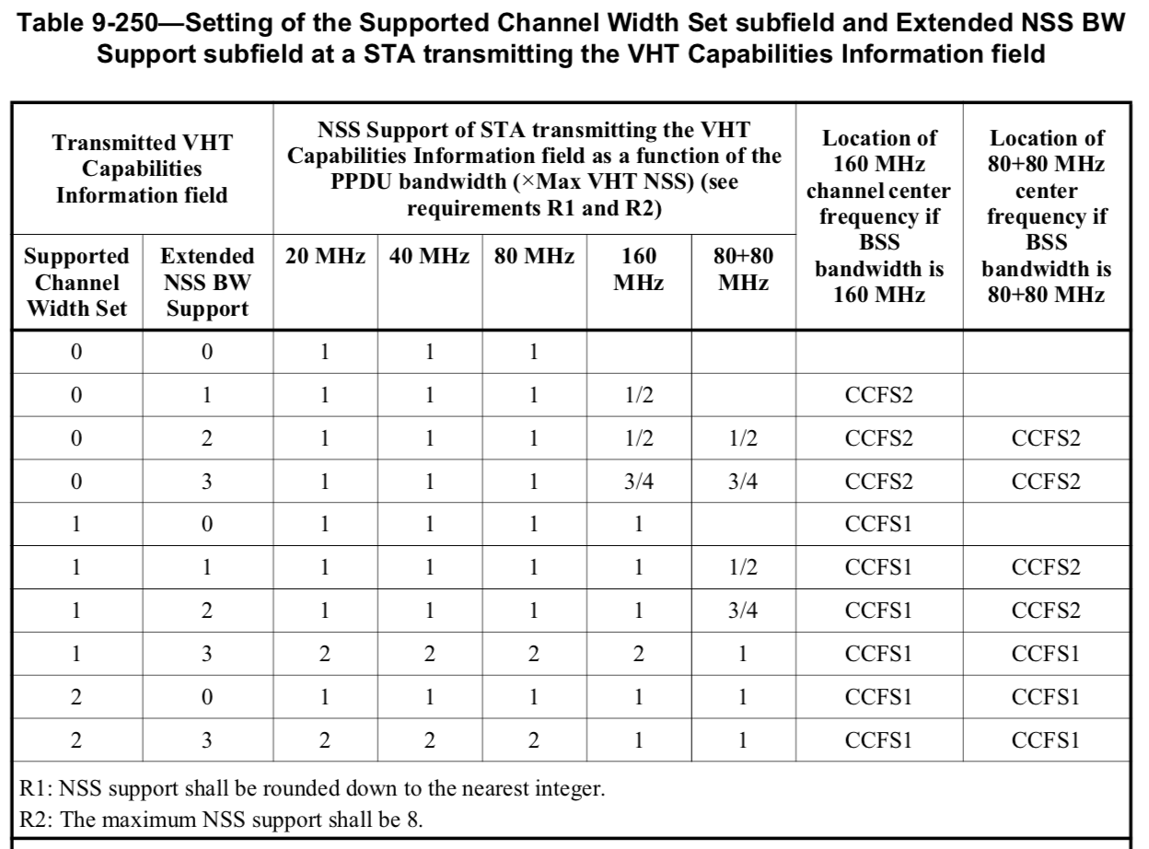
HE channel width + NSS capacity encoding is depicted in HE-MCS And NSS Set field in HE Capabilities element:
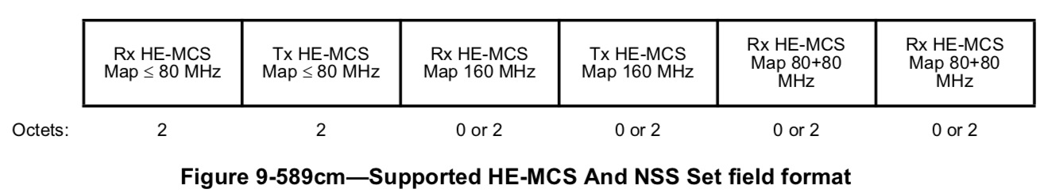
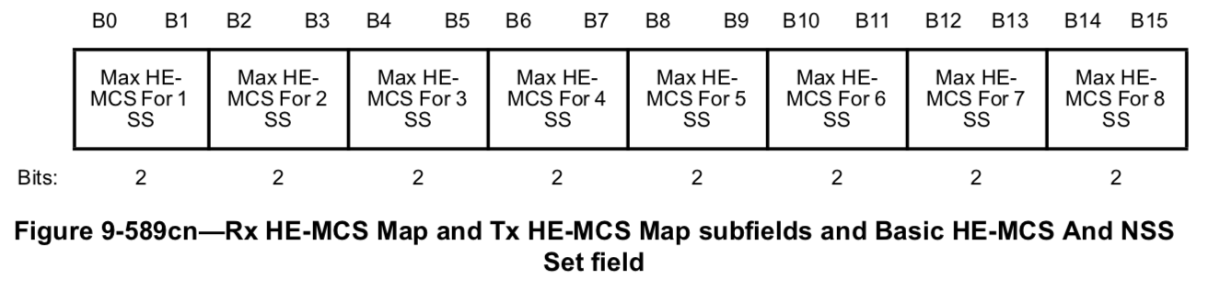
VHT and HE also have their own mechanisms of signaling channel bandwidth:
VHT uses Operation Mode Notification element to signaling runtime channel width, Rx NSS:
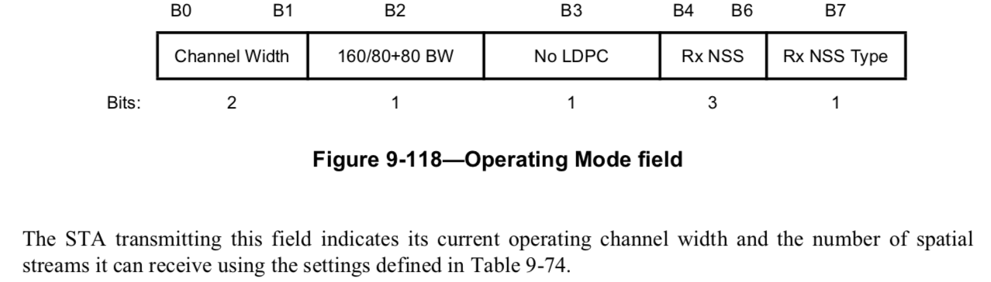
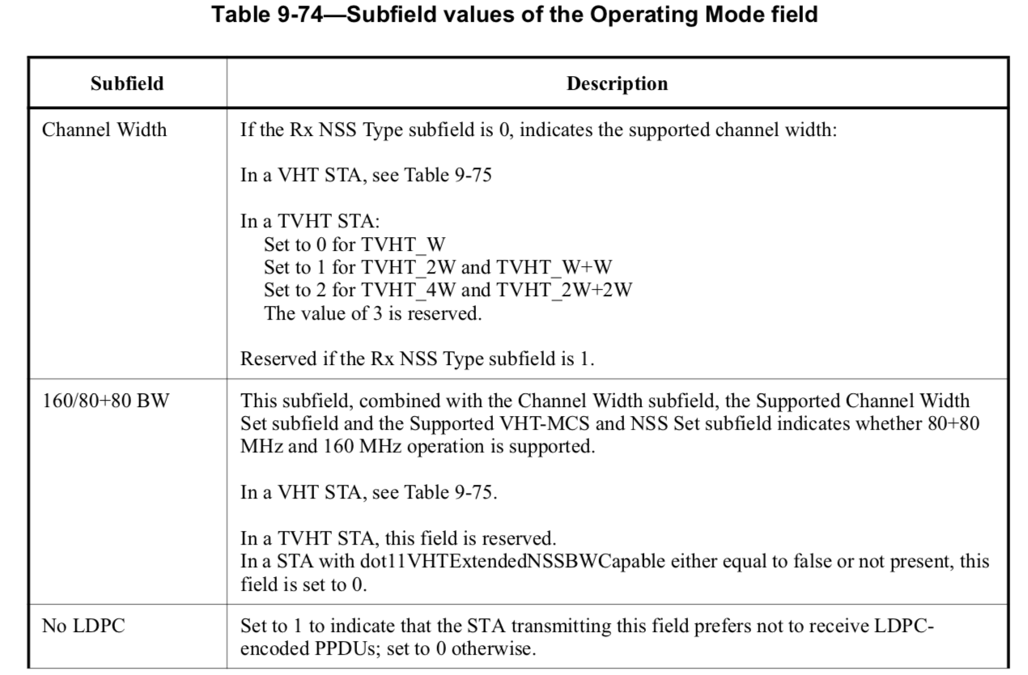
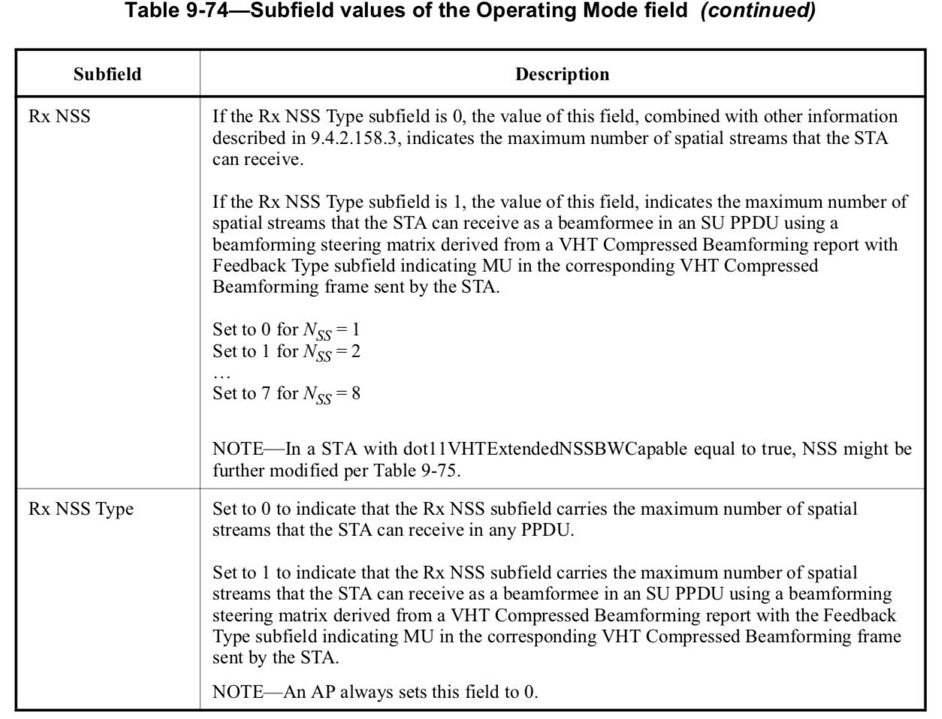
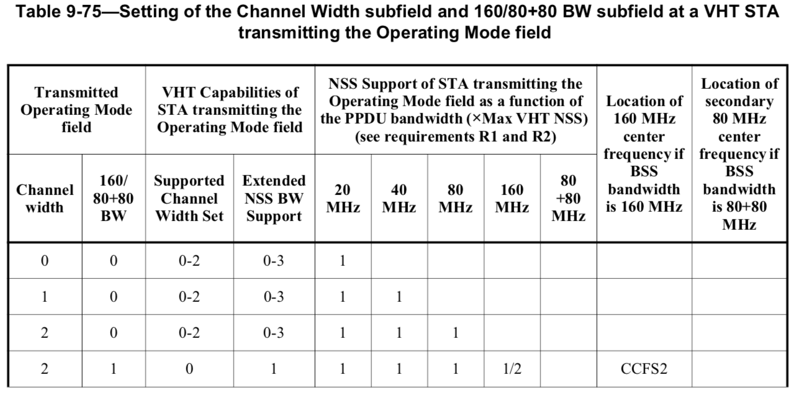
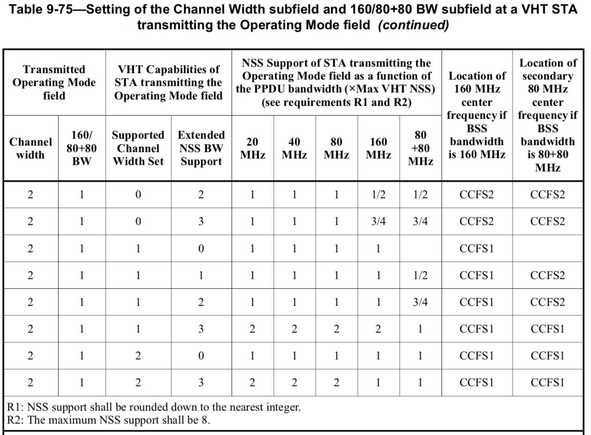
HE uses OM Control field to signal runtime channel width + Tx/Rx NSS changes:
