IEEE P802.11
Wireless LANs
CR of CID 13754
Date: 2018-1-1
Author(s):
Name | Affiliation | Address | Phone | Email
Zhou Lan | Broadcom Ltd. | 250 Innovation Drive San Jose CA 95134 | (+1) 408 543 3450 | zhou.lan@broadcom.com
Chunyu Hu | Broadcom Ltd. | 250 Innovation Drive San Jose CA 95134 |  | chunyu.hu@broadcom.com
Matthew Fischer | Broadcom Ltd. | 250 Innovation Drive San Jose CA 95134 |  | matthew.fischer@broadcom.com

Abstract
Comment resolution with proposed changes to TGax D2.0 for CIDs from the WG LB for TGax related to CID 11001.

The CID list is:
11001

The proposed changes on this document are based on TGax Draft 2.0.

REVISION NOTES:

R0: Initial draft with comments from group.

END OF REVISION NOTES

Interpretation of a Motion to Adopt

A motion to approve this submission means that the editing instructions and any changed or added material are actioned in the TGax Draft. This introduction is not part of the adopted material.

Editing instructions formatted like this are intended to be copied into the TGax Draft (i.e. they are instructions to the 802.11 editor on how to merge the text with the baseline documents).

TGax Editor: Editing instructions preceded by “TGax Editor” are instructions to the TGax editor to modify existing material in the TGax draft. As a result of adopting the changes, the TGax editor will execute the instructions rather than copy them to the TGax Draft.

CIDs

11001 | Abhishek Patil | 85.10 | 9.3.1.23 | Random access for unassociated STAs is broken. In case of random access for unassociated STAs (AID12=2045), the most likely case is that an unassociated STA wishing to use the random access RU has not received any other frames from the AP sending the Trigger frame. As a result, the unassociated STA has no knowledge of the reference channel (primary 20). Since the RU indexing is with respect to the primary20 of the AP, how would an unassociated non-AP STA know the RU mapping of the Trigger frame? | As in comment | Revised  This part of the comment is incorrect:  “Since the RU indexing is with respect to the primary20 of the AP,” is not correct. For the unassociated STA to understand the RU index of the RA-RU, the knowledge of the primary subband ID is not necessary cause the RU is indexed with the physical tone from lowest frequency to the highest frequency of the PPDU bandwidth. Please refer to the discussion section in this document for detail.  So this part of the comment should be rejected.  On the other hand, it was suggested that if the AP were to send a probe response, the unassociated STA might not be able to receive the MMPDU if the STA only listens on the 20MHz channel on which it transmitted the HE TB PPDU with the probe request, and this might not be the primary channel of the BSS.  So we propose to mandate the AP to send any response MMPDU to an unassociated STA in an HE PPDU to solve this problem. Please refer to the discussion section for details.  TGax editor, please make changes as shown in doc 11-18/185r0 that are marked with CID 11001

Discussion:

Problem 1: Determining the relationship between RU index values and the frequencies of the tones represented by the values.

The following figure shows the RU index of an 80 MHz PPDU as an example. The RU index has no relationship with the primary channel index, but is related to the BW of the BSS.

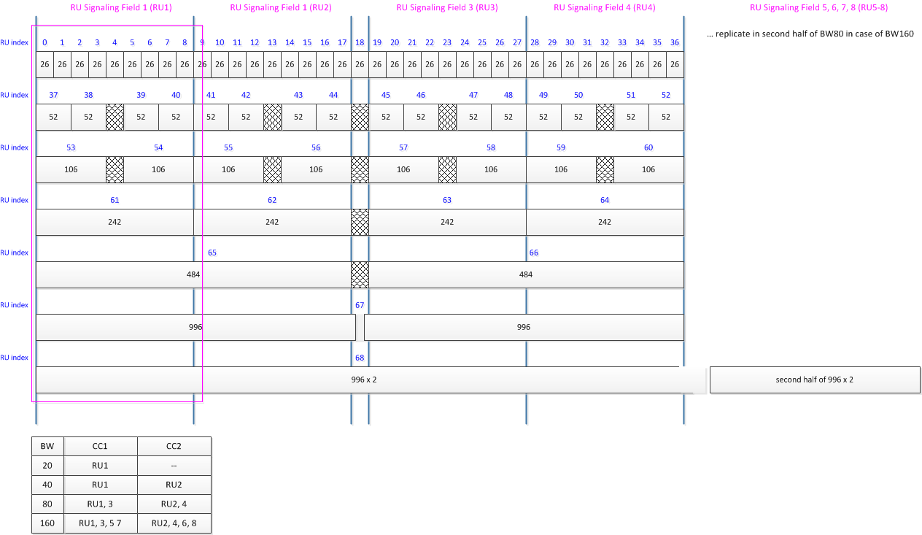

An unassociated STA that receives a Trigger frame needs to know which frequencies are identified by the individual tones of the HE TB PPDU per the index value in the Trigger. In order to do this, the STA needs to know some reference frequency, and normally, that is the lowest frequency of the band of operation of the AP transmitting the Trigger. The Trigger contains a bandwidth indication, but no fixed frequency information. However, because there is no overlapping channelization in the 5GHz band for each BW value, the STA can correctly determine the channel that is being used by noting which channel it is tuned to when it receives the Trigger and combining that information with the channel map and the BW value. In the 2.4GHz band, only 20MHz operation is permitted, so there is no confusion for the STA.

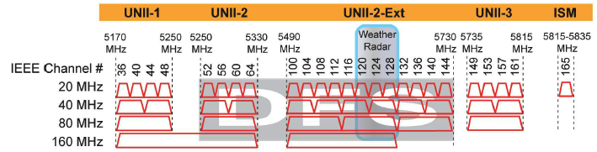

Conclusion: primary channel subband ID is not required for UORA operation.

Next problem: How to make certain that an unassociated STA can receive an MMPDU that is a response to an HE TB PPDU that used an RARU (for unassociated STA)?

802.11ax mandates 80 MHz TX/RX capability. An unassociated STA that is 802.11ax compliant is able to receive an 80MHz HE PPDU. So after receiving an MMPDU from an RARU, the AP should send the response MMDPU in an HE PPDU format (setting any RU in 80MHz with AID = 2045), which the STA shall be able to receive.

For a 20MHz only STA, the response MMPDU shall be sent on the RUs that are not restricted for the 20 MHz STA to operate under broader bandwidth.

The AP may also send the response in a non-HT PPDU if at least one copy of the PPDU is transmitted on at least one of the 20 MHz channel(s) within which the UL MMPPDU was transmitted and the PPDU meets other requirements for transmission on the primary channel.

Conclusion: AP sends response MMPDU in appropriate format and location, i.e. on a channel that it knows the STA is located.

Proposed Changes to Draft Text of TGax D2.0:

TGax Editor: add a new section after 27.5.5.4 as follows (11ax D2.0 P260L29):
27.5.5.5 Additional Considerations to Support Random Access for Unassociated STAs
……
(#CID 11001)An AP that received the MMPDU from an unassociated STA using UORA that has not associated with it may send the response MMDPU in HE PPDU. For a 20MHz only STA that operates under broader bandwidth, the response MMPDU shall be sent in an RU that the 20MHz only STA is capable receiving and not a restricted RU as specified in section 28.3.3.6 (RU restrictions for 20 MHz operation). The AP may also send the response MMPDU in a non-HT PPDU if at least one copy of the PPDU is transmitted on at least one of the 20 MHz channel(s) within which the UL MMPPDU was transmitted and the PPDU meets other requirements for transmission on the primary channel

……
End of proposed changes.

