802.11ba Draft Specification

Spec Text for Vendor Specific Frame
Date: 2018-01-xx
Author(s):
Name | Affiliation | Address | Phone | email
Po-Kai Huang | Intel | 2200 Mission College Blvd, Santa Clara, CA 95054 | +1-765-418-6733 | po-kai.huang@intel.com
Abstract
This submission contains spec text to be incorporated in P802.11ba D0.1 related to these motions:

- The Frame Control field is 8 bits and contains:
- A Type subfield that identifies the type and, together with the Length field differentiates between constant length (CL) and variable length (VL) WUR frames
- A Length/Misc field which contains:
  - The length of the Frame Body field for a VL WUR frame
  - Bits that are expected to be used for other purposes for a CL WUR frames
    - No Length field is present in CL WUR frames

- TBD bits Type field is included in the Frame control field of MAC header with the following mapping of the Type field:
- 0 assigned to WUR Beacon
- 1 assigned to Wake-Up frame
- 2 assigned to Vendor specific frame

- The contents of the Address field are as defined below:

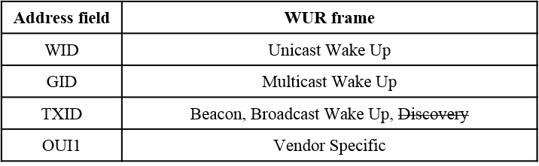

- Where:
  - WID is the WUR ID provided by the AP and identifies one WUR STA
  - GID is the GROUP ID provided by the AP and identifies one or more WUR STAs
  - TXID is a transmitter identifier that is decided by the AP
    - Which bits, from where, and how they are selected is TBD
  - OUI1 is the 12 MSBs of the OUI

Reference slide deck(s):
[1] 11-17-1008-00 Vendor Specific WUR Frame
[2] 11-17-1334-00 Vendor Specific WUR Frame Follow up
[3] 11-17-1638-06 WUR Frame format follow-up
[4] 11-17-1645-03 WUR Frame format follow-up

Revision History:
- Rev 0: Initial version of the document

Editing instructions formatted like this are intended to be copied into the TGba Draft (i.e. they are instructions to the 802.11 editor on how to merge the text with the baseline documents).

TGba Editor: Editing instructions preceded by “TGba Editor” are instructions to the TGba editor to modify or insert material in the TGba draft. As a result of adopting the changes, the TGba editor will execute the instructions rather than copy them to the TGba Draft.

TGba Editor: Instruction: Add subclause 9.10.3.4 WUR Vendor Specific frame formats as he following:
9.10.3.4 WUR Vendor Specific frame format

The frame format of the WUR Vendor Specific frame is defined in 9-AA1.
The Frame Control field is set as defined in 9.10.2.1.1 (Frame Control field).
The Address field is set to the 12 MSBs of the OUI (see 9.4.1.32 (Organization Identifier field)).
The Frame Body field of the WUR Vendor Specific frame contains vendor specific information and its length is defined in 9.10.2.4 (Frame Body field).
The vendor specific information contained in the Frame Body field is outside the scope of this standard.

