IEEE P802.11
Wireless LANs
Comment Resolutions on Clause 9.4.1.63 D2.0 (HE Compressed Beamforming Report field)
Date: 2017-12-12
Author(s):
Name | Affiliation | Address | Phone | email
Kome Oteri | InterDigital | 9710 Scranton Road, San Diego, CA 92121 | +1-858-210-4826 | kome.oteri@interdigital.com
Rui Yang
Lochan Verma | Qualcomm

Abstract
This submission proposes resolutions for the following 3 comments on 9.4.1.63 (HE Compressed Beamforming Report field) of TGax D2.0:
11121, 12683, 12684, 12690, 12701, 12702, 12746, 12769, 12771, 12772, 13696, 13697

Revisions:

Interpretation of a Motion to Adopt

A motion to approve this submission means that the editing instructions and any changed or added material are actioned in the TGax Draft. This introduction is not part of the adopted material.

Editing instructions formatted like this are intended to be copied into the TGax Draft (i.e. they are instructions to the 802.11 editor on how to merge the text with the baseline documents).

TGax Editor: Editing instructions preceded by “TGax Editor” are instructions to the TGax editor to modify existing material in the TGax draft. As a result of adopting the changes, the TGax editor will execute the instructions rather than copy them to the TGax Draft.

CID | Clause Number | Page/  Line | Clause | Comment | Proposed Change | Resolution
11121 | 9.4.1.63 | 110.04 | 9.4.1.63 | I spotted the deliberate editorial mistake to see if I was paying attention. | Make the "i" in the where inequality italic. | Accepted  TGax editor to make the changes shown in 11-18/0080r0 under all headings that include CID 11121
12683 | 9.4.1.63 | 113.34 | 9.4.1.63 | Pilot subcarriers should not be included in the list of subcarriers for which BF feedback is given (they were not included for ac either) | Delete the pilot subcarrier indices from Table 9-76e | Accepted  TGax editor to make the changes shown in 11-18/0080r0 under all headings that include CID 12683
12684 | 9.4.1.63 | 114.01 | 9.4.1.63 | There are behavioural requirements in 9.4.1.63, which is a subclause about format not behaviour and it's about what the BFee can't ask for, not what the BFee should provide | Move the last 3 paras of 9.4.1.63 to 27.6.3 | Accept  The paragraphs were moved to Pg 266 line 10, under a discussion of rules governing Ng  TGax editor to make the changes shown in  11-18/0080r0 under all headings that include CID 12684
12690 | 9.4.1.63 | 109.52 | 9.4.1.63 | "A beamformee may choose to reduce Ns by using a method referred to as grouping" -- in HE the BFer gets to choose sometimes | Change "beamformee" to "beamformee or beamformer, depending on the situation," in the cited text | Revised  TGax editor to make the changes shown in 11-18/0080r0 under all headings that include CID 12690
12701 | 9.4.1.63 | 113.37 | 9.4.1.63 | Ng not always italicised | Italicise in Table 9-76e | Accepted  TGax editor to make the changes shown in 11-18/0080r0 under all headings that include CID 12701
12702 | 9.4.1.63 | 114.03 | 9.4.1.63 | "Ng = 16 For SU/MU" -- no such field | Change to "Ng = 16 SU Feedback" and "Ng = 16 MU Feedback" | Rejected  The fields that have been highlighted are in the HE PHY capabilities to make a request, the STA uses the fields in Table 9-25a. i.e. Feedback Type and Ng subfield
12764 | 27.13 | 310.53 | 27.13 | "TxBF" -- no such field | Change to "Tx BF" | Accept  TGax editor to make the changes shown in 11-18/0080r0 under all headings that include  CID 12764
12769 | 9.4.1.63 | 109.52 | 9.4.1.63 | "A beamformee may choose to reduce Ns by using a method referred to as grouping" -- it's not a "may" since Ng is not allowed to be 1 in HE | Change "may choose to reduce" to "reduces" in the cited text | Accept  TGax editor to make the changes shown in 11-18/0080r0 under all headings that include  CID 12769
12771 | 9.4.1.63 | 110.01 | 9.4.1.63 | "For the left of DC, scidx(i) = scidx(i-1) + Ng, where 1 <= i <= L and scidx(L) = -4.  For the right of DC, scidx(i) = scidx(i-1) + Ng, where L + 2 <= i <= Ns -- 2 and scidx(L + 1) = 4." -- the cases where i is L+1 or Ns -- 1 are undefined | Extend the equations to cover these two cases | Revised:  The formulas are correct. Subcarriers scidx(0) and scidx(Ns - 1) represent the S (Start)-tone corresponding to the RU Start Index and E (End)-tone corresponding to the RU End Index, respectively. (pg 109 lin 57) and as such have been already defined explicitly. All we need to do is define the indices from scidx(1) to to scidx(Ns-2).  However, some confusion may arise from the fact that  L is not explicitly defined.  L is the number of subcarriers on the left of DC  for which feedback is sent to the beamformer (with scidx(L) = -4 in the case of 80 MHz).  In this case, L + 1 is the first fed back subcarrier on the right of DC (scidx (L+1) = +4, in the case of 80 MHz) and is defined explicitly in the specification. As such there is no need to define L+ 1 again. Note: We add text to explicitly define L.  TGax editor to make the changes shown in 11-18/0080r0 under all headings that include  CID 12771
12772 | 9.4.1.63 | 109.51 | 9.4.1.63 | There are references to a "Compressed Beamforming Feedback Matrix subfield" but no such subfield is defined | Refer to an defined subfield in 9.3.1.20, 9.4.1.63, | Revised: It is appropriate to refer to the Feedback field only and not the NDP request (not 9.3.1.20) so only made a reference to 9.4.1.63  TGax editor to make the changes shown in 11-18/0080r0 under all headings that include CID 12772
13696 | 9.4.1.63 | 114.01 | 9.4.1.63 | Normative expression should not be used in clause 9. Two occurences, may and shall, in the paragraph starting from pp.ll 114.1. | Change the first two sentences starting from pp.ll 114.1 to be a non-normative text. | Revised  Moved to 266.10 as in comment 12684  See resolution to CID 13696
13697 | 9.4.1.63 | 114.04 | 9.4.1.63 | "... in the Ng = 16 For SU subfield or Ng = 16 For MU subfield, respectively, ..." The two "For" should not start with an upper case. | As in comment. | Accepted  TGax editor to make the changes shown in 11-18/0080r0 under all headings that include CID 13697

Discussion
#12683
The pilot subcarriers are captured in Table 28-10 shown below. Based on this:
For Ng = 4 and 20 MHz, +/- 116, +/-76, +/-48, +/- 36 are removed
For Ng = 16 and 20 MHz, +/-116, +/-36 are removed
We explicitly add a statement indicating that the pilots are not used to the text.
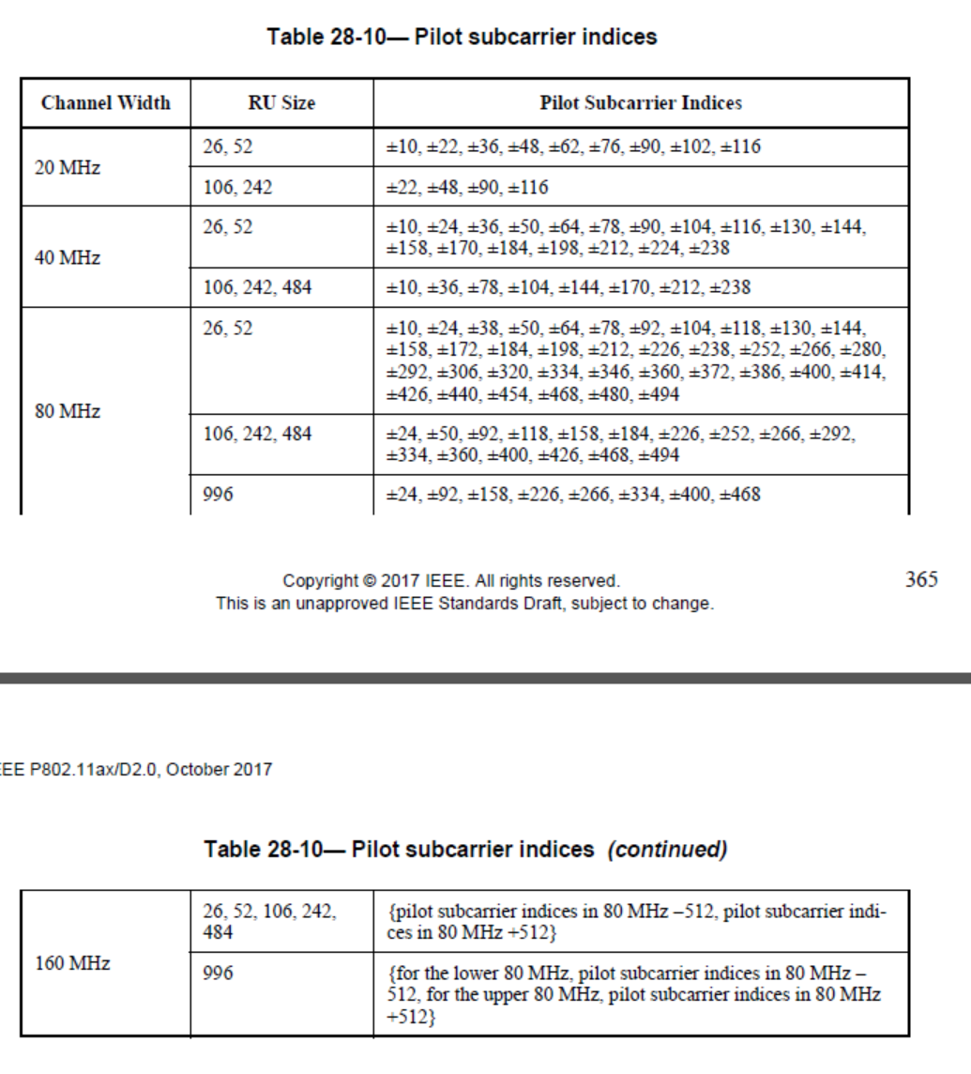

Changes to D2.0

TGax Editor: Please make the following change on Pg 110 ln 1 (#11121), (#12771):

For 40 MHz and 80 MHz, when the aforementioned S-tone and E-tone indices lie on the same side of DC, scidx(i) = scidx(i - 1) + Ng, where 1 ≤ i ≤ Ns - 2. However, when the S-tone and E-tone indices lie on different sides of DC, the following relationships hold separately for the two sides of DC.

For the left of DC, scidx(i) = scidx(i - 1) + Ng, where 1 ≤ i ≤ L, L is the number of subcarriers on the left of DC for which feedback is sent to the beamformer (#12771) and scidx(L) = - 4.

For the right of DC, scidx(i) = scidx(i - 1) + Ng, where L + 2 ≤ i (#11121) ≤ Ns – 2, L + 1 and scidx(L + 1) = 4.

TGax Editor: Please make the following change on Pg 113 ln 34 (#12683)(#12701):

Table 9-76e—Feedback subcarrier indices for 20 MHz bandwidth for Ng = 4 and Ng = 16 (#12701)

Ng (#12701) | Subcarrier indices
4 | -122, -120, -116, -112, -108, -104, -100, -96, -92, -88, -84, -80, -76, -72, -68, -64, -60, -56, -52, -48, -44, -40, -36, -32, -28, -24, -20, -16, -12, -8, -4, -2, 2, 4, 8, 12, 16, 20, 24, 28, 32, 36, 40, 44, 48, 52, 56, 60, 64, 68, 72, 76, 80, 84, 88, 92, 96, 100, 104, 108, 112, 116, 120, 122 (#12683)
16 | -122, -116, -100, -84, -68, -52, -36, -20, -4, -2, 2, 4, 20, 36, 52, 68, 84, 100, 116,  122 (#12683)

TGax Editor: Please make the following change on Pg 114 ln 1 (#12684) (#13696):

An HE beamformee may support Ng = 16 in the HE Compressed Beamforming Report field for both SU and MU feedback types. A beamformer shall not request Ng = 16 for SU or MU feedback in an HE NDP Announcement frame unless the beamformee indicates support in the Ng = 16 For SU subfield or Ng = 16 For MU subfield, respectively, in the HE PHY Capabilities Information field of the HE Capabilities element it transmits (see 9.4.2.237 (HE Capabilities element)).

An HE beamformee may support a codebook size (ϕ, ψ) = {4, 2} in the HE Compressed Beamforming Report field for SU feedback type. A beamformer shall not request codebook size (ϕ, ψ) = {4, 2} in an HE NDP Announcement frame unless the beamformee indicates support in the Codebook Size (ϕ, ψ) = {4, 2} SU Feedback subfield in the HE PHY Capabilities Information field in the HE Capabilities element it transmits (see 9.4.2.237 (HE Capabilities element)).

An HE beamformee may support a codebook size (ϕ, ψ) = {7, 5} in the HE Compressed Beamforming Report field for MU feedback type. A beamformer shall not request the codebook size (ϕ, ψ) = {7, 5} in an HE NDP Announcement frame unless the beamformee indicates support for the Codebook Size (ϕ, ψ) = {7, 5} MU Feedback subfield in the HE PHY Capabilities Information field in the HE Capabilities
element it transmits (see 9.4.2.237 (HE Capabilities element))

TGax Editor: Please make the following change on Pg 266 ln 10 (#12684)(#12702)(#13696) (#13697):

27.6.3 Rules for HE sounding protocol sequences

An HE beamformer that transmits an HE NDP Announcement frame and sets the Feedback Type and Ng subfield of the STA Info field to indicate MU shall indicate Ng = 4 or Ng = 16 in the Feedback Type and Ng subfield of the STA Info field (see Table 9-25a (Feedback Type And Ng subfield and Codebook Size sub-field encoding)).

An HE beamformee may support Ng = 16 in the HE Compressed Beamforming Report field for both SU and MU feedback types. A beamformer shall not request Ng = 16 for SU or MU feedback in an HE NDP Announcement frame unless the beamformee indicates support in the Ng = 16 Ffor SU subfield or Ng = 16 Ffor (#13697) MU subfield, respectively, in the HE PHY Capabilities Information field of the HE Capabilities element it transmits (see 9.4.2.237 (HE Capabilities element)).

An HE beamformee may support a codebook size (ϕ, ψ) = {4, 2} in the HE Compressed Beamforming Report field for SU feedback type. A beamformer shall not request codebook size (ϕ, ψ) = {4, 2} in an HE NDP Announcement frame unless the beamformee indicates support in the Codebook Size (ϕ, ψ) = {4, 2} SU Feedback subfield in the HE PHY Capabilities Information field in the HE Capabilities element it transmits (see 9.4.2.237 (HE PHY Capabilities element)).

An HE beamformee may support a codebook size (ϕ, ψ) = {7, 5} in the HE Compressed Beamforming Report field for MU feedback type. A beamformer shall not request the codebook size (ϕ, ψ) = {7, 5} in an HE NDP Announcement frame unless the beamformee indicates support for the Codebook Size (ϕ, ψ) = {7, 5} MU Feedback subfield in the HE PHY Capabilities Information field in the HE Capabilities
element it transmits (see 9.4.2.237 (HE Capabilities element)) (#12684)(#13696)

TGax Editor: Please make the following change on Pg 109 ln 52 (#12690) (#12683) (#12772):

In Table 9-76b (HE Compressed Beamforming Report information), Ns is the number of subcarriers for which the Compressed Beamforming Feedback Matrix subfield (9.4.1.63 HE Compressed Beamforming Report field) (#12772) is sent back to the beamformer. A beamformer or beamformee, depending on the HE STA that decides on the feedback parameters, (#12690) may choose to reduces Ns by using a method referred to as grouping, in which only a single compressed beamforming feedback matrix is reported for each group of Ng adjacent subcarriers. For HE Compressed Beamforming Report, Ns is a function of the RU Start Index, RU End Index and Grouping subfields in the HE MIMO Control field (see 9.4.1.62 (HE MIMO Control field)). Subcarriers scidx(0) and scidx(Ns - 1) represent the S (Start)-tone corresponding to the RU Start Index and E (End)-tone corresponding to the RU End Index, respectively. NOTE: pilot subcarriers should not be included in the list of subcarriers for which BF feedback is sent. (#12683)

TGax Editor: Please make the following change on Pg 310 ln 53 (#12764):

Unsolicited HE-MCS, NSS, DCM, BW, and RU estimates reported of an HLA Control field sent by a STA are computed based on the most recent PPDU received by the STA whose PPDU format, Tx BF TxBF , (#12764) and Coding Type, are indicated in the subfileds of the same HLA Control field.

References:
- IEEE P802.11axTM/D2.0, Nov 2017.

