IEEE P802.11
Wireless LANs
CR on HE-SIG-B part 1
Date: 2018-01-15
Author(s):
Name | Affiliation | Address | Phone | email
Yujin Noh | Newracom | 9008 Research Dr.  Irvine, CA 92618 |  | yujin.noh at newracom.com
Abstract
This submission shows
- Resolution for a comment received from TGax comment collection (TGax Draft D2.0)
- The proposed changes are based on 11ax D2.0.

The submission provides resolutions to comments related to HE-SIG-B field.
- The submission provides resolutions to 11 CIDs:
13464, 11436, 11437, 11438, 14176, 14177, 14178, 11412, 14179, 13470,
11439

Revisions:
- Rev 0: Initial version of the document.

CID | P.L | Comment | Proposed Change | Resolution
13464 | 421.40 | "look up the corresponding resources in the data portion of the frame." to "STAs to look up the corresponding resources that are used in the data portion of the frame.". The former makes it sound like the resources should be looked up in the data portion. | See comment | Revised.  Agreed in principle.  The original description is modified to make it clear. Similar misleading expressions in the spec are updated.  TGax Editor: make changes according to this document 11-18-0050-01-00ax CR on HE-SIG-B part 1.
To TGax editor: P421L40 replace the current text with the proposed changes below.
------------- Begin Text Changes ---------------

The HE-SIG-B field provides the OFDMA and DL MU-MIMO resource allocation information to allow the STAs to look up the corresponding resources to be used in the data portion of the frame. (#13464)

------------- End Text Changes ---------------

To TGax editor: P422L01 replace the current text with the proposed changes below.
------------- Begin Text Changes ---------------

The Common field of an HE-SIG-B content channel contains information regarding the resource unit allocation such as the RU assignment to be used in the data portion in the frequency domain, the RUs allocated for MU-MIMO and the number of users in MU-MIMO allocations. The Common field is described in detail in 28.3.10.8.5 (HE-SIG-B common content). (#13464)

------------- End Text Changes ---------------

To TGax editor: P426L31 replace the current text with the proposed changes below.
------------- Begin Text Changes ---------------

- Common field
Subfield | Number of bits | Description(#13464)
RU Allocation | N x 8 | Indicates the RU assignment to be used in the data portion in the frequency domain. It also indicates the number of users in each RU. For RUs of size greater than or equal to 106-tones that support MU-MIMO, it indicates the number of users multiplexed using MU-MIMO.  Consists of N RU Allocation subfields:  N = 1 for a 20 MHz and a 40 MHz HE MU PPDU  N = 2 for an 80 MHz HE MU PPDU  N = 4 for a 160 MHz or 80+80 MHz HE MU PPDU

------------- End Text Changes ---------------

To TGax editor: P427L5 replace the current text with the proposed changes below.
------------- Begin Text Changes ---------------
An RU Allocation subfield in the Common field of HE-SIG-B consists of 8 bits that indicates the following for a 20 MHz PPDU BW:
- The RU assignment to be used in the data portion in the frequency domain: indexes the size of the RUs and their placement in the frequency domain. (#13464)
- The number of User fields in a 20 MHz BW within the HE-SIG-B content channel: the number of users multiplexed in the RUs indicated by the arrangement; for RUs of size greater than or equal to 106 tones that support MU-MIMO, it indicates the number of users multiplexed using MU-MIMO.

------------- End Text Changes ---------------

CID | P.L | Comment | Proposed Change | Resolution
11436 | 422.36 | In Fgure 28-26 the note" [-112: 112]" at the left side of the figure is misleading. The 20 MHz symbol carrying HE-SIG-B only has only 64 sub-carriers. | Remove the note "[-112:112]" | Revised  Agreed in principle.  Deleting leftmost [-122:122], tone range -122:122 shown in Common field of Figure 28-26 is already enough to indicate that corresponding RUs’ subcarrier indices fall in this range.  TGax Editor: make changes according to this document 11-18-0050-01-00ax CR on HE-SIG-B part 1.
11437 | 422.53 | In Fgure 28-27 the note"[-244:-3], [3:244]" at the left side of the figure is misleading. The 20 MHz symbol carrying HE-SIG-B only has only 64 sub-carriers. | Remove the note at the left side of the figure | Revised  Agreed in principle.  Deleting leftmost [-244:-3] and [3: 244], each tone range -244:-3 and 3: 244 shown in Common field of Figure 28-27 is already enough to indicate that corresponding RUs’ subcarrier indices fall in each range.  TGax Editor: make changes according to this document 11-18-0050-01-00ax CR on HE-SIG-B part 1.
To TGax editor: P422L37 remove leftmost tone range [-122:122] in Figure 28-26 and leftmost tone range [3:244] and [-244:-3] in Figure 28-27 below.
------------- Begin Text Changes ---------------

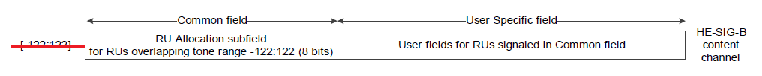
- HE-SIG-B content channel for a 20 MHz PPDU(#11436)

…

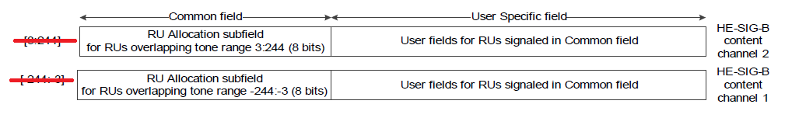
- HE-SIG-B content channel for a 40 MHz PPDU(#11437)

------------- End Text Changes ---------------

CID | P.L | Comment | Proposed Change | Resolution
11438 | 423.34 | In Fgure28-28 the note"[-500:-259][-258:-17][-16:-4, 4:16][17:258][259:500] " at the left side of the figure is misleading. The 20 MHz symbol carrying HE-SIG-B only has only 64 sub-carriers. | Remove the note at the left side of the figure | Revised  Agreed in principle.  Deleting leftmost [-500:-259], [-258:-17], [-16:-4,4:16], [17:258], each tone range shown in Common field of Figure 28-28 is already enough to indicate that corresponding RUs’ subcarrier indices fall in each range.  TGax Editor: make changes according to this document 11-18-0050-01-00ax CR on HE-SIG-B part 1.
11439 | 424.10 | In Fgure28-28 the note"[-1012:-771]...[771:1012] " at the left side of the figure is misleading. The 20 MHz symbol carrying HE-SIG-B only has only 64 sub-carriers. | Remove the note at the left side of the figure | Revised  Agreed in principle.  Deleting leftmost "[-1012:-771], ..., [771:1012], each tone range shown in Common field of Figure 28-29 is already enough to indicate that corresponding RUs’ subcarrier indices fall in each range.  TGax Editor: make changes according to this document 11-18-0050-01-00ax CR on HE-SIG-B part 1.

To TGax editor: P423L35 replace the current text with the proposed changes below.
------------- Begin Text Changes ---------------

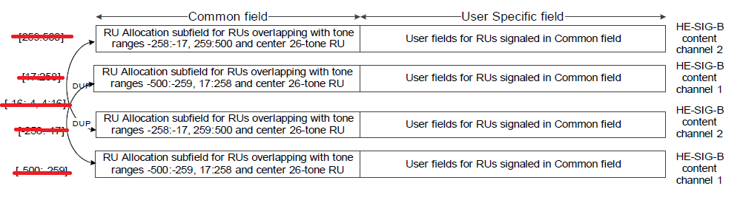
- Mapping of the two HE-SIG-B content channels and their duplication in an 80 MHz PPDU when the SIGB Compression field in the HE-SIG-A field of an HE MU PPDU is set to 0 (#11438)

…

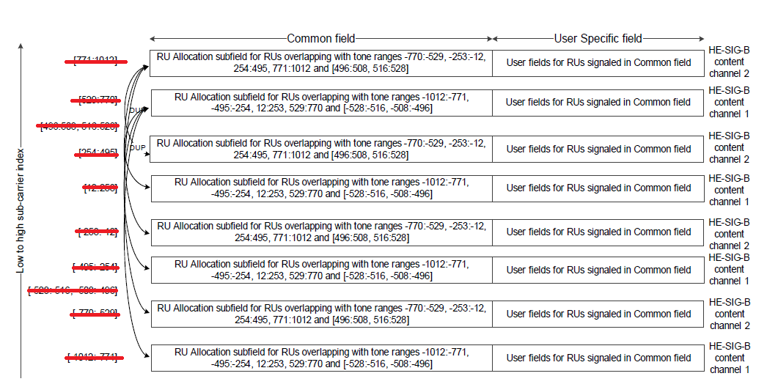
- Mapping of the two HE-SIG-B content channels and their duplication in a 160 MHz PPDU when the SIGB Compression field in the HE-SIG-A field of an HE MU PPDU is set to 0 (#11439)

------------- End Text Changes ---------------

CID | P.L | Comment | Proposed Change | Resolution
13470 | 424.64 | Change "added" to "appended" | See comment | Revised  Agreed in principle.  TGax Editor: make changes according to this document 11-18-0050-01-00ax CR on HE-SIG-B part 1.
To TGax editor: P424L64 replace the current text with the proposed changes below.
------------- Begin Text Changes ---------------

In the User Specific field, in any 20 MHz band, each User Block field shall have CRC and tail bits appended and then be BCC encoded at rate R = 1/2.(# 13470)

------------- End Text Changes ---------------

CID | P.L | Comment | Proposed Change | Resolution
14176 | 427.13 | Looking at "In the table, the number of entries column refers ...”. Here number of entries is the name of column such that "the number of entries" needs to be modified with "the Number of entries" | as in comment | Revised  Agreed in principle.  TGax Editor: make changes according to this document 11-18-0050-01-00ax CR on HE-SIG-B part 1.
To TGax editor: P427L13 replace the current text with the proposed changes below.
------------- Begin Text Changes ---------------

In the table, the Number of entries column refers to the number of 8-bit indices that refer to the same RU assignment to be used in the data portion in the frequency domain but differ in the number of User fields per RU.(#14176)

------------- End Text Changes ---------------

CID | P.L | Comment | Proposed Change | Resolution
14177 | 429.29 | Looking at "number of 8-bit indices that ...”. Here 8-bit indices is the name of column such that "8-bit indices" needs to be modified with "8 bits indices" | as in comment | Revised  Agreed in principle.  TGax Editor: make changes according to this document 11-18-0050-01-00ax CR on HE-SIG-B part 1.
To TGax editor: P429L29 replace the current text with the proposed changes below.
------------- Begin Text Changes ---------------

number of 8 bits indices that refer to the same RU assignment in the frequency domain but differ in the number of User fields per RU.(#14177)

------------- End Text Changes ---------------

CID | P.L | Comment | Proposed Change | Resolution
14178 | 430.52 | Considering the first row of Table 28-25, User field consists of many field. So"subfields" needs to be modified with "fields." | as in comment | Revised  Agreed in principle.  TGax Editor: make changes according to this document 11-18-0050-01-00ax CR on HE-SIG-B part 1.
To TGax editor: P430L52 replace the current text with the proposed changes below.
------------- Begin Text Changes ---------------

The User field for a non-MU-MIMO allocation contains the fields shown in Table 28-25 (User field for a non-MU-MIMO allocation).(#14178)

------------- End Text Changes ---------------

CID | P.L | Comment | Proposed Change | Resolution
11412 | 431.04 | NSTS is the number of space-time stream instead of spatial streams. | as in the comment | Revised  Agreed in principle.  TGax Editor: make changes according to this document 11-18-0050-01-00ax CR on HE-SIG-B part 1.
14179 | 431.37 | Considering the first row of Table 28-26, User field consists of many field. So"subfields" needs to be modified with "fields." | as in comment | Revised  Agreed in principle.  TGax Editor: make changes according to this document 11-18-0050-01-00ax CR on HE-SIG-B part 1.
To TGax editor: P431L04 replace the current text with the proposed changes below.
------------- Begin Text Changes ---------------

- User field for a non-MU-MIMO allocation
Bit | Field | Number of bits | Description
B0–B10 | STA-ID | 11 | Set to a value of the element indicated from TXVECTOR parameter STA_ID_LIST (see 27.11.1 (STA_ID_LIST)).
B11–B13 | NSTS | 3 | Number of space-time stream. (#11412)  Set to the number of space-time streams minus 1.
B14 | Tx Beamforming | 1 | Use of transmit beamforming.  Set to 1 if a beamforming steering matrix is applied to the waveform in an SU transmission.  Set to 0 otherwise.
B15–B18 | MCS | 4 | Modulation and coding scheme  Set to n for MCSn, where n = 0, 1 ,2 …., 11  Values 12 to 15 are reserved
B19 | DCM | 1 | Indicates whether or not dual carrier modulation is used.  Set to 1 to indicate that the HE-Data portion of the corresponding user of the HE MU PPDU is modulated with dual carrier modulation for the MCS.  Set to 0 indicates that the payload of the PPDU is not modulated with dual carrier modulation for the MCS.
B20 | Coding | 1 | Indicates whether BCC or LDPC is used.  Set to 0 for BCC  Set to 1 for LDPC
NOTE—Integer fields are transmitted in unsigned binary format, LSB first, where the LSB is in the lowest numbered bit position.

The User field for an MU-MIMO allocation contains the fields shown in Table 28-26 (User field for an MU-MIMO allocation). (#14179)

------------- End Text Changes ---------------

