IEEE P802.11
Wireless LANs
Discussion on Dynamic Fragmentation Level 3
Date: 2017-11-07
Author(s):
Name | Affiliation | Address | Phone | email
Huizhao Wang | Quantenna Communications | Quantenna Communications, Inc.  1704 Automation Parkway,  San Jose, CA 95131, USA |  | hwang@quantenna.com
Abstract
This submission discusses the issues of the 11ax dynamic fragmentation level 3, propose the changes in the current 11ax Draft 2.0
Discussion
11ax dynamic fragmentation level 0, 1, 2 & 3 are defined in HE Capability element Fragmentation Support subfield in Table 9-262z (Subfields of the HE MAC Capabilities Information field):

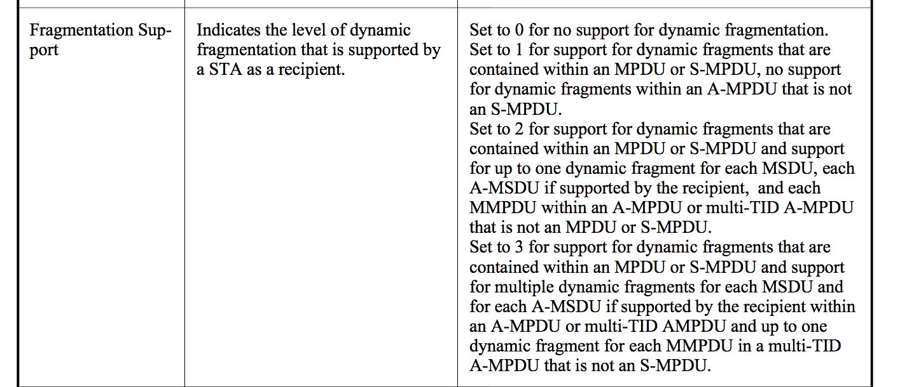

The corresponding changes in BlockAck & M-STA BlockAck frames to support dynamic fragmentation levels are defined in the Table 9-24a (Fragment Number subfield encoding for the Compressed BlockAck variant), and in the Table 9-24c (Fragment Number subfield encoding for the Multi-STA BlockAck variant):
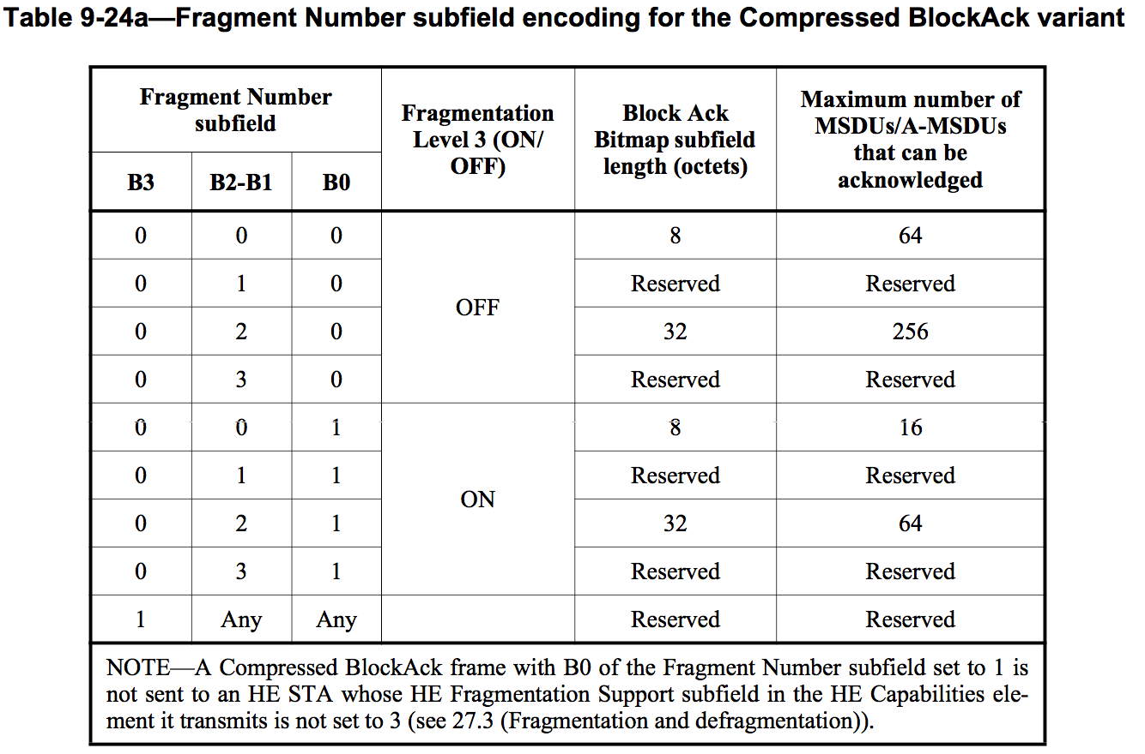
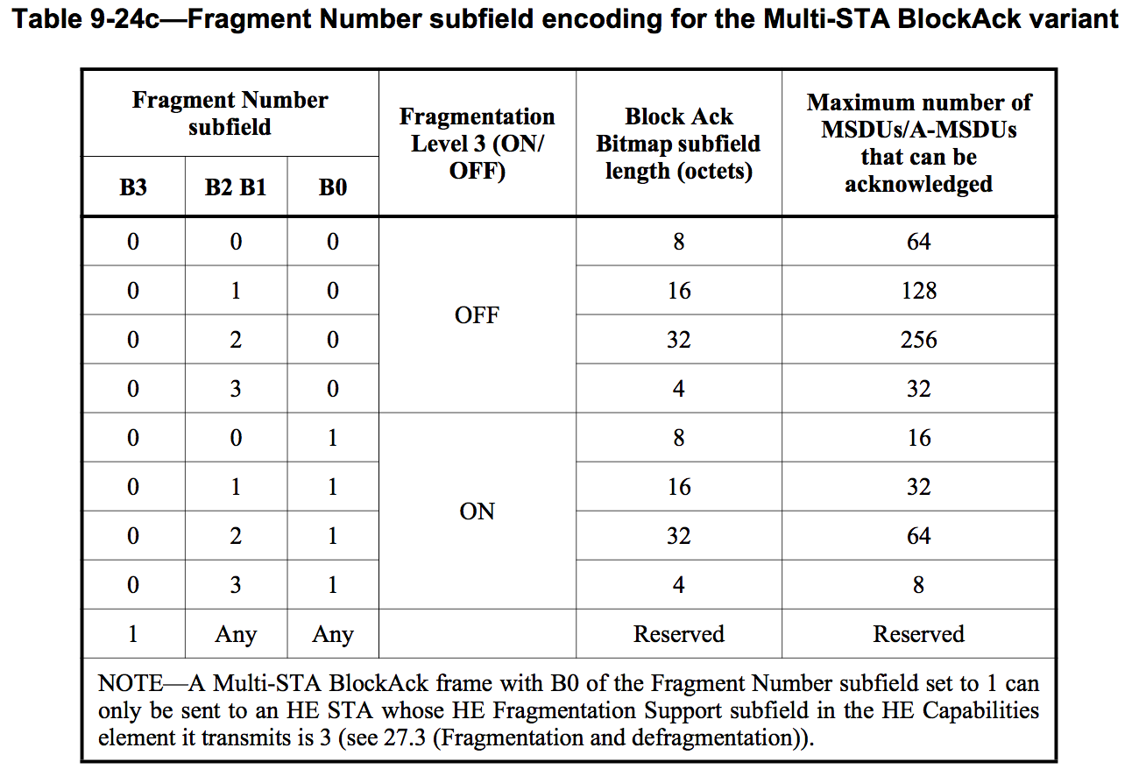
Issue:
Dynamic fragmentation level 3 assumes that the transmitter will fragment any MSDUs or A-MSDUs in an A-MPDU into up to 4 separate fragments:
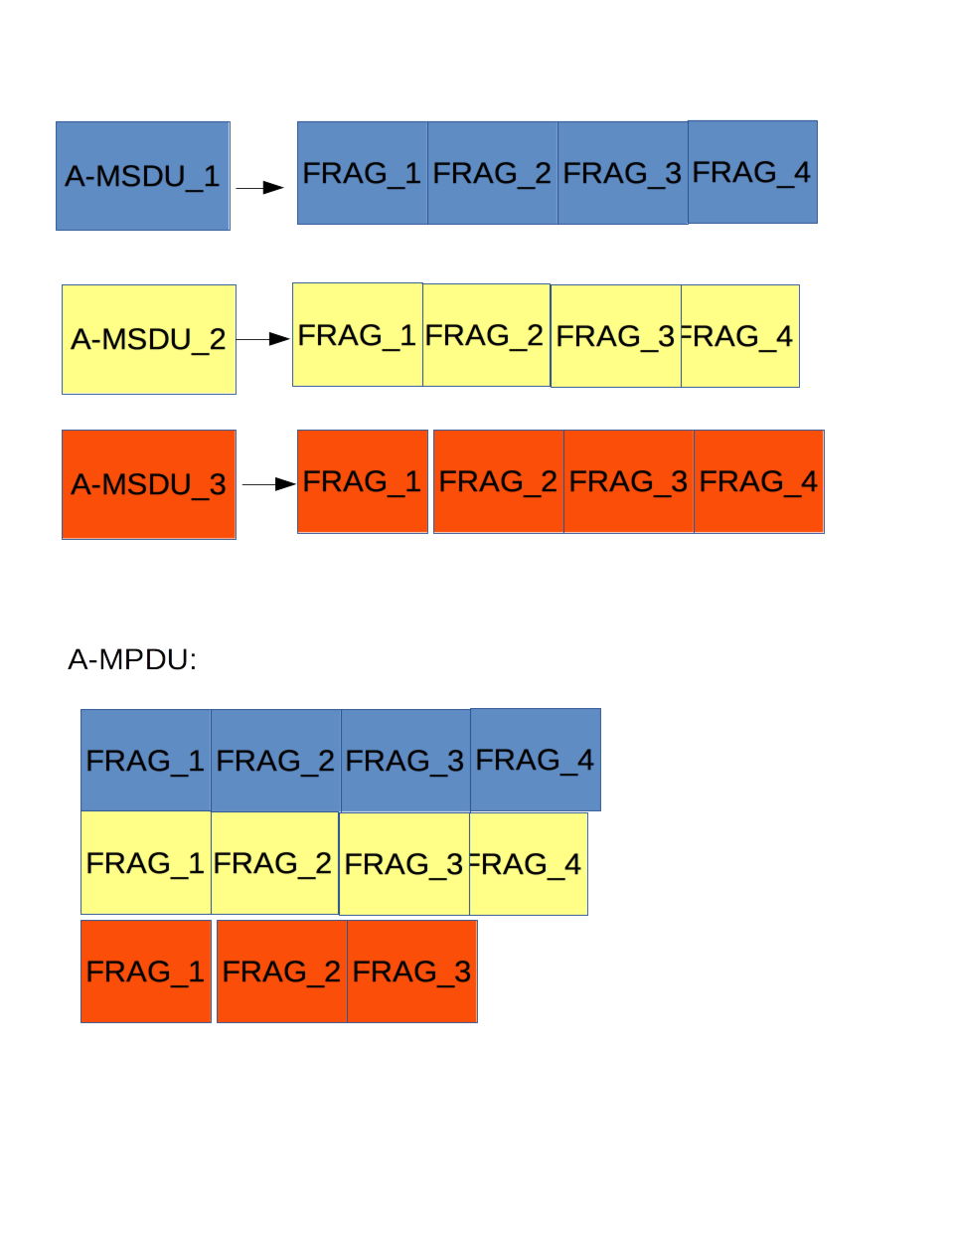
But in the realistic cases, there will be just have two cases level 3 dynamic fragments are needed with at most two MSDUs/A-MSDUs are fragmented with at most 3 fragments in total:
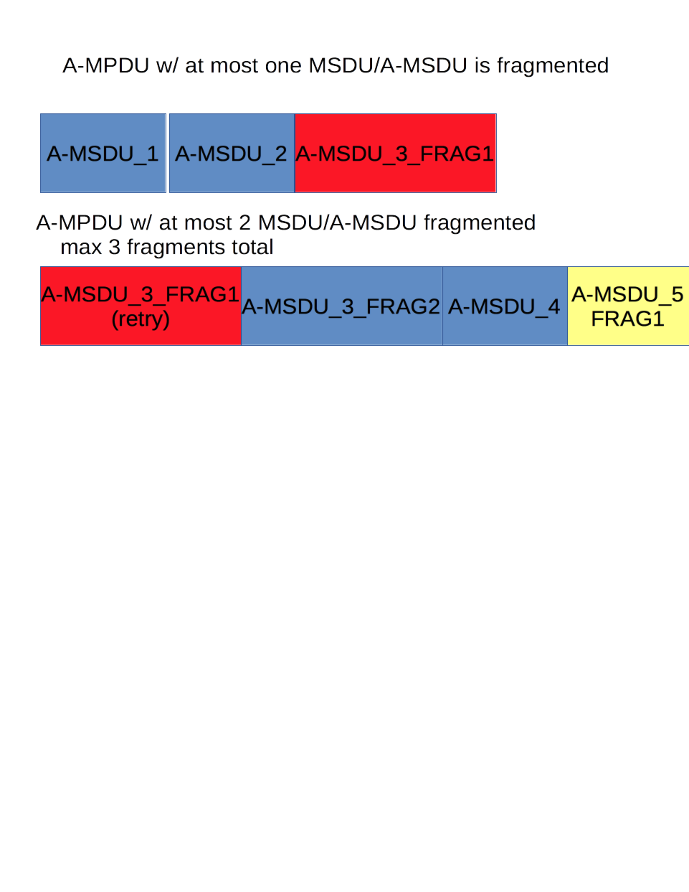
But the current Level 3 dynamic fragment support in Compressed BlockACK and M-STA BlockACK reduces the total number of MSDUs can be acknowledged to a quarter of bitmap capacity.
Proposed solution:
Since there are most only 3 fragments can be in an A-MPDU, instead of redefine the Block bitmap for Level 3 dynamic fragmentation, suggest to keep the bitmap field “as is”, and use the 3 LSBs of Fragmentation Number in Block Starting Sequence Control subfield to carry the acknowledge information of up to 3 fragments in receiving order:
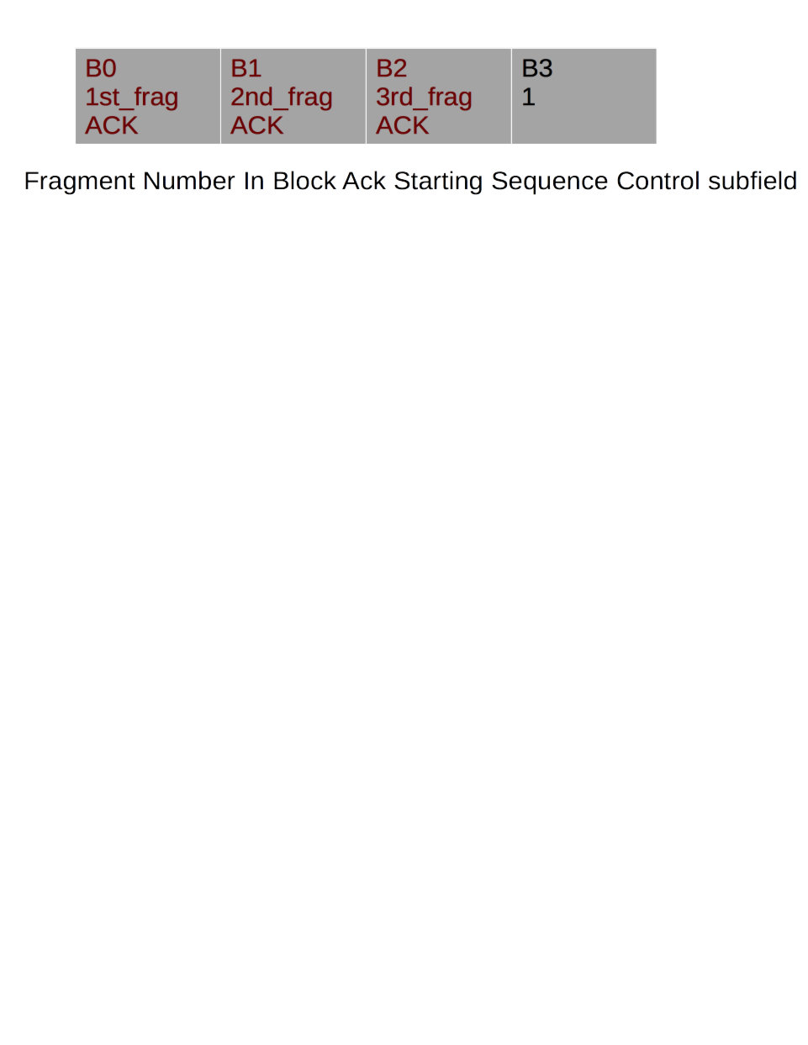

SP1
Do you agree that the current Level 3 dynamic fragmentation support in Compressed BlockACK and M-STA BlockACK is inefficient of using the bitmap?
Y/N/A

SP2
Do you agree the proposed solution of using Fragment Number subfield only to acknowledge Level 3 dynamic fragments in Compressed BlockACK and M-STA BlockACK?
Y/N/A

