IEEE P802.11  
Wireless LANs

|  |  |  |  |  |
| --- | --- | --- | --- | --- |
| Addressing the Inconsistence of Assigning CCF0 Value For BSS Bandwidth Is Less Than 80MHz in The Table 11-25 | | | | |
| Date: 2017-11-06 | | | | |
| Author(s): | | | | |
| Name | Affiliation | Address | Phone | email |
| Huizhao Wang | Quantenna Communications | Quantenna Communications, Inc. 1704 Automation Parkway, San Jose, CA 95131, USA |  | hwang@quantenna.com |
| Sigurd Schelstraete | Quantenna Communications | Quantenna Communications, Inc. 1704 Automation Parkway, San Jose, CA 95131, USA |  | sschelstraete@quantenna.com |
| Menzo Wentink | Qualcomm | Utrecht, the Netherlands |  | mwentink@qti.qualcomm.com |

Abstract

This submission is to address an inconsistence in Table 9-242 (VHT Information Operation subfields) in assigning CCFS0 when the BSS bandwidth is less than 80 MHz.

**Discussion**

Table 11-25 specifies that for BSS bandwidths 20 and 40 MHz, the Channel Center Frequency Segment 0 subfield is set to the value of dot11CurrentChannelCenterFrequencyIndex0:

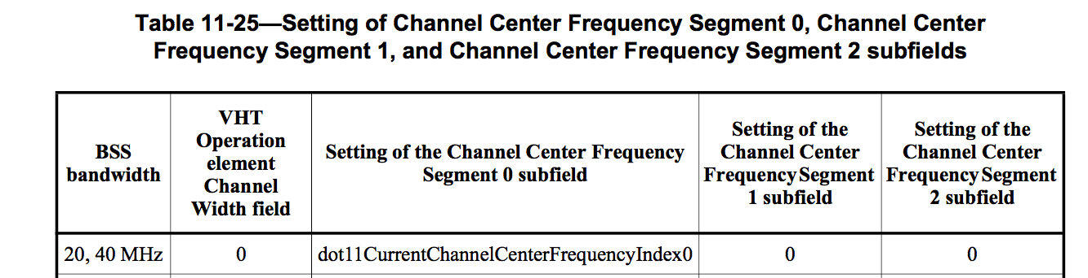

However, in Table 9-252, the CCFS0 subfield is “reserved” for BSS bandwidth less than 80MHz:

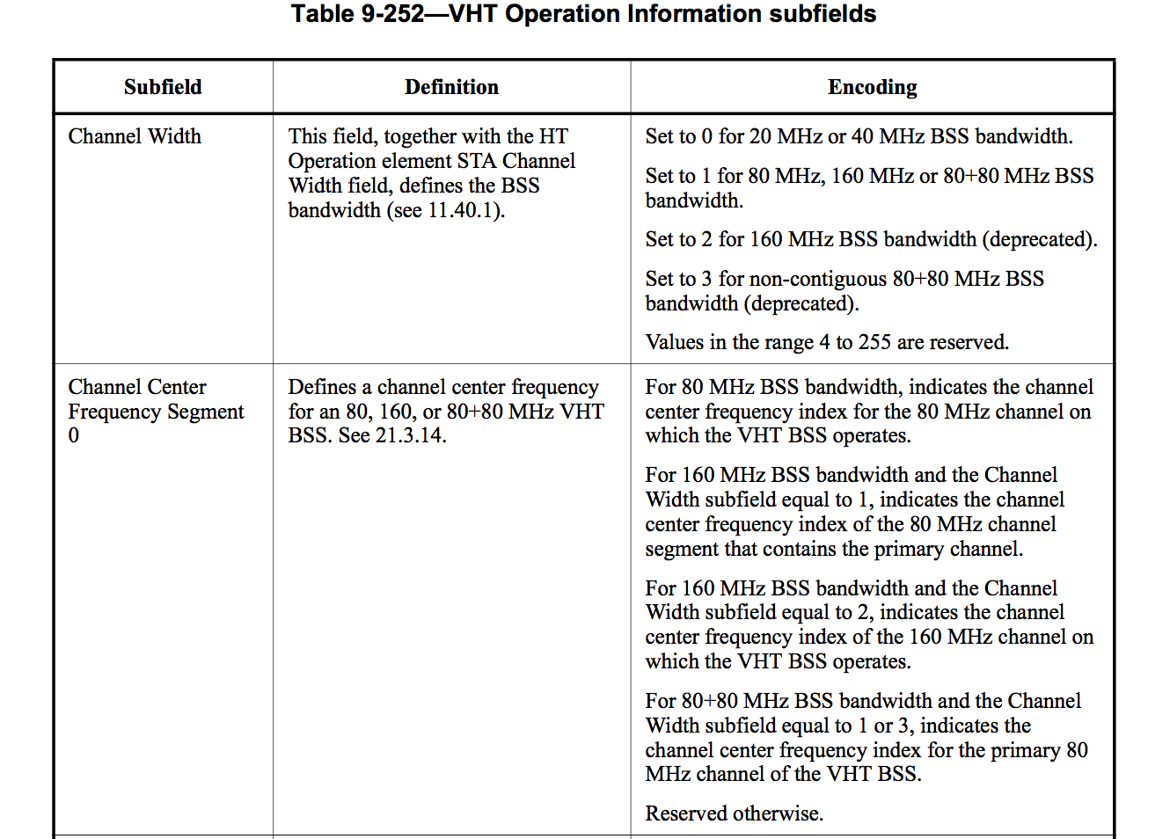

This appears to be an oversight. Other uses of CCFS0 also specify CCFS0 use for 20 and 40 MHz:













Therefore, an obvious fix would be to add 20 and 40 MHz to Table 9-252.

***Modify Table 9-252 (VHT Operation Information subfields) as follows:***

|  |  |  |
| --- | --- | --- |
| **Table 9-252—VHT Operation Information subfields** | | |
| **Subfield** | **Definition** | **Encoding** |
| Channel Width | This field, together with the HT Operation element STA Channel Width field, defines the BSS bandwidth (see 11.40.1 (Basic VHT BSS functionality)). | Set to 0 for 20 MHz or 40 MHz BSS bandwidth.  Set to 1 for 80 MHz, 160 MHz or 80+80 MHz BSS bandwidth.  Set to 2 for 160 MHz BSS bandwidth (deprecated).  Set to 3 for non-contiguous 80+80 MHz BSS bandwidth (deprecated).  Values in the range 4 to 255 are reserved. |
| Channel Center Frequency Segment 0 | Defines a channel center frequency for a~~n~~ 20, 40, 80, 160, or 80+80 MHz VHT BSS. See 21.3.14 (Channelization). | For 20, 40, or 80 MHz BSS bandwidth, indicates the channel center frequency index for the 20, 40, or 80 MHz channel on which the VHT BSS operates.  For 160 MHz BSS bandwidth and the Channel Width subfield equal to 1, indicates the channel center frequency index of the 80 MHz channel segment that contains the primary channel.  For 160 MHz BSS bandwidth and the Channel Width subfield equal to 2, indicates the channel center frequency index of the 160 MHz channel on which the VHT BSS operates.  For 80+80 MHz BSS bandwidth and the Channel Width subfield equal to 1 or 3, indicates the channel center frequency index for the primary 80 MHz channel of the VHT BSS.  Reserved otherwise. |
| Channel Center Frequency Segment 1 | Defines a channel center frequency for a 160 or 80+80 MHz VHT BSS. See 21.3.14 (Channelization). | For a 20, 40, or 80 MHz BSS bandwidth, this subfield is set to 0.  For a 160 MHz BSS bandwidth and the Channel Width subfield equal to 1, indicates the channel center frequency index of the 160 MHz channel on which the VHT BSS operates.  For a 160 MHz BSS bandwidth and the Channel Width subfield equal to 2, this field is set to 0.  For an 80+80 MHz BSS bandwidth and the Channel Width subfield equal to 1 or 3, indicates the channel center frequency index of the secondary 80 MHz channel of the VHT BSS.  See **Error! Reference source not found.**.  Reserved otherwise. |