IEEE P802.11
Wireless LANs
Addressing the Inconsistence of Assigning CCF0 Value For BSS Bandwidth Is Less Than 80MHz in The Table 11-25
Date: 2017-11-06
Author(s):
Name | Affiliation | Address | Phone | email
Huizhao Wang | Quantenna Communications | Quantenna Communications, Inc.  1704 Automation Parkway,  San Jose, CA 95131, USA |  | hwang@quantenna.com
Abstract
This submission is to address the incosistence of assigning CCF0 value when the BSS bandwidth is less than 80MHz in the Table 11-25.
Discussion
In the Table 11-25, in the second row specifies that: for BSS bandwidth “20, 40 MHz”, the “setting of the Channel Center Frequency Segment 0 subfield” is set to the value of dot11CurrentChannelCenterFrequencyIndex0:
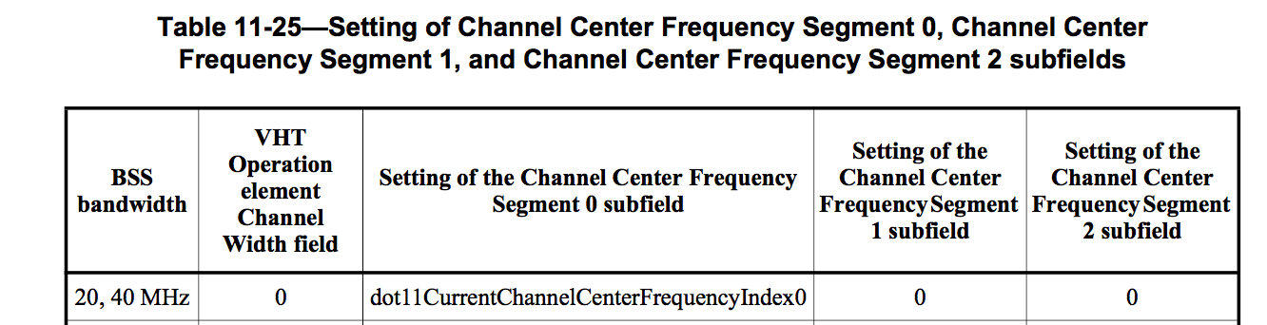

But clause 9.4.2.159, Table 9-252, the CCF0 subfield is “reserved” for BSS bandwidth is less than 80MHz:
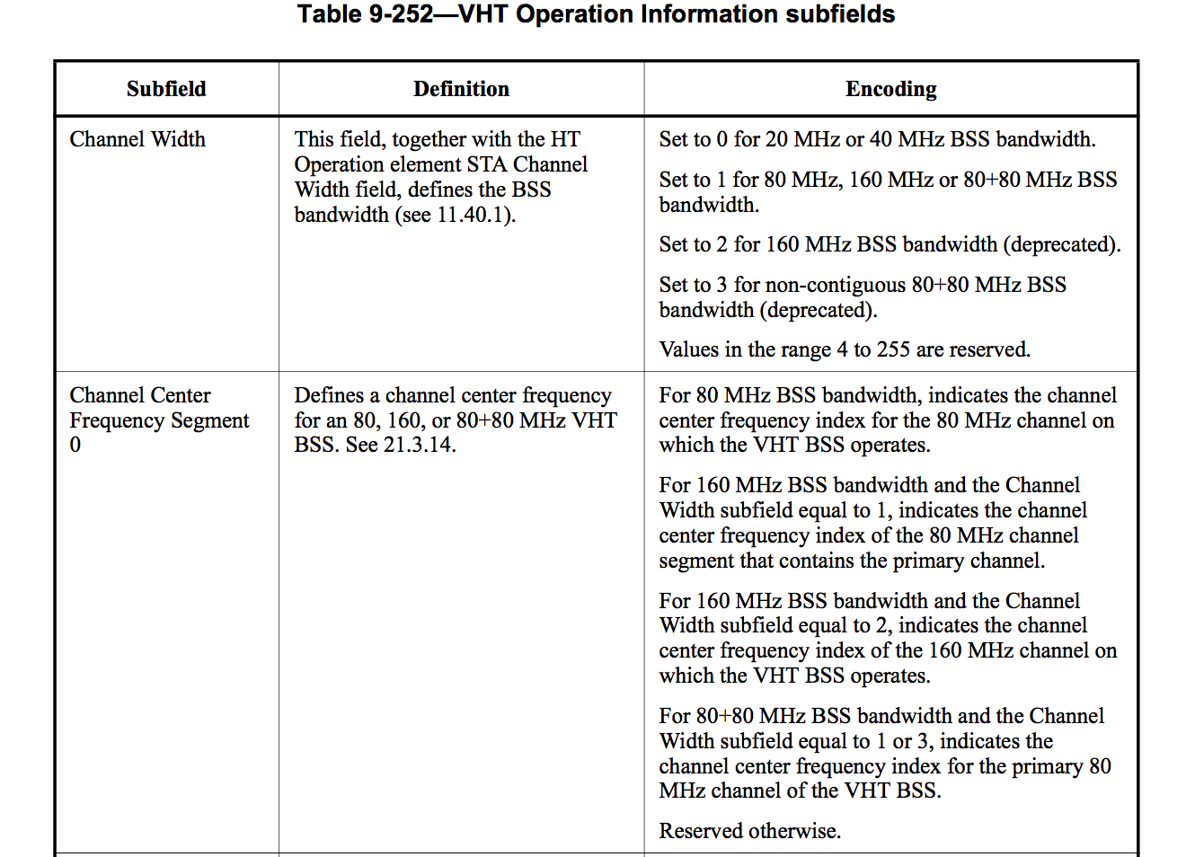
In order to be consistent to the Table 9-252, in the Table 11-25, the value of “setting of the Channel Center Frequency Segment 0 subfield” should be specified as 0 (zero) for BSS bandwidth of “20, 40 MHz”.

Instruct the editor to modify the Table 11-25 as indicated:

BSS  Bandwidth | VHT Operation element Channel Width field | Setting of the Channel Center Frequency Segment 0 subfield | Setting of the Channel Center Frequency Segment 1 subfield | Setting of the Channel Center Frequency Segment 2 subfield
20, 40 MHz | 0 | dot11CurrentChannelCenterFrequencyIndex0 0 | 0 | 0

