IEEE P802.11
Wireless LANs
Signaling for MU-MIMO BF Training
Date: 2017-11-06
Author(s):
Name | Affiliation | Address | Phone | email
SungJin Park | LG Electronics | Yangjae-daero 11gil, Seocho-gu, Suoul,  137-893, Korea |  | allean.park@lge.com
Carlos Cordeiro | Intel |  |  | carlos.cordeiro@intel.com
Lei Huang | Panasonic |  |  | lei.huang@sg.panasonic.com
Abstract
This document proposes draft changes to include signaling method for the intended responders that should perform receive AWV training in the MU-MIMO BF Training subphase.

Discussion
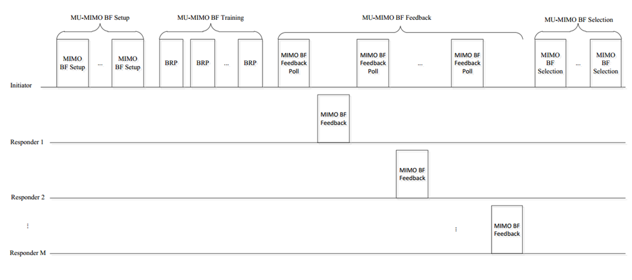
In the MU-MIMO BF Setup subphase, the STAs that receive the MIMO BF Setup frame operate as follows:
- The intended STAs expect BRP frames for MU-MIMO BF training.
- The STAs of third party that received the MIMO BF Setup frame set the NAV.

In the MU-MIMO BF Training subphase, the STAs that receive the BRP frame operate as follows:
- The intended STAs that received the MIMO BF Setup frame perform receive AWV training.
- The STAs of third party that did not receive the MIMO BF Setup frame may unnecessarily perform receive AWV training if there is no indication for intended STAs. It is inefficient in respect of power consumption.

Therefore, the signaling of which STAs are intended responders should be defined.

10.38.9 EDMG beamforming

10.38.9.2 MIMO beamforming

10.38.9.2.4 MU-MIMO beamforming

10.38.9.2.4.3 MIMO phase

10.38.9.2.4.3.2 Downlink MIMO phase
The initiator shall initiate the MU-MIMO BF training subphase a MBIFS following the transmission of the MIMO BF Setup frame. In the MU-MIMO BF training subphase, the initiator shall transmit one or more EDMG BRP-RX/TX packets to the remaining responders in the MU group. Both the TA and RA fields of each EDMG BRP-RX/TX packet shall be set to the MAC address of the initiator. If a responder whose corresponding bit in the Group User Mask field within the last received MIMO BF Setup frame from the initiator was equal to 1 receives an EDMG BRP-RX/TX packet with both the TA and RA fields set to the MAC address of the initiator, the responder should perform receive AWV training. Each EDMG BRP-RX/TX packet shall be separated by SIFS. Each transmitted EDMG BRP-RX/TX packet is used to train one or more transmit sectors and, for each transmit sector, a number of receive AWVs. In each EDMG BRP-RX/TX packet, the initiator shall include, for each selected transmit sector, TRN subfields in the TRN field for remaining responders to perform receive AWV training. For each EDMG BRP-RX/TX packet, the TXVECTOR parameter EDMG_TRN_LEN shall be set to a value greater than zero. The parameters RX_TRN_PER_TX_TRN and EDMG_TRN_M shall be set in such a manner that the number of TRN subfields included in the TRN field used for receive AWV training is the maximum number of receive sectors across all the remaining responders based on the L-TX-RX subfields and the EDMG TRN-Unit M subfields in the feedback from all the remaining responders in the SISO phase. The initiator may transmit each EDMG BRP-RX/TX packet to train multiple TX DMG antennas simultaneously using TRN subfields defined in 30.9.2.2.6 to reduce the training time. The TX Antenna Mask field of each EDMG BRP-RX/TX packet shall indicate the TX DMG antenna(s) which is being used by the responder to transmit the EDMG BRP-RX/TX packet. The BRP CDOWN field of each EDMG BRP-RX/TX packet shall indicate the number of remaining EDMG BRP RX/TX packets to be transmitted by the initiator in the MU-MIMO BF training subphase.

SP/Motion
Do you agree to include the text for signaling intended responders in the MU-MIMO BF Training subphase proposed in (11-17-1659-00-00ay-Signaling for MU-MIMO BF Training) into the draft?

