IEEE P802.11
Wireless LANs
Unsolicited RSS after BTI
Date: 2017-10-18
Author(s):
Name | Affiliation | Address | Phone | email
Gaius Wee | Panasonic Corporation | 202 Bedok South Avenue 1 #02-11, Singapore 469332 | +65 6550 5335 | yaohuang.wee@sg.panasonic.com
Abstract
This document proposes draft specification text to enable the use of unsolicited RSS in response to the BTI.

Discussion

The current 11ay D0.5 draft [1] enables an EDMG STA to perform an unsolicited RSS after receiving an ISS addressed to another STA during the DTI. This proposal seeks to extend the existing unsolicited RSS scheme to cover responding to a received BTI (e.g. for unassociated STAs performing discovery) and expedite beamforming, especially when the A-BFT is not present.

The Unsolicited RSS Enabled field is included in the DMG Beacon. To avoid expanding the size of the DMG Beacon, which increases BTI overhead, the Unsolicited RSS Enabled field takes the place of the existing IsResponderTXSS field when the A-BFT is not present (as signaled by Next A-BFT>0). Note: The IsResponderTXSS field is useful only when A-BFT is present so there is no impact on existing behaviour. An EDMG STA may perform the unsolicited RSS during the DTI in response to a received DMG Beacon with Unsolicited RSS Enabled set to 1 and shall not if set to 0.

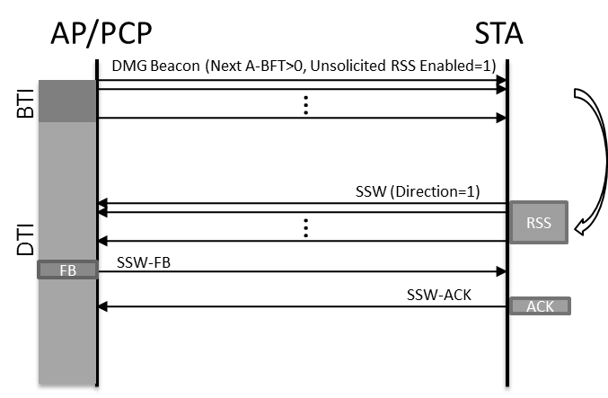

Proposed draft text to be included is below.

9. Frame formats

9.3 Format of individual frame types

9.3.4 Extension frames

9.3.4.2 DMG Beacon

Modify the paragraph before Figure 9-61 as follows:

The format of the Beacon Interval Control field when the Next A-BFT subfield is set to 0 is shown in Figure 9-61 and the format of the Beacon Interval Control field when the Next A-BFT subfield is greater than 0 is shown in Figure 9-61a.

Modify the caption of Figure 9-61 as follows:

Figure 9-61—Beacon Interval Control field when the Next A-BFT subfield is set to 0

Add the following figure after Figure 9-61 as shown:

 | B0 | B1 | B2 B5 | B6 | B7 B9 | B10 B13 | B14 | B15 B18
 | CC Present | Discovery Mode | Next Beacon | ATI Present | A-BFT Length | FSS | Unsolicited RSS Enabled | Next A-BFT
Bits: | 1 | 1 | 4 | 1 | 3 | 4 | 1 | 4

 | B19 | B20 B26 | B27 B30 | B31 B36 | B37 B42 | B43 | B44 B45 | B46 B47
 | Fragmented TXSS | TXSS Span | N BIs A-BFT | A-BFT Count | N A-BFT in Ant | PCP Association Ready | A-BFT Multiplier | A-BFT in Secondary Channel
Bits: | 1 | 7 | 4 | 6 | 6 | 1 | 2 | 2

Figure 9-61a—Beacon Interval Control field when the Next A-BFT subfield is greater than 0

Insert a new paragraph after the 13th paragraph as follows:

The Unsolicited RSS Enabled subfield is present when the Next A-BFT subfield is greater than 0 and is set to 1 to indicate the STA is capable of receiving an unsolicited RSS in response to its BTI. This subfield is set to 0 otherwise.

10. MAC sublayer functional description

10.38 DMG beamforming

10.38.2 Sector-level sweep (SLS) phase

10.38.2.2 Initiator sector sweep (ISS)

10.38.2.2.2 Initiator TXSS

Modify the following paragraph as follows:

During a CBAP, an EDMG STA may obtain a TXOP with an unsolicited RSS or use an existent TXOP for an unsolicited RSS. If a TXOP is obtained through the transmission of a Grant frame and the TXOP holder intends to start the TXOP with an unsolicited RSS, the TXOP holder shall set the Unsolicited RSS subfield in the Grant frame to 1 to indicate the SLS begins with an unsolicited RSS and is performed without an ISS.

10.38.6 Beamforming in DTI

10.38.6.2 SLS phase execution

Modify the following paragraphs as follows:

NOTE—If a TXOP holder or source STA of an SP transmits SSW frames with the Direction field set to 1 at the beginning of a TXOP or SP, respectively, the STA is considered as the responder for an ISS or RSS that occurred in an earlier BTI, TXOP or SP. The EDMG STA performing the ISS or RSS in the earlier BTI, TXOP or SP is considered as the initiator for the subsequent unsolicited RSS.

If an EDMG STA receives a DMG Beacon or SSW frame from an EDMG STA with the Unsolicited RSS Enabled subfield equal to 1, the STA may process the received DMG Beacon or SSW frames as a responder even if the A-BFT is not present for the case of a received DMG Beacon frame, or even if the STA’s MAC address does not match the RA field of the for the case of a received SSW frame. The STA may then perform an RSS with the initiator in response to the received SSW frames in a subsequent TXOP or SP. This is known as an unsolicited RSS.

An EDMG STA shall not perform an unsolicited RSS in response to a DMG Beacon or SSW frame with the Unsolicited RSS Enabled subfield set to 0.

Modify the following paragraph as follows:

An unsolicited RSS takes place when all of the following conditions are met:
a) An EDMG STA transmits an DMG Beacon or SSW frame with the Unsolicited RSS Enabled subfield set to 1
b) Following the transmission of an DMG Beacon or SSW frame with the Unsolicited RSS Enabled subfield set to 1, the STA identified in (a) receives an SSW frame that is not a response to an immediately preceding ISS and transmitted as part of an RSS for which the Direction field is set to 1 and the RA field of the SSW frame is equal to the STA’s MAC address
c) In the case an SSW frame was transmitted in (a), tThe STA that transmitted the SSW frame identified in (b) is different than the STA addressed by the SSW frame identified in (a).

Modify the following paragraph as follows:

Figure 58 shows an example of an unsolicited RSS. STA A that performs an ISS or RSS with STA C sets the Unsolicited RSS Enabled subfield to 1 to indicate it is operating as an initiator corresponding to a potential unsolicited RSS in a subsequent TXOP or SP. STA B (TXOP holder or source STA of the SP) transmitting SSW frames with the Direction subfield set to 1 at the beginning of a TXOP or SP (e.g., TXOP2 or SP2) is considered as the responder of STA A for the ISS or RSS in the earlier BTI, TXOP or SP (e.g., TXOP1 or SP1). In the TXOP2 or SP2, if a SSW frame with the Direction subfield set to 1 is received, STA A operates as the initiator and responds with a SSW Feedback frame without performing an ISS.

Replace figure 58 with the following figure:

SP

- Do you support the addition of the proposed text to enable unsolicited RSS after BTI to the draft 11ay specification?
  - Yes
  - No
  - Abstain

References:
- Draft P802.11ay_D0.5.doc

