IEEE P802.11
Wireless LANs
Resolution to CID7548
Date: 2017-09-10
Author(s):
Name | Affiliation | Address | Phone | email
Yujin Noh | Newracom |  |  | yujin.noh at newracom.com
Bin Tian | Qualcomm | 5775 Morehouse Dr. San Diego, CA, USA |  | btian@qti.qualcomm.com

Abstract

This submission provides resolution to CID 7548.
• Resolution for a comment received from TGax comment collection (TGax Draft D1.0)
• The proposed changes are based on 11ax D1.4

Revisions:
• Rev 0: Initial version of the document.

Interpretation of a Motion to Adopt

A motion to approve this submission means that the editing instructions and any changed or added material are actioned in the TGax Draft. This introduction is not part of the adopted material.

Editing instructions formatted like this are intended to be copied into the TGax Draft (i.e. they are instructions to the 802.11 editor on how to merge the text with the baseline documents).

TGax Editor: Editing instructions preceded by “TGax Editor” are instructions to the TGax editor to modify existing material in the TGax draft. As a result of adopting the changes, the TGax editor will execute the instructions rather than copy them to the TGax Draft.

CID | P.L | Comment | Proposed Change | Resolution
7548 | 225.1 | Consistent terminology? In table 28-11 for tone allocation related constants in OFDMA, it states that NST=NSD+NSP where NST is the total number of subcarriers per RU, NSD is the total number of complex data numbers per RU, and NSP is the number of pilot subcarriers. However, in equations 28-122 and 28-124 NST is defined as the total number of data tones of occupied RU. I wonder if for consistency/clarity, either the term NSD should be used OR change the NST definition in eq 28-122 and 28-124 to be defined as total number of subcarriers in occupied RU | Change NST to NSD in equations 28-122 and 28-124 or change NST definitions in those equations to total number of subcarriers in used RU. | Revised-  Agreed in principle.  TGax Editor: make changes according to this document 11-17- 1462-00-00ax Resolution to CID7548.

Changes to Section 28.3.18.4.4 Transmitter modulation accuracy (EVM) test

To TGax editor: P451L33 replace original texts (N_{ST}) with the proposed changes (N_{SD}) below.

------------- Begin Text Changes ---------------

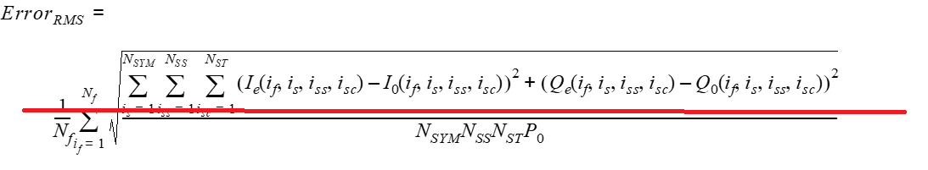
where
I₀(i_{f}, i_{s}, i_{ss}, i_{sc}) Q₀(i_{f}, i_{s}, i_{ss}, i_{sc}) denotes the ideal symbol point in the complex plane in data tone i_{sc} of the RU under test, spatial stream i_{ss}, and OFDM symbol i_{s}(#4878) of frame i_{f}.
I_{e}(i_{f}, i_{s}, i_{ss}, i_{sc}) Q_{e}(i_{f}, i_{s}, i_{ss}, i_{sc}) denotes the equalized observed symbol point in the complex plane of the i_{sc}-th data tone of the RU under test, spatial stream i_{ss}, and OFDM symbol i_{s}(#4878) of frame i_{f}.
P₀ is the average power of constellation
N_{f} is the number of tested frames
N_{SDT} is the number of data tones of the occupied RU
N_{SS} is the number of spatial streams of the data
N_{SYM} is the number of data OFDM symbols
NOTE 1—In the case the transmit modulation accuracy test is performed simultaneously for the two frequency segments of the 80+80 MHz transmissions with 2×996-subcarrier RU.

------------- End Text Changes ---------------

To TGax editor: P452L55 replace original texts (N_{ST}) with the proposed changes (N_{SD}) below.

------------- Begin Text Changes ---------------

(28-118)

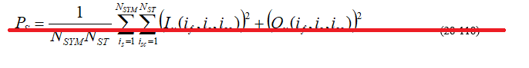

N_{f} is the number of tested frames
N_{SYM} is the number of data OFDM symbols
N_{SDT} is the number of data tones of the occupied RU

------------- End Text Changes ---------------

